Technical Interview – Part 1

1. Case:

在City A中有两家店，Store A 和Store B。在2020年初，开了第三家店Store C。在2021年初之际，Store A B发现过去一年内增长困难，想看一下是否新开店吸引了已有顾客，如何用数据分析结果解答门店同事的疑惑。请简单阐述你的思路。

已有数据: City A up to date交易记录（包含会员信息）

The below is an ERD of a simple database storing transaction, customers, stores and products data. You will use it as a reference to answer the questions following.

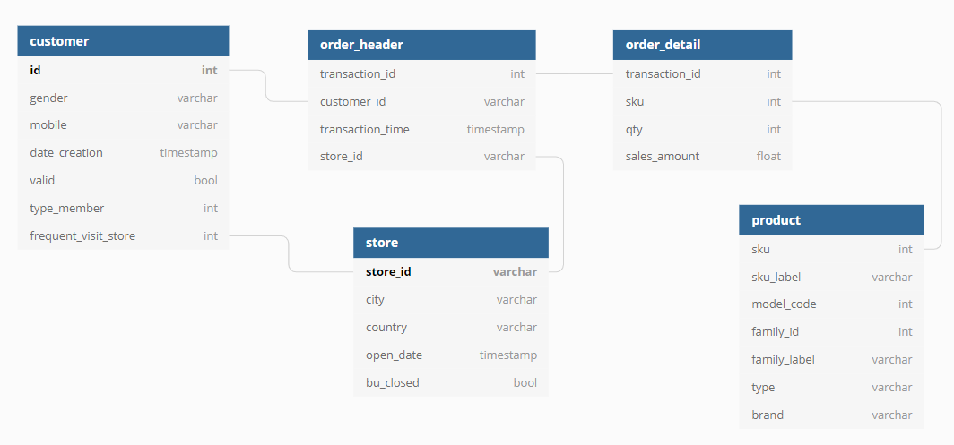

Qty: quantity sold of sku in every transaction.

Sales_amount: revenue contribution of sku in every transaction.

In table order_header: customer_id will be null if the customer is not member.

Please refer to ERD to finish the following tasks.

1. Please tell the proportion of men and women in China (country = ‘CN’) respectively.
2. Please tell the monthly performance of each brand in each city of 2020.(please focus on membership behavior only)

Performance means:

1. Number of members who purchased,
2. Number of orders placed,
3. Total quantity sold,
4. Total revenue