背最少的词，答最多的题

——词汇逆推、背词不亏 181018帅哥公益课笔记

最开始的时候​，我们要先说一下，很多同学特别关心口语考试中自己的eye contact，body language等等，它们都很好，如果你能有，如果你在考试的时候能展现这些的同时，也可以展现很好的英文的话，那很好。但问题​是​，如果你有这些东西，却影响了自己的英文表达​，你完全不知道要说什么​。一旦，眼神沟通、肢体语言，影响你的沟通的时候，影响你的英文表达的时候，请记住，这些东西本身没有那么重要，因为他们没出现在评分标准当中。

接下来的一小时课程，帮助大家提升“一个半”评分标准。一个是词汇资源，半个是流利度。

* **流利度、连贯性**
* **词汇资源**
* **语法广度与准度**
* **发音**

我相信，很多同学在平常备考的时候​，积累了好多词汇表达，可能从我的微信公众号和微博上，找到了很多很多材料。但是你可能背了一千个词，最后只用出来7个。你会觉得自己亏了，对不对​？语言学习没有亏不亏的问题，可能现在用不上，之后也会有帮助的，但如果我们只是从口语考试通过​的角度来看，如何可以​，背了十个词就努力把它用上​，如何可以不吃亏​。

我们来学习成为一个有意思的方法——词汇逆推、背词不亏。

* **词汇逆推、背词不亏**

这是什么意思呢？什么叫做逆推​？大部分情况下，考官问你一个问题​，你脑子里会想到内容，你通过这个内容去想用什么词汇​，对不对​？这是个正向的推导方式。比如，这个公园很美丽，你想到了this park is really beautiful, beautiful这个词，这个叫做正向推导。

什么叫做逆向推导​？你今天学了一个词儿叫Picturesque，风景美如画的。你学的这个词儿你琢磨着，我会的词也不多​，会了一个考场上还不说，我就亏了。你就想办法把这个词汇使用出来。

我们今天会特别强调话题词汇topic-related vocabulary的词汇​。​说到音乐，你就会使用tone-deaf跑调的，Melodious悠扬的，好听的。

* + **话题词汇充分运用**
    - 正向使用
    - 逆向使用
    - 对比使用

话题词汇充分使用，有三种，正向使用、逆向使用、对比使用。正向使用就是你学了一个beautiful、picturesque，你就想去描述一个公园很漂亮，一个地方很漂亮，如果那里不漂亮，你就用不上了。这叫做正向使用​，我相信大部分同学脑筋是可以转过这个弯的。我们今天开阔一下更多的使用方式​。如何来操作，我们一点点来看。

来，我们先学习一些词汇​，非常常用的和电影有关的词汇表达。movies是本季度p1的话题。

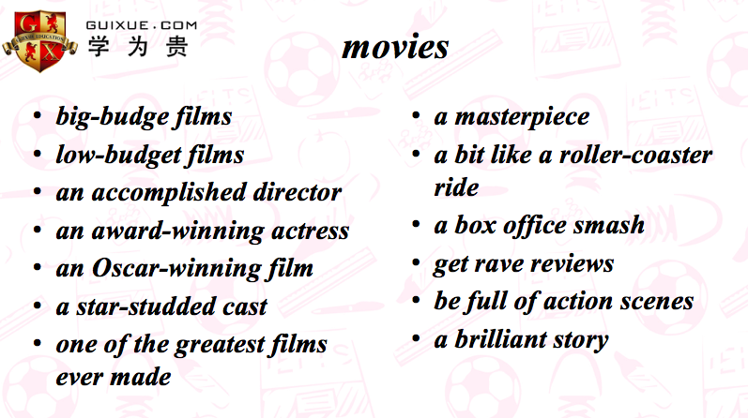

* ***big-budget films 小成本电影***
* ***low-budget films 低成本电影***
* ***an accomplished director 一个有成就的导演（你可以把director换成teacher、actor等等）***
* ***an award-winning actress 一个获过奖的女演员（可以把actress换成film～）***
* ***an Oscar-winning film 一个获过奥斯卡的电影***
* ***a star-studded cast 群星云集***
* ***one of the greatest films ever made 有史以来最好的影片之一（有同学说，我想跟考官说一个电影名，但是我不知道它英文名，怎么办？当然，你可以在平时上网查。但你在考场上的时候，可以直接跟考官说它的中文名，然后告诉考官 I'm sorry, I don't know its English name, I'm not even sure whether it has an English name, perhaps it doesn't. so yeah, I just gonna keep saying its Chinese name to you, I'm so sorry about that, bear with me.大体意思是不好思议我不知道它的英文名字，我甚至不确定它是否有英文名，可能是没有的。所以我只能跟你说它的中文名，非常抱歉哈，请忍受我一下。）***
* ***a masterpiece 杰作***
* ***a bit like a roller-coaster ride 像过山车一样，跌宕起伏=twists and turns***
* ***a box office smash 票房大卖的影片***
* ***get rave reviews 好评如潮***
* ***be full of action scenes 有很多动作场景***
* ***a brilliant story 一个非常棒的故事***

事实上，就算不考这个话题，你也一定能够使用的，你们不觉得么。比如考官在p1问你关于无聊的话题。

**What would you like to do when you feel bored?**

回答：Well，what would I like to do? Um… actually first of all, I have to tell you that I feel bored most of the time, because I'm a pretty boring person. I live alone I don’t have any family​ members and I don’t have a girlfriend​. So yeah, in most cases, I don't have anything​ better to do. When that happens, I like to watch a movie on my computer. Most of the time, I just stay at home and watch movies on my computer. I don't go to movie theaters. Usually I like to watch some movies that were masterpieces, that were box office matches and that got rave reviews, but sometimes I watch low-budget film, too. **即使这个话题本身不是movies，你可以聊到这个上边来，是不是？**

有些词不能描述所有的电影，比如很多动作场景，有些电影它就是没有动作场景呀，怎么办。假设我们就会这些词，我们怎么在更多的题目里使用他们？

**正向使用**

* ***The movie was directed by an accomplished director.***
* ***The film has a star-studded cast.***
* ***It is one of the greatest movies ever made.***
* ***It got rave reviews.***

正常使用的就是它是什么，你就说就完了。如果这部电影确实他是一个很杰出的导演执导的​。这个电影确实有一个全明星的卡斯阵容，非常的大牌，都是明星。这部电影确实是有史以来最好的电影之一​。这部电影确实好评如潮。

**反向使用**

* ***The movie didn't have any action scenes.***
* ***I don't suppose the film told a brilliant story.***
* ***There's no award-winning actor in the movie.***

这个电影如果他们没有那么多的动作，场景之间加个否定不就好了吗​？didn't xxx, no xxx，don't suppose xxx.

**对比使用**

* ***Unlike some of the other movies that I've seen before which were like roller-coaster rides, this one wasn't exciting at all.***
* ***Some people like to watch movies that are full of action scenes. I'm completely different. I prefer those that are slow-moving.***

把这部电影和其他电影做对比。你想说的电影没有跌宕起伏的情节，别太死心眼～你可以加点别的！你就可以跟非常跌宕起伏的电影做对比～

如果你的脑子不太能转过来，用这些方法帮助你转。正向不行反向，反向还不行，对比使用。我们接下来看看几道本季度口语的题目，操练操练。

* **答题**
  + ***Do you like watching movies?***
  + ***How often do you watch movies?***
  + ***What kind of movies do you like to watch?***
  + ***Do you prefer to go to the cinema alone or with others?***

***Do you like watching movies?***

随便造答案。

Yeah, I do. I am crazy about movies​. I have to go to the movie theater every weekend because it's my favorite leisure activity. In most cases, I watch big budget films because they are very exciting and they are always like roller-coaster ride.

换个方式，yeah, I do. Actually yesterday I watched​ a low-budget film called shawn’s sky（肖恩的天空，瞎造的电影哈哈哈）.（反向使用） It's not​ directed by an accomplished director and there are no award winning actors and actresses, there are no star- studded cast. However, the movie is really good. It told a brilliant story.

***How often do you watch movies?***

这道题跟上一题没啥区别

***What kind of movies do you like to watch?***

Well, I am pretty different from other people​, because you know most people around me, most of my friends and family members enjoy watching those movies that are full of action scenes. ​However, I am very different. I prefer those movies that are slow-moving慢节奏的. You know, yesterday, I watched the movie name shawn’s sky （反向使用）which is not directed by an accomplished director and there are no award winning actors, but the movie is so beautiful. You know, it told a brilliant story. It’s very moving, and I was even touched​ to tears​ at one point in the middle of the movie. It was really good​.

***Do you prefer to go to the cinema alone or with others?***

这个也可以用哈，就不给答案了。

我们再来复习一下这些词，等会儿还要用呢。

* ***big-budget films 小成本电影***
* ***low-budget films 低成本电影***
* ***an accomplished director 一个有成就的导演***
* ***an award-winning actress 一个获过奖的女演员***
* ***an Oscar-winning film 一个获过奥斯卡的电影***
* ***a star-studded cast 群星云集***
* ***one of the greatest films ever made 有史以来最好的影片之一***
* ***a masterpiece 杰作***
* ***a bit like a roller-coaster ride 像过山车一样，跌宕起伏=twists and turns***
* ***a box office smash 票房大卖的影片***
* ***get rave reviews 好评如潮***
* ***be full of action scenes 有很多动作场景***
* ***a brilliant story 一个非常棒的故事***

我们想想，除了p1, 在p2能用吗？

描述一个电影，肯定能用对吧

如果是别的题目呢。描述一本小说，描述一个喜剧，描述一个有名的人（shawn是个有成就的导演，导过怎么样的电影，获得怎么样的反响），也能用。

带着大家看一道题

* ***Describe a childhood friend of yours***
* ***you should say*** 
  + ***who he or she was***
  + ***when and where you met him or her***
  + ***what you did together***
* ***and explain why you were good friends***

这个跟电影看起来没啥关系，描述一个童年的朋友。编呗，非得说实话吗哈哈。朗读一遍答案。

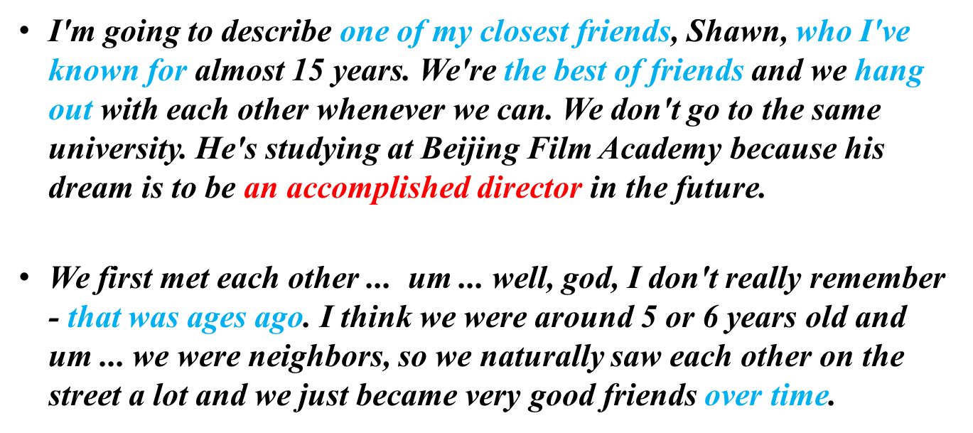

one of my closest friends我最好的朋友之一

who I’ve known for我认识他（多久）

the best of friends最好的朋友

hang out呆着

an accomplished director一个有成就的导演

that was ages ago 几年前

over time随着时间的推移

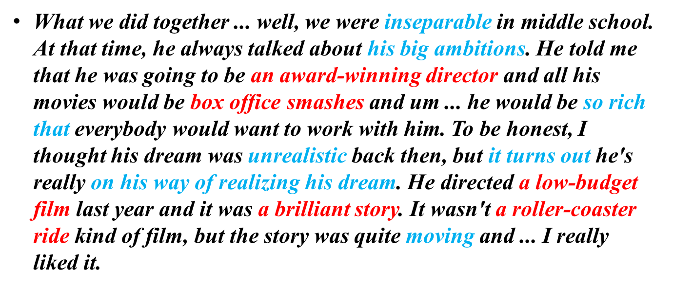

inseparable形影不离的=wear the same pants

his big ambitions他的远大抱负

an award-winning director获过奖的导演

box office smashes票房大卖的影片

so rich that很富以至于

unrealistic不实际的

it turns out事实证明

on his way of realizing his dream正在实现自己的梦想

a low-budget film低成本电影

a brilliant story很棒的故事

a roller-coaster ride情节跌宕起伏



第四点，我觉得可能说不到了，因为前三个点说完已经时间够了。我知道大家有要说了，第四点不说不会扣分吗？有些老师说第四点最重要啊？

解答一些，这是完全错误的理念。第四点一点不说，也不扣分。

难道只有这一道题能用到刚才学过的词汇吗？我觉得不是，都可以用。

* ***a happy experience you had before看电影，开心呗。***
* ***a language you would like to learn 爱什么语言什么语言，反正你喜欢这个语言的电影，虽然小制作，但是很棒，为了更好地看懂电影，你要继续学习这门语言。***
* ***a magazine you like 电影杂志，有些情节跌宕***
* ***a place far from your home that you would like to travel to电影的拍摄场地***
* ***a popular comedian徐峥，拍过什么电影***
* ***a teenager you know 刚才那个小时候的玩伴呗哈哈***
* ***a time that you looked for information on the internet 没事搜电影看***
* ***a time that you needed to change your plan本来想逛街，结果下雨了，临时决定去看电影***
* ***...***

题目可以千变万化，但是无聊的生活千篇一律。不止这些p2，其他很多都可以用。

今天的作业：用这些电影的词汇，答这道p2，尝试开口说。

* ***Describe a time that you were looking for information on the internet***
* ***you should say***
  + ***when it happened***
  + ***what you were looking for***
  + ***where you were searching on the internet***
* ***and explain how you felt about the information***