剑桥雅思口语核心音标
单元音 | /ɑ:/、/ɔ:/、/ə:/、/i:、/u:/  /ʌ/、/ɔ/、/ə/、/ɪ/、/u/  /e/、/æ/
双元音 | /ɪə/、/eə/、/uə/  /eɪ/、/aɪ/、/ɔɪ/  /au/、/əu/
辅音 | /v/、/ð/、/θ/

音标和单词汇总

单元音
/i:/ | feeling  been  steam  sleep  easy | 
/i/ | chill  physical  distance  interesting  intimate  nutrition  vitamin  dinner | 
/ə:/ | Prefer  learn | 
/ə/ | communicate  commute  forget | 
/ɔ:/ | more  shorten  watermelon  restore  chore | 
/ɔ/ | economy (economical)  often  enjoy  psychological  kaleidoscopic  probably  watch | 
/u:/ | boost  food  mood | 
/u/ | would  cook  could | 
/a:/ | arm  harmony  large  pastime  hard | 
/ʌ/ | Some  (a few but not many , a few of this group but not all)  Becoming  Fun  Enough  sunny | 
/æ/ | have  fantastic  hang  relax  happiness | 
/e/ | when  depressed  pleasure  health  help  refreshed  stretch  instead | 

双元音
/ei/ | stay  make  decade  amazing  space  favorite  daily | 
/ai/ | like  life  time  find  while  quite  might  stylish  provide  sky | 
/ɔɪ/ | annoying  toy  choice  avoid  noisy | 
/au/ | Without  Crowd  Hometown  cloud | 
/əu/ | load  home  clothes  whole  float | 
/ɪə/ | really  cheerful  near  seriously | 
/eə/ | share  where  there  air  parent | 
/uə/ | tour  sure | 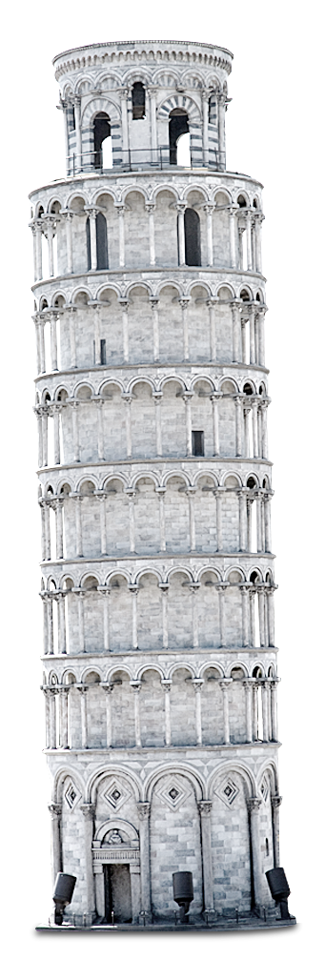

辅音
/v/  /θ/  /ð/ | very  think  them | 

