0731：0731精品班第一次正课

内容:讲解一篇文章，课上给出范文；专题讲解

题目：Many parents in these days work in other countries, taking their families with them. Do you think advantages of the development outweigh its disadvantages?

开头段：

Working overseas has become popular, and numerous couples who are deployed to positions abroad choose to take their children to other countries. I agree that this is a positive development, although it has drawbacks. (6.5-7)

主体段一：

A 带家人出国 B 小孩在海外成长 C 视野开阔

解释（B-C）：不同的教育方式，不同的做事方式

解释（B-C）：接触不同的生活习惯，理解不同的价值观

解释（why C is a benefit）：更加接受不同的文化，看事情更加全面，适合更大的公司，做比较高的位置

Growing up in a foreign country can benefit children in career advancement because living overseas can broaden their horizons. They attend school in a different education system and come into contact with a different way of completing work when they observe how locals work and run their business. Meanwhile, they are exposed to ways of life and values of local communities. Therefore, they are more likely to take senior positions of big companies in the future as they are culturally competent and able to take a broad perspective. (6.5-7)

主体段二：

A带小孩出国 B 生活开心 C 不想家, 工作好

解释：参与成长，可以看着孩子长大，每天交流和互动

解释（B-C）：生活更有方向感，工作更有动力

Another benefit is that parents can maintain the quality of work in other countries because children can bring enjoyment to them and they would not feel homesick. They are involved in upbringing of children and happy to bond with children in different ways. As children grow up happily around them, they have a sense of purpose in their lives and the motivation to work hard. (6.5-7)

主体段三:

A 带家人出国 B家人适应不了外国的环境 C不开心

解释（A-B）：语言差异，文化差异，习惯不同

解释（B-C）： 自己的孩子觉得很压抑，很孤独，大人觉得比较内疚

On the other hand, some families may not be happy if their children fail to adapt to the foreign environment. They have difficulty in overcoming language barriers, and conforming to social norms of foreign countries. As a consequence, they feel lonely and isolated, and adults will experience a sense of guilt when they think their children’s emotional well-being is affected by their career. (6.5)

结尾段：

In conclusion, taking children to another country can be a sensible decision, as long as children can integrate into the local community successfully with parents’ help.

聊天记录：

顾家北 19:05:42

animal shit

顾家北 19:06:23

thereby doing

顾家北 19:06:26

the more the more. .

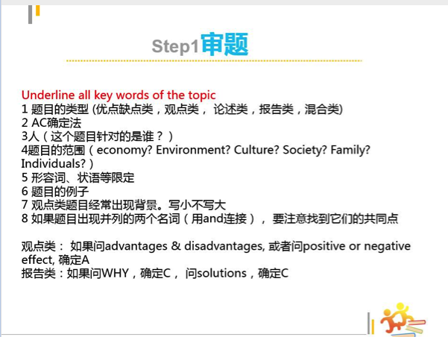

顾家北 19:09:14

Many parents in these days work in other countries, taking their families with them. Do you think advantages of the development outweigh its disadvantages?

顾家北 19:12:42

overheads

顾家北 19:13:20

students attend courses at a lower cost

顾家北 19:14:02

online quizzes

顾家北 19:14:42

ocean amount..

顾家北 19:14:54

a wealth of information

顾家北 19:15:51

transcend geographical limits

顾家北 19:17:39

Many parents in these days work in other countries, taking their families with them. Do you think advantages of the development outweigh its disadvantages?

顾家北 19:18:54

raise a family

顾家北 19:20:56

Do you think advantages of the development for these parents outweigh its disadvantages for their employers?

顾家北 19:23:08

As countries develop, more and more people buy and use their own cars. Do advantages of this trend for individuals outweigh the disadvantages for the environment?

顾家北 19:24:25

Nowadays more and more people have consumer goods, such as refrigerators or washing machines. Do you think this development has more advantages than its disadvantages?

顾家北 19:30:57

In many countries, People can eat a wide variety of food today. As a result, they eat food from other regions rather than local food. Do you think the advantages of the development outweigh disadvantages?

顾家北 19:31:27

A 饮食丰富 B 消费提高 C 促进经济

顾家北 19:37:05

preservative



顾家北 19:40:33

Many parents in these days work in other countries, taking their families with them. Do you think advantages of the development outweigh its disadvantages?



顾家北 19:45:10

a sense of identity

顾家北 19:46:10

A 带家人出国 B 小孩在海外成长 C 视野开阔

A带小孩出国 B 生活开心 C 工作好，不想家

A 带家人出国 B 家人适应不了外国的环境 C不开心



顾家北 19:47:01

Many parents in these days work in other countries, taking their families with them. Do you think advantages of the development outweigh its disadvantages?

顾家北 19:47:39

Many: a large number of, a growing number of , numerous

顾家北 19:48:22

Parents: working couples, working parents, expatriates

顾家北 19:49:49

Take with family: live with their children overseas, abroad, in foreign countries, in the host country

顾家北 19:51:33

Working overseas has become popular

顾家北 19:53:12

and numerous couples who work overseas choose to take their children to other countries as well.

顾家北 19:54:42

Working overseas has become popular, and numerous couples who are deployed to positions abroad choose to take their children to other countries as well.

顾家北 19:56:27

I agree that this is a positive development, although it has drawbacks.

顾家北 19:56:36

Working overseas has become popular, and numerous couples who are deployed to positions abroad choose to take their children to other countries. I agree that this is a positive development, although it has drawbacks. (6.5-7)

顾家北 19:57:12

I believe that taking children to overseas is a positive development, although it has drawbacks.

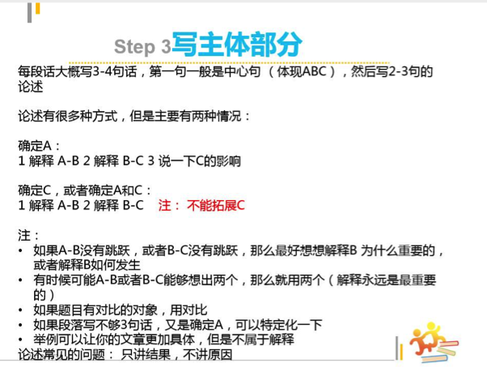

顾家北 19:59:33

A 带家人出国 B 小孩在海外成长 C 视野开阔

顾家北 20:00:50

A 带家人出国 B 小孩在海外成长 C 视野开阔

顾家北 20:04:16

A 带家人出国 B 小孩在海外成长 C 视野开阔解释（B-C）：不同的教育方式，不同的做事方式解释（B-C）：接触不同的生活习惯，理解不同的价值观解释（why C is a benefit）：更加接受不同的文化，看事情更加全面，适合更大的公司，做比较高的位置

顾家北 20:05:52

A 带家人出国 B 小孩在海外成长 C 视野开阔

顾家北 20:06:25

Broaden horizons, broaden their minds

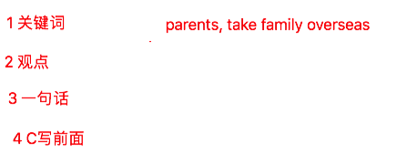

顾家北 20:10:04

A 带家人出国 B视野开阔 C 职业更好

顾家北 20:11:12

Growing up in a foreign country can benefit children in career advancement because living overseas can broaden their horizons.

顾家北 20:12:42

解释（A-B）：不同的教育方式，不同的做事方式

顾家北 20:13:52

Teaching methods, education system, ways of completing work, tackling problems.

顾家北 20:15:33

解释（A-B）：他们会接触不同的教育方式，看到不同的做事方式

顾家北 20:16:42

【顾家北】025haottt090

顾家北 20:19:36

They attend school in a different education system and come into contact with a different way of completing work when they observe how locals work and run their business.

顾家北 20:20:15

Exposure to different liefstyles, values, value systems

顾家北 20:21:55

【顾家北】069晨雨091

顾家北 20:22:28

Meanwhile, they are exposed to ways of life and values of local communities.

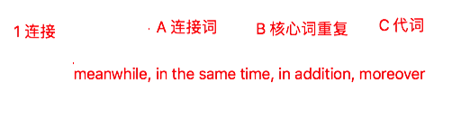

解释（why C is a benefit）：更加接受不同的文化，看事情更加全面，适合更大的公司，做比较高的位置

顾家北 20:24:40

Accept/appreciate cultural diversity, become culturally competent,

顾家北 20:25:27

take a broad perspective

顾家北 20:26:06

fill management positions

顾家北 20:27:55

【顾家北】128Eric 8.2

顾家北 20:29:31

Therefore, they are more likely to take senior positions of big companies in the future as they are culturally competent and able to take a broad perspective.

顾家北 20:30:26

Growing up in a foreign country can benefit children in career advancement because living overseas can broaden their horizons. They attend school in a different education system and come into contact with a different way of completing work when they observe how locals work and run their business. Meanwhile, they are exposed to ways of life and values of local communities. Therefore, they are more likely to take senior positions of big companies in the future as they are culturally competent and able to take a broad perspective. (6.5-7)

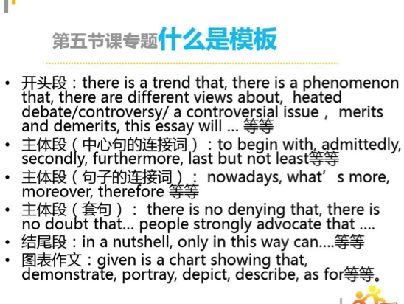

顾家北 20:41:17

勤奋学习。增加知识。考进好大学。进入好单位。

顾家北 20:41:44

nowadays 勤奋学习。for example, 增加知识。 therefore, 考进好大学。in addition, 进入好单位。

顾家北 20:42:07

last but not least, 生活越来越好。

顾家北 20:44:44

additionally

顾家北 20:47:56

A带小孩出国 B 生活开心 C 不想家, 工作好



A带小孩出国 B 生活开心 C 不想家, 工作好

顾家北 20:55:21

Live a happy life, have a sense of satisfaction, bring enjoyment, experience a sense of happiness, feel homesick, miss family, perform well in the workplace, the quality of work is high

顾家北 20:57:04

【顾家北】281Cynthia082

顾家北 20:59:29

Another benefit is that parents can maintain the quality of work in other countries because children can bring enjoyment to them and they would not feel homesick. (6.5-7)

顾家北 21:01:11

Involved in upbringing of children, grow up, bond with, connect to,, interact with

顾家北 21:01:41

解释：参与成长，可以看着孩子长大，每天交流和互动

21:01:50 Independence已加入群

顾家北 21:02:37

【顾家北】328YY091

顾家北 21:03:43

They are involved in upbringing of children and happy to bond with children in different ways.

顾家北 21:03:53

They are involved in upbringing of children and happy to bond with children in different ways. (6.5)

顾家北 21:05:27

解释（B-C）：生活更有方向感，工作更有动力

顾家北 21:05:49

Sense of purpose

顾家北 21:06:33

Sense of purpose have motivation to…

顾家北 21:06:39

incentive

顾家北 21:09:17

As children grow up happily around them, they have a sense of purpose in their lives and the motivation to work hard.

顾家北 21:10:04

Another benefit is that parents can maintain the quality of work in other countries because children can bring enjoyment to them and they would not feel homesick. They are involved in upbringing of children and happy to bond with children in different ways. As children grow up happily around them, they have a sense of purpose in their lives and the motivation to work hard. (6.5-7)

顾家北 21:10:55

A 带家人出国 B家人适应不了外国的环境 C不开心

顾家北 21:13:09

A 带家人出国 B家人适应不了外国的环境 C不开心

解释（A-B）：语言差异，文化差异，习惯不同

解释（B-C）： 自己的孩子觉得很压抑，很孤独，大人觉得比较内疚

顾家北 21:14:48

On the other hand, some families may not be happy if their children fail to adapt to the foreign environment.

顾家北 21:16:33

Language barriers, cultural shocks, customs and social norms

顾家北 21:17:27

Young children in particular, have difficulty in overcoming language barriers, and conforming to social norms of foreign countries.

顾家北 21:20:17

As a consequence, they feel lonely and isolated, and adults will experience a sense of guilt when they think their children’s emotional well-being is affected by their career.

顾家北 21:20:59

On the other hand, some families may not be happy if their children fail to adapt to the foreign environment. They have difficulty in overcoming language barriers, and conforming to social norms of foreign countries. As a consequence, they feel lonely and isolated, and adults will experience a sense of guilt when they think their children’s emotional well-being is affected by their career. (6.5)

顾家北 21:21:21

In conclusion, taking children to another country can be a sensible decision, as long as children can integrate into the local community successfully with parents’ help.

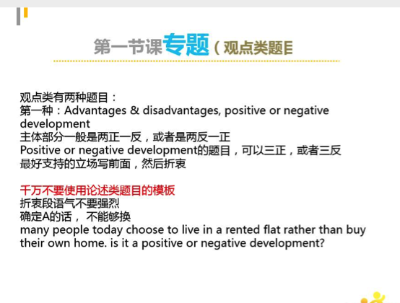

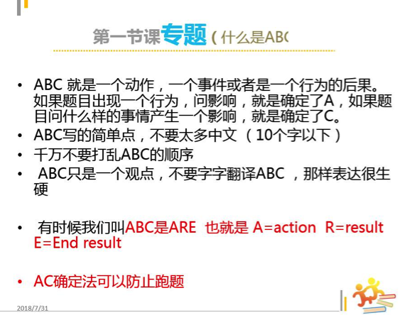

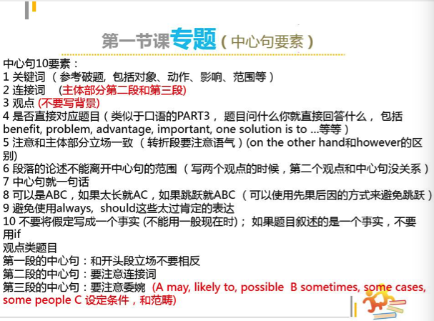

顾家北 21:33:10

newspapers will disappear, which can make it difficult for people to read real news.

顾家北 21:33:45

if newspapers disappear, it is difficult for people to read real news.

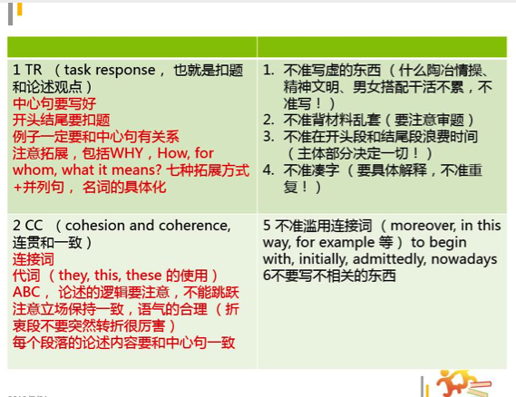

accept, receive

顾家北 21:39:41

agree on

顾家北 21:40:37

question, problem

顾家北 21:41:01

matter