Some people think that in the modern society individuals are becoming more dependent on each other，while others say that individuals are becoming more independent of each other. Discuss both views and give your own opinion.

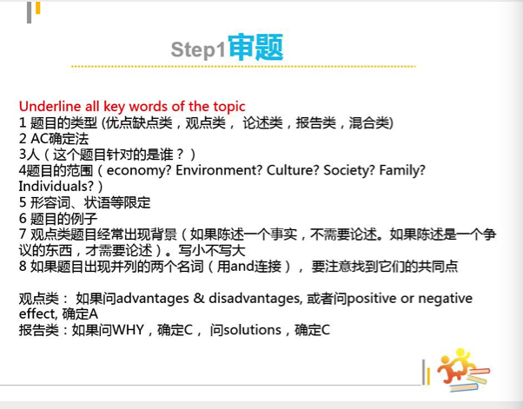

顾家北 19:07:39

in modern society, some people think that people should be more independent. to what extent do you agree or disagree?

顾家北 19:11:54

today， more and more people will work from home. do you agree or disagree?

顾家北 19:13:34

today, many people argue that it is a good idea for workers to work from home. do you agree or disagree?

顾家北 19:14:46

Some people think that in the modern society individuals are becoming more dependent on each other，while others say that individuals are becoming more independent of each other. Discuss both views and give your own opinion.

顾家北 19:16:33

题目解析：

这个题目确定C，如果支持的话，讨论为什么人们现在相互依赖。

如果反对的话，要讨论为什么人们非常独立。

最常见的错误就是以为确定A，讨论独立或者合作的好坏处。

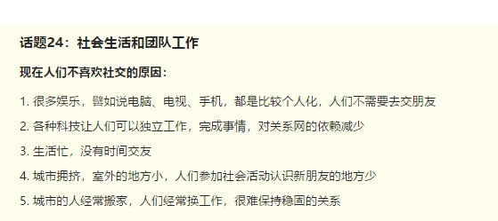

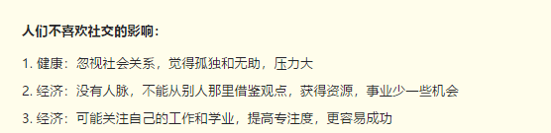

顾家北 19:22:02

Some people think that in the modern society individuals are becoming more dependent on each other，while others say that individuals are becoming more independent of each other. Discuss both views and give your own opinion.

顾家北 19:24:53

aloof

顾家北 19:27:59

It is sometimes argued that people living in today’s society tend to rely on each other. I agree with this view, although sometimes, technology has enabled some of them to live an indepdent life. (6.5-7)

顾家北 19:28:25

Some people think that: some people argue that, it is sometimes argued that…

In the modern society: In the modern world, in today’s world, in modern times,

More dependent on : Rely on others, collaborate with others, work together with, teamwork, cooperation with others

Independent: Do things independently, do things on their own, do many things themselves, in isolation…

顾家北 19:30:20

in some cases,

顾家北 19:30:25

in some instances,

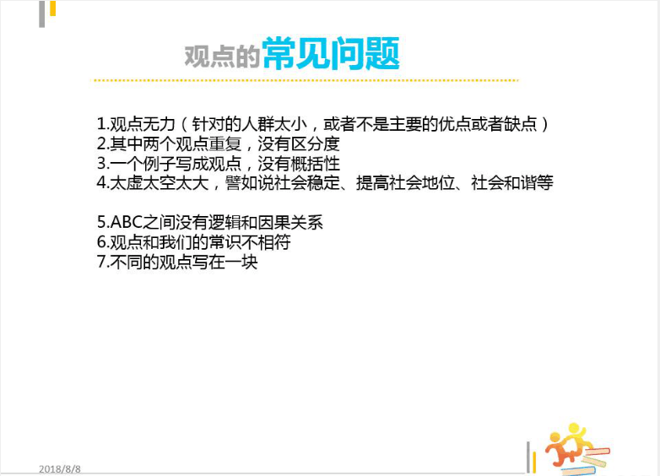

顾家北 19:31:28

A社会工作越来越复杂和繁重 B 工作需要合作完成 C 相互依赖

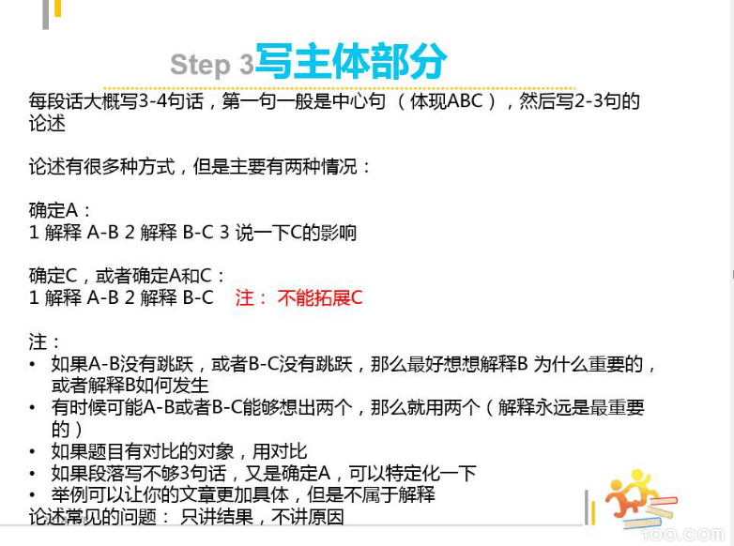



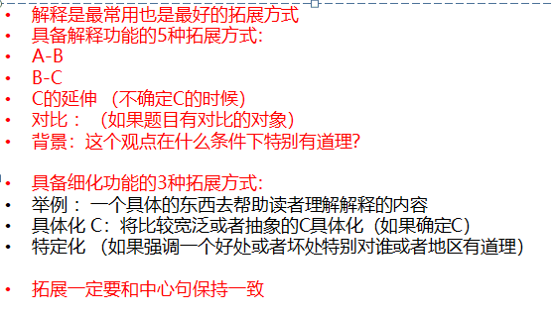

顾家北 19:44:58

A社会工作越来越复杂和繁重 B 工作需要合作完成 C 相互依赖解释（解释必要性）：工作很专业，个人，没有时间和精力学习那么多东西，自己不能做完解释（how）：分工，负责自己比较擅长的部分，发挥各自的优势，更好地完成事情对比：自己单干，没什么成就，而且很累

顾家北 19:45:58

Complex, demanding, Require cooperation/collaboration/teamwork

顾家北 19:47:37

［顾家北］081肉仔082

顾家北 19:48:20

People tend to rely on others because jobs today are much more complex and damanding.

顾家北 19:48:30

People tend to rely on others

顾家北 19:48:40

jobs today are much more complex and damanding.

顾家北 19:49:09

解释（解释必要性）：工作很专业，个人，没有时间和精力学习那么多东西，自己不能做完

顾家北 19:50:51

Specialised, time and energy, expand knowledge, complete work/tasks

顾家北 19:52:35

Jobs have become more specialised.

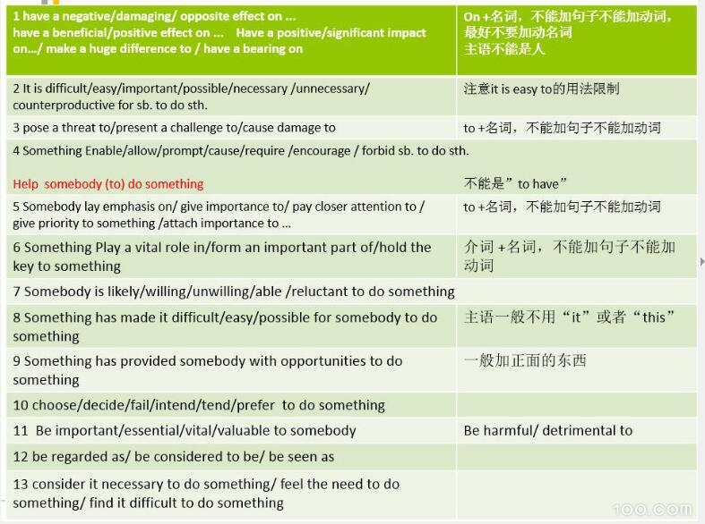

顾家北 19:53:54

people are unable to devote time and energies to increasing knowledge about every job.

顾家北 19:54:46

It is impsosible to complete all work alone.

顾家北 19:55:30

Jobs have become more specialised, and people are unable to devote time and energies to increasing knowledge about every job, so It is impsosible to complete all work alone.

顾家北 19:56:01

解释（how）：分工，负责自己比较擅长的部分，发挥各自的优势，更好地完成事情

顾家北 19:56:27

Divide work, allocate tasks, allocate work,

顾家北 19:57:11

Show talents and expertise, competence.

顾家北 19:59:19

they need to divide work with others

顾家北 20:00:38

they take charge of the tasks they are good at

顾家北 20:01:26

they are able to show their talents and expertise

顾家北 20:01:49

Therefore, they need to divide work with others and they take charge of the tasks they are good at; for this reason, they are able to show their talents and expertise.

顾家北 20:02:34

In this way, they can work more effectively.

顾家北 20:02:46

People tend to rely on others because jobs today are much more complex and damanding. Jobs have become more specialised, and people are unable to devote time and energies to increasing knowledge about every job, so It is impossible to complete all work alone. Therefore, they need to divide work with others and they take charge of the tasks they are good at; for this reason, they are able to show their talents and expertise. In this way, they can work more effectively. (6.5)

顾家北 20:04:12

People tend to rely on others because jobs today are much more complex and damanding.

顾家北 20:05:45

A growing number of people consider it necessary to rely on others because the reality is that jobs have become complex and require cooperation.

顾家北 20:06:23

Jobs have become more specialised, and people are unable to devote time and energies to increasing knowledge about every job, so It is impossible to complete all work alone.

顾家北 20:08:27

It is virtually impossible for them to complete all work alone since they are unable to devote time and energies to increasing knowledge about every job, which has become specialised

顾家北 20:09:12

Therefore, they need to divide work with others and they take charge of the tasks they are good at; for this reason, they are able to show their talents and expertise. In this way, they can work more effectively.

顾家北 20:11:10

Therefore, they have to divide work with colleagues, superiors and other people who take charge of tasks in different areas of expertise.

顾家北 20:12:04

Therefore, they have to divide work with colleagues, superiors and other people who take charge of tasks in different areas of expertise, thereby working more effectively

顾家北 20:12:57

than they do when working individually. (7+)

顾家北 20:13:35

A growing number of people consider it necessary to rely on others because the reality is that jobs have become complex and require cooperation. It is virtually impossible for them to complete all work alone since they are unable to devote time and energies to increasing knowledge about every job, which has become specialised. Therefore, they have to divide work with colleagues, superiors and other people who take charge of tasks in different areas of expertise, thereby working more effectively than they do when working individually. (7+)

顾家北 20:21:10

A现代科技发展 B 自己可以通过科技解决问题不靠别人 C 年轻人更独立

顾家北 20:25:38

A现代科技发展 B 自己可以通过科技解决问题不靠别人 C 更独立解释 （A –B ）：很多技术方便人们学习知识解释（A-B）：有很多工具和软件

顾家北 20:28:52

Technological advances, technological change, progressTackle problems, advanced technology, modern technology, new technology, cutting-edge technology,

顾家北 20:30:58

On the other hand, modern technology has made us independent because it enables us to solve problems individually.

顾家北 20:32:44

解释 （A –B ）：很多技术方便人们学习知识, 因此可以更容易找到解决方法

顾家北 20:33:41

Do internet searches, acquire knowledge, gather information on the Internet, find solution

20:35:24 小寺台已加入群

顾家北 recalled a message

顾家北 20:42:39

It is easy for us to do Internet searches to gain information to find solutions to problems.

顾家北 20:44:36

解释（A-B）：有很多工具和软件，完成工作，处理事情，不需要找人

顾家北 20:46:39

they have numerous tools and computer programmes available online

顾家北 20:46:58

they are able to complete tasks

顾家北 20:47:18

without turning to others for help.

顾家北 20:47:44

Meanwhile, they have numerous tools and computer programmes available online, and they are able to complete tasks without turning to others for help

顾家北 20:47:57

On the other hand, modern technology has made us independent because it enables us to solve problems individually. It is easy for us to do Internet searches to gain information to find solutions to problems. Meanwhile, they have numerous tools and computer programmes available online, and they are able to complete tasks without turning to others for help. (6.5)

顾家北 20:49:51

On the other hand, opponents argue that modern technology has made people independent because it enables them to solve problems individually. (7+)

顾家北 20:53:41

The development of computer technology has improved problem-solving abilities of people,

顾家北 20:54:32

who can do Internet searches to gain formation,

顾家北 20:55:35

for example, when they are faced with some complex tasks or unfamiliar subjects in work or studies.

顾家北 20:56:15

The development of computer technology has improved problem-solving abilities of people, who can do Internet searches to gain formation, for example, when they are faced with some unexpected difficulties or unfamiliar subjects in work or studies.

顾家北 20:57:17

Meanwhile, they have numerous tools and computer programmes available online, and they are able to complete tasks without turning to others for help.

顾家北 20:59:58

They also make the most of tools and computer programmes available online, which can complete a great variety of tasks without turning to others for assistance. (7+)

顾家北 21:01:33

They also make the most of online tools and computer programmes, which can complete a great variety of tasks without turning to others for assistance. (7+)

顾家北 21:03:04

On the other hand, opponents argue that modern technology has made people independent because it enables them to solve problems individually. The development of computer technology has improved problem-solving abilities of people, who can do Internet searches to gain formation, for example, when they are faced with some unexpected difficulties or unfamiliar subjects in work or studies. They also make the most of tools and computer programmes available online, which can complete a great variety of tasks without turning to others for assistance. (7+)

顾家北 21:04:35

A 经济压力大 B 个人很难独立生存和解决问题 C 要依赖别人

顾家北 21:08:23

A 经济压力大 B 个人很难独立生存和解决问题 C 要依赖别人解释 (A-B)：物价飞涨，收入比较低解释（HOW）：和父母一起住，减少生活费用解释（how）：投资，创业可以借助别人的资源

顾家北 21:10:31

economic pressure, live on tight budget, financial hardships, achieve independence, make a living themselves, make ends meetfinancial matters, problems

顾家北 21:13:50

In my view, people have to rely on others due to the fact that the economic pressure is enormous, and it is difficult for them to make a living themselves..

顾家北 21:14:48

cost of living, low income

顾家北 21:16:16

They are unable to handle the rising cost of living as their income is limited.

顾家北 21:18:34

As a result, they choose to live with parents or colleagues to cover living expenses.

顾家北 21:21:00

In addition, they need to use the financial resources of other people when they want to make investments and set up a business. (6.5)

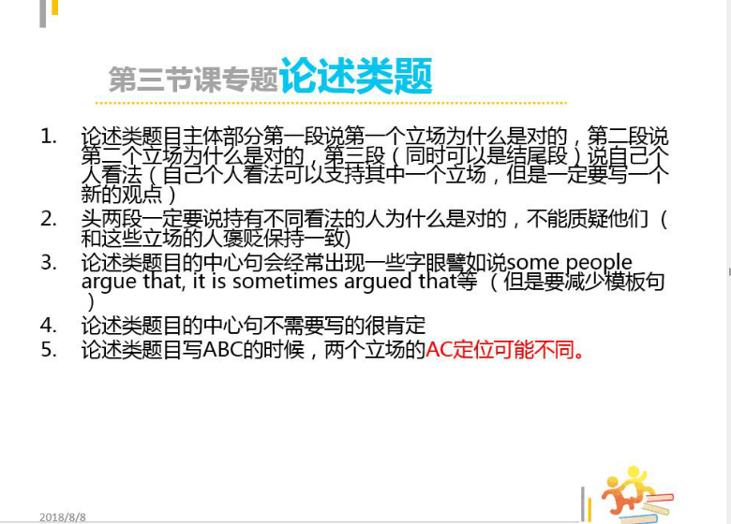



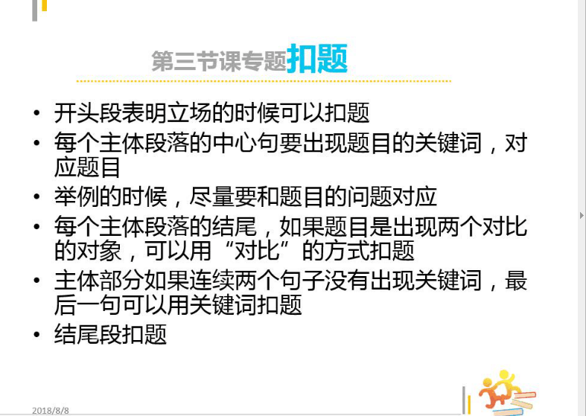

顾家北 21:32:07

A 经济压力大 B 个人很难独立生存和解决问题 C 要依赖别人

解释 (A-B)：物价飞涨，收入比较低

解释（HOW）：和父母一起住，减少生活费用

解释（how）：投资，创业可以借助别人的资源

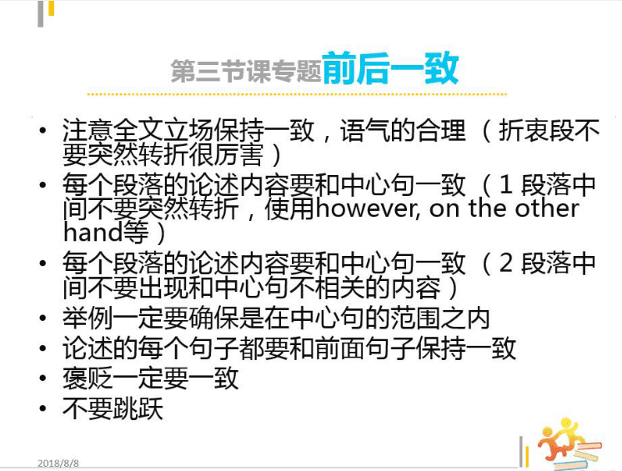

顾家北 21:32:36

对比：如果自己生活，花很多钱，活不下去

顾家北 21:33:22

In my view, people have to rely on others due to the fact that the economic pressure is enormous, and it is difficult for them to make a living themselves.. They are unable to handle the rising cost of living as their income is limited. As a result, they choose to live with parents, friends or colleagues to cover living expenses. In addition, they need to use the financial resources of other people when they want to make investments and set up a business.

顾家北 21:33:32

make a living themselves.

顾家北 21:34:12

use the financial resources of

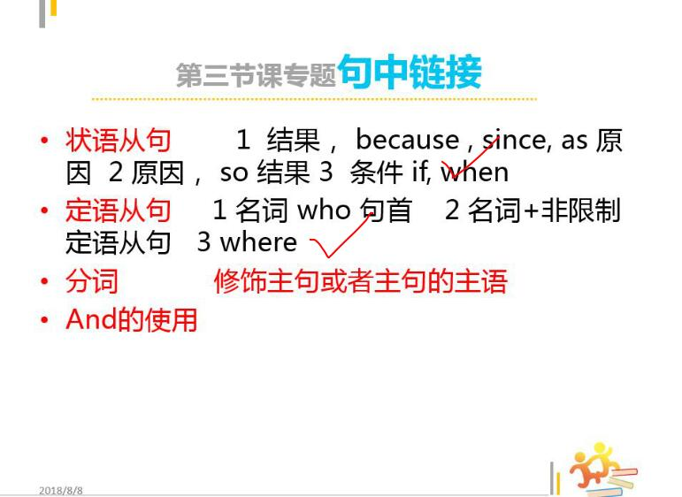

顾家北 21:42:20

i am poor, thereby marrying a rich guy

【小班长】095Asher0908 21:43:00

