舌尖上的声料库白金36句
1. It is an easy source of entertainment. |  | 高分口语词搭  简单容易的娱乐方式【印象词搭】
2. Music usually chills me out when I am feeling depressed. |  | 使我冷静下来【欲望词搭】
3. My life is getting more kaleidoscopic. | 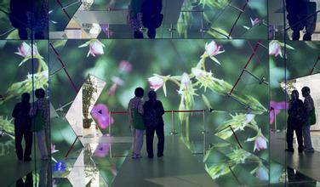 | 更丰富多彩的  【印象词搭】
4. The main advantage of watching films is simply for the pleasure of it. |  | 就是为了那份开心【印象词搭】
5. I find a great pleasure in doing it. | 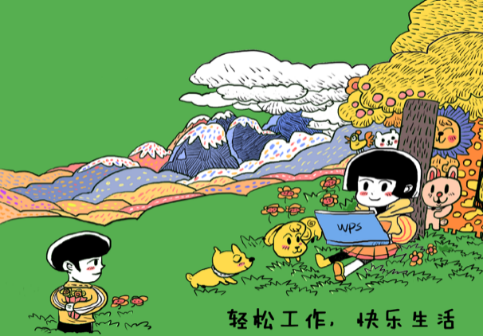 | 发现巨大乐趣【探索词搭-心灵】
6. To while away the time I often do some window-shopping. | 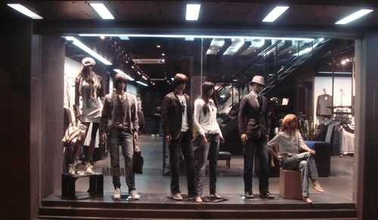 | 只看不买的购物【探索词搭-手脚】
7. It costs not a penny to look up and feast my eyes on the view. |  | 让眼睛享受美景【欲望词搭】
8. It has boosted my physical health |  | 改善身体健康  【欲望词搭】
9. It helps me let off steam and stay refreshed |  | 释放压力，保持清醒【欲望词搭】
10. I can Stretch my arms and legs by doing it | 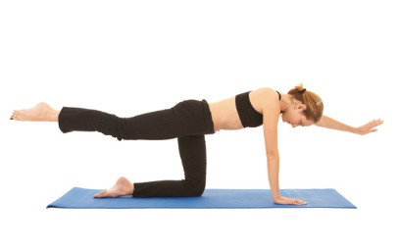 | 舒展手脚【探索词搭-手脚】
11. It can shorten the psychological distance between me and my friends |  | 缩短我和朋友们的心理距离  【欲望词搭】
12. I can communicate with my friends without us seeing each other |  | 不见面就可以交流【探索词搭-嘴巴】
13. I am enjoying a more efficient life now than I did a decade ago | 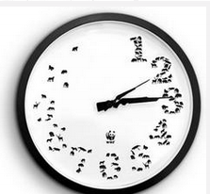 | 享受更有效率的生活【探索词搭-效率】
14. In this way I have got a load of useful and interesting information |  | 得到很多有用有趣的信息【探索词搭-头脑】
15. I’d say my life is becoming more fun and much easier |  | 更加有趣更加容易【感受词搭】
16. It has brought me quite a few benefits |  | 给我带来很多好处【欲望词搭】
17. I have a more intimate connection with my friends |  | 和朋友们有更亲密的关系【探索词搭-情谊】
18. I would prefer to share my life experience with them |  | 和他们分享我的人生经历【探索词搭-头脑】
19.Dressing well can make me stand out in the crowd |  | 使我引人注目【欲望词搭】
20. I feel more confident when I am wearing stylish clothes |  | 感到更加自信【探索词搭-心灵】
21. They provide me with enough nutrition such as vitamins and fiber and so on |  | 提供足够营养【欲望词搭】
22. Visitors can gain better understanding of cultural and natural heritage of my hometown | 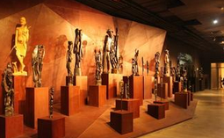 | 更好地了解我家乡的文化和自然遗产【探索词搭-头脑】
23. I can have a fantastic view of the whole amazing city. |  | 看到整个城市的壮丽景色  【探索词搭-眼睛】
24. It is absolutely suitable for having a comfortable and wonderful life. |  | 拥有舒服超棒的生活【探索词搭-环境】
25. For me, it is an ideal way to commute from my home to my work place | 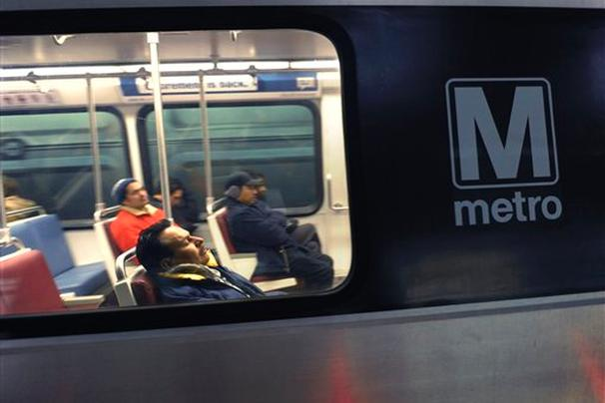 | 在家和工作地之间往返穿梭  【探索词搭-手脚】
26. I could have a larger space instead of standing in a busy bus like sardines in a can | 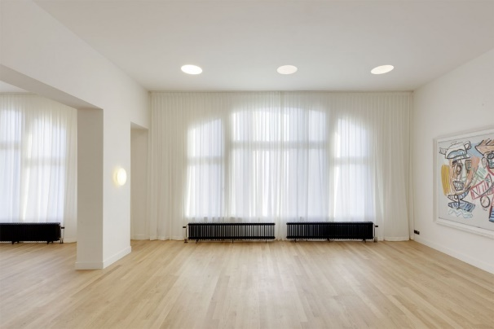 | 拥有更大的空间【探索词搭-环境】
27. It is probably the best way for me to restore my energy |  | 恢复能量  【欲望词搭】
28. I am interested in hanging out with my friends and having a nice dinner |  | 和朋友们闲逛【探索词搭-手脚】
29. Listening to some beautiful music is one of my favorite pastimes. |  | 我最喜欢的消遣方式之一  【印象词搭】
30. I could breathe fresh, clean air which can make me feel so relaxed | 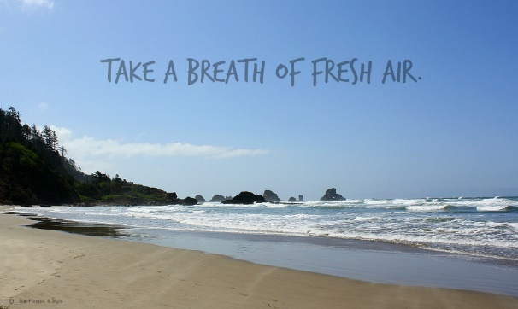 | 呼吸新鲜干净的空气【探索词搭-鼻子】
31. The sunny weather often puts me in a good mood |  | 使我有好心情【欲望词搭】
32. I often look up to the sky and watch the clouds go floating by |  | 看云起云落  【探索词搭-眼睛】
33.Their life is filled with daily chores, so they often forget about something. |  | 忘记一些事情  【头脑】
34.My parents gave me my name which means ‘good future’. |  | 意味着“好未来“【印象词搭】
35.Happiness is hard to define sometimes you might just feel satisfied | 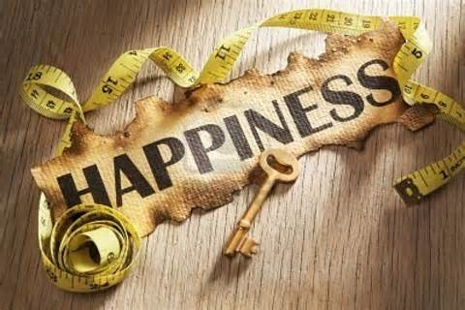 | 感到满足【探索词搭-心灵】

36.I like to play chess with a robot when I’m feeling bored. |  | 下棋【探索词搭-手脚】

