顾家北 19:02:52

Responsible tourists could preserve the local culture and environment. Some people think it's impossible to become responsible tourists. To what extent do you agree or disagree?

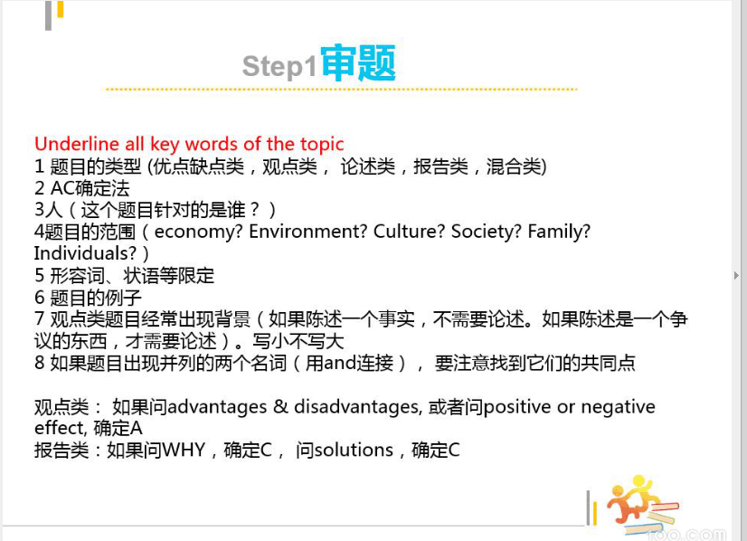

Some people think it's important to become responsible tourists.

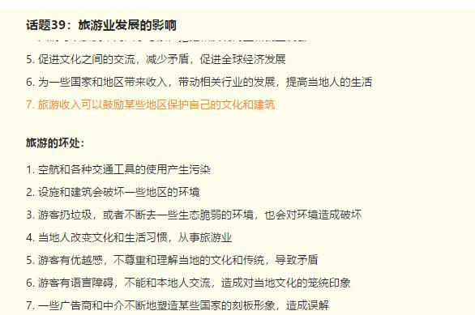

顾家北 19:20:11

A 去到一些地方旅游 B 人的出现肯定会对环境和文化古迹有影响 C impossible to become responsible

A 旅游业发展 B 游客不可能阻止当地社区改变传统和使用资源去迎合行业发展 C impossible to become responsible

A 提高意识 B 知道自己每个行为的影响 C尽量履行自己的职责

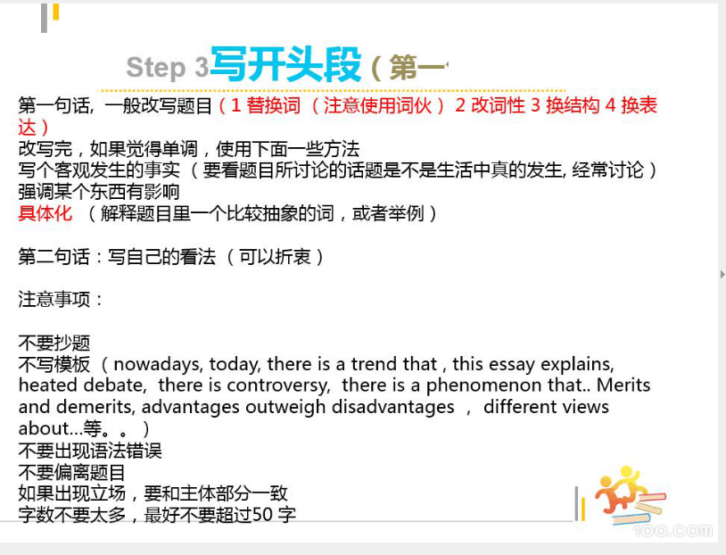

顾家北 19:36:27

Preserve the environment: preserve natural resources, support green/sustainable tourism practices

顾家北 19:38:52

Responsible tourists: visitors who have a sense of responsibility, visitors who exhibit ow responsibility

Preserve the culture: protect the culture of the local community

Preserve the environment: preserve natural resources, support green/sustainable tourism practices

Impossible: it is unlikely to, impractical, workable solution to…

顾家北 19:43:05

It is sometimes argued that travellers are unlikely to make an effort to protect the culture of the community they visit and to preserve natural resources.

顾家北 19:44:13

I agree that it is not easy for visitors to show responsibility, although they can pay attention to their behaviour.

顾家北 19:46:32

A 去到一些地方旅游 B 人的出现肯定会对环境和文化古迹有影响 C impossible to become responsible

顾家北 19:49:08

解释（A-B）：尾气造成污染，人的出现会破坏植物， 扰乱动物的生活

顾家北 19:52:00

解释（A-B）：尾气造成污染，人的出现会破坏植物， 扰乱动物的生活解释（A-B）：去到某些地方不符合当地的社会风俗，影响了文化的完整性

顾家北 19:53:25

A 去到一些地方旅游 B 人的出现肯定会对环境和文化古迹有影响 C impossible to become responsible解释（A-B）：尾气造成污染，人的出现会破坏植物， 扰乱动物的生活解释（A-B）：去到某些地方不符合当地的社会风俗，影响了文化的完整性

顾家北 19:57:22

Have an adverse effect on, cause damage to …

Cultural norms, customs, cultural sites

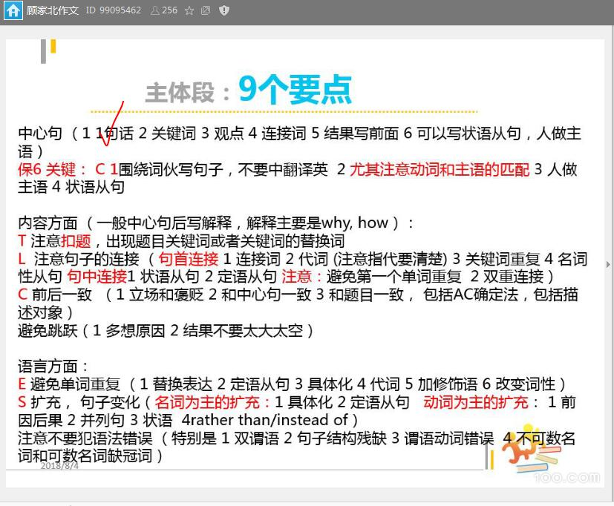

顾家北 20:00:00

One reason that traveller can never be such responsible visitors is that people will more or less have a negative effect on the local environment and cultural sites

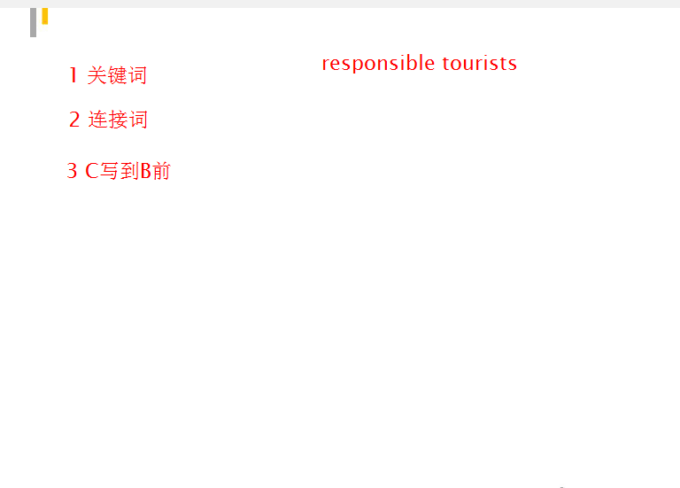

顾家北 20:02:37

One reason why travellers cannot make a trip responsibly

顾家北 20:04:14

One reason why travellers cannot make a trip responsibly is that the presence of these people can cause damage to the local environment and cultural heritage.

顾家北 20:05:24

解释（A-B）：游客过来使用的交通工具产生尾气造成污染，人的出现会破坏植物， 扰乱动物的生活



顾家北 20:08:09

Means of transport, Create emissions, cause pollution, damage vegetation, disturb wildlife, disrupt the life of wild animals.

顾家北 20:11:51

【顾家北】221吕无敌未

the emissiom pollution that caused by means of transport is likely to damage vegetation and disrupt the life of wild animals when visitors travel around

【顾家北】044甘

顾家北 20:13:25

tramping

顾家北 20:13:37

They may rely on different means of transport, which create emissions and cause pollution, and when they visit some areas of natural beauty, their trips may damage vegetation and disturb wildlife.

顾家北 20:15:28

They may rely on different means of transport, which create emissions and cause pollution. Meanwhile, they visit some areas of natural beauty, their trips may damage vegetation and disturb wildlife.

顾家北 20:15:48

解释（A-B）：去到某些地方不符合当地的社会风俗，影响了文化的完整性

顾家北 20:17:26

Violate cultural norms, conform to cultural norms, cultural integrity

顾家北 20:19:29

【顾家北】112QQ小冰082

【小班长】095Asher0908 20:22:20

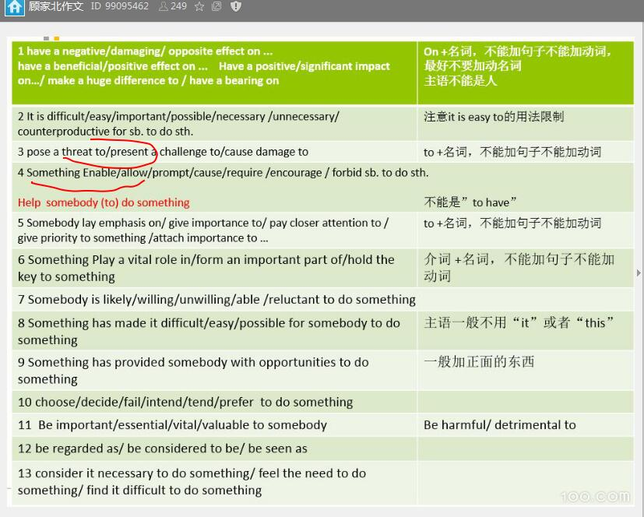

顾家北 20:23:20

Increased tourism can also pose a threat to cultural integrity since they sometimes fail to conform to cultural norms, and their presence can also damage cultural attractions.

顾家北 20:24:12

tourism=number of tourists

顾家北 20:24:27

increased tourists (X)

顾家北 20:27:23

One reason why travellers cannot make a trip responsibly is that the presence of these people can cause damage to the local environment and cultural heritage. They may rely on different means of transport, which create emissions and cause pollution. Meanwhile, they visit some areas of natural beauty, their trips may damage vegetation and disturb wildlife. Increased tourism can also pose a threat to cultural integrity since they sometimes fail to conform to cultural norms, and their presence can also damage cultural attractions. (7)

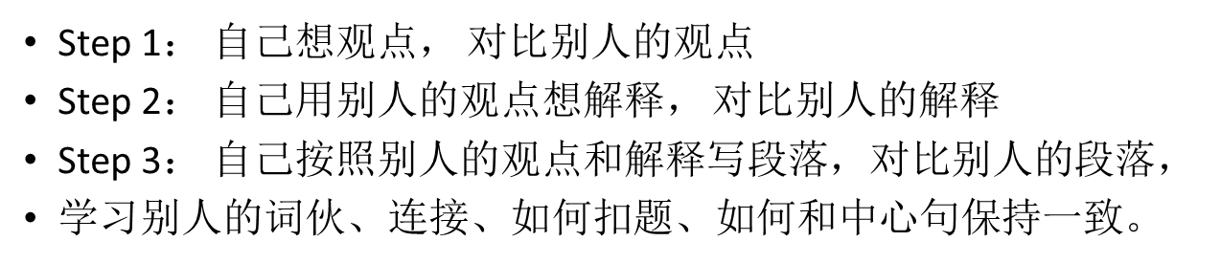

A 旅游业发展 B 游客不可能阻止当地社区改变传统和使用资源去迎合行业发展 C impossible to become responsible

顾家北 20:43:20

解释（A-B）：清空土地修路和建一些酒店还有饭店去满足游客的需求，破坏当地的景色和生态系统解释（A-B）：旅游业成为支柱的产业，当地人放弃传统的谋生手段，进入旅游业，当地的文化传统改变了

顾家北 20:45:23

Break traditions, use/exploire natural resources, support the tourism industry/travel industry

顾家北 20:48:00

Another reason is that tourists cannot stop locals from break traditions and using natural resources to support the tourism industry.

顾家北 20:49:17

解释（A-B）：清空土地修路和建一些酒店还有饭店去满足游客的需求，破坏当地的景色和生态系统

顾家北 20:51:01

Clear land, build roads and hotels, satisfy the needs/ serve visitors/accommodate visitors, destroy/ ruin scenery and ecosystem/ecology

顾家北 20:54:06

Residents of the local community may clear land to build roads and hotels, which can accommodate visitors, but these activities can destroy scenery and ecosystem.

顾家北 21:00:13

The engine of the economy/ the main part of the economy, traditional livelihood, way of making a living,

顾家北 21:03:48

Moreover, as tourism has become an integral part of the local economy, numerous people have chosen to abandon traditional livelihoods and find employment in the travel industry; this can lead to dramatic changes to their culture.

顾家北 21:06:05

Moreover, as tourism has become an integral part of the local economy, numerous people have chosen to abandon traditional livelihoods and find employment in the travel industry, thereby driving changes to their culture.

顾家北 21:07:20

Another reason is that tourists cannot stop locals from breaking traditions and using natural resources to support the tourism industry. Residents of the local community may clear land to build roads and hotels, which can accommodate visitors, but these activities can destroy scenery and ecosystem. Moreover, as tourism has become an integral part of the local economy, numerous people have chosen to abandon traditional livelihoods and find employment in the travel industry; this can lead to dramatic changes to their culture. (7)

顾家北 21:09:04

A 提高意识 B 知道自己每个行为的影响 C尽量履行自己的职责

21:11:13 无上密.已加入群

顾家北 21:15:51

A 提高意识 B 知道自己每个行为的影响 C尽量履行自己的职责解释（B-C）：支持环保的旅游活动（多走路，不要扔垃圾，生态脆弱的景点可以少点去）解释（B-C）：保护当地的文化，入乡随俗(保护当地的文化传统)

顾家北 21:20:15

Raise awareness, impact of .., fulfil/assume the responsibility to ..Support sustainable tourism practices, travel on foot, drop litter, visit ecologically fragile destinations during peak season. Follow local norms

顾家北 21:22:23

On the other hand, if the government raises the awareness of the impact of tourism on the environment and culture, visitors will fulfil their responsibilities to minimise the damage.

顾家北 21:25:20

They are willing to support sustainable tourism practices, such as travelling on foot, disposing of waste in responsible ways and cancelling their journeys to ecologically fragile areas during peak seasons.

顾家北 21:26:57

In addition, they can follow local norms in dress codes, religious practices and table manners, thereby keeping the local culture unchanged.

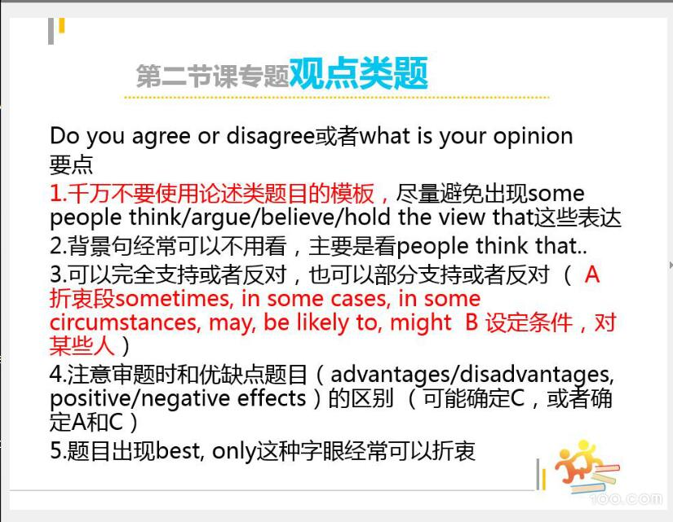

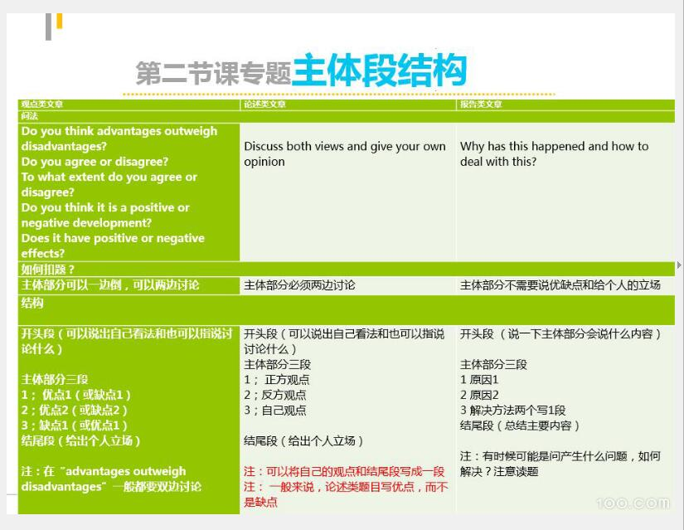

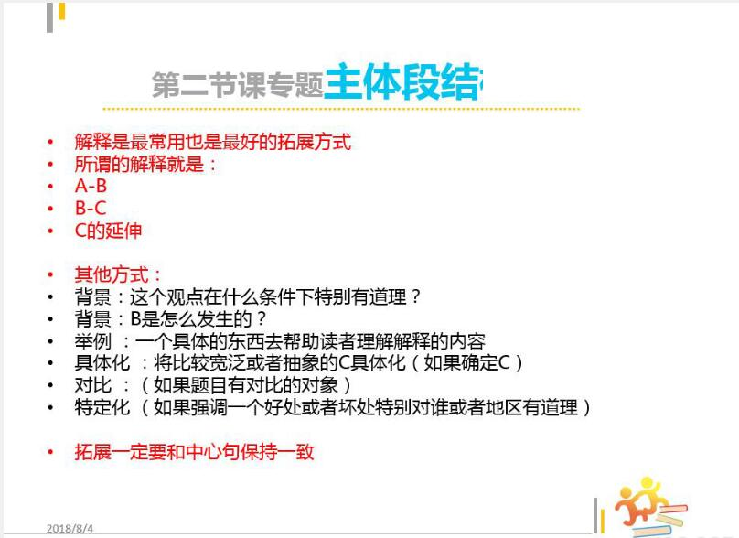

顾家北 21:33:41

A 读大学 B 学到知识 C 找工作

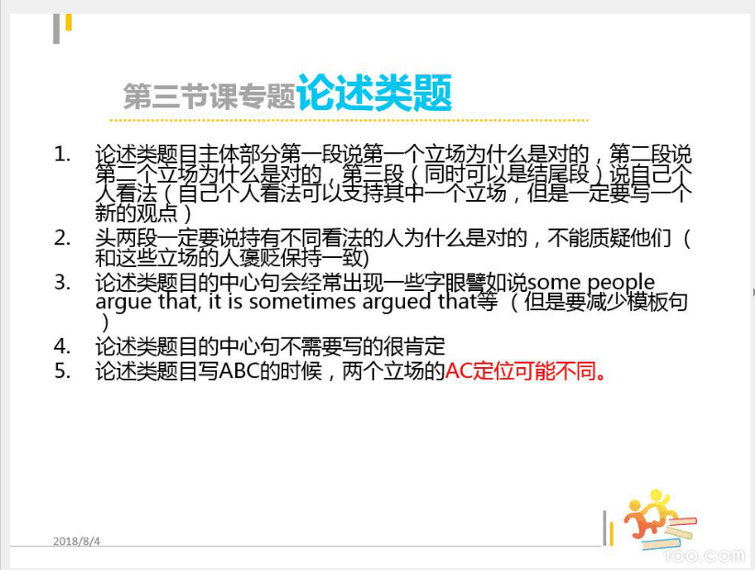

顾家北 21:38:04

In some countries, there has been an increase in the number of parents who educate their children themselves at home instead of sending them to school. do the advantages of home education outweigh disadvantages?

顾家北 21:39:27

A 送去学校 B 老师教 C 学的更多 （X）

顾家北 21:39:54

Some people think parents should educate their children themselves at home instead of sending them to school. Do you agree or disagree?