## All-in-one Speaking toolbox

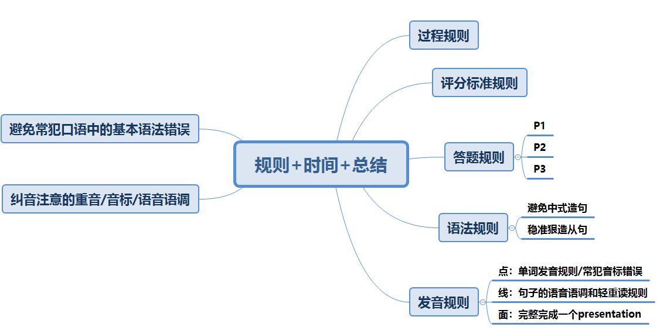

## Procedure

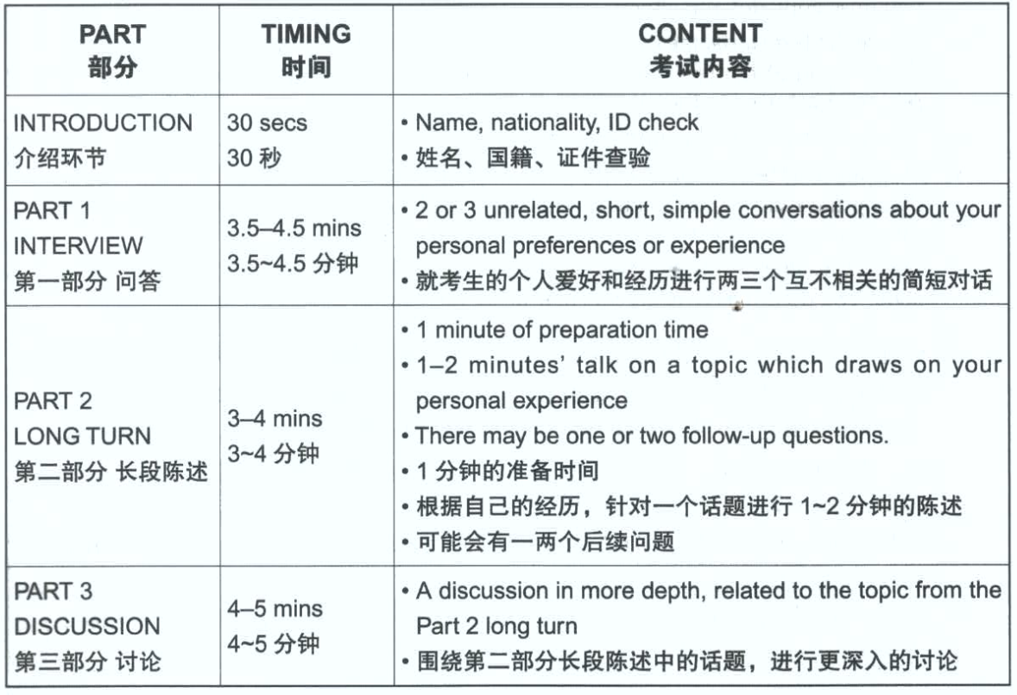

## Marking criteria

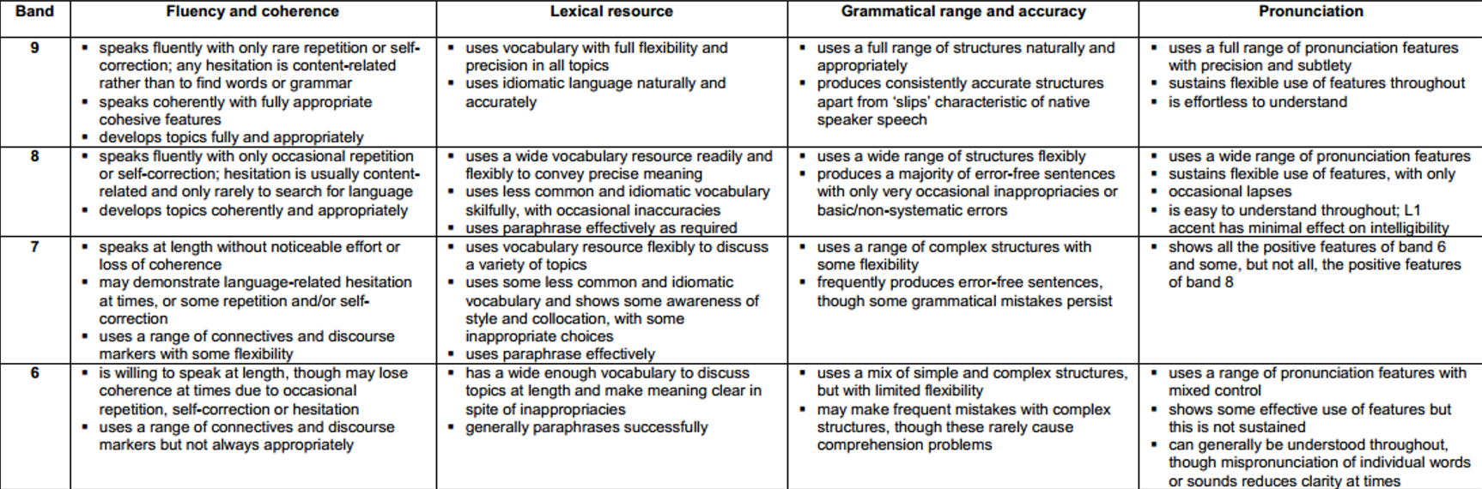

## Part 1 and part 3 左手总结

|  |  |
| --- | --- |
| Part1独有题目5W  Do you like sth?  How often do you do sth?  Have you done sth?  Did you do sth? | 1. Do you like doing sth?   Yes, and normally speaking, as long as I have spare time, I would do sth with sb at/in somewhere, I love it since xxx vibe is immersive  No, frankly speaking, I am not into doing sth; since I think it is time/labor/money-consuming/troublesome/laBorious 辛苦的  Replacements for keys, like card, face id, fingerprints passcode  没尝试过；to be honest, barely do I have a chance to do sth; but in the near future, I am willing to have a try if there is any chance. |
| Listing 罗列  1 列举名词动名词  2. listing solution  3 人物具备的素质 | 1. What books do people like to read? (boys and girls) 罗列名词或者动名词   There be + including (science fiction, novel, magazine, newspaper, textbook, reference book, comic book, stories about HTC)   1. How can parents do to ensure that children are interested in reading? 人们怎么做实现xx?   People can do heaps of things to make it happen,  For example, xxx have to understand the importance of doing sth; after all, their behavior lies on mentality. 提高意识  And then, xxx need to put words into action/put theory into practice, doing different things like going to the library, attending book-sharing meetings, telling stories to each other and so on  So that their understanding can be bettered.  3 . what qualities should a good teacher have? 罗列人的素质  Surely, a good teacher should have the following traits  (职业核心professional)for example, they have to be knowledgeable and experienced, since their main job is to teach others and answer questions.  2 social skills as well, like 七分词汇表  3 品质加分one more to mention, it will be great if xxx are patient/responsible/honest; otherwise, they would lose credit or trust easily  And something like that. |
| Change古今对比改变类  Used to  But now | How has people way of doing sth changed? Over the past Decades  接过来It has been changing all the time  以前是Internet出现之前大家的传统做法For instance, in the past/Previously, people used to do sth in traditional/physical/offline ways, like doing xxx and xxx  但是现在在social media/app上做 But now, it is quite a trend for us to do sth on the Internet or on social media/in a virtual way/live stream/video games, since it is time/labor/money-saving, straightforward  结论And I believe this trend will carry on in the future. |
| Comparison 比较  Lies on取决于不同方面  To be more specific 举一个or两个例子 | What is the difference between a and b? 两者有什么区别？  Between reading magazine and newspaper?  House and an apartment  接过来To some degree, they are very different; and main differences lie on the following Aspects, like frequency, price, content, weight, form, timeliness时效性 and even focal users  具体说：More specifically, 基本维度的common sense区别  Newspaper will be published daily, while/whereas/whilst magazine is printed/presented on a monthly basis  And similarly, the content of newspaper is broad/comprehensive/inclusive, while the content of magazine is very focused in only one area  And something like that  What is the difference between young and old regarding doing sth? 老少or男女对比的话（先定性再定量）  接过来To some degree/extent, they are different/distinctive  年轻人特点Given that young people are open-minded/energetic/lively, they are likely to do something that is fashionable/trendy/dynamic/engaging/imaginative/up-to-date/creative, like reading comic book, romance novel, detective novel and so on. Techno music, songs in other languages  老年人特点While for senior, considering that they are conventional/old-school/conservative, they might choose mature subjects, like books regarding history, tradition or culture (trousers, jackets, suits, or boots, shirts) (folk music, musical, classical music, country music, blues, opera)  And something like that. |
| Reasons八词找动机和好处 | What are the benefits of reading bedtime story to children? (brainstorming) 点线面的语言组织风格  It allows me to do xxx/by doing sth, xxx can /doing sth can be viewed a way to do sth /it offers us a chance to do /it is rewarding/beneficial for /be encouraged to do/it challenges sb to do xx  Hone  接过来Benefits can be multiple/manifold explore  好处1For instance, by doing sth xxx, children can boost ties with their parents, and they can enjoy each other’s company  好处2And additionally, children can be cheered up when they listen to the reading, since stories can bring joy to them. (push the boundary of science and tech)  好处3 One more to add/mention, it can be viewed as a way to hone children’s abilities;  And something like that. |
| Personal opinion 个人意见 | 必考的好坏处：What are the advantages and disadvantages of doing sth? Merits/demerits; pros and cons (do you think doing sth is always good? Can we do sth? Should we do sth? What do you think of doing sth) critical thinking?  可以是好事Surely, sth can be good, since it is rewarding for us to do sth；Especially when people are on the move;  但是走极端就会有问题But conversely, when talking about shortcomings, I have to say if   1. Sth is too much(do sth all day long ), people might feel 不好的情绪/健康受损（shortsighted/obese） 2. Or similarly, if it lacks supervision/control/censorship/planning, xxx is likely to happen   二选一的结论  That’s why xxx should be responsible  There should be a balance.  Xxx重要吗？听到important就首选if或者without的切入点，part3可以使用完整的六边形起承转合结构  Is reading important? Important = if/without + especially 鉴于这样的situation social trend society/job-hunting is competitive  1鉴于这个现状  2这么做有什么好处to be knowledgeable and experienced/wise  3反之 without reading/knowledge, people would be Ignorant/illiterate 文盲的  That’s why reading is crucial |
| Speculation 臆想猜想  Speculate on trend or possibility | 1 未来趋势，线下xxx会被取代吗？消失吗？Some people say that in the future, offline library will be disappearing, do you agree or disagree? Online vs offline  子集一定能够导致合集结果吗？Some people say that if children can read or study well, they tend to be successful in life/career when they grow up, do you agree or disagree?  有可能导致这个结果Surely, if children do sth well, they are likely/it is possible for them to be xxx, since it is foundational,  但是不是100%，因为还有其他因素but it is not always the case, since there are still other factors, like hard work, talent, personality, opportunity, luck, timing, financial support, social network and so on; that’s why it is not a 100% thing.  千人千面 do you think children in your country all like reading?  What is the best age to do xxx？  答案是yes and no，很多种情况It is personal and situational, when talking about xxx love of reading  具体来说：It depends on/lies on/lies in/replies on many factors, like parenting/schooling, personality, hobby, interest, peer influence/social circle, mood/timing; job nature  满足条件就yes：As long as 1 有能力 2 有意愿, they just go ahead  反之就no：Otherwise, I don’t think so  挑起性别或者年龄之争，actually it is not relevant: 请问年龄是一个决定因素吗？  Who is more likely to read well, boys or girls?  仍然是先说哪些因素决定When talking about xxx it lies on many factors like xxx(knowledge, experience, wisdom, personality, timing, mood, peer Influence)  看得出年龄并不是其中一个考量And I don’t think gender is one of the main concerns  换句话说满足条件就yes，In other words, AS LONG AS 1 有能力 2 有意愿, they can do sth well, regardless of the sex.  反之就no：Otherwise, I don’t think so  为什么并不能简单粗暴说哪个性别就一定能做到或者做不到That’s why it is not relevant |

Part2 左手总结

客观型（人物，地点，物品）

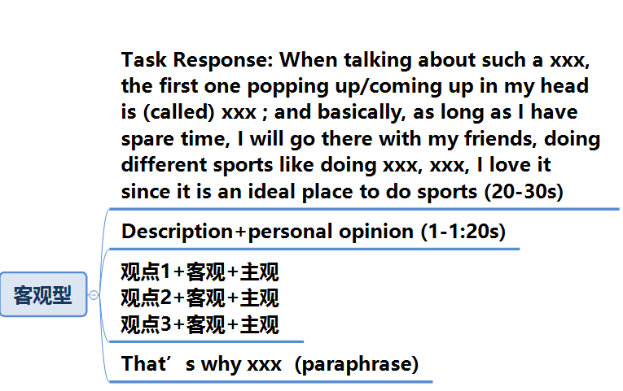

讲故事型（事件类）

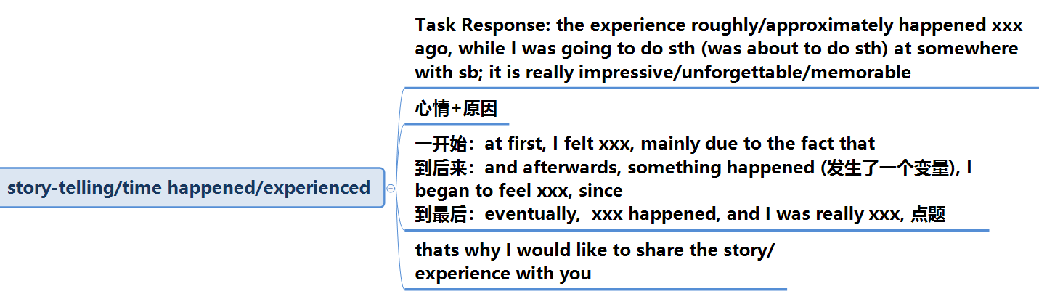

## 语法规则

中式思维造句vs西式思维造句

首先我们要明确一个完整英文句子的构成

核心：主语（名词或者动名词，短语或者句子）+谓语（动词或者动词短语）

中文母语表达方式——条件在前，把想表达的动作放在最后

我每天坐地铁去上班

我跋山涉水，翻山越岭地最终找到了你

英文顺序表达——将主要想表达的动作紧跟在主语之后（时间，和空间和副词的放置可以很灵活）

I go to work every day by subway （强调的是上班，subway是方式）

or I go to work by subway every day (时间节点的放置可以很灵活)

I eventually found you here after tramping mountains and rivers. (强调动作是找到了你)

Eventually, I found you here after tramping mountains and rivers (副词可置守，表示强调)

总结：

Step1: 想强调的主要动作紧跟在主语或者助动词后面;

Step2: 介词所引导的途径，方式，工具，条件放到后面去或者将介词短语作为条件放在前面(by/through/at/in/with),

例如：我只要有空就会在网上浏览新闻

As long as I have spare time, I’d like to browse news on the Internet

或者将介词短语放在句首作为条件

例如：我动动鼠标就可以在网上买到我中意的商品

Only with the click of mouse, I am able to buy anything I want by shopping online.

Step3：时间空间可以很灵活（句子前中后均可）

In my country，there are a number of occasions that family members will get together

练习：

1. 我可以通过出国留学来锻炼我的独立性和生存技能

I am able to hone my survival skills and independence through studying abroad.

1. 上个礼拜六我和我表弟还有爷爷还有Simon一起去朝阳区的人民医院看了我奶奶

Last Saturday, I visited my grandmother with my cousin in the hospital or

I visited my grandmother in the hospital with my cousin last Saturday.

1. 只要我有空，我就会在网上听英文广播节目来提高我的英文水平

As long as I have spare time, I would improve my English skills through listening to the English radio program on the Internet.

1. 通过触摸GPS的屏幕，我就能够轻松地找到目的地和开车路线 (介词短语置前，可以表示强调)

Only with the touch of GPS screen, I can get access to the destination and driving route very easily.

## 强调句 Cleft sentences

把要强调的信息放在句首能够给听者留下非常深刻的印象，也能够为后面的答案创造思考的时间，比较典型的考场实战句型：

What引导的强调句：What I like to do in my spare time is to play badminton with my sister.

It引导的强调句：It is the badminton that I like to play most with my sister

主语从句：The most frequent way that I would relax is to play badminton with my sister

What/it引导的强调句

简单句：I will practice a lot of mock questions before I take the real exam

强调句：What I will do before the real exam is to practice a lot of mock questions.

OR: It is to practice a lot of mock questions that I will do before the real exam.

或者

简单句：I really can’t stand the traffic congestion.

强调句：What I really can’t stand is the traffic congestion.

OR: It is the traffic congestion that I really can’t stand

主语从句引导的强调句：

简单句：I want to talk about a restaurant named Pizza hut

强调句：The restaurant I am going to talk about is the one named Pizza hut.

Or

简单句：I’d like to mention the other point, which is smoke-free law can offer additional protection for the most vulnerable groups.

强调句：The other point I’d like to mention is that smoke-free law can offer additional protection for the most vulnerable groups.

Or

简单句：I dislike sunny day because I once got serious sunburn before

强调句：The reason why I dislike sunny day is because I once got serious sunburn before.

练习：

1. 我打算在毕业之后去英国继续深造

2. 我整个暑假都是在我的家乡度过的

3. 我最喜欢的就是季节之间的变换 (transitions between the seasons)

What I like the most is the seasonal transitions

4. 禁烟法的另外一个很大的好处就是能够保护小孩子免收二手烟的危害

参考答案：

1. What I plan to do after graduation is to further my study in UK

OR

It is to further my study in UK that I plan to do after graduation

1. The place where I spent my entire summer vacation is my hometown.

OR

It is my hometown where I spent my entire summer vacation.

1. What I like best is the transitional time between seasons

OR

It is the transitional time between seasons that I like best.

1. The other major benefit that smoke-free law can introduce is that children can be protected from the harm of second-hand smoking.

## 虚拟语气 Conditional sentences

第一条件：First conditional (主观意愿是有可能发生的, something is possible)

If + 一般现在时； …will/can/may/could/be going to+动词原形

例：If I study harder, I will get the offer from my dream company

如果我努力学习的话，我是可以被我心仪的公司录取的

第二条件：Second conditional (主观意愿不可能发生, something is impossible)

If +一般过去时； …would/might/could +动词原形

例：If I studied harder, I would get the offer from my dream company

要是我能学习努力点，我也可以被我心仪的公司录取的

第三条件：Third conditional(设想的情况在过去并没有发生，有明显的过去时间节点，属于不常用表达)

If+过去完成时；…would/might/could +现在完成时

If I had studied harder last year, I would have got the offer from my dream company

要是我去年那会好好学习，我肯定已经被我心仪的公司给录取了

You should have told me earlier (in the first place )

We should have been together

如果我当初选择了工程学，我早就找到工作了

If I had chosen e as my major, I should have found a job

如果我们去年还在一起，我们早就买房子了

If we had been together last year, we should’ve bought a house already

我告诉了你很多次，你一开始就应该意识到这一点的

I had told you many times about this point, and you should have realized that earlier

练习：

1. 如果我这次能够通过雅思考试，我就去环游世界

2. 如果我是你，我会选择公共交通而不是开私家车

3. 不论我如何刻苦训练，我都不会成为一个杰出的运动员的

4. 如果我从去年就开始准备雅思考试，我现在肯定已经通过了

参考答案

1. If I can pass IELTS this time, I will take a round-world trip. （可能发生）
2. If I were you, I would choose the public transport instead of driving a private car （我不可能是你）
3. No matter how hard I trained, I would never be an excellent athlete (主观意愿上不可能)
4. If had started preparing my IELTS exam since last year, I would have passed it already. （明显的时间节点Last year）

## 被动句表达

中国考生喜欢用人称作为主语进行主动表达，其实多使用被动句可以更好地体现出语言表达的灵活性

主动 My mum thinks a country lifestyle is best.

被动 it is thought by my mum that a country lifestyle is best.

主动 Many people say that Beijing is a multicultural city.

被动 It is said by many that Beijing is a multicultural city.

Or

Beijing is said by many to be a multicultural city.

主动 Dancing can really cheer me up.

被动 I can be greatly cheered up when I dance.

主动 They have found that the new canal is a flood risk.

被动 The new canal has been found to be a flood risk.

练习：

1. 他们选举Michael作为下一届的学生会主席
2. 很多人争论说犯罪率高的原因是贫穷 I consider myself to be a xx person

Poverty is argued to be the major reason of the high crime rate

1. 他们说小意大利是城里面最棒的西餐厅

Little Italy is said to be the best xxx in town

1. 人们认为圣托里尼岛是世界上最美丽的地方之一

参考答案

1. Michael was selected to be the next chairman of student union.
2. It is argued that poverty is the reason of resulting in high rate of crime rate.
3. Little Italy is said to be the best western style restaurant in town.
4. Santorini is viewed as one of the most gorgeous places in the world.

## 从句 (Subordinate clauses)

从句基本上可以分为名词从句(包括主语从句，表语从句，宾语从句和同位语从句)，定语从句和状语从句，具体区别和解析上令人眼花缭乱，但是从口语应用的角度出发，我们的目的是能用一种清晰的线索表达出心里想的中文句子，然后在实战当中尽可能少地犯语法错误。要做到这一点，首先我们要搞清中文和英文在造句上的区别

中文母语：将各种描述的细节或者形容的条件放在句子中间的box里面，例如

有很多工作机会

北京是一个 的大城市

而英文的造句模式是，将句子的外延拿在一起先组成一个笼统的句子（a general sentence）作为主句, 然后把box里面的细节添加在主句后面，所以这个句子就变成了

有很多工作机会

北京是一个大城市（where）

Beijing is a big city where there are so many job opportunities.

再例如

我爸爸是一个 的人 （box里可以替换其他说法，正义感很强，兴趣爱好很多等）

幽默感很强

My father is a person who has a strong sense of humour

举例

我妈妈有能力可以把晚餐时间变成一个人人可以参与沟通和分享他们人生经验的机会

My mum is able to turn the dinner time into a chance that everyone can communicate and share their xxx with xxx

我们公司的总部坐落在中关村一座顶楼你可以看到可口可乐广告板的叫做ABC的摩天大楼里

The HQ of my company is in one of the skyscrapers named ABC in ZGC where you can see a huge billboard of cc on the rooftop

中国农历新年是一个大家通过做很多活动来庆祝传统和欣赏文化的最重要的节日

Chinese lunar new year is the most important festival that people would do a and do b by doing sth

My mum has the ability to turn dinner time into a chance that everyone can participate in to communication and share with each other.

在路尽头可以看到可口可乐大招牌的区域就是著名的国王十字街Kings Cross了

That district is King’s cross where you can see a huge billboard of “Coca Cola” at the end of the street.

练习：

1. 那边那个穿红色体恤的小男孩就是我的表弟

2. 只要我有多于十天的假期，我就会去旅行

3. 这是一个需要五男五女的团队通过出国旅行和做游戏才能完成的困难任务

5. 北京是一个四季分明的城市

6. 四合院是一种在中国各地都很常见的建筑类型

参考答案

The boy over there is my cousin who wears a red T-shirt

As long as there is a holiday that is longer than ten days, I will go traveling to different places

This is the task that only could be accomplished by a team that consists of 4 men and women by traveling abroad and playing games.

Beijing is a city where four seasons are quite distinctive

Siheyuan is a typical form of residential building that can be commonly found all across China.

## 发音规则

|  |  |
| --- | --- |
| Band 8 | * Uses a wide range of pronunciation features * Sustains flexible use of features, with only occasional lapses * Is easy to understand throughout; L1 accent has minimal effect on intelligibility |
| Band 7 | * Shows all the positive features of band 6 and some, but not all, the positive features of Band 8 |
| Band 6 | * Uses a range of pronunciation features with mixed control * Shows some effective use of features but this is not sustained * Can generally be understood throughout, though mispronunciation of individual words or sounds reduces clarity at time. |

以7分这一栏进行说明，

我们需要做到的是

* ***Use a range of pronunciation features with mix control*** ☑

***能够让发音体现出不同的特点***

* ***Sustain flexible use of features*** ☑

***能够灵活使用不同的特点***

* ***Can be understood throughout, try to avoid mispronunciation of individual words*** ☑

***不会因为发错音而造成理解上的问题***

具体来说，发音的不同特点包括了：

* Intonation 语音语调
* Word stress 重音
* Individual sounds 单个词的发音
* Connected speech 连续发音
* Chunking with rhythm 用发音的节奏去断句

但如果你出现并纠结于以下问题，以下技能就强烈推荐学习！！

* ***Mispronunciation of syllable sounds 音标没有发准确***
* ***Monotonous speech 没有抑扬顿挫的平调发音***
* ***No chunking with rhythm 不懂得断句***
* ***No attitude expression 没有通过语调表达出感情的变化***
* ***reduced clarity or less accurate 发音不清楚***
* ***Wrong word/sentence stress 单词重音发错或者句子没有强调的重读***

#### Key point 1：How to exhibit strong form and weak from through chunking 如何通过断句体现出弱读和强读

我们首先来看一下几个句子

* I come to CANADA to STUDY
* I am from CHINA
* I have to get SEVEN in IELTS to go to my (DREAM UNIVERSITY)
* I am (SO EXCITED) right now
* I like to do (ALL SORTS OF THINGS) in my (SPARE TIME), like (WATCHING MOVIES) or (PLAYING COMPUTER GAMES)
* Currently, I am still a SENIOR at (Central University of Finance and Economic), majoring in (BUSINSS STUDIES) and specializing in MARKETING.

以上共有六个句子，其中用红色标红的部分都是一句话中的重要信息，是你最想让对方听到的，所以肯定要重读才能表达清楚你的意思；同时在句子里面出现了两种符号都表示需要重读，分别是下划线和括号，区别在于:

* 下划线表示的单个词语的重要信息，需要重读
* 而括号表示的是意群（应视为一个词群），读的时候需要连读，中间不能停顿，可采用语气上扬的方式将意群概括表达出来

其他未标红的部分都采用轻读的方式，如下图所示

Currently, I am still a SENIOR at (CENTRAL UNIVERSITY OF FINANCE AND ECONOMICS),

majoring in (BUSINSS STUDIES) and specializing in MARKETING.

其中第一个SENIOR 可以用升调或者降调读出来，取决于你当时的语气是想要很正式还是很轻松；CENTRAL UNIVERSITY OF FINANCE AND ECONOMICS 用弧线发音的方式连读，后面的BUSINESS STUDIES 也是同理，最后的MARKETING 用降调的方式读出来，表示这句话的结束。我们再来看几个句子：

The novel I am reading at the moment is a (real page-turner). I just can’t (put it down). It’s

set in (Renaissance Italy) and is about (young women) who are forced to become nuns,

because they’ve brought shame on their families for (various reasons).

In the (opening chapters), (for example), a character falls in love with her (music teacher)

and the family don’t approve.

一般来说需要重读的信息有：

主系表的表语： I am a boy ; it is (really interesting)

主谓宾的谓语或者宾语（取决于你想强调的）: I plan to travel to (United States)

最高级: the (most interesting part) is that…

副词表示程度: it is( really/rather/very/so important) that…

连接词: but, because, (on the other hand), … (单个信息可以升调也可以降调，取决于当时的语境是很口语轻松化还是很正经的语气，需要强调)

在听力考试中，朗诵题目的叔叔阿姨何尝不适用这种方式来呈现的呢？（注意，下划线部分一般是答案哦）

（Section one）

You will hear a conversation between (two friends) called (George and Nina) about

(summer music festival), first, you will have (one min) to look at question (one and two)

哪怕是生活当中的场景，也符合这样的朗读方式

(Ladies and gentlemen), may I have your attention please, (flight No) CA175 now is boarding,

could you please take (all your belongings) and passport and go to the gate No 21 with your

(boarding pass), (Thank you)!

#### Key point 2：How to express attitude through word stress 如何通过单词的重读来表达出出语气和态度

* His performance is inCREdible!
* Views there are just BREATHtaking!
* I have NEVER expected this trip to be aMAzing like this!
* Are you inSANE?
* The movie is AWEsome!

发音时，语气从单词重音的地方开始往下读，就能将一句话的重要信息读出来强调的效果。

#### Key point 3：Typical pronunciation mistakes from Chinese candidates 中国考生常读错发音总结

1. [ i: ] vs [ i ];

I wish I could travel by a sheep [ i :]someday，应该是ship [ i ]

There are a lot of ship [ i ] on the grassland. 应该是sheep [ i :]

常发[ i: ]的有：bleach, read, week, keep, sheep

常发[ i ]的有：bill, pitch, bliss, lip, stick

[ u: ] vs[ u ]或者[u:l]读成[uə]

I am pretty fool[ u: ], I can’t eat any more, 应该是full [ u ]

I like to swimming in a swimming poor [uə] 应该是 pool [uːl]

I need a tour[uə] to fix it, 应该是tool [uːl]

常发[ u: ]的有：food, fool, root, afternoon, troop

常发[ u ]的有：look, book, cook, good, soot

[ɔ:]vs[ɔ]vs[au]

My favourite food is hot port[ɔ:], 应该是hotpot [ɔ]

The mountain top is my favourite sport [ɔ:] for views, 应该是spot [ɔ]

This park is located in the sauce[ɔ:] of city, 应该是south[au]

常发[ ɔ: ]的有：fought, four, bought, port, sport

常发[ ɔ ]的有：shot, pot, spot, clock, fox

常发[au]的有：south, loud, shout, bow, mouth

[n] vs[l]

I need to do… 读成 I leed to do…; nowadays 读成lowadays； good night 读成 good light;

Ninety nine 读成 linety line;

常发[n]的有：night, need, now, notebook, take a nap

常发[l]的有：light, lead, low, laptop, luck

[æ] &[e]vs [ai];

Go to bed[e] 读成go to 拜得；fair 读成 fire[ai]；my back [æ] is hurt 读成 my bike [ai]is hurt; set[e] a good example 读成 sight [ai]a good example;

常发[e]的有：bed, fair, air, care, there

常发[æ]的有：bad, back, sad, mad, lack

常发[ai]的有：bike, light, sight, pipe, kite

[s] vs[θ]&[z]vs[ð]

在需要发清辅音[θ]和浊辅音[ð]的部分，舌头没有在碰到牙齿的情况下就会发成[s]和[z]，thank you就发成了三克油；three 就发成了思锐；thirsty 读成 瑟sty；等

常发[s][z]的有：six, sample, zoo, strategy, skill

常发[θ] [ð]的有：three, thirsty, thought, weather, nevertheless

[w]vs[v]

在需要发[v]的地方，上牙没有碰到下嘴唇，就变成了[w]；例如说university 被发成uni-wsity; advantage 发成 ad-wantage; very much 发成 wery much; verification 发成了werficication 等等。

常发[w]的有：why, witch, woman, wonder, withdraw

常发[v]的有：valid, view, vision, vow, venture

习惯在每个辅音后加元音[ə]，发出儿化音r

People读成“披泡儿”; colleague 读成 “拷累个儿”，Great wall 读成 “Great 沃尔”， China读成“拆哪儿”，Hip hop读成“黑泡儿”，for example 读成 “for 一个赞泡儿” 等；

#### Key point 4：Silent letters in words 单词中不发音的情况

|  |  |  |  |  |  |
| --- | --- | --- | --- | --- | --- |
| B不发音 | C不发音 | D不发音 | G不发音 | H不发音 | K不发音 |
| Numb  Climb  Debt  Lamb  Tomb  Bomb  Doubt | Ascend  Disciple  Excess  Fascinate  Scissor  Excellent  Adolescence | Hedge  Sandwich  Badge  Judge  Adjacent  Handsome  Edge | Night  Sight  Caught  Sign  Design  Foreign  Tight | Honour  Honest  Heir  Ghost  Rhythm  What  While | Knee  Knight  Know  Knock  Knife  Knot  Knit |
| L不发音 | N不发音 | P不发音 | T不发音 | U不发音 | W不发音 |
| Talk  Walk  Half  Palm  Almond  Folk  chalk | autumn  hymn  column  damn  condemn  solemn  limn | Psychology  Physics  Psalm  Pneumonia  Psychiatrist  Philanthropist  Receipt | Witch  Listen  Often  Watch  Castle  Match  Pitch  Whistle | Guest  Guitar  Building  Tongue  Biscuit  Guess  Guard | Wrap  Wrath  Wreath  Wrinkle  Sword  Wrong  Wrestling |