# 14天蜕变计划（网课学习指南）

###### Welcome and Greetings! Simple and straightforward

欢迎大家来到Simon821的最新题库刷题班，我们的目标是经过这个班的学习和训练，大家

1 首考就分手雅思

2 基于之前的口语成绩至少提高一分，分手雅思

我们的改变从一轮14天的蜕变计划开始：

|  |  |
| --- | --- |
| 基本要求： | 1. 每次上课必须出席，如有事情请提前跟Simon请假 2. 每节课后的作业尽量准时或者延期一两天之内交齐 3. 每节课后的打卡要认真的详细，总结自己的dos and don’ts 4. 上课期间还没有和我做过一对一电话测试的同学请和我预约 5. 在上课的间隙可以有针对性学习我们的微课堂系列，包括了词汇，语法，发音和写作，其中词汇微课堂是必看内容 |
| Day1-2C1 | Part1重点刷题内容 上，掌握一级准备 |
| Day3-4C2 | 开始part2的题目和素材总结，包括了所有的人物类和物品类 |
| Day5-6C3 | 继续part2的刷题，结束事件类 |
| Day7-8C4 | 总结所有part2的题型，掌握地点类 |
| Day9-10C5 | 开始part3刷题和提醒总结，其中利用1-2节公开课掌握结构 |
| Day11-12C6 | 带领所有学生利用学过的知识再次共同备考part3 |
| Day13-14MOCK | 准备和我的考前模考 0.5-1 |

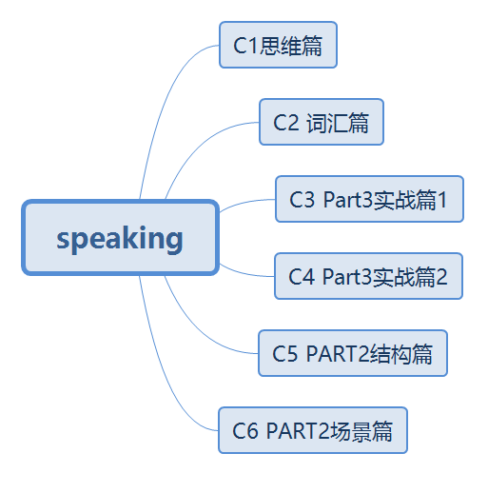

### 关于我们的交语音作业和批改的流程

我每节课后会布置具体的作业，并且放在群通告中specify每天的任务，纠音需要完成两部

Step 1： 学习日志：我学到了什么+印象深刻的表达+我认为我需要提高的地方+我自己的做的笔记 （你发朋友圈at我，微博/小红书 于磊simon， 课程评价 #c1# ）

Step 2： 找我的微信说，simon，c1打卡完毕，给我看截图，开始交作业 时一条text作为问题 下面是一条语音 在一条text问题 不要去看着背；记着我的思路慢慢学着过脑子去说，示意如下：#c1#

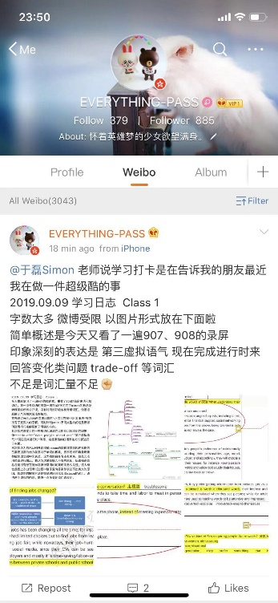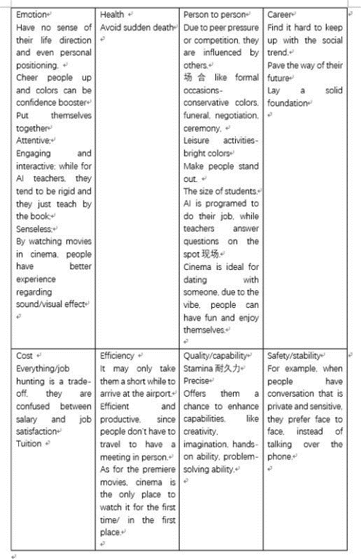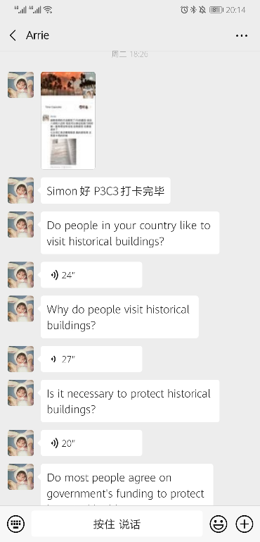

微信语音only no M4a 2 没有deadline 3 mid-term part1 – 在你整个part1题库刷完练完之后be well prepared !! final exam 考前三四天约我，我们p123 提前一天约simon第二天具体时间即可；

###### 关于和partner练习 城市坐标；日期；目标分数；time availability

希望大家不忘初心，每天拿出来至少半个小时的时间做到相互提问，从耳朵听到问题-脑子思考-嘴巴输出的正确方式练习，partner做好基本语法和音标的记录，以及共同找到为什么停顿的原因。双方可以自行商定练习三个部分的节奏。

### 口语考试形式一览

|  |  |  |  |
| --- | --- | --- | --- |
| 阶段 | 时间和形式 | 考题范围 | 考察目的 |
| 确认 | 30 secs | What’s your full name?  Where are you from?  Can I see your identification? | 个人介绍 |
| Part 1 | 4-5 mins （每问回答时间大概是20-30 secs左右，依问题类型情况而定） | 从以下四个方面当中抽出来3个话题，然后每个topic会问3-4道小问题, 其中第一个分类是必考范围（问题方向是what, where, when, who, why, how, etc）   1. Must-have questions 肯定考的问题(major/work, hometown, accommodation) 2. Hobbies & Interests 兴趣爱好类(movie, music, sport, travel, etc) 3. Lifestyle 生活方式类(clothing, food, housing, transportation, color, etc) 4. Abstract & school抽象，上学类 （time management, being in a hurry, subject, language. etc） | 就一般性爱好类和经历类问题能够做到理解问题，组织答案和回答问题，属于一个热身(warm-up)的阶段，考查重点是流利度和连贯性（fluency & coherence）,基本语法错误 （basic grammatical errors ） |
| Part 2 | 1 min 做笔记  1-2 mins 个人陈述 | 从考官手里面接过来话题卡片之后，首先花一分钟在白板上做笔记，然后开始一个1-2分钟的陈述，问题类型可以分为   1. 地点类 place 2. 物品类 object 3. 人物类 people 4. 事件类 event 5. 媒体类 media   典型题目为:  Describe a restaurant   * What kind of restaurant it is? * How often do you go to this restaurant? * What food selections do they offer? * Why do you like this restaurant?   后续会有一道一句话回答的小问题 | 能够在1分钟之内有效地写下陈述的重点，包括了对象，时态，关键句型，主要观点，支持等。  在1-2分钟的时间里，能够进行6-7句话完整的陈述，在不能跑题的情况下保证流利度和连贯性。 |
| Part 3 | 5 mins 左右 | 给予part2给出的topic进行一系列更加抽象和具体的延伸，提问主体由part1的“你”变成了“你们国家的”，“人们的想法”等，主要出题类型有   * Listing 列举 * Personal opinion 个人意见 * Make a comparison 作比较 * Changes 改变类 * Reasons 原因类 * Speculation 臆想，猜想 | Part3所需要的核心能力是：听到题目——辨别问题类型——用对应的回答结构对问题进行解析，除了观点之外，需要从多角度进行支持，包括了解释，举例，强调，对比，反证等。 |

## Part 1高分公式纵览

|  |
| --- |
| 1. 聊聊看 Tell me something about your …? 2. 喜欢做什么吗？Do you like …? 3. 罗列都有哪些? What kinds of … are there? 4. 曾经做过什么吗？ Have you ever done …? Do you know how to do …? 5. 动机和原因What are the benefits of doing…? 6. 两个选一个Do you prefer doing … or doing …? 7. 重要还是不重要？ Do you think … is important? |
| 总的来说可以分为两种类型；第一种类型 stating facts 陈述事实题（用What/where/who/when/why/how解决） |
| 公式1：高分公式1. Tell me something about your…? 聊聊你的…? Chatting 聊天   * Tell me something about your major/hometown/housing? * What is your future plan? * Tell me when was the last time you were in a hurry? |
| 公式2：Do you like …? 你喜欢…吗？chatting 聊天   * Do you like watching movies/listening to music/reading books/dancing?   答法：  Yes: as long as I have xxx, I would like to do sth with xxx in/at xxx, I like it since it is good for  No: actually, I don’t like it, since I reckon that doing sth is xxx |
| 公式3. What kinds of … will you do? 都做哪些…? What kinds of …are there? What is your favorite …? Listing 列举   * What kinds of outdoor/indoor activities will you do? * What types of movies are there? * What is your favorite color?   答法：there are many kinds of xxx, including xxx and xxx  罗列动名词 how can people do sth to realize sth? 五官动名词 |
| 公式4. Have you ever done…? Do you know how to do…? 你曾经做过…吗？有过…经历吗？personal experience 个人经历   * Do you know how to dance? * Have you ever been to a museum? * Do you have a mobile phone?   答法: if my memory is correct, I can recall that it was xxx ago, while I was in xxx, and I did sth, it is impressive since xxx |
| 第二种类型 Why 原因类题目（用八词六边形解决） |
| 公式5. Why do people do …? What are the benefits of doing…? 为什么做…? 做…的好处是什么？reasons 原因   * Why did you choose this major? * What are the benefits of international travel? * What are the reasons of buying imported goods?   答法: reasons are multiple  For example, it allows me to do xxx  Besides, it is also rewarding for me to do xxx  Last but not least, by doing sth, I can do xxx |
| 公式6. Do you prefer …or …? 两个选一个； personal opinion 个人意见   * Do you prefer to be a driver or to be a passenger? * What do you prefer, writing letters or emails? * Which one is better, shopping online or in a store?   答法: between two options, my preference is to do xxx,  Since  If I choose to do xxx, probably I might feel  Especially when I do xxx  That’s why xxx is better |
| 公式7. Do you think that…is important? 重要吗？personal opinion 个人意见   * How important is having a good sleep? * Do you think that time management skill is important? * Why is animal protection important?   答法:  Sth is quite important, since if there is no xxx, we might feel xxx, and sth would happen too. |

## Part2的学习

Part2在最短时间之内熟悉我们的场景内容，做到不跑题熟练即可，具体方法如下

|  |  |
| --- | --- |
| 地点类 | 多感官法结合八词 |
| 人物类 | 背熟悉人物性格词汇表 |
| 物品类 | 八词法直接解决 |
| 事件类 | 心情三段式 |

## Part 3 七个高分公式纵览

|  |
| --- |
| 1. 好坏处/个人看法 advantages and disadvantages of … /what do you think about …? 2. 我也说不清楚/看情况 Do you think that all people should do …? 3. 你们国家最流行什么？ What is the most popular … in your country? 4. 改变类 How has something changed since …? 5. 比较类 Tell me the differences between … and …? 6. 解决问题和列举方法How could people do to have a …? 7. 推测猜测类what will happen if …? What do you think of … in the future? |
| 公式1： advantages and disadvantages of …/What do you think about …? 好坏处/你怎么看？   * What do you think about playing computer games? * What do you think about raising pets? * What are the advantages and disadvantages of studying abroad?   Solution: 好处找八词，坏处走极端 |
| 公式2：Do you think that all people should do …? 我也说不清楚/看情况   * Do you think that all students should study abroad? * What is the best age of getting married? * Do you think that finding a good job in your country is easy?   Solution：只要满足几个方面就可以做，反之就算了 |
| 公式3. What is the most popular … in your country? 流行类   * What is the most popular music in your country? * Where do Chinese often travel to? * What is the most popular way of relaxation in your country?   Solution： |
| 公式4. How has something changed since …? 改变类   * How has people’s way of communication changed? * How has your hometown changed in recent years? * How has technology changed our life? |
| 公式5. Tell me the differences between … and …? 对比类   * What are the differences between reading newspapers and magazines? * Tell me the difference between Chinese movies and foreign movies? * How can big city be different from small city?   Solution:  Compared with/in contrast to/unlike xxx/ A is xxx, while B is xxx/A is not as XXX as B |
| 公式6. How could people do to have a …?/what are the factors?/qualities? 解决问题和列举方法   * What kinds of challenges will travelers have when they go for an international trip? * What factors will parents consider when they buy children toys? * What are qualities of being a leader?   Solution  列举八词，牢记be supposed to/be meant to/it is awesome if they can/they are required to |
| 公式7. what will happen if …? What do you think of … in the future? 推测猜测类   * What will happen if we don't protect our environment? * How will the technology develop in the future?   Solution  八词的各个方面都会得到提高和加强，或者如果不做，各个方面都会出问题；the Olympic spirit 更高更快更强. |

###### 21天学习计划 （按照自己的实际考试天数灵活使用）

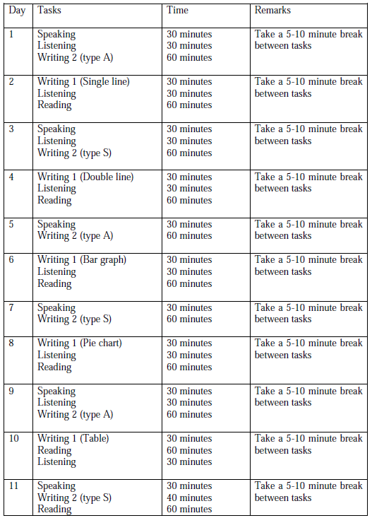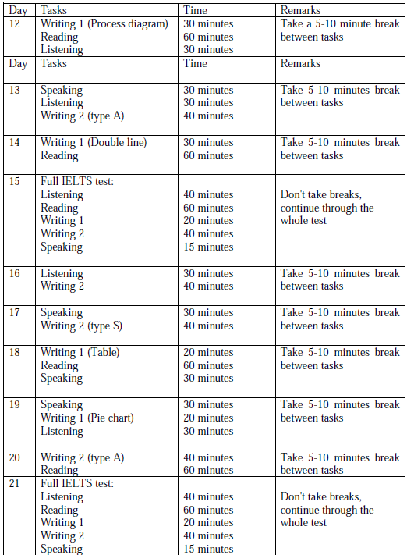

###### 关于模考

准备好之后，可以在考前两周-一周左右的时间来私信找SIMON预约登记模考的具体日期，一般会排在周六日一的上午，模考形式是qq语音，我的重点会是在Q & A 的P13部分，也有可能考到part2，因为part2大家可以自己练习做到不跑题即可，并且交作业纠音part2的方式会更加的高效。而我模考的重点会是根据四项评分标准给出你的加分和扣分项，给出分数区间；更重要的是给出考场的软技能提醒和如果扬长避短地拿分。