Part2

人

关注的网络红人

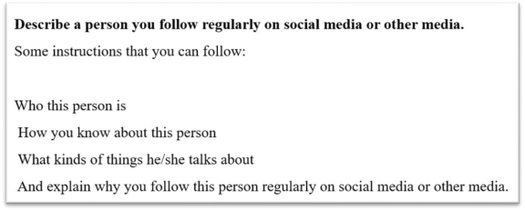

His name is CongMingXueZhang, which can be loosely translated as Mr. Smart. He is an influencer on DouYin, the Chinese version of TikTok. He creates videos about his studying methods and experience.

How I knew him? Actually, I found out about him by accident. My friend was browsing videos on DouYin the other day, and shared his videos with me. The video, I still remember, was about how to memorize difficult vocabulary in English. It was so interesting, so intriguing, and it captivated me at once, and I started following him since then.

Basically, he shares videos about his studying experiences, studying methods, and even life lessons, sometimes. From his video, you can totally tell that he is so smart, it’s like everything in studying is just a piece of cake to him, he is almost, how to put it, omniscient, I guess. The most impressive video was how he managed to remember 1000 words in three days. I mean, come on, that’s more than difficult, it’s very difficult, it’s a daunting task. But, he did it! He shared how he divided these words into different groups, and how he adopted various ways to memorize them, and even how he took advantage of different locations to consolidate the memories. I was surprised to see this, no, I was more than surprised, I was stunned.

This is him, a superman in the academic field. I guess I followed him not only because he is smart, but also because deep deep down, he resonates with me, I want to become smart, become brilliant, and become omniscient as well. And I believe his videos are going to go viral on DouYin very soon.

主题词汇和亮眼表达：

can be loosely translated as： 可以被粗略翻译为

influencer: 网红

the Chinese version of TikTok： TikTok 的中国版

creates videos： 做视频

browsing videos： 刷视频

follow him：成为他的粉丝

intriguing： 有趣的

captivate sb：吸引某人

you can totally tell： 你能轻易发现…

a piece of cake： 小菜一叠

omniscient：全知全能的

a daunting task：兼具的任务

adopt various ways：采用各种方法

take advantage of： 利用

consolidate the memories：加固记忆

stunned：目瞪口呆的

deep deep down： 内心深处

resonate with me： 和我有共鸣

brilliant：聪明的

omniscient：全知全能的

go viral： 爆火

对社会有贡献的人

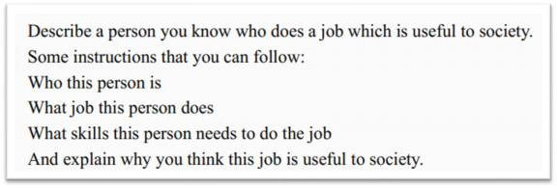

His name is CongMingXueZhang, which can be loosely translated as Mr. Smart. He is an

influencer on DouYin, the Chinese version of TikTok. He creates videos about his studying

methods and experience.

He is an English teacher, actually. Being an influencer is his part-time job, or a hobby, I guess.

The skill he needs to do this job is… excellent mastery of English, I think. Actually, I still

remember the first video I saw about him, it was about how to memorize difficult vocabulary

in English. It was so interesting, so intriguing, and it captivated me at once, and I started

following him since then.

Basically, he shares videos about his studying experiences, studying methods, and even life

lessons, sometimes. I think all of these helped me a lot, and are also beneficial to someone like me in society. From his video, you can totally tell that he is so smart, it’s like he knows

everything about studying, he is almost, how to put it, omniscient, I guess. The most impressive video was how he managed to remember 1000 words in three days. I mean, come on, that’s more than difficult, it’s very difficult, it’s a daunting task. But, he did it! He shared how he divided these words into different groups, and how he adopted various ways to memorize them, and even how he took advantage of different locations to consolidate the memories. I was surprised to see this, no, I was more than surprised, I was stunned.

And from then on, I started to use his method to memorize English vocabulary. And I also saw a lot of his fans doing this, too. So I think as his videos go viral on the Internet, he is actually helping a lot of people, especially students. His contribution to society not only has short-term benefits, I think, but also far-reaching influence. Students like me really learned a lot from him.

主题词汇和亮眼表达：

part-time job：兼职工作

excellent mastery of English：英语好

be beneficial to：对 XX 有好处

contribution to the society： 对社会的贡献

short-term benefits：短期好处

far-reaching influence： 长远影响

最近认识并想更深入认识的人

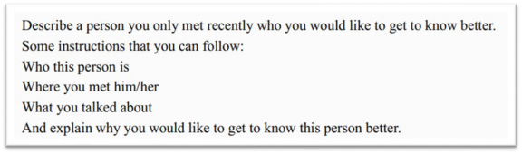

His name is CongMingXueZhang, which can be loosely translated as Mr. Smart. He is an

influencer on DouYin, the Chinese version of TikTok. He creates videos about his studying

methods and experience.

Since he is a celebrity, you know, it should be hard to meet him in person. But, fortunately, he used to study at the same university as I do, and he was kind of invited back to give a speech last month, so I not only saw him, but also chatted with him a little bit!

In his speech, he shared his studying experiences, studying methods, and even life lessons. From his speech, you can totally tell that he is so smart, it’s like everything in studying is a piece of cake to him, he is almost, how to put it, omniscient, I guess. The most impressive part was how he managed to remember 1000 words in three days. I mean, come on, that’s more than difficult, it’s very difficult, it’s a daunting task. But, he did it! He shared how he divided these words into different groups, and how he adopted various ways to memorize them, and even how he took advantage of different locations to consolidate the memories. I was surprised to know this, no, I was more than surprised, I was stunned.

This is the first time I have met a big fish in person. I would really like to know him better. He

is like a superman in the academic field. I guess I want to know him not only because he is

smart, but also because deep deep down, he resonates with me, I want to become smart,

become brilliant, and become omniscient as well. So, if I get more chance to know him, I will

never miss the boat.

主题词汇和亮眼表达：

celebrity： 名人

meet someone in person：见到真人

chat with sb：和某人闲聊

a big fish：大人物

miss the boat： 错过机会

和你度过愉快时光的人

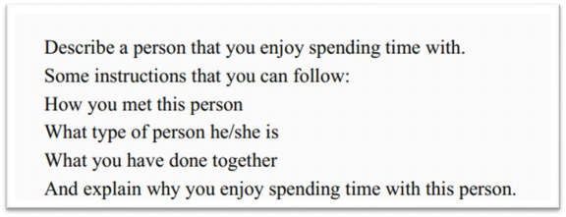

His name is CongMingXueZhang, which can be loosely translated as Mr. Smart. He is an

influencer on DouYin, the Chinese version of TikTok. He creates videos about his studying

methods and experience.

Actually, I only met him once, that was kind of a serendipity. Since he is a celebrity, you know, it should be hard to meet him in person. But, fortunately, he used to study at the same university as I do, and he was kind of invited back to give a speech last month, so I not only saw him, but also chatted with him a little bit!

Actually, we didn’t do anything together: in the speech, it was mainly like he talking and I

listening to him. In his speech, he shared his studying experiences, studying methods, and even life lessons. From his speech, you can totally tell that he is so smart, it’s like everything in studying is a piece of cake to him, he is almost, how to put it, omniscient, I guess. The most

impressive part was how he managed to remember 1000 words in three days. I mean, come on, that’s more than difficult, it’s very difficult, it’s a daunting task. But, he did it! He shared how he divided these words into different groups, and how he adopted various ways to memorize them, and even how he took advantage of different locations to consolidate the memories. I was surprised to know this, no, I was more than surprised, I was stunned.

This was the first time I had met an influencer in person. The meeting was really short, actually, fleeting, I guess. But he really made my day. He is like a superman in the academic field. I

guess I admire him not only because he is smart, but also because deep deep down, he

resonates with me, I want to become smart, become brilliant, and become omniscient as well.

So, god, I wish I would have more time with him.

主题词汇和亮眼表达：

serendipity： 令人惊喜的邂逅

celebrity： 名人

meet someone in person：见到真人

chat with sb：和某人闲聊

fleeting： 转瞬即逝的

made one’s day： 让某人的一天都完美了

地

乡下

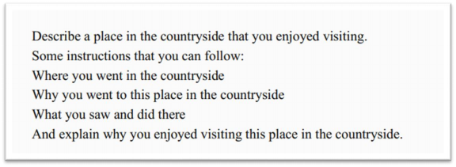

Well, I have always been very attached to the countryside. My grandparents live there and I went there last summer. It is just so peaceful and quiet, or you may say, it is tranquil. It slows everything down, and blocks out all the hustle and bustle of the city.

I go to the countryside every summer. It is easier for me to feel the beauty of nature when I am there. You can always find peace there. It’s not a cliché , I really feel so. I do. In the countryside, you don’t need someone else to tell you spring is here. Instead, you get to see the little buds and the sprouting flowers. I mean, you can see the change of seasons, and it’s with your own eyes. Everything can be so natural, so real, and so tangible.

Last summer, when I was in the countryside, I found something even more meaningful: the bonds between people. I mean, people living in the city are always so busy. They are always buzzing around, never willing to spare a second to say hi. You can feel the distance between people. We are separated by endless traffic jams, by all the tall, fancy but boring buildings. But when I was in the countryside, things were totally different. The community there is small but close-knit. People know each other, care about each other, and sympathize with each other. It’s good to know there is always a place for you.

主题词汇和亮眼表达

be attached to： 喜欢

tranquil： 宁静

blocks out all the hustle and bustle of the city： 屏蔽城市的喧嚣

find peace： 找到安宁

cliché： 陈词滥调

little buds and the sprouting flowers：小嫩芽和开苞的花

tangible： 可以触摸得到的

bonds between people： 人之间的纽带

buzzing around：忙得团团转

spare a second： 腾出一点点时间

traffic jam： 堵车

fancy but boring buildings：高级但无聊的大楼

close-knit：紧密团结的

理想之家

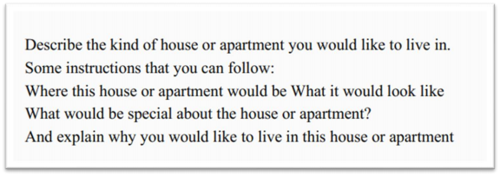

The first thing that popped into my mind is a country cottage. It doesn’t have to be a super large one. All I need is just a cozy place.

And I want to make sure that the cottage is located in a village, because I have always been

very attached to the countryside. It is just so peaceful and quiet, or you may say, it is tranquil. It slows everything down, and blocks out all the hustle and bustle of the city.

Oh, it would be perfect if there is a yard as well. Because I enjoy being surrounded by the

beauty of nature so much. And you can always find peace there. It’s not a cliché, I really feel

so. I do. you don’t need someone else to tell you spring is here. Instead, you get to see the

little buds and the sprouting flowers. I mean, you can see the change of seasons, and it’s with

your own eyes. Everything can be so natural, so real, and so tangible.

I would like to live in a country cottage also because I cherish the bonds between people. I

mean, people living in the city are always so busy. They are always buzzing around, never

willing to spare a second to say hi. You can feel the distance between people. We are

separated by endless traffic jams, by all the tall, fancy but boring buildings. But when I was in

the countryside, things were totally different. The community there is small but close -knit.

People know each other, care about each other, and sympathize with each other. It’s good to

know there is always a place for you.

主题词汇和亮眼表达

pop into one’s mind：突然想到

super： =very， 是很口语化的用词

cozy：温暖舒适的

being surrounded by： 周围环绕着

country cottage：乡间小屋

yard： 小院子

新地方

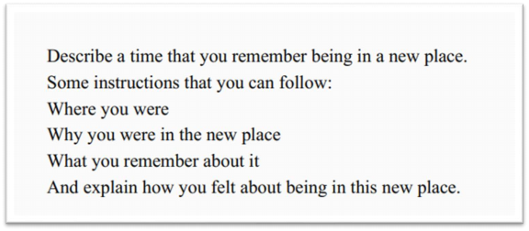

I remember it was like eight years ago, I was brought by my parents to visit a distant relative. At the very beginning, I didn’t want to go at all. Because the family lived in a remote village. I

mean, no one likes to be stuck at such a boring place, right?

But I totally changed my mind after the visit. It was just so peaceful and quiet, or you may say,

it was tranquil. It slowed everything down, and blocked out all the hustle and bustle of the

city.

The local people in the village were very hospitable to me, even though I was a total stranger. I could feel the special bonds between people. I mean, people living b in the city are always

so busy. They are always buzzing around, never willing to spare a second to say hi. You can feel the distance between people. We are separated by endless traffic jams, by all the tall, fancy but boring buildings. But we I was in the countryside, things were totally different. The community there is small but close -knit. People know each other, care about each other, and sympathize with each other. It’s good to know there is always a place for you.

At that time, all of these were very new to me and now it’s my unique experience.

主题词汇和亮眼表达

distant relative： 远房亲戚

remote：偏远的

be stuck at： 被困在

hospitable：热情好客的

a total stranger：素不相识的陌生人

有趣的著名的城市

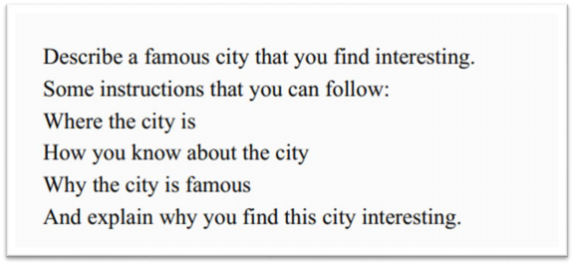

The first city that popped into my mind is Guilin. It’s there, in the textbook, that’s how I knew it. It’s famous for its jaw-dropping scenery. The city is like a dream destination for millions of tourists, home and abroad.

There is a very interesting rule set by the local government. That is, no buildings in the city are allowed to be higher than 25 meters. Why? It is to make sure that buildings do not stand in the way of nature.

One of the benefits is that it is easier for residents to feel the beauty of nature in the city. In Guilin, you do not need someone else to tell you spring is here. Instead, you get to see the

little buds and the sprouting flowers. I mean, you can see the change of seasons, and it’s with

your own eyes. Everything can be so natural, so real, and so tangible.

Another special thing about the city is the bonds between people. If you think about Beijing, the capital of China, people are always so busy. They are always buzzing around, never willing

to spare a second to say hi. You can always feel the distance between people. They are

separated by endless traffic jams, by all the tall, fancy but boring buildings. But you see, things

in Guilin are very different. The community there is small but close -knit. People know each

other, care about each other, and sympathize with each other. It’s good to know there is

always a place for you.

主题词汇和亮眼表达

jaw-dropping ：令人惊叹不已的

dream destination： 梦想胜地

home and abroad： 国内外

stand in the way of sth.： 阻碍某事

物

蛋糕

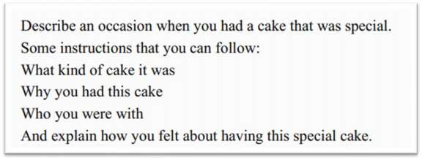

This reminds me of a cake made by my best friend. I think it was my 19th birthday. My best friend was being mysterious all day. She told me she had a big surprise for me. We met at a nice little restaurant as planned. She carefully placed a beautiful cake on the table. It was a handmade mousse cake, my favorite flavor! She told me, she spent the whole day making it. I felt so excited, so happy, so, how to say, exhilarated to receive such a present.

She was not a professional chef. But this is a unique present. One of a kind ! Think about it, she had to search for the recipe, collect all the ingredients, and all the mixing and stirring! After all, she could just buy one, right? But she did not. That made the cake so special and so precious.

And I still remember the end of that day, we talked a lot, from the cake to other stuff, it seems that there used to be a line, I mean, a boundary, between us, but because of the cake, the boundary was gone. We became much closer, and that’s great.

When you think about friendship, or any other interpersonal relationships, it is always about loving and caring for each other. I mean, no one is an island. Sending a handmade gift is the best way to say: we are bonding. When someone receives something so kind, so personal, so genuine, they will be touched.

主题词汇和亮眼表达：

mysterious： 神秘的

as planned： 按计划

handmade：手工制作的

mousse cake： 慕斯蛋糕

exhilarated：兴奋

one of a kind：独一无二的

stuff：事情

boundary： 界限

was gone： 消失了

recipe： 菜谱

ingredient： 烹饪材料

interpersonal relationships：人际关系

no one is an island：没有人是一座孤岛

bonding： 绑定

personal： 亲密的

genuine：真诚的

touched： 被触动到；感动

歌

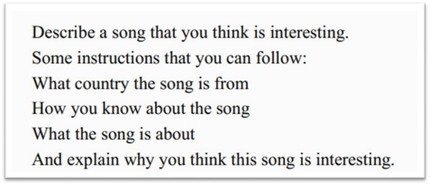

This reminds me of a song written

by my best friend. I think it was my 19th birthday. She was

being mysterious all day. She told me she had a big surprise for me. We met at a nice little

restaurant as planned. She gave me a DVD and told me she had recorded a song on it. She gave it to me as a birthday present. I felt so excited, so happy, so, how to say, exhilarated to

receive such a present.

The song was an interesting variation on the common“happy birthday song”. She was not a professional singer. But this is a unique present. One of a kind! Think about it, she had to create the tune, write all the lyrics, and all the recording and editing! After all, she could just

buy a DVD, right? But she did not. That made the present so interesting, so precious.

And I still remember the end of that day, we talked a lot, from the song to other stuff, it seems

that there used to be a line, I mean, a boundary, between us, but because of the song, the

boundary was gone. We became much closer, and that’s great.

When you think about friendship, or any other interpersonal relationships, it is always about

loving and caring for each other. Sending a handmade gift is the best way to say: we are

bonding. When someone receives something so kind, so personal, so genuine, they will be

touched.

主题词汇和亮眼表达：

variation：改编

tune： 曲调

lyrics： 歌词

recording and editing： 录制和编辑

衣服

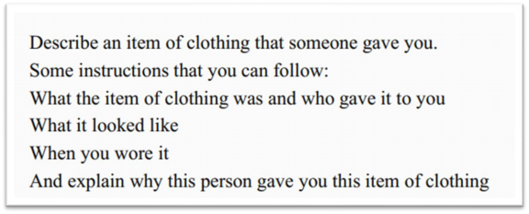

This reminds me of a sweater knitted by my best friend. I think it was my 19th birthday. My

best friend was being mysterious all day. She told me she had a big surprise for me. We met

at a nice little restaurant as planned. She carefully placed a beautiful box on the table. It was a white striped sweater, my favorite color! She told me, she spent the whole month knitting.

I felt so excited, so happy, so, how to say, exhilarated to receive such a present.

She was not a professional knitter. But this is a unique present. One of a kind! Think about it, she had to learn how to use a needle, get all the yarn, and all the looping! After all, she could just buy one sweater, right? But she did not. That made the sweater so special and so precious.

And I still remember the end of that day, we talked a lot, from the sweater to other stuff, it seems that there used to be a line, I mean, a boundary, between us, but because of the sweater, the boundary was gone. We became much closer, and that’s great.

When you think about friendship, or any other interpersonal relationships, it is always about

loving and caring for each other. I mean, no one is an island. Sending a handmade gift is the

best way to say: we are bonding. When someone receives something so kind, so personal, so

genuine, they will be touched.

主题词汇和亮眼表达：

knit： 编织

striped：有条纹的

needle： 缝衣针

yarn：编织毛线

loop： 绕圈

玩具

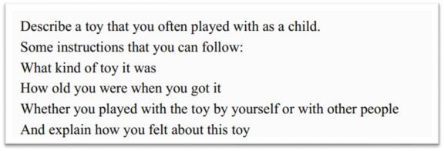

This reminds me of a teddy bear/model car made by my aunt/uncle. It was a birthday gift. I

think it was my 5th birthday. She was being mysterious all day. She told me she had a big

surprise for me. She carefully placed a beautiful box on the table. It was a teddy bear/model car, my favorite! According to my mom, I took it everywhere with me. And I wouldn’t let it go

even when I was sleeping.

Looking back, I still find it a very unique present. One of a kind! Think about it, my aunt made it all by herself! She had to prepare all the materials, design the look, and all the other stuff. After all, she could just buy one, right? But she did not. That made the toy so special and so

precious.

And I still remember last year, my aunt and I talked about all the memories. We talked a lot,

from the bear to other stuff, it seems that there used to be a line, I mean, a boundary, between

us, but because of the bear, the boundary was gone. We became much closer, and that’s

great.

When you think about interpersonal relationships, it is always about loving and caring for

each other. I mean, no one is an island. Sending a handmade gift is the best way to say: we

are bonding. When someone receives something so kind, so personal, so genuine, they will

be touched.

主题词汇和亮眼表达：

take it everywhere with me ：去哪儿都带着

teddy bear： 泰迪熊

model car： 模型车

let it go：放手

looking back：回头看看

stuff：事情

送朋友的礼物

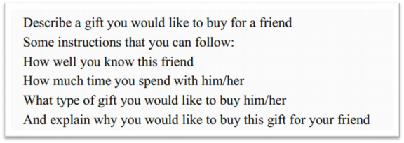

Well, I think I won’t buy anything for my friend. I mean, we are very close; we have known each other for 10 years, so I would choose something more meaningful: maybe a handmade gift.

A handmade mousse cake seems to be a nice choice. I am not a professional chef. But this is going to be a unique present. One of a kind! I know it’s not easy to make a cake. I need to search for the recipe, collect all the ingredients, and all the mixing and stirring! But I also know that my friend will be so excited, so happy, so, how to say, exhilarated to receive such a

present.

And I still remember the last time I had given a DIY gift to my friend, we talked a lot, from the gift to other stuff, it seems that there used to be a line, I mean, a boundary, between us, but because of the gift, the boundary was gone. We became much closer, and that’s great.

A DIY gift has a lot of layers of meaning. Because when you think about friendship, or any

other interpersonal relationships, it is always about loving and caring for each other. I mean,

no one is an island. Sending a handmade gift is the best way to tell my friend that, we are

bonding. When someone receives something so kind, so personal, so genuine, they will be

touched.

主题词汇和亮眼表达：

a lot of layers of meaning: 很多层次的含义

免费得到的东西

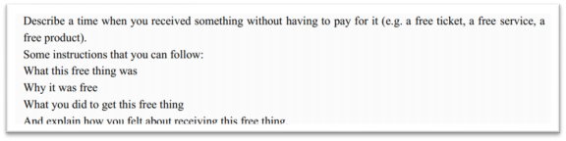

This reminds me of a birthday cake made by my best friend. I think it was my 19th birthday. My best friend was being mysterious all day. She told me she had a big surprise for me. We met at a nice little restaurant as planned. She carefully placed a beautiful cake on the table. It was a handmade mousse cake, my favorite flavor! She told me, she spent the whole day making it. I felt so excited, so happy, so, how to say, exhilarated to receive such a present.

She was not a professional chef. But this is a unique present. One of a kind! Think about it,

she had to search for the recipe, collect all the ingredients, and all the mixing and stirring!

After all, she could just buy one, right? But she did not.

And I still remember the end of that day, we talked a lot, from the cake to other stuff, it seems

that there used to be a line, I mean, a boundary, between us, but because of the cake, the

boundary was gone. We became much closer, and that’s great.

Since it was a gift, I did not have to pay for it. But it means more than anything I have to pay for. It says a lot about friendship, or any other interpersonal relationships, it is always about

loving and caring for each other. I mean, no one is an island. Sending a handmade gift is the

best way to say: we are bonding. When someone receives something so kind, so personal, so

genuine, they will be touched. And you can’t put a price on that, right?

主题词汇和亮眼表达：

say a lot about：充分说明

can’t put a price on that：无法用金钱衡量

离不开的东西

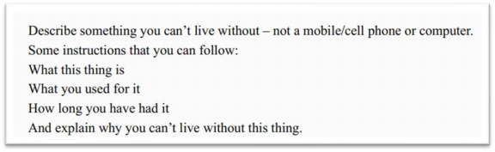

A mobile phone or a computer is of course very important, we can’t live without them. But besides them…if I have to say… perhaps we need something more meaningful here, something that we are attached to, I guess. For me, actually, it’s a song.

It’s a song written by my best friend. I think it was my 19th birthday. She gave me a DVD and told me she had recorded a song on it. She gave it to me as a birthday present. I felt so excited, so happy, so, how to say, exhilarated to receive such a present. And from then on, I couldn’t live without it; especially when she was not nearby.

The song was an interesting variation on the common“happy birthday song”. Every year, I will listen to it. It reminds me of how she had to create the tune, write all the lyrics, and all the

recording and editing.

The song is totally different from a mobile phone, or a computer, of course. A mobile is more functional, so we can’t live without it; but for me, the song is more personal, more emotional,

it says a lot about friendship, or any other interpersonal relationships, it is always about loving and caring for each other. Sending a handmade gift is the best way to say: we are bonding. When someone receives something so kind, so personal, so genuine, they will be touched.

Every time I bought a new phone, I would transfer the song to the new phone. I guess I will do it all the time: it has become an emotional support for me, and I can’t live without it.

主题词汇和亮眼表达：

be attached to： 喜欢；被深深绑定

functional：实用的

say a lot about：充分说明

事

一次体验很好的远行

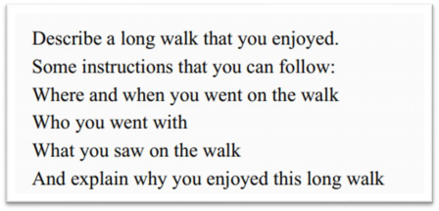

Actually, I hate long walk: it’s tiring, it’s dull, and you’ve got nothing to do but keep walking. But, I enjoyed the long walk last year to the top of Taishan Mountain. It’s like the most famous mountain in China, very prestigious. Generally, I would never go there myself. But, that time, I had a company, we had the long walk together and I had a super wonderful time.

His name is CongMingXueZhang, which can be loosely translated as Mr. Smart. He is an

influencer on DouYin, the Chinese version of TikTok. He creates videos about his studying

methods and experience. The whole mountain climbing thing was his idea, he invited his fans

to climb the mountain with him, and I was one of the fans.

Actually, I didn’t pay much attention to the scenery along the way cuz/because I was listening

to him all the time. He shared with us his studying experiences, studying methods, and even

life lessons, sometimes. You can totally tell that he is so smart, it’s like he knows everything

about studying, he is almost, how to put it, omniscient, I guess.

I still remember at lunchtime, everybody was kind of tired, and he started to tell us how he

managed to remember 1000 words in three days. I mean, come on, that’s more than difficult,

it’s very difficult, it’s a daunting task. But, he did it! All of the fans were surprised to hear this,

no, we were more than surprised, we were stunned.

Finally, we reached the top of the mountain. The view was really beautiful, how to say, it was gorgeous. Just as the views he revealed for us in the academic field. I am so glad I had the long walk with him, and I still benefit from this experience.

主题词汇和亮眼表达：

dull：无聊的

prestigious： 有名的

company：同伴

super wonderful：无比精彩

cuz： because 的口语化说法

gorgeous：极美的

reveal： 揭露

benefit from sth： 受益于

一次有趣的谈话

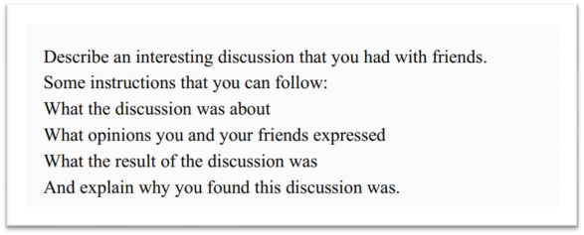

I had a super interesting discussion three months ago. But actually it was not with my friends;

it was with my academic idol. His name is CongMingXueZhang, which can be loosely

translated as Mr. Smart. He is an influencer on DouYin, the Chinese version of TikTok. He

creates videos about his studying methods and experience. We had the discussion on his live

show on Douyin.

The discussion was mainly about how to memorize difficult vocabulary in English. Mr. Smart shared his studying experiences, studying methods, and even life lessons, as well. From his

words, you can totally tell that he is so smart, it’s like everything in studying is a piece of cake

to him, he is almost, how to put it, omniscient, I guess.

In the middle of the discussion, also the most impressive part, he shared how he managed to

remember 1000 words in three days. I mean, come on, that’s more than difficult, it’s very

difficult, it’s a daunting task. But, he did it! He shared how he divided these words into different

groups, and how he adopted various ways to memorize them, and even how he took

advantage of different locations to consolidate the memories. At last, everyone, including me,

was surprised to see this, no, I was more than surprised, I was stunned.

Actually, I not only found the discussion interesting, I found it enlightening, because deep

deep down, he resonates with me, I want to become smart, become brilliant, and become

omniscient as well.

主题词汇和亮眼表达：

super interesting： 超级有趣

academic idol：学术偶像

live show：直播秀

enlightening：有启发性的

筹办的活动

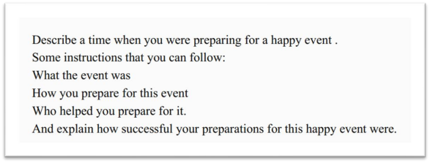

Last semester, I prepared a meeting for the students in my department. We invited an

academic influencer to give a speech for us. His name is CongMingXueZhang, which can be

loosely translated as Mr. Smart. He is an influencer on DouYin, the Chinese version of TikTok.

He creates videos about his studying methods and experience.

Actually, at first, I didn’t know him very well. But for the meeting, I had to give a good introduction about him. So I browsed his videos on DouYin and found what I needed. The

video, I still remember, was about how to memorize difficult vocabulary in English. It was so

interesting, so intriguing, and it captivated me at once, and I decided to use that as the

introduction material.

Then I needed to decide what he was going to share in the meeting. My classmates gave me some advice, and we narrowed down the topics to his studying experiences, studying

methods, and some life lessons.

At last, he totally blew our minds. You can totally tell that he is so smart, it’s like everything in studying is a piece of cake to him, he is almost, how to put it, omniscient, I guess. At the climax of the meeting, also the most impressive part, he shared how he managed to

remember 1000 words in three days. I mean, come on, that’s more than difficult, it’s very difficult, it’s a daunting task. But, he did it! He shared how he divided these words into different groups, and how he adopted various ways to memorize them, and even how he took advantage of different locations to consolidate the memories. Everyone was surprised to know this, no, we were more than surprised, we were stunned.

Actually, we had been preparing for the meeting like three weeks, but the meeting was just one hour. But I think it was totally worth it. We all learned a lot from our idol.

主题词汇和亮眼表达：

department：系

narrowed down the topics to… ：把话题范围缩小到

blow one’s mind： 让某人大开眼界

climax：高潮

帮助你学外语的事情

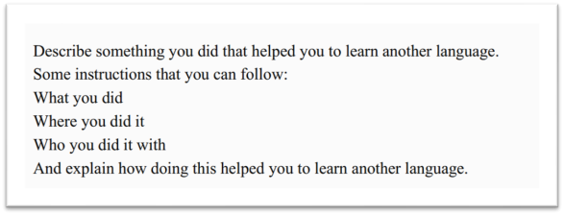

Actually, it may sound weird, but recently, what I did to learn a foreign language is to follow an influencer. I’ll explain.

This influencer’s name is CongMingXueZhang, which can be loosely translated as Mr. Smart.

He is an influencer on DouYin, the Chinese version of TikTok. He creates videos about his

studying methods and experience. I still remember his first video: that was about how to

memorize difficult vocabulary in English. It was so interesting, so intriguing, and it captivated

me at once, and I started following him since then, and also since then, my foreign language

studying began to take off.

Basically, he shares videos about his studying experiences, studying methods, and even life lessons, sometimes. From his video, you can totally tell that he is so smart, it’s like everything in studying is just a piece of cake to him, he is almost, how to put it, omniscient, I guess. So

what I did was just follow his lead, keep practicing, and I could pick up some really good skills.

The most impressive skill I learned from him was how he managed to remember 1000 words

in three days. I mean, come on, that’s more than difficult, it’s very difficult, it’s a daunting task.

But, he did it! And I did it! He taught me how to divide these words into different groups, and

how to adopt various ways to memorize them, and even how to take advantage of different

locations to consolidate the memories. I was surprised to learn this, no, I was more than

surprised, I was stunned.

There are surely millions of ways of studying a foreign language, but I think I found the most effective one. That is, to follow someone who is much better in this field and then learn from him and keep practicing. Then, mission accomplished!

主题词汇和亮眼表达：

weird：奇怪的

take off： 某件事情成功

follow one’s lead： 跟着某人（有样学样）

pick up：学会

millions of： 成千上万的

mission accomplished： 任务完成

别人告诉你的事情

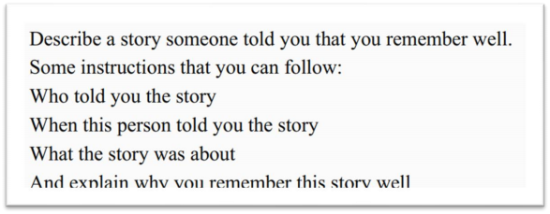

The most inspiring story I have heard in the last year, I guess, was how my ex -roommate became an academic influencer.

His name is CongMingXueZhang, which can be loosely translated as Mr. Smart. He is an

influencer on DouYin, the Chinese version of TikTok. He creates videos about his studying

methods and experience.

I met him last year, we grabbed a bite, and he told me how he started from scratch and became a famous influencer. He started by sharing videos about his studying experiences,

studying methods, and even life lessons, sometimes.

The first three months were not easy; he had only hundreds of fans. But he never gave up and kept creating new videos. Then one of his videos went viral and over 10 thousand people

followed him. The video was about how he managed to remember 1000 words in three days.

I mean, come on, that’s more than difficult, it’s very difficult, it’s a daunting task. But, he did it! He shared how he divided these words into different groups, and how he adopted various

ways to memorize them, and even how he took advantage of different locations to

consolidate the memories. Actually I saw this video, too. I was surprised to see this, no, I was

more than surprised, I was stunned.

This is the story of him, a superman in the academic field. I guess I like his story not only

because he is smart, but also because deep deep down, he resonates with me, perhaps I want

to become an influencer as well.

主题词汇和亮眼表达：

grab a bite： 撮了一顿

start from scratch： 从零开始

go viral： 爆火

未实现的目标

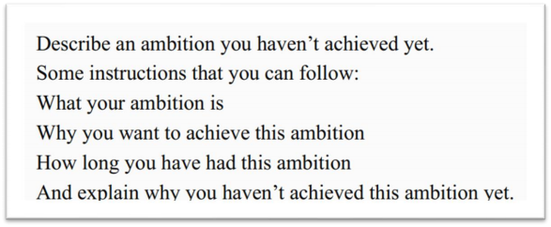

Actually, I had a lot of ambitions I haven’t achieved, but the last one was the most frustrating.

My ambition was to study English well. Well, this is like every Chinese student’s ambition, and this has been my ambition like forever. But I constantly tried, and constantly gave up. However, last year I saw an influencer’s video and it rekindled my passion.

His name is CongMingXueZhang, which can be loosely translated as Mr. Smart. He is an

influencer on DouYin, the Chinese version of TikTok. He creates videos about his studying

methods and experience.

Basically, he shares videos about his studying experiences, studying methods, and even life lessons, sometimes. From his video, you can totally tell that he is so smart, it’s like everything

in studying is just a piece of cake to him, he is almost, how to put it, omniscient, I guess. I wanted to become someone like him! So I followed one of his most impressive videos: that was how he managed to remember 1000 words in three days. I mean, come on, that’s more than difficult, it’s very difficult, it’s a daunting task. But, he did it! He shared how he divided these words into different groups, and how he adopted various ways to memorize them, and even how he took advantage of different locations to consolidate the memories. I was surprised to see this, no, I was more than surprised, I was stunned.

All of those sound amazing. I decided to try. But, on the second day, my professor gave me a lot of work to do, and it took me a week to finish it. After that, it seems I forgot the English studying thing, or not. But anyway, I haven’t finished my three -day project and it was a bummer.

主题词汇和亮眼表达：

frustrating： 令人沮丧的

constantly：持续地

rekindled：重燃

bummer：令人失望的事物

从年长者那里学到的技能

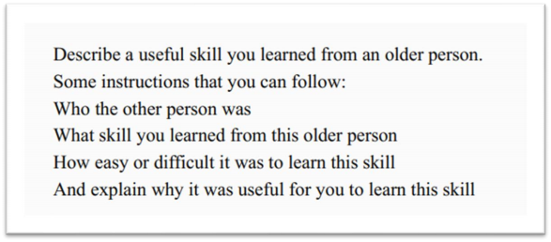

I’d like to share some English -studying skills I learned from another person. His name is

CongMingXueZhang, which can be loosely translated as Mr. Smart. He is an influencer on DouYin, the Chinese version of TikTok. He creates videos about his studying methods and

experience. I am pretty sure he is older than me because he has been working for 10 years.

Basically, he shares videos about his studying experiences, studying skills, and even life lessons, sometimes. From his video, you can totally tell that he is so smart, it’s like everything in studying is just a piece of cake to him, he is almost, how to put it, omniscient, I guess. I learned a lot of useful English-studying skills from him. The most impressive skill was how he managed to remember 1000 words in three days. I mean, come on, that’s more than difficult, it’s very difficult, it’s a daunting task. But, he did it! He shared how he divided these words into different groups, and how he adopted various ways to memorize them, and even how he took advantage of different locations to consolidate the memories. I was surprised to know this, no, I was more than surprised, I was stunned.

I followed his lead and started my three -day project. I went through it, but I managed to remember just 500 words. I guess it was kind of lame for some other people, but it was really cool for me! I mean, if I could nail 500 words in three days, I can nail more in the future! This is exciting！

主题词汇和亮眼表达：

lame： low， 弱， 挫（很口语化的表达）

nail： 搞定（很口语化的表达）

印象深刻的一堂课

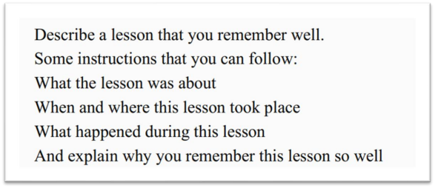

The lesson that I remember well is actually not a lesson from my teacher, but from an influencer.

His name is CongMingXueZhang, which can be loosely translated as Mr. Smart. He is an

influencer on DouYin, the Chinese version of TikTok. He creates videos about his studying

methods and experience.

Basically, he shares lessons about his studying experiences, studying methods, and even life lessons, sometimes. From his lessons, you can totally tell that he is so smart, it’s like everything in studying is just a piece of cake to him, he is almost, how to put it, omniscient, I guess. The most impressive lesson was how he managed to remember 1000 words in three days. I mean, come on, that’s more than difficult, it’s very difficult, it’s a daunting task. But, he did it! He shared how he divided these words into different groups, and how he adopted various ways to memorize them, and even how he took advantage of different locations to consolidate the memories. I was surprised to see this, no, I was more than surprised, I was stunned.

This is him, a superman in the academic field. He is not a teacher, but he gives better lessons

than a lot of teachers do. I guess I followed him not only because he is smart, but also because

deep deep down, he resonates with me, I want to become smart, become brilliant, and

become omniscient as well.

学校中不喜欢的规定

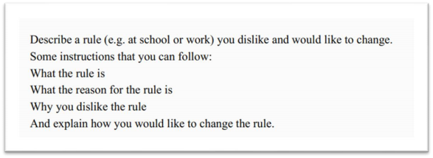

Actually, I am ok with most rules at my school, but there is one I don’t like. It’s set by my English teacher. She tells us to study English hard, which I am totally ok with; but she also tells us to follow an influencer on Douyin, the Chinese version of TikTok, to totally copy his studying methods, I don’t like it.

如果是上班族， 可以做如下修改：

Actually, I am ok with most rules at my work, but there is one I don’t like. It’s set by my boss. English is necessary for our work, and my boss tells us to study English hard, which I am totally ok with; but she also tells us to follow an influencer on Douyin, the Chinese version of TikTok,

to totally copy his studying methods, I don’t like it.

The influencer’s name is CongMingXueZhang, which can be loosely translated as Mr. Smart.

He creates videos about his studying methods and experience.

The first video my English teacher asked us to watch, I still remember, was about how to memorize difficult vocabulary in English. My English teacher thought it was so interesting, so intriguing, and it captivated her at once, and she asked us to follow him since then.

And last month, my English teacher told us to follow one of his most popular videos: it was how he managed to remember 1000 words in three days. I mean, come on, that’s more than difficult, it’s very difficult, it’s a daunting task. But, he did it! He shared how he divided these words into different groups, and how he adopted various ways to memorize them, and even how he took advantage of different locations to consolidate the memories. I admit I was surprised to see this, no, I was more than surprised, I was stunned. But, the problem is, I didn’t have the time! And, what he memorized was GRE vocabulary, and I don’t need it!

So, I don’t see the point of this rule. To follow someone excellent, that sounds great; but it’s not feasible sometimes, I think we should just consider our own situation as well.

主题词汇和亮眼表达：

be ok with： 能接受

set rules： 作出规定

copy：照抄； 照搬

the point of sth： 某件事的意义

feasible：可行的

修复的坏物件

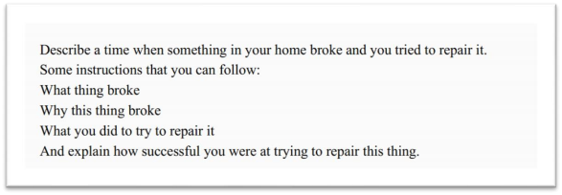

This reminds me of my 19th birthday. It should be romantic and perfect, but I broke my phone, and even worse, my best friend’s phone as well.

I remember vividly that my best friend was being mysterious all day. She told me she had a

big surprise for me. We met at my place. My mother cooked up a storm for us. My best friend

carefully placed a beautiful cake on the table. It was a handmade mousse cake, my favorite

flavor! She told me, she spent the whole day making it. I felt so excited, so happy, so, how to

say, exhilarated to receive such a present.

And the next stage was just romantic, I still remember we talked a lot, from the cake to other

stuff, it seems that there used to be a line, I mean, a boundary, between us, but because of

the cake, the boundary was gone. We became much closer, and that’s great.

And, I had the feeling that something would come up, and it did. I got too excited and knocked over the soda and it spilled everywhere, the table, our clothes, and, the worst, our phones. Since our phones were just on the table, next to the soda, so they got totally wet.

The rest of the night was all about trying to repair the phones. We searched on the Internet and tried every method. We even tried to bury our phones in the rice, I mean, the rice that hasn’t been cooked. The Internet guys said it would help to suck up all the moisture.

However, at last, no luck. This taught me a lesson: no soda, don’t get excited, and buy new phones that are waterproof.

主题词汇和亮眼表达：

remember vividly：清楚地记得

the next stage： 下一个阶段

something would come up：有事会发生

knock over： 碰翻

spill： 喷洒

suck up all the moisture： 吸干水分

no luck： 没成功（是一个很口语的说法）

waterproof： 防水的