# 于磊Simon帮你梳理口语题库

#### 

#### Part1 必考题三道：

Work/study; hometown; living area/accommodation

#### 一级准备5-12

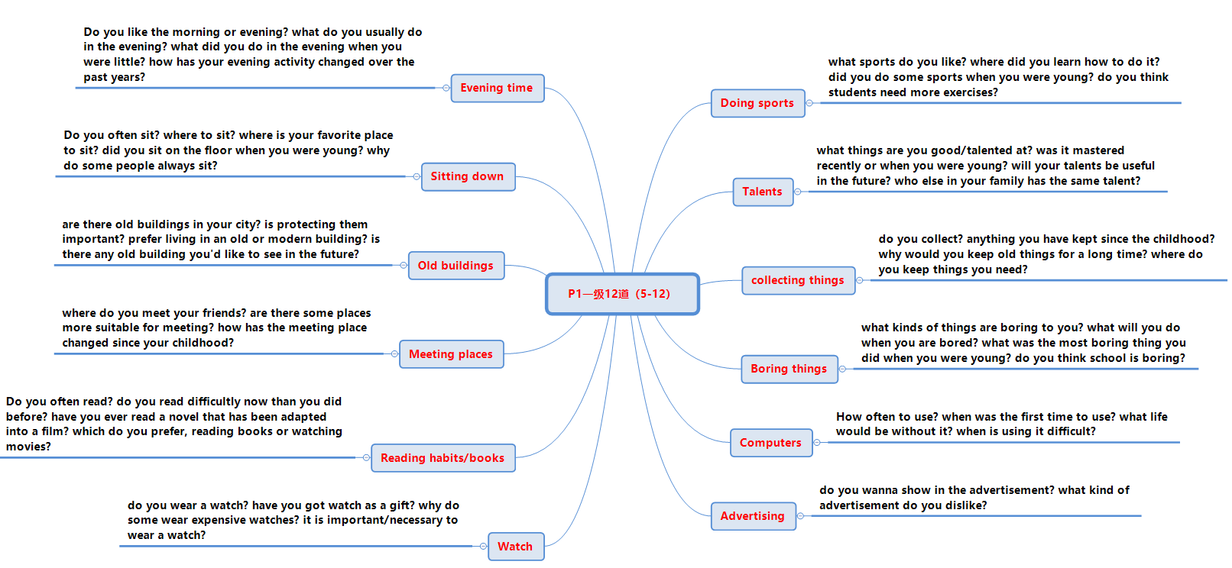

#### 二级准备 5-9

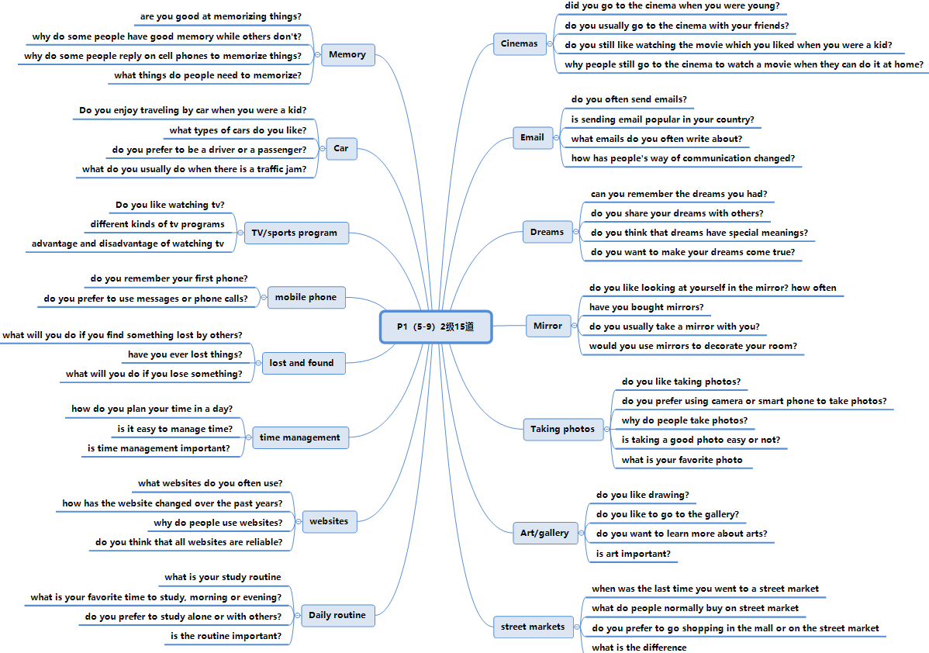

#### Part2 一级准备 24道 5-12

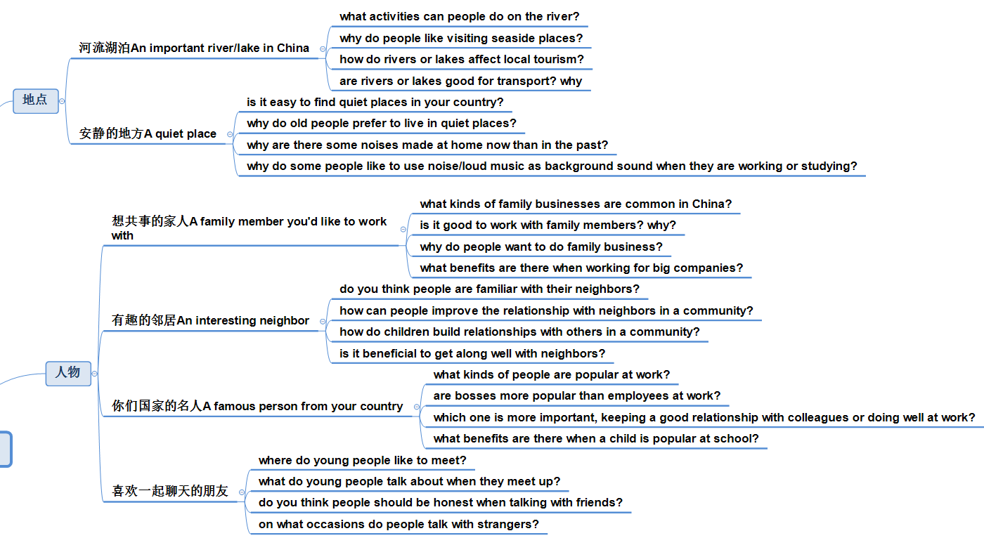

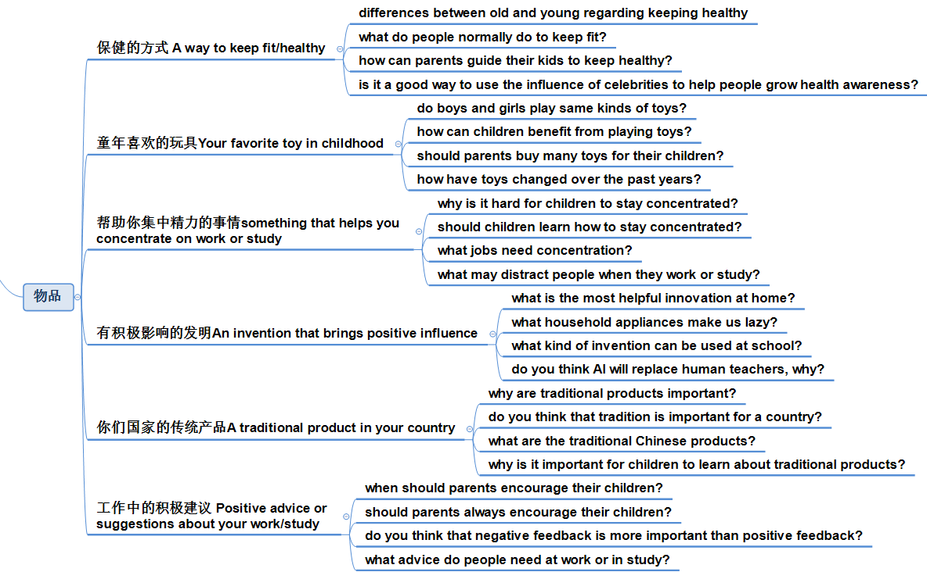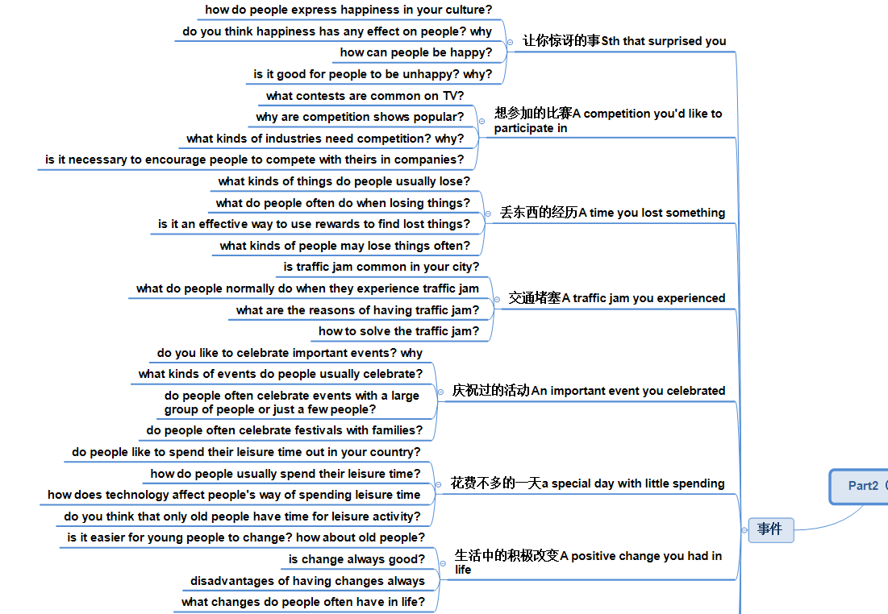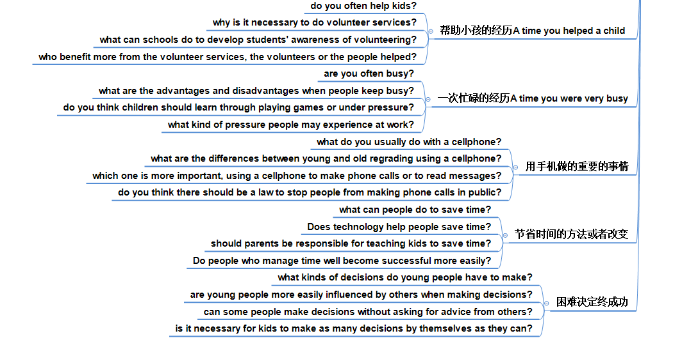

#### Part2 二级准备 5-9 24道

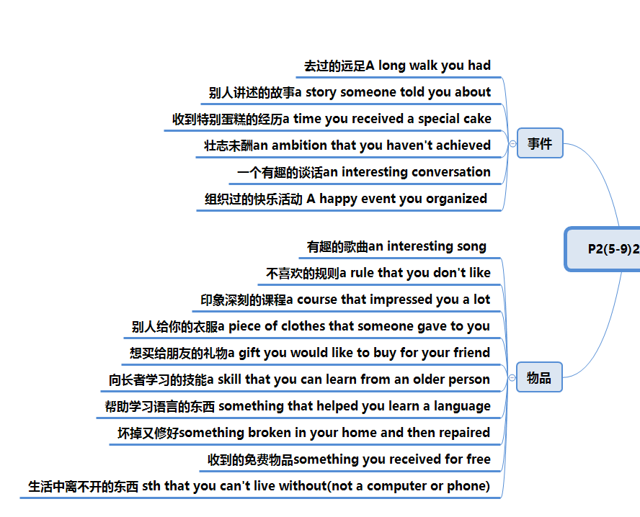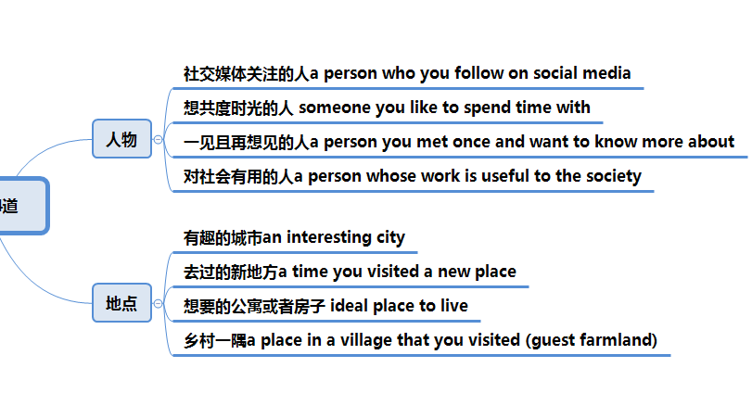

#### 备考和答题：

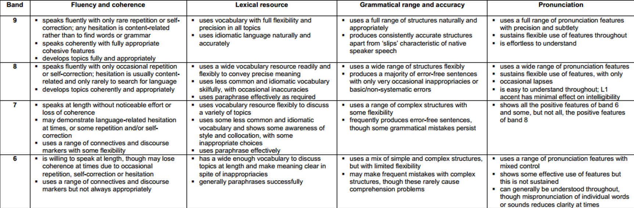

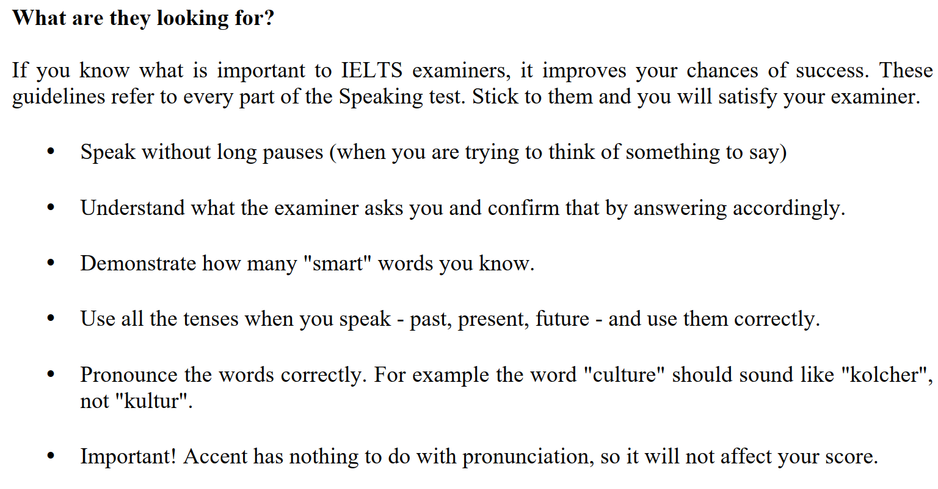

|  |  |
| --- | --- |
| P1  3句话  扩展答案的重点是  5W  和  六边形 | TOPIC ONE 2-3  Are you a student or do you work?  Currently, I am a xxx student from xxx, majoring in xxx, and specializing in xxx  I am working at a company called xxx, which is a kind of xxx, and my position is xxx, I have been working there for xxx  I am in between a and b, job hunting, graduation; but I used to study xxx  Why did you choose your work/major?  Is your major popular in your country?  TOPIC TWO  Do you often read? （WH）  I read on a daily basis,  What kinds of books are there?  Do you prefer to read ebook or paper book?  Is reading important?  TOPIC THREE  Do you like drawing? (troublesome)  No: barely do I + but I am willing  What different types of arts are there?  Have you been to an art gallery before?  Should children learn arts? |
| P2  重点是语言组织框架和扩展 | Personal long turn monologue  Describe something free you received from others (when/what/who/why)    TR: the experience roughly happened xxx ago, while I was receiving a free xxx from xxx at xxx, and it is really impressive  Description: basically, I was invited to attend a special event/campaign/initiative called xxx, and it comes like this xxx  Personal opinion: I love it for some reasons  For starters,  Additionally,  One more to mention  That’s why it is memorable |
| P3  对于固定题型的第一反应和语言组织 | Do you think people should pay for higher education?  Is it good or bad for people to have a free education in the future?  What free gifts do companies usually give to their customers?  Why do customers like to receive free gifts from companies? |
| 考场禁忌taboos | 1. Don’t give short answers 2. Don’t give long answers in part1 3. Don’t memorize answers 4. Don’t panic if you are stopped 5. Don’t give complicated and abstract answers 6. Use those words or phrases carefully (of course; you know; you; that’s all; that’s it;) |

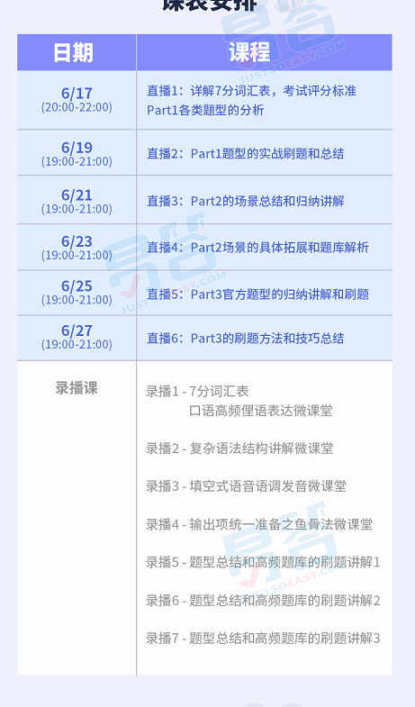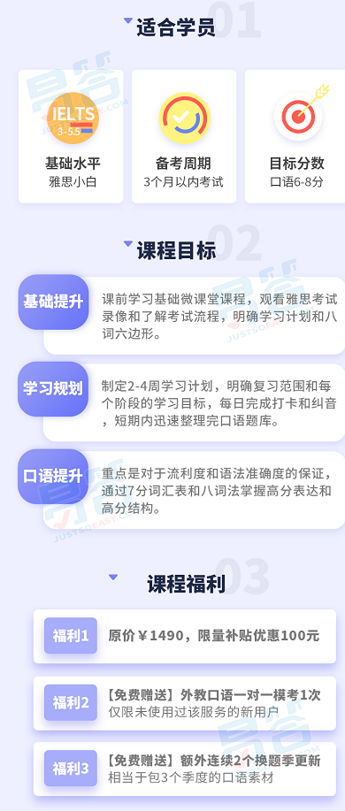

来跟SIMON上课的五点

1. 系统刷题，熟知题库
2. 获取我的全部课程资料
3. 课前语音测试制定学习计划，考前全真官方标准模考，每次半个小时
4. 课后一对一纠音找到个性化提高方向，共同完成需要每次一个小时
5. 随时答疑，更新课件，直到完成考试