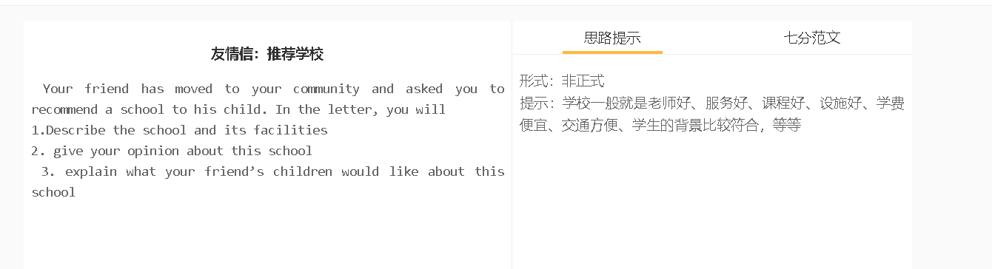

7分范文1
Hi, Alice, I’ve been thrilled about your decision to move to our neighbourhood. We can visit each other more frequently as your home is only two blocks away. I’d recommend Avondale Elementary school, if you ask me what is the best option for Adam. Established in 1950, this school has been serving the community more than seven decades. With the funding received by the city council as well as from alumni, it has gradually been extended with a hot of facilities, including a swimming pool, lab, library and gym, which support a broad range of extracurricular activities. What I like most about the school is its inclusive culture. It has students of different nationalities, half from immigrants’ families. Children can mix with classmates from diverse backgrounds, thereby finding it easy to adapt to this multicultural community. Cultural competence also prepares them for employment in this country. I think Adam would love the English courses provided by school. These lessons are taught by teachers who are expert at both English and Chinese, so Adam can have all questions answered in either language. This can help him to overcome obstacles to speaking English with fluency. If you need any help about enrolment, please tell me. Amy is also studying at school, so I’m familiar with how to sign up for courses. With love, Jessica 嗨,Alice, 我很高兴你决定搬到我们这来。我们可以更频繁地见面，因为你家离我们这里只有两个街区。 如果你问我Adam的最佳选择是什么，我建议你去Avondale小学。这所学校成立于1950年，已经服务社区70多年了。在市议会和校友的资助下，学校逐渐扩大，配备了游泳池、实验室、图书馆和健身房等设施，为广泛的课外活动提供了支持。 我最喜欢这所学校的是它包容的文化。这里有来自不同国家的学生，其中一半来自移民家庭。孩子们可以和来自不同背景的同学混在一起，因此很容易适应这个多元文化的社区。文化能力也为他们在这个国家就业做好准备。 我想Adam会喜欢学校提供的英语课程。这些课程由熟悉英语和汉语两种语言的老师教授，所以Adam所有的问题可以得到两种语言的回答。这可以帮助他克服说流利英语的障碍。 如果你在入学方面需要任何帮助，请告诉我。Amy也在学校学习，所以我很熟悉如何报名。 与爱, Jessica

