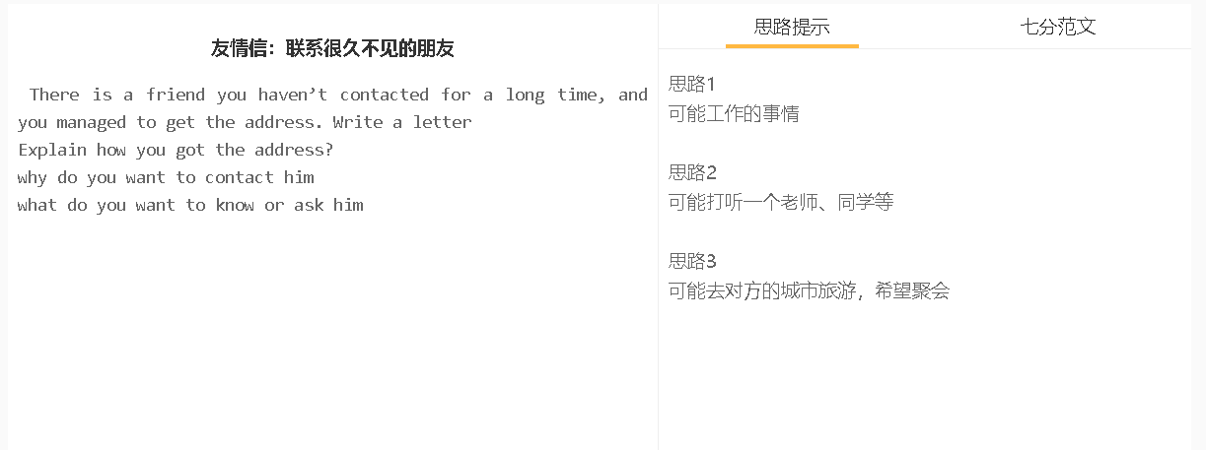
7分范文1
Dear Jack, Long time no see. It’ Helen. It’s been about 5 years since we graduated from university. It took me several days to find your address from David, and it’s great to get in contact with you. I really want you to do me a favour with my yoga. I have been practicing it for more than 3 years. I happened to know that you are a renowned yoga coach in Beijing, winning numerous awards in industry. I’m so proud of your achievement, and wondering whether you can come to Shijiazhuang to make a demo class for our yoga association. I hope this invitation would not cause you excessive inconvenience since you have a strict timetable. You can check your schedule ahead if you are available in next few months. Whenever you are free for a brief trip, you can call me any time. My phone number is 99888234. Apart from reimbursing your trip, I’ll personally show you around in town. There are a number of fine restaurants which specialises in regional food and some cultural attractions worth visiting. Thanks a lot. I’ll be thankful if you can make the trip. Best wishes, Helen

