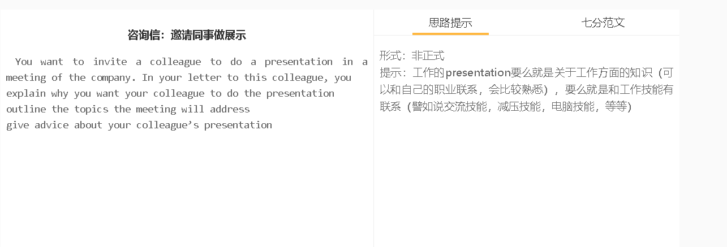

7分范文1
中文思路 你好，Jessica， 听说你最近参加了一个关于售后服务的网络研讨会。我想知道你是否可以来我们办公室做一个演示，分享一下你学到的东西。 我的同事在处理客户的投诉时有时会感到沮丧，希望您的专业知识能缓解他们的焦虑。他们的收入取决于客户的满意度，而未解决的投诉激增损害了他们的士气，影响了他们的收入。 如果可能的话，我想请你谈谈如何处理不满意的客户。你可以教我的同事们沟通技巧。如果你能教他们如何设计一些流程，以防止任何未能满足客户期望的情况发生，那就更好了。 我知道您的日程很紧。为了使这次演讲的效果最大化，我想你可以问问我的员工他们通常会遇到什么问题。这可以让你很好地知道你需要具体解决哪些问题。 非常感谢你的帮助。本周三晚上你有空共进晚餐吗?这样我可以跟你详细谈谈。 Hi, Jessica, I’ve heard that you have recently attended a webinar about after-sales services. I wondered whether you could come to our office to do a presentation to share what you have learned. My colleagues are frustrated sometimes when handling customers’ complaints, so I hope that your expertise can ease their anxiety. Their income hinges on customer satisfaction, and the surge in unsolved complaints has damaged their morale and affected their earnings. If possible, I’d like you to talk about a number of issues related to handling unhappy clients. You can impart communication skills to my coworkers. It would also be nice if you can teach them how to design some procedures to prevent any failure of meeting expectations of customers. I understand that you have a tight schedule. To maximise the outcome of this presentation, I think you can ask my staff about what problems they usually encounter. This can give you a good idea what issues you need to address specifically. Thanks a lot for your help. Are you available this Wednesday evening for a dinner, so I can talk to you in greater detail? With regards, Rebecca

