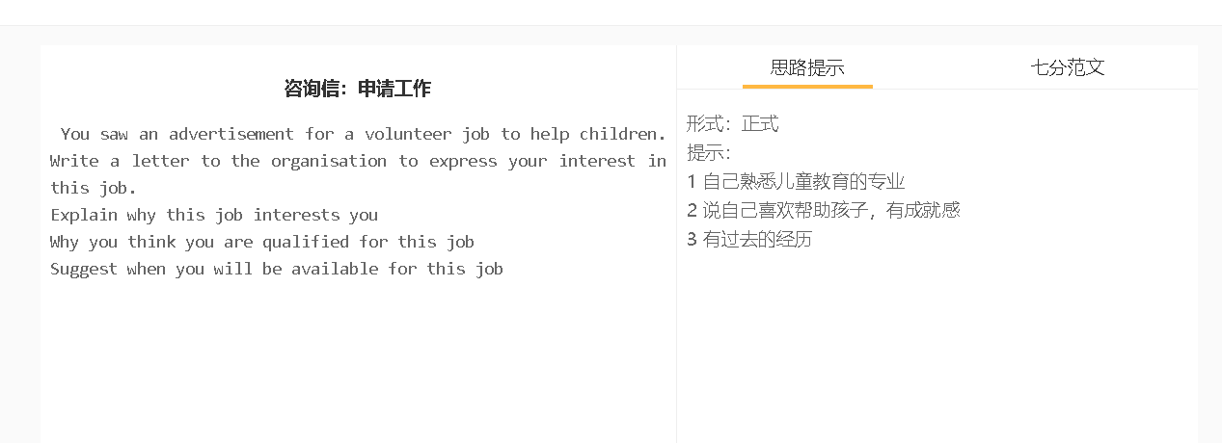

分范文1
中文大意 致有关人士: 我对志愿顾问的职位很感兴趣，我认为我可以做这个岗位。 这份工作吸引我，不仅因为我热爱服务社区，还因为我有技巧和技能与年轻的父母分享如何管理他们的时间，处理他们的孩子的行为问题和与他们的孩子的联系。 我认为我能胜任这份工作，因为我以前在平衡工作和家庭生活方面遇到了困难。六年前，我是一家酒店的经理，由于工作原因，没有时间陪我的第一个孩子。我接到老师的电话，说我的孩子行为不佳，然后我参加了一些关于为人父母和压力管理的课程。现在我能够更轻松地处理我的工作和家庭责任，并愿意与父母分享这些。 如果我有这份工作，我可以在周末开研讨会，做一些演讲，与这些家庭分享我的经验和知识，如何处理前面提到的问题。我非常希望能得到这份工作的考虑，我已经准备好参加任何您认为必要的面试。 此致 敬礼 珍妮 To whom it may concern, I was interested in the position for a volunteer consultant and think I could be the person who fills the vacancy. This job appeals to me not only because I have a passion for serving the community but also because I have techniques and skills to share with young parents about how to manage their time well, deal with behavioural problems of their children and bond with their children. I think I am capable of doing this job because I had difficulty in striking the balance between work and family life. Six years ago, I was a hotel manager and had no time to accompany my first child because of my work commitments. I received phone calls from teachers about poor behaviour of my child, and I then attended some courses about parenting and stress management. Now I am able to handle my work and my family commitments more easily, and willing to share these with parents. If I have this job, I can give seminars at weekends and give some presentations to share my experience and knowledge with these families about how to deal with the problems mentioned earlier. I do hope that I may be considered for this job and I am ready to attend any interview which you think is necessary. Faithfully yours, Jenny

