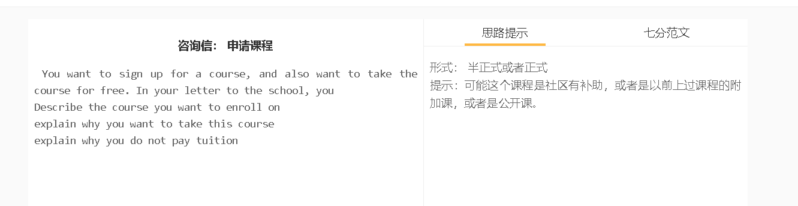

7分范文1
中文思路 亲爱的史密斯先生, 道我是否能参加你们学校即将举办的语法课。我收到了贵校关于这门新课程的短信。 从你们学校在网上发布的信息中，我知道这是针对中级水平的学生。它提供了关于如何写出没有错误的句子的系统训练。它还有各种各样的练习，帮助学习者巩固知识。 我非常有兴趣参加这个课程，因为我的教授一直在指出我的语法错误。他警告说，这些问题可能会损害我的写作，并给我的学术生涯带来一些障碍。我想我需要更多的语法方面的专业知识。 去年夏天，我参加了戴维斯女士的词汇课，她告诉我可以免费报名一个语法课。课程协调人约翰逊女士证实了这一点。我想我有资格获得豁免。 如果您能告诉我如何注册这门课，我将非常感激。我对上一门课的学习效果非常满意。这就是为什么我把它介绍给我的一些朋友。 Dear Mr. Smith, I wonder whether I can attend the grammar workshop your school is about to run. I have received a text message from your school about this new course. From the information your school has released online, I know it is intended for intermediate level students. It offers systematic training about how to write error-free sentences. It also has a great variety of exercises that help learners consolidate knowledge. I am really interested in attending the workshop since my professor has pointed out my grammar mistakes continuously. He warns that these problems can impair my writing and present some obstacles to my academic career. I think I need to gain more expertise in syntax. Last summer, I attended the vocabulary course of Ms. Davis, who told me that I could sign up for a grammar course for free. This was confirmed by the course coordinator, Ms. Johnson. I suppose I am entitled for the exemption. I would be grateful if you could inform me what to do to register this class. I was really happy with the learning outcome of the last course. That’s why I introduced it to a number of my friends. Kind regards, Ann

