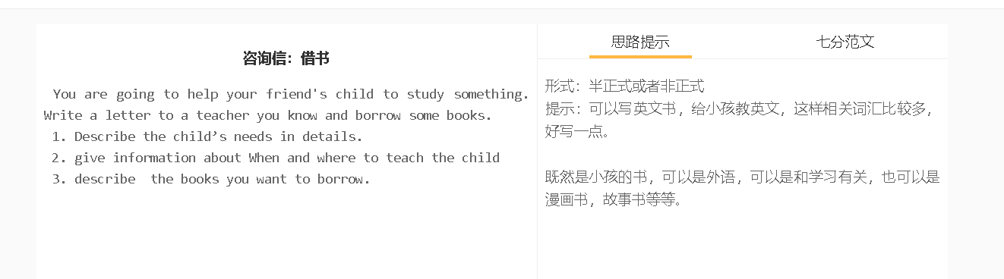

7分范文1
中文大意： 我写这封信是想借一些小学英语课本。您已经教了这么多年英语，我相信您有一些资源适合那些不是以英语为第一语言的学龄前儿童。 我的一个朋友最近和他的妻子和一个6岁的儿子搬到了加拿大，他们问我是否愿意教他们的儿子英语。因为他在中国读完了一年级，所以他知道一些基本的单词和基本的句子。然而，他的英语交流能力还有待提高。 我的朋友每隔两天晚上就会送他的孩子来我家学习一小时。他们问我什么时候可以上第一堂课，我开始焦虑起来，因为我在努力找书备课。 我想知道你是否可以借我一些你在课堂上可能不再使用的教学材料。我知道你已经从一年级转到二年级了，所以可能有一些合适的教材，我可以用来教我朋友的儿子。 我知道您的日程很紧，所以如果方便的话，我想去您那里取书。我一看完就还给你。 Dear Mary, I’m writing this letter to borrow some primary English textbooks. You have been teaching English for so many years that I believe you have some resources suitable for preschool children who do not speak English as the first language. One of my friends recently moved to Canada with his wife and a 6-year-old boy, and they asked me if I would help teach their boy English. Since he had finished the first grade in China, he knows some basic words and some basic sentences. His ability to communicate in English, however, needs improvement. My friend would send his kid to my house every two days in the evening to study for one hour. They ask me when I am available for the first tutorial, and I am getting anxious, as I struggle to find books to prepare for the lesion. I’m wondering if you can borrow me some teaching materials that you may not use anymore for your classes. I know you have been switched from the first grade to the second one, so there may have some appropriate textbooks I would use to teach my friend’s son. I understand you have a tight schedule, so if convenient, I’d like to visit you to pick up books. I will return them as soon as I finish reading them. Kind regards, Wenbo

