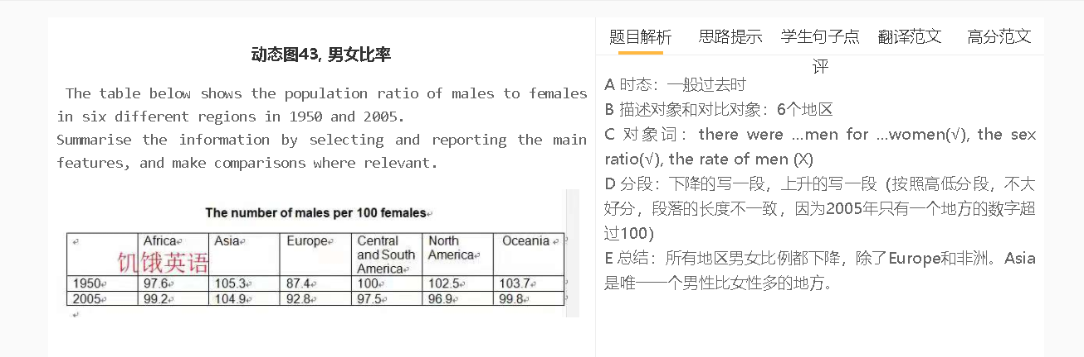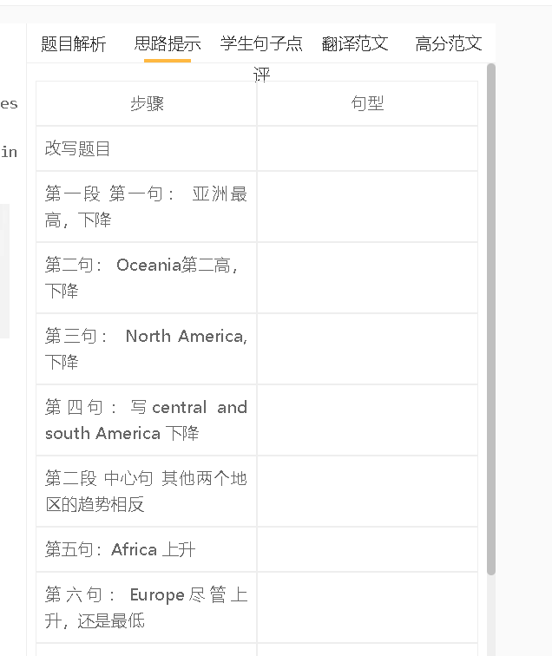

学生句子

学生的句子：Except for Asia countries, the population of female was higher than the population of male.
错误的原因：使用except for的时候，要有匹配的东西进行对比。
提升的句子：Except for Asia countries, all these regions had a sex ratio below 100.

学生的句子：Asia remained the highest proportion of the population ratio of males to females
错误的原因：remained是系动词，Asia是个国家， proportion是个数字，不能充当Asia的补足语；更何况proportion 在这里也是错误的
提升的句子：Asia had the highest ratio.

学生的句子：In Africa, the number of males was smaller than females between 1950 and 2005, but the gap narrowed.
错误的原因：the number of males和females不能比较
提升的句子：In Africa, the number of males was smaller than that of females in 1950 and 2005, but the gap narrowed.

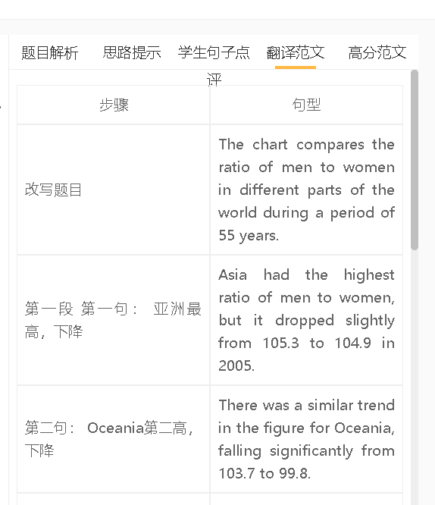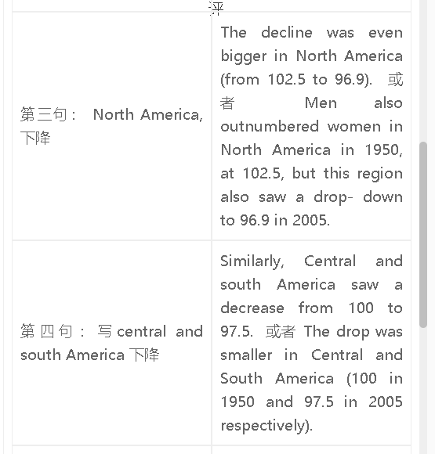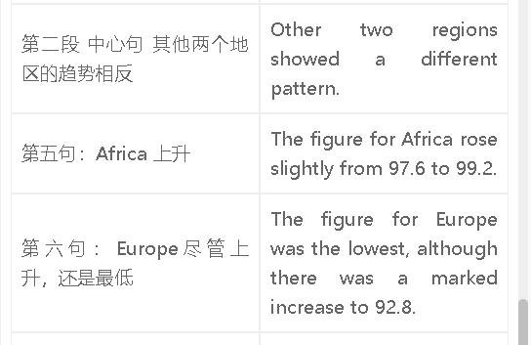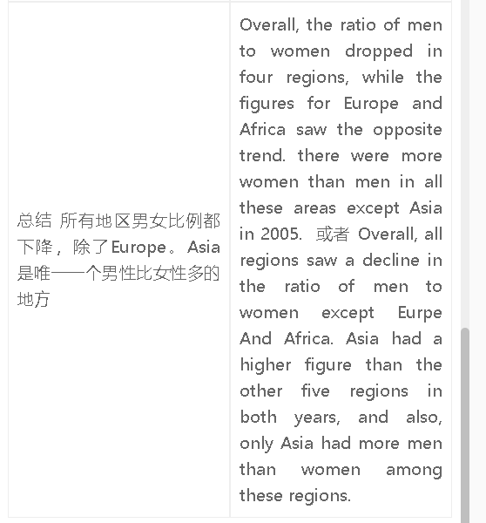

高分范文1
The table compares six regions of the world in the ratio of men to women in the years 1950 and 2000. In 1950, the highest ratio of men to women was in Asia, where there were 105.3 men for every 100 women, and the situation was similar in 2005, despite a drop to 104.9. North America and Oceania saw the same trend, with the figure dropping to 96.9 and 99.8 respectively. Similarly, in Central and South America, the number of men for 100 women declined to 97.5, although the numbers of men and women were the same in 1950. Africa and Europe were two areas where the female population was bigger in both years. The figure for Africa increased slightly to 99.2 in 2005, and Europe, which had the lowest ratio of men to women in 1950, saw a significant rise to 92.8. Overall, the ratio of men to women dropped in four regions, while the figures for Europe and Africa saw the opposite trend. Asia had a higher figure than the other five regions in both years, and also, only Asia had more men than women among these regions in 2005.

