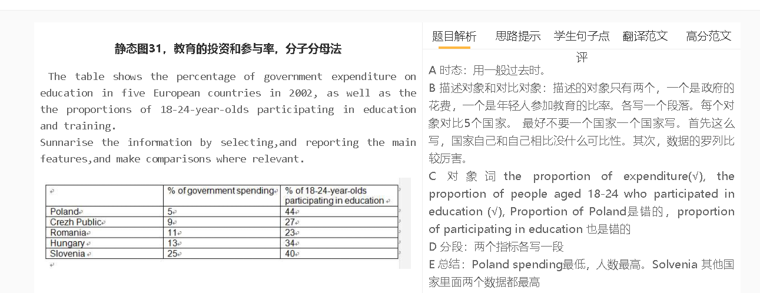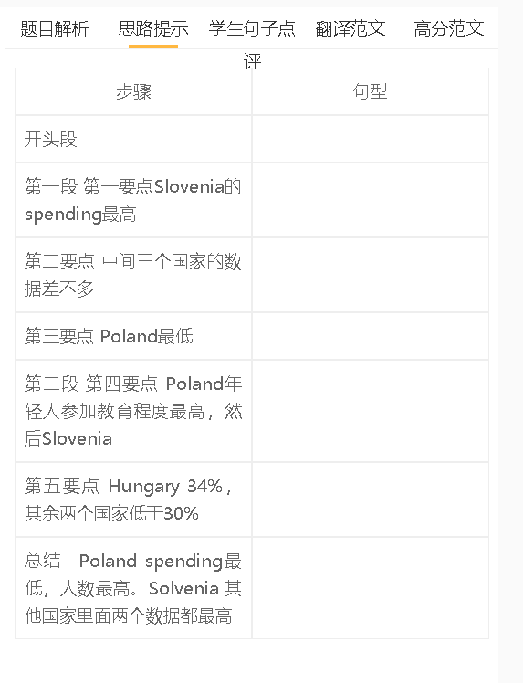

学生句子

学生的句子：The highest proportion of government educational spending was saw in Slovenia, at 25%, followed by the the figure in Hungary, at 13%.
错误的原因：see过去分词是seen；figure的介词是for
提升的句子：The highest proportion of government educational spending was in Slovenia, at 25%, followed by the the figure for Hungary, at 13%.

学生的句子：Slovenia also had a relatively high level of participation rate which is 40% while it was 34% in Hungary.
错误的原因：level of participationg rate里的level和rate都是重复的；而定语从句说which is多余
提升的句子：Slovenia also had a relatively high participation rate （40%）, slightly higher than 34% in Hungary.

学生的句子：Overall, Poland had the highest proportion of 18-24-year-olds participating in education in 5 countries while it only spend 5% on education
错误的原因：结尾不要出现数据
提升的句子：Overall, Poland had the lowest level of government budget on education but the highest proportion of 18-24-year-olds participating in education.

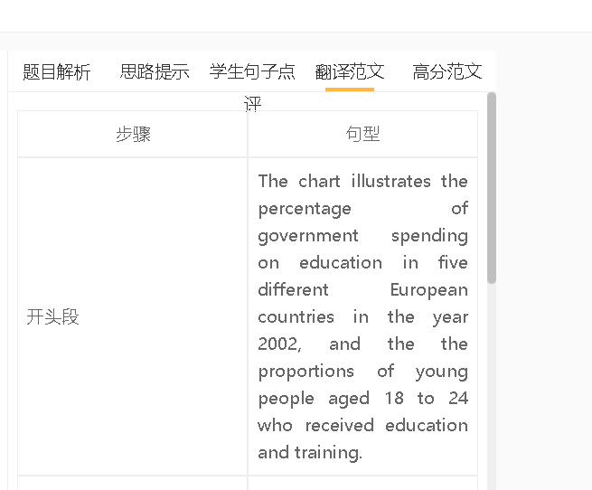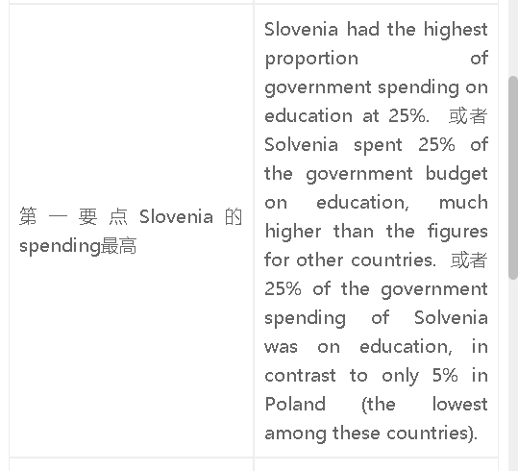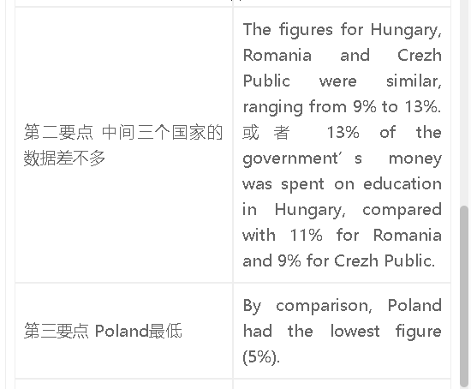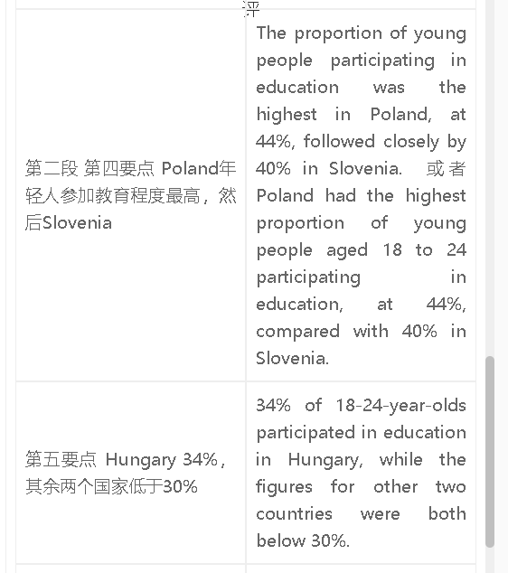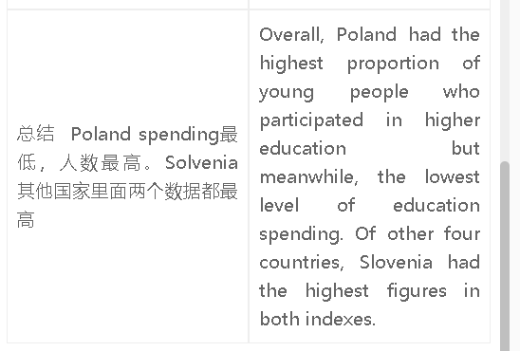

范文

高分范文1
The table compares five countries in terms of the government budget on education in in the year 2002 and the proportion of 18-24-year-olds who continued their studies. Slovenia had the highest proportion of education expenditure (25%), around twice the level of spending in Hungary. The figures for Romania and Cezh Public were lower (9% and 11% respectively), while only 5% of the government expenditure went to education in Poland. Poland, however, had the highest participation rate, with 44% of young people aged between 18 and 24 receiving education. The figure was Slovenia was slightly lower at 40%, followed by 34% in Hungary. The figures for Crezh Public and Romania were both below 30%, meaning that only a quarter of young people in these two countries chose to go to college after they completed school. Overall, Overall, Poland had the highest proportion of young people who participated in higher education but meanwhile, the lowest level of education spending. Of other four countries, Slovenia had the highest figures in both indexes.

