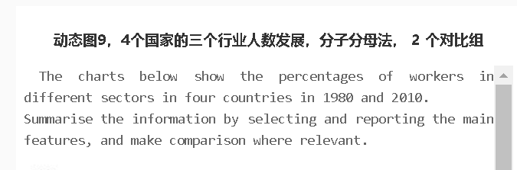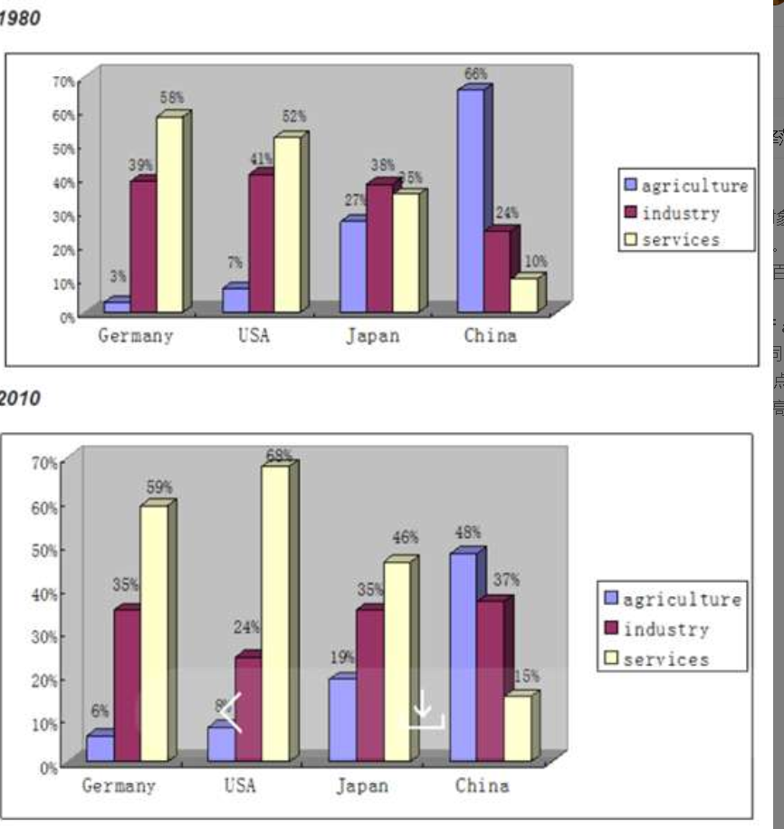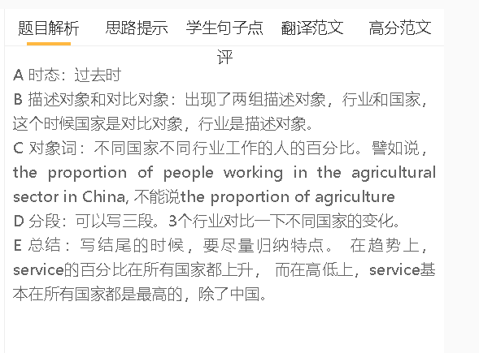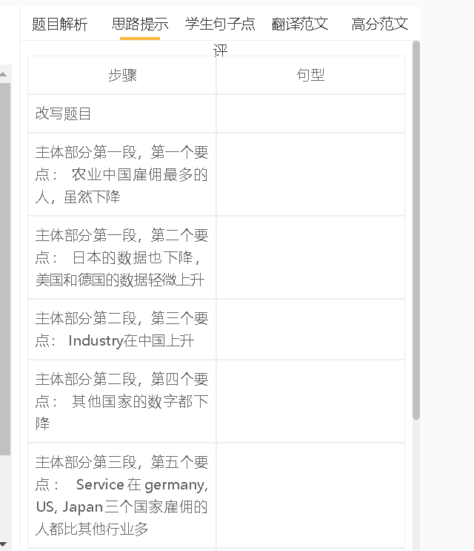

学生句子点评
学生的句子：The figure for people who engaged in industry different from country to country.
错误的原因：没有动词，应该改differed
提升的句子：The proportion of people working for these industries differed from country to country.

学生的句子：From the first chart we could see that in 1980, in Germany and USA, the most popular sector was services, which were 58% and 52% workers employed, respectively.
错误的原因：学生不清楚主系表的结构， service是个行业，不是workers
提升的句子：In Germany and the US, the largest employer wsa the service sector, which recruited 58% and 52% of the respective working population.

学生的句子：A growth in the proportion of people who work in the industry sector can be found in Germany.
错误的原因：work和can be found时态错误
提升的句子：The proportion of people who worked in industry grew in Germany.

学生的句子：Overall, there are changes of three parts in China, USA and Japan, but Germany did not see a significant change.
错误的原因：1 过去时 2 parts不能替换sectors, industries
提升的句子：Overall, there were changes in the proportions of workers in different sectors in these countries, but Germany did not see any significant change.

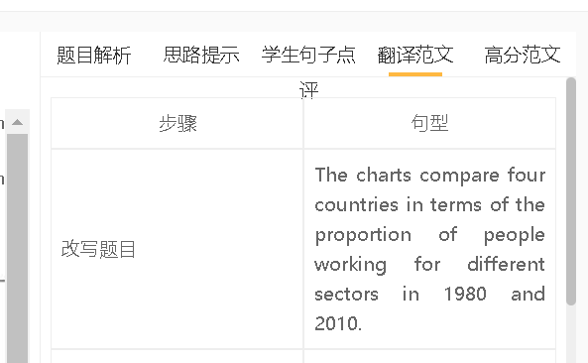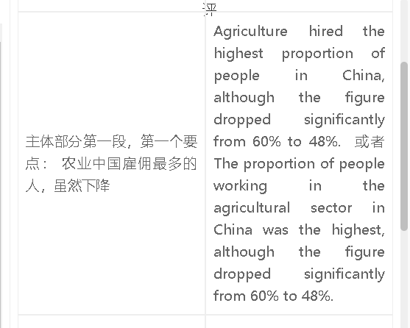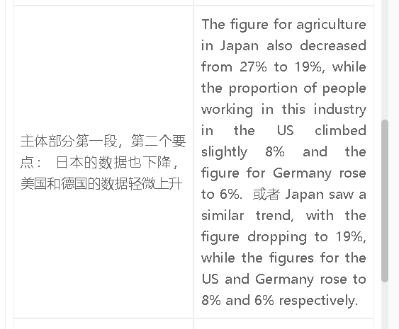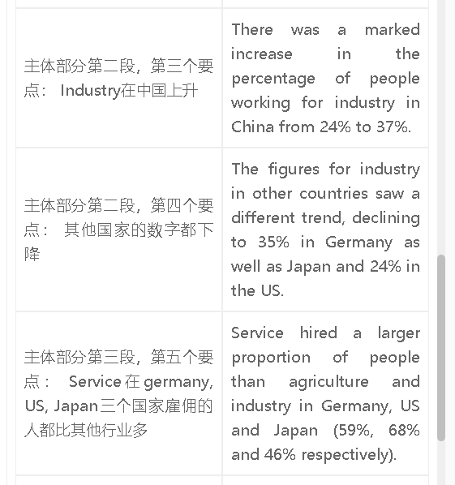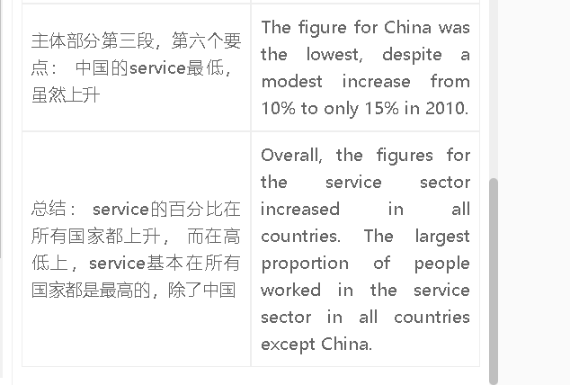

范文

高分范文1
The charts show the differences between 4 countries in the proportion of people working in 3 sectors in 1980 and 2010. Agriculture hired the smallest proportion of the workforce in all countries except China. In 1980, the agricultural sector created 66% of jobs in China, despite a decline 48% in 2010. In contrast, less than one fifth of Japan’s workers worked in this industry and less than 10% in the US and Germany in 2010. China also differed from other countries in the workforce of the industry. The proportion of people working in industry increased considerably to 37% in 2010 in China, while the figures for other three countries all dropped. The biggest decline was seen in the US to 24%, and the fall was less dramatic in Germany and Japan. There was an upward trend in the proportion of service workers in all countries, and a significant majority of Americans worked in the service sector (68%) in 2010. The figures for Germany and Japan increased to 59% and 46% respectively, but the figure for China was still the lowest at 15%. To sum up, the proportion of workers in the service sector increased in all these countries. The service industry was the biggest employer in Germany, Japan and the US in both years, whereas China relied on agriculture in job creation.

