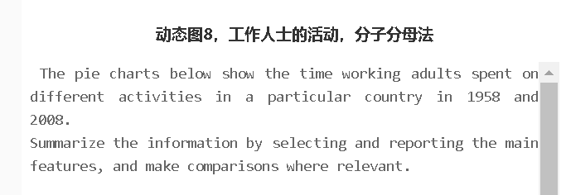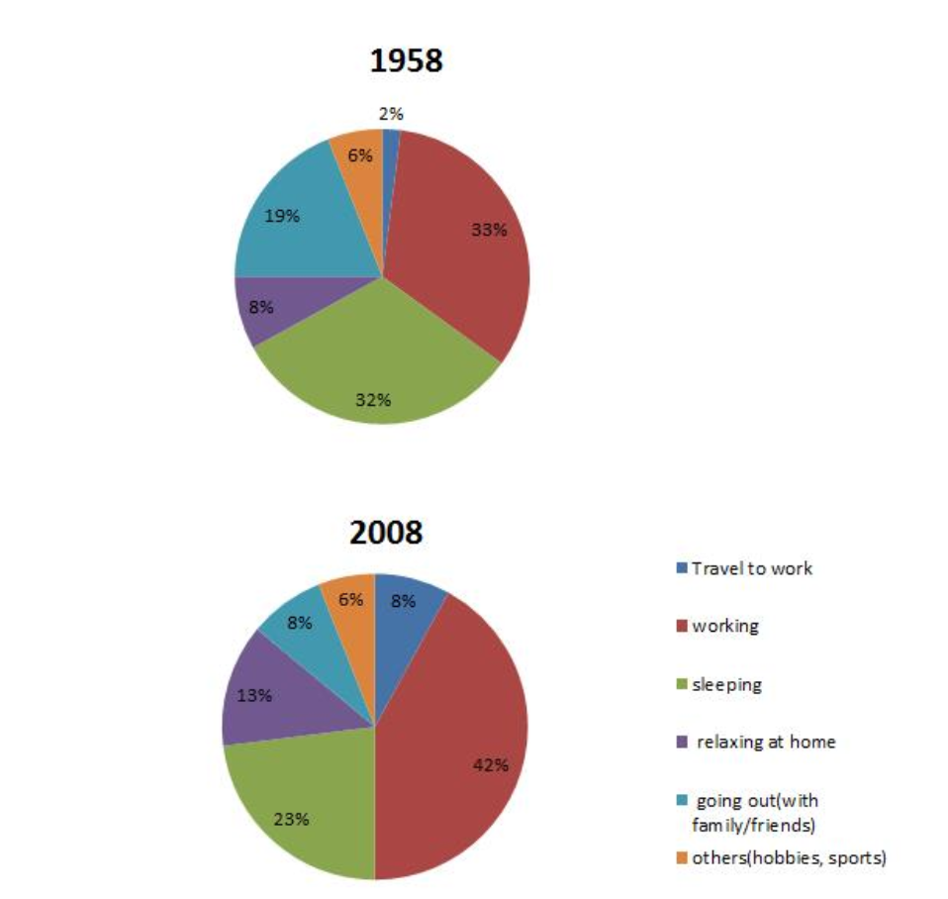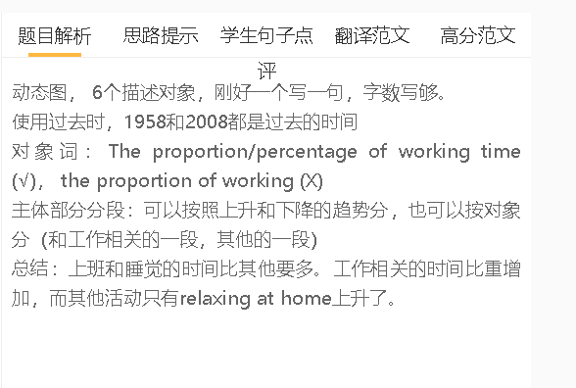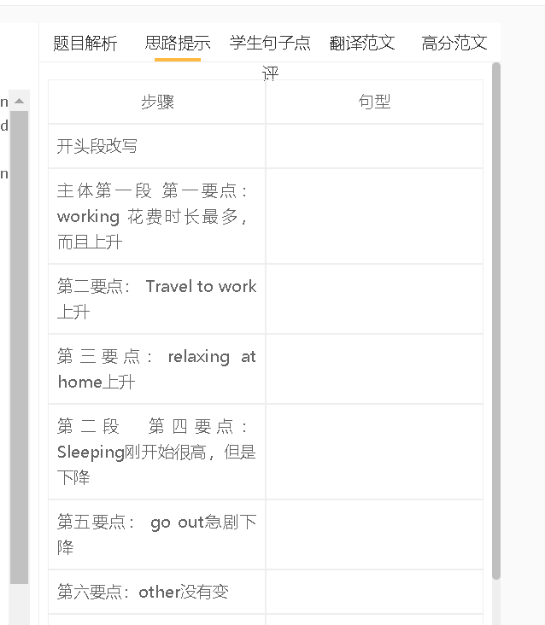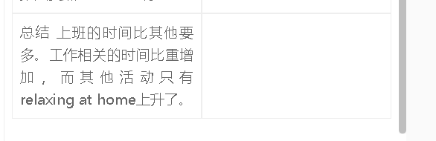

学生点评

学生的句子：The pie chart below reveal the time of several activities working adults participate in a particular country in 1958 and 2008.
错误的原因：1 主谓不一致 2 participate没有用过去时 3 time of activities 也不是很恰当

学生的句子：Working were the main activity of the adults throughout the period.
错误的原因：主谓不一致
提升的句子：working accounted for the largest proportion of time in both years.

学生的句子：The proportion of sleeping time is 32% which was just 1% lower than the figure for working
错误的原因：1 时态错误 2 定语从句读数据多余
提升的句子：The proportion of sleeping time was 32%, just 1% lower than the figure for working in 1958.

学生的句子：The time workers spent on going out shows the downward trend, which had declined 11% during this period.
错误的原因：1 时态错误shows 2 定语从句修饰语不清楚
提升的句子：The time workers spent on going out saw a decline of 11% to 8%.

学生的句子：It is surprised that other activities such as hobbies and sports did not change from 1958 to 2008.
错误的原因：1 没有it is surprised that这个说法 2 只有文字信息没有数据
提升的句子：Interestingly, the time for other activities such as hobbies and sports remained unchanged at 6%.

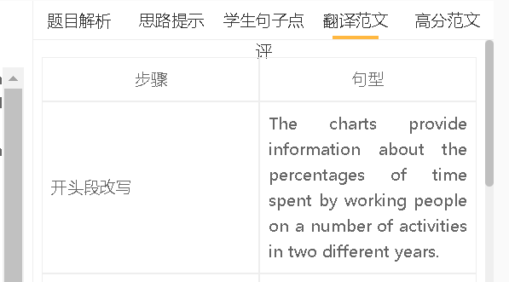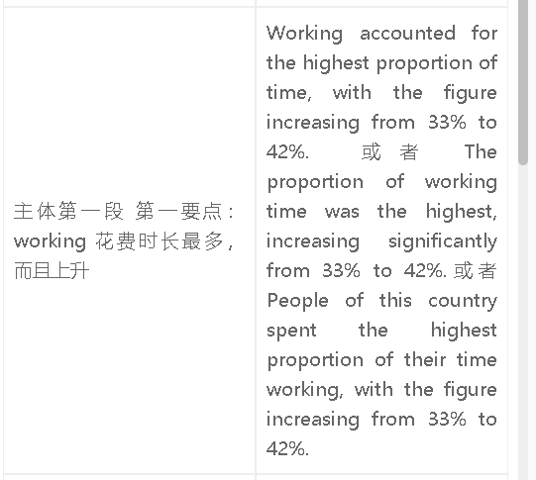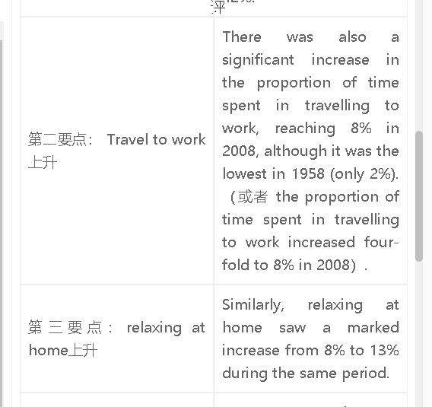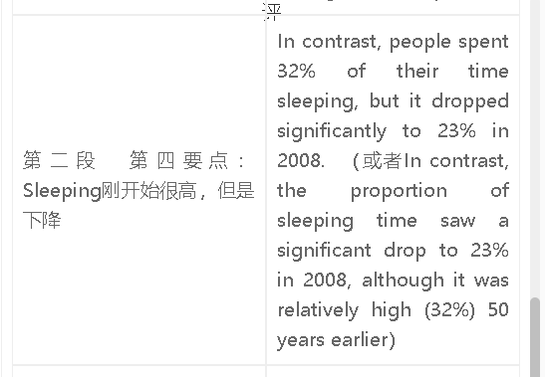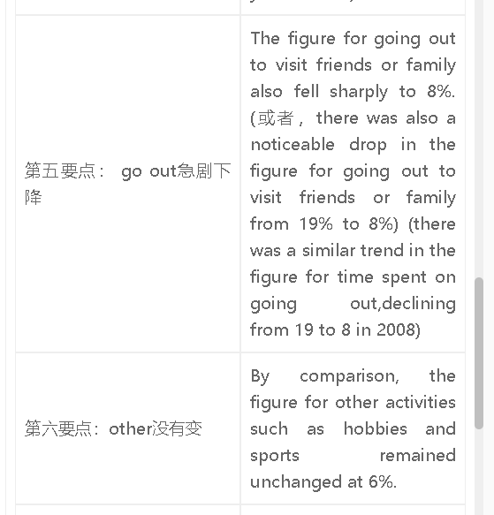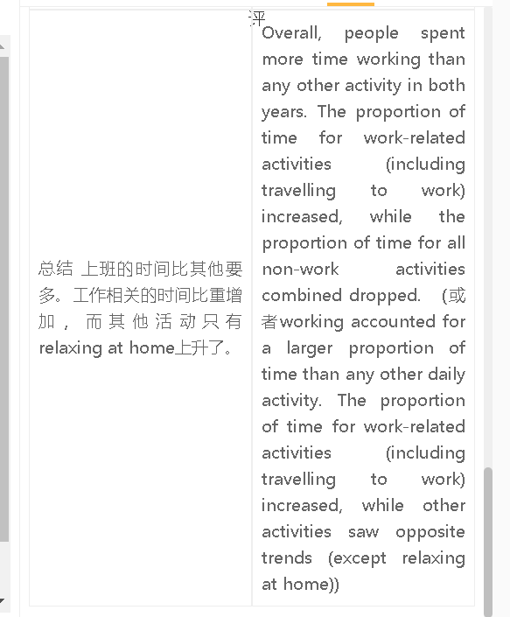

范文

高分范文1
The charts show how people spent their time every day in two different years. It is clear that people were busier with work and commuting also took more time in 2008. People spent the largest proportion of their time working in both years, and it is clear that the figure rose significantly from 33% to 42%. Interestingly, there was also a four-fold increase in the time they spent commuting to work, reaching 8% in 2008. In contrast, a smaller proportion of time was used for sleeping, dropping from 32% to 23% during these 50 years, meaning that people slept less. The increase in work-related time had a direct impact on the time available for other activities. While the time spent on family or social life dropped significantly to 8%, the figure for ‘other activities’ remained constant at 8%. Relaxing at home was the only non-work activity that saw a rise from 8% to 13%. Overall, people spent more time working than any other activity in both years. The proportion of time for work-related activities (including travelling to work) increased, while the figures for other activities all declined (with the exception of relaxing at home).

