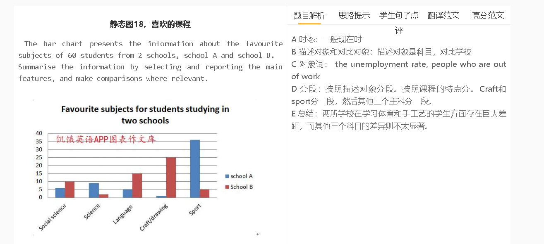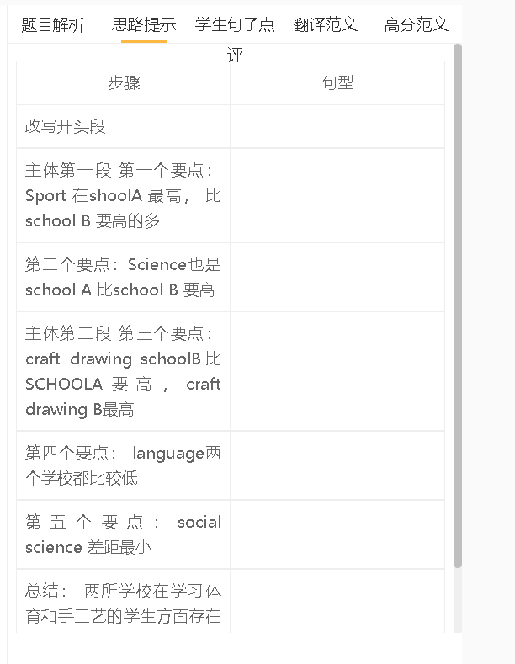

学生点评

学生的句子：10 students choose social science,which has about doubled than school A.
错误的原因：double 作为动词使用的时候，一般用在动态图
提升的句子：10 students choose social science, twice the number of students who like this subject in school A.

学生的句子：In summary, sport made up the highest proportion of favourite subject in school A, but a majority of students in school B choose craft and drawing.
错误的原因：对象词错了
提升的句子：students who choose sports make up the largest proportion of students in school A.

学生的句子：All in all, different school`s students are interested in varies subjects . students are crazy about sport in school A , however the subjects of the craft and drawing become the most popular in school B .
错误的原因：没有varies subjects这个说法；crazy表达不对；however不是连词
提升的句子：All in all, students in different schools are interested in different subjects. Students are in favour of sport in school A, but craft and drawing is the most preferable in school B.

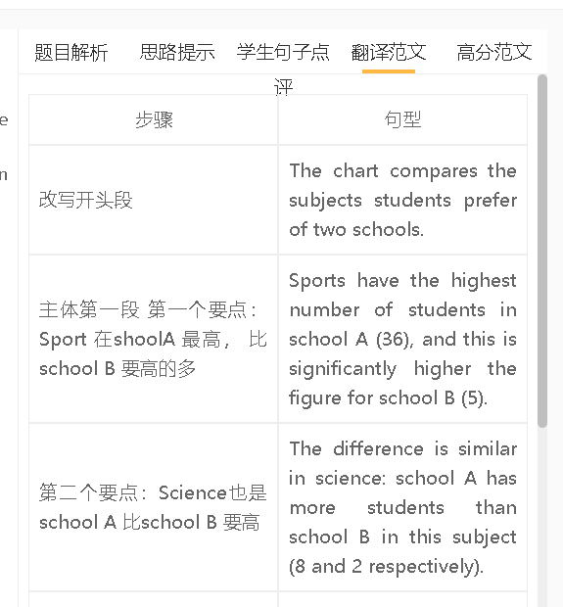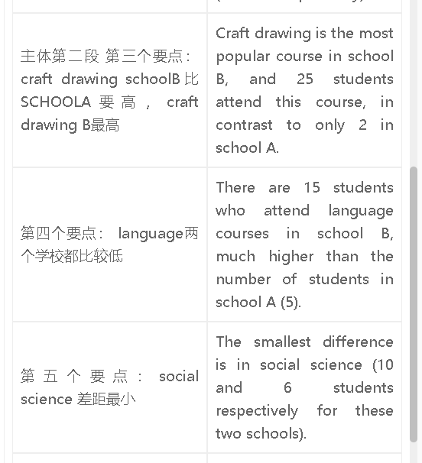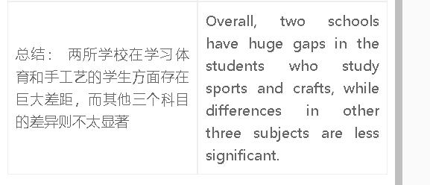

高分范文1
The chart compares two schools in terms of students’favourite subjects. The biggest gap between two schools is in sport, in which 35 out of 60 students in school A regard this as their favourite subject, in contrast to only five students in school B. Craft/drawing is the most popular subject (25) in school B, while only a small number of students favour this subject in school A. There are also striking differences between these schools in the preferences for science and languages. 15 students in school B are keen to take language courses, three times higher than the figure for school A. Furthermore, 9 students in school A choose science, compared with only 2 students in school B. The gap is narrow in social science. Overall, students in these two schools are fond of different subjects. While students in school A predominantly love sports, the most popular option for those in school B is craft and drawing.

