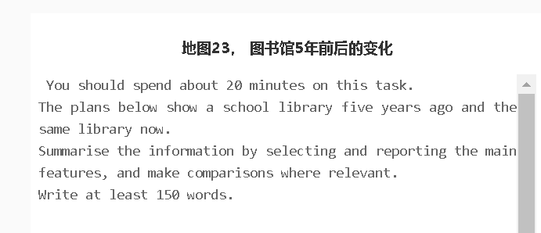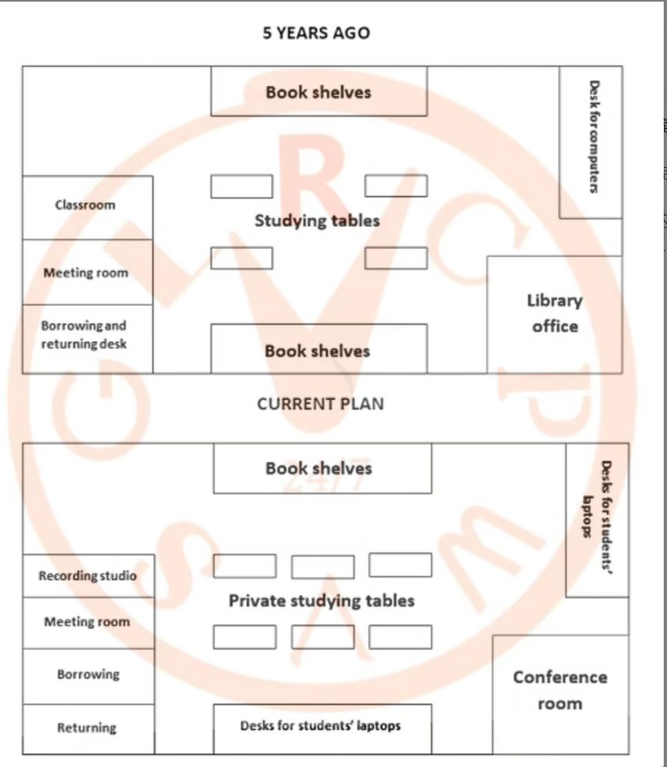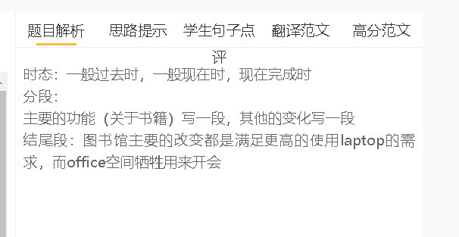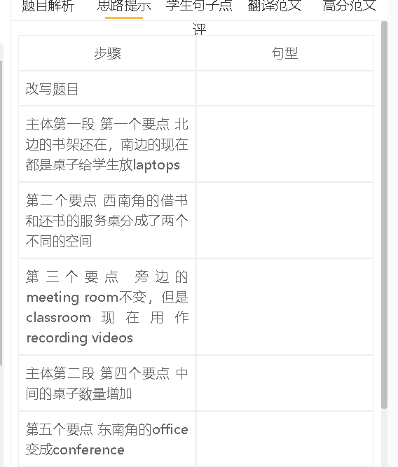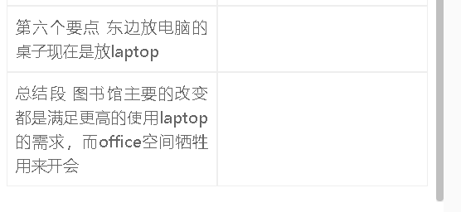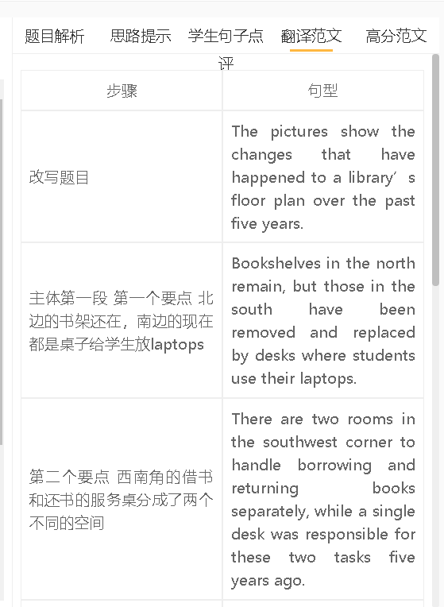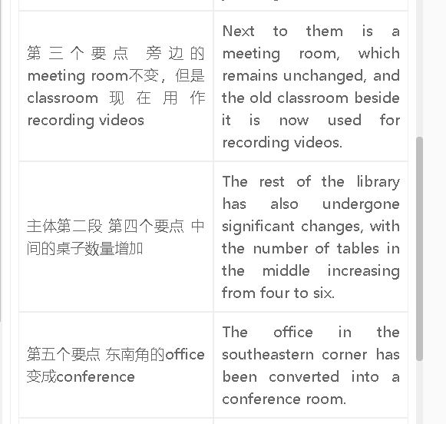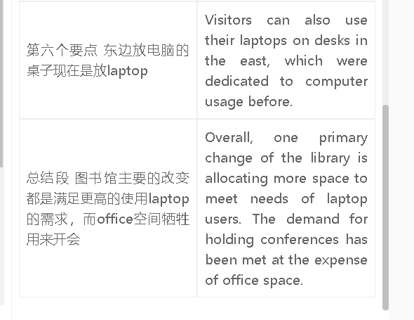

高分范文1
The floor plans illustrate the changes that have been made to a school library over the past five years. Some developments possibly reflect the changes to the functions of the library for students. Bookshelves in the south have been replaced by desks for the use of laptops, while those on the opposite side remain. Currently, desks are also provided/available in the north-eastern corner for laptop users, where this section was dedicated to computer use. It is also noticeable that the classroom in the west has been converted into a recording studio. Other changes have been intended for better user experience. The number of tables for private studies has increased from four to six in the middle of the library. There was an office to the east, which has now been changed into a conference room. The service desk in the southwestern corner has been divided into two separate sessions, which handle borrowing and returning needs respectively. There has been no change to the meeting room next to it. Overall, the library floor plan has been altered to meet renewed needs, such as more space for using laptops and private learning and specific rooms for holding conferences and making recordings. These changes have been accompanied by a drop in bookshelves and the removing of office space.

