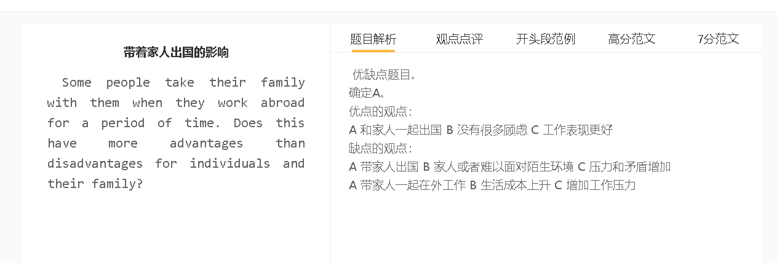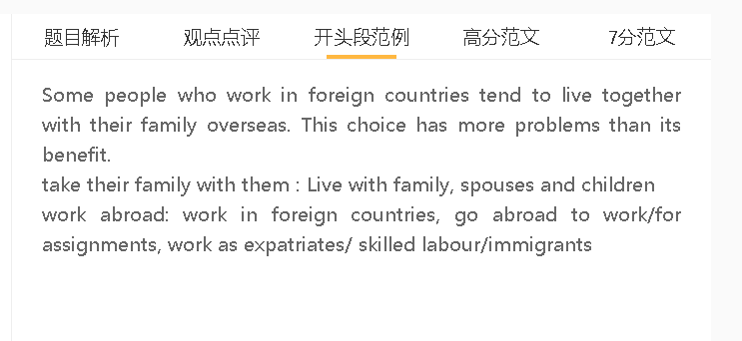

范文

Some people who work in foreign countries tend to live together with their family overseas. This choice has more problems than its benefit.

A 带着家人 B 需要照顾家庭 C无法专心工作
解释（A-B）：语言差异、文化冲突的问题，家人很难适应
解释（B-C）：需要很花时间和精力
具体化： 送孩子去学校， 买菜，就医
拓展结果：工作表现不好，有可能影响收入，影响家庭
家庭可能会分散注意力，因为他们需要持续的照顾和关注。他们很难适应东道国，因为他们需要克服语言障碍和文化冲击。照顾他们涉及许多任务，包括送孩子上学、购买食品杂货，以及生病时带家人去医院，这些都会消耗时间和精力。这会影响工人在工作场所的表现，从而影响他们的收入以及整个家庭的生活质量。
Family can be a distraction because they are in need of constant care and attention. They have difficulty in adapting to the host country as they need to overcome Language barriers and cultural shocks. Looking after them involves numerous tasks, including sending children to school, buying groceries, and taking any family member to hospital when sick, which consume time and drain energy. This can undermine workers’ performance in the workplace, which can affect their income as well as the quality of life of the whole family.
A 带着家人 B 生活成本上升 C 很难承担
解释（A-B）： 收入没有变，但是需要养活更多人（因为家人不会说很快就在国外找到工作什么的）
解释（B-C）： 只是做普通的工作，公司没有给什么补贴
具体化：各种生活成本上升 ， 房租，交通，食物，等。
拓展结果：生活质量下降、家庭矛盾增加
在另一个国家与家人一起生活对许多人来说也是负担不起的，因为生活成本很高。考虑到他们的配偶不容易找到工作，他们有更多的口要养活，有固定的收入。这些人很难支付生活费用，如房租、交通费和食物费，尤其是当他们得不到丰厚的工资和家庭津贴时。这些经济困难可能影响生活水平，并导致家庭成员之间的紧张关系。
Living together with family in another country is also unaffordable for many since the cost of living is high. They have more mouths to feed, with fixed income, considering that their spouses cannot find employment easily. These people struggle to cover living expenses, such as rent, transport and food, especially when they are not paid handsomely and entitled for family allowance. These financial difficulties can affect the standard of living and cause tensions among family members.

A 带着家人 B 保持家庭的联系 C 避免孤独感
解释（B-C）： 交流解决问题，生活不好的情绪可以得到安慰 soothing words, emotional support, encouragement
具体化： 住吃饭娱乐都在一起，可以进行交流
拓展结果：心理健康有帮助
另一方面，他们不会有孤独感，因为他们可以与家人亲密相处。当他们在生活中遇到一些问题时，如在办公室面临的歧视和难以遵守当地规范时，他们可以从亲人那里获得情感/道德支持。家人之间交流安慰的话语可以缓解压力，增强信心，从而改善情绪。
On the other hand, they will not have a sense of loneliness as they can stay with family closely. They can receive emotional/moral support from loved ones when faced with some problems in their lives, such as discrimination they face in the office and the difficulty of following local norms. The exchange of soothing words among family can relieve stress and boost confidence, which can improve emotional well-being.

In conclusion, going abroad with family can interfere with work and add a financial burden, although the company of family members can provide relief for stresses of working lives.

