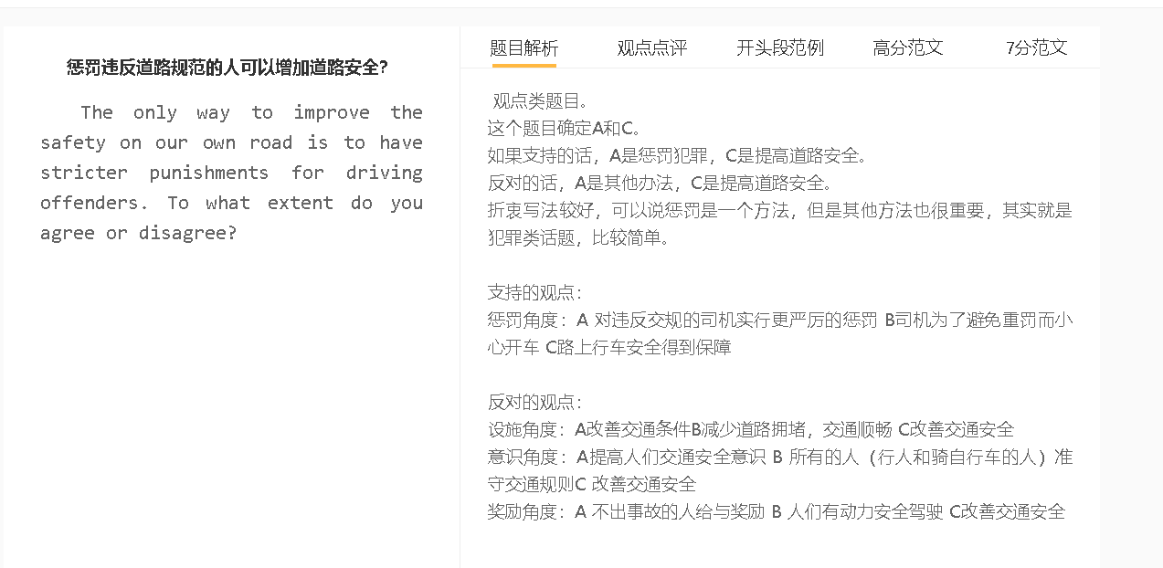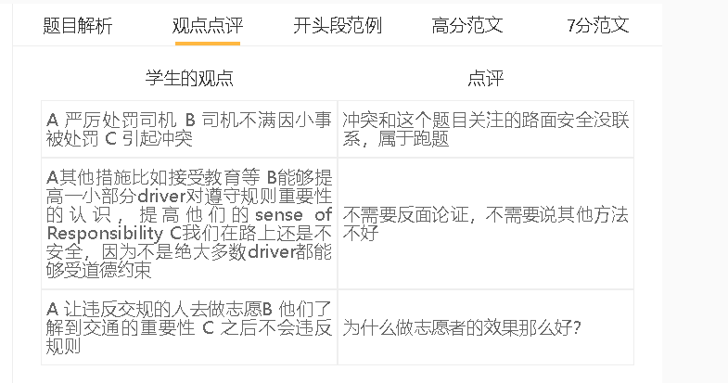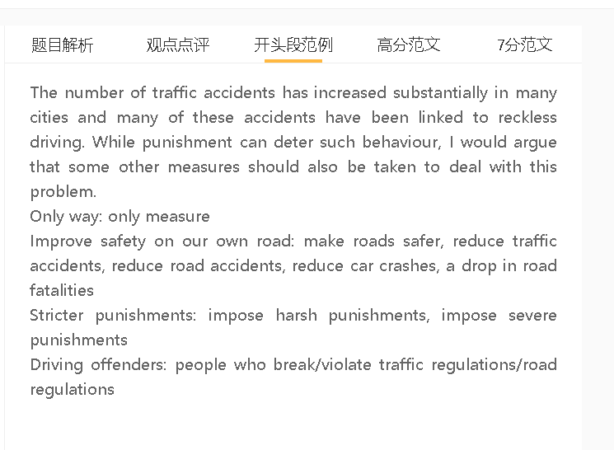

范文

The number of traffic accidents has increased substantially in many cities and many of these accidents have been linked to reckless driving. While punishment can deter such behaviour, I would argue that some other measures should also be taken to deal with this problem.

A提高人们交通安全意识 （而不只是加大惩罚） B所有的人（行人和骑自行车的人）遵守交通规则 C 提升安全
背景：司机应该明白，不负责任的驾驶行为可能导致伤害和死亡，对他们和受害者的生活都可能产生灾难性的影响。
举例：有些人可能在轮椅上度过他们的余生，失去了过充实生活的能力，也失去了养家糊口的能力。
解释：充分意识到这些后果的道路使用者会更愿意遵守交通规则
举例：避免超速、边开车边打电话等违法驾驶行为
对比：严厉的惩罚并不是在所有情况下都有效，因为人们可能认为他们可以逃避惩罚，或者他们可以接受一些惩罚，比如高额罚款。
injuries and deaths, road fatalities/death tolls,
obey traffic regulaitons, exceed speed limit, avoid talking on the phone while driving,
get away from , escape punishment, take the risk,

Raising the public’s awareness of safe driving is an important way to reduce traffic accidents. Drivers should understand that irresponsible driving behaviour can lead to injuries and deaths that could have a catastrophic effect on their lives and victims’. Some people may spend the rest of their lives on wheelchairs and lose the ability to live a fulfilling life and ean money to feed their family. Road users who are fully aware of these consequences will be more willing to obey traffic regulations and avoid illegal driving behaviours such as exceeding the speed limit and talking on the phone while driving. Harsh punishments are not effective in all cases as people may think that they can get away with what they do or they can take some punishments, such as heavy fines.
A 改善交通条件和增加道路设施（而不只是增加惩罚） B 减少道路拥堵，交通顺畅 C 改善交通安全
背景：一些设施的缺乏和不利的道路条件使司机很难安全驾驶和有效地应对不同的情况。
解释：可以拓宽道路或修建新的高速公路，以确保交通顺畅，减少因过度拥挤而造成的事故。
解释2：一些设施和设备也应该增加，以稳定交通或给司机提供指导。
举例：如信号灯、路标、超速摄影机和减速带
对比：如果没有这些，即使政府实施严格的交通法规，车祸也会频繁发生

broaden roads, traffic flows smoothly,
signal lights, road signs, speed cameras, speed bumps, calm traffic,
The investment in transport infrastructures can also prevent traffic jams or problems that are responsible for road accidents. The lack of some facilities and unfavourable road conditions make it difficult for drivers to drive safely and respond effectively to different situations. Roads can be broadened or new motorways can be built to ensure that traffic flows smoothly and accidents caused by overcrowding will decline. Some facilities and devices such as signal lights, road signs, speed cameras, and speed bumps should also be increased to calm traffic or to give motorists guidance. Without these, car accidents would happen frequently, even though the government imposes tough traffic laws.
A 对违反交规的司机实行更严厉的惩罚 B 司机为了避免重罚而小心开车 C安全得到保障
解释：惩罚会对司机的生活产生很大的影响，会有震慑力
解释2：惩罚也会传达一个信息，某些行为是不能容忍
举例1：司机如果闯红灯，会被罚款
举例2：如果酒驾，可能会被吊销驾照，受到刑事处罚
特定化：对于那些没有公德心的人来说很管用，提高意识是不够的。

break/violate traffic rules/ regulations, harsh,stiff punishments, drive carefully/responsibly.
Have a deterrent effect, act as a deterrent
Run red lights, Be fined, ticketed, pay a heavy fine,
Commit drink driving, suspend license, a criminal offence, serve a prison term,
economic cost of breaking the law
On the other hand, in some cases, punishment is possibly the only way to regulate drivers’ behaviour and force them to drive in a responsible way. Harsh penalties can affect their lives significantly and serve as a deterrent. Meanwhile, tightening traffic regulations can convey the message that some offences cannot be condone. For example, drivers who run red lights will pay a heavy fine, whether or not their behaviour has led to car accidents. Those who are caught drink driving will lose the driving license or even serve a prison term. These policies work best for those people who have no conscience, while publicity campaigns that promote safe driving do not change their behaviour significantly.

In conclusion, while punishment can deter driving offences, this approach alone does not ensure our roads are safe for all users.

