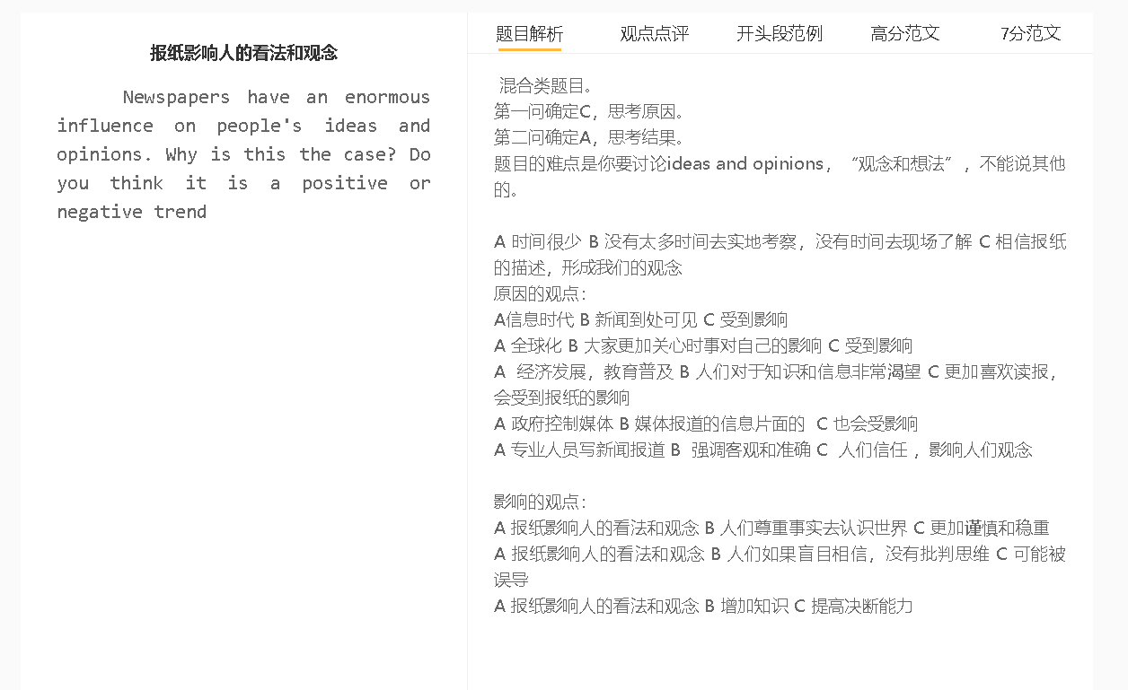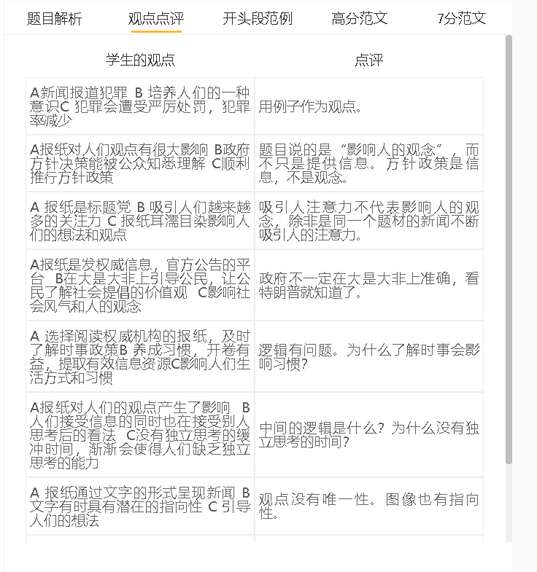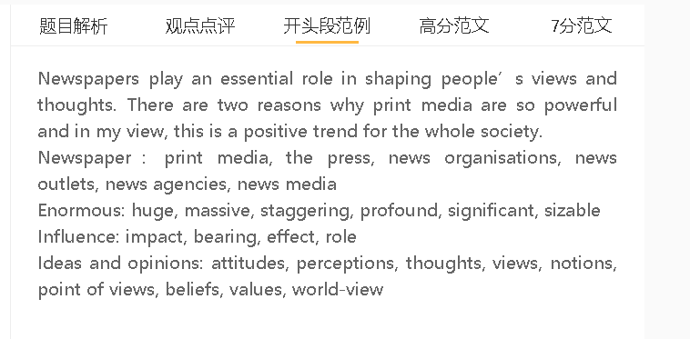

范文

Newspapers play an essential role in shaping people’s views and thoughts. There are two reasons why print media are so powerful and in my view, this is a positive trend for the whole society.
A 政府或者商业机构控制媒体 B 媒体报道的信息片面的 C 也会受影响
背景：很多报纸需要商业机构和政府的资助
解释：新闻报道符合这些sponsors的利益
解释（B-C）：人们信以为真
举例：美化或者丑化一些国家，从而让公众来支持自己的政策
Unbalanced, biased
Newspapers have a lasting impact on public opinions since they tend to give biased news coverage to serve the interests of political or commercial sponsors. Print media relies on the sponsorship of commercial organisations and politicians primarily because advertising revenue alone is insufficient to cover running costs, such as the salaries of journalists. News articles are biased in favour of these sponsors; otherwise, newspapers can go bankrupt. Some state-owned newspapers, for example, intentionally portray some countries in a positive or negative light, in an attempt to win public support for relevant government policies. People who are exposed to unbalanced news reports tend to believe in all they read in newspapers, since they have no time or resources to check validity of information. The more they read, the stronger stereotypes they have.

A 全球化 B 大家更加关心时事对自己的影响 C 受到影响
背景（A-B）：各国之间联系紧密，很大程度上利益与共
解释：一个国家产生的影响会迅速传导到其他国家
举例：经济事件、战争、疾病
解释（B-C）：人们更加愿意看报纸，通过报纸去了解世界
Another reason is that globalisation has prompted people to stay alert about what happens throughout the world. Countries are increasingly interconnected, thanks to technological advances in telecommunication and transportation,. What happens in a nation, such as a financial crisis, military conflict and epidemic, can soon see its rippling effect on the rest of the world. Those who have realised the impact of international issues on their jobs, business or other aspects of lives are keen to read newspapers, which open a window on the world. Without time or money to leave hometowns to explore the world, newspapers are the only means of gaining information for most people, thereby increasing the influence of print media.

A 报纸影响人的看法和观念 B 增加知识 C 提高决断能力
背景：很多人未必有机会出国
解释（A-B）：报纸与时俱进
解释（B-C）：可以知道更加多的选择和可能性
举例：出国工作、学习、投资，等等
拓展结果：个人潜力最大化

A powerful journalism industry can be seen positively as people can acquire more knowledge to make well-informed decisions. Print media are particularly important for those who are relatively narrow-minded due to having no opportunities to travel abroad. Newspaper readers can keep up to date with the latest changes throughout the world, so they can stay abreast of choices, possibilities, threats and opportunities that exist. They can capitalise on such information for personal benefits, for example, deciding whether to make work, study or conduct business abroad in the right circumstances.

In conclusion, globalisation and sponsorships have accounted for the massive influence of newspapers, which can have positive implications for society.

