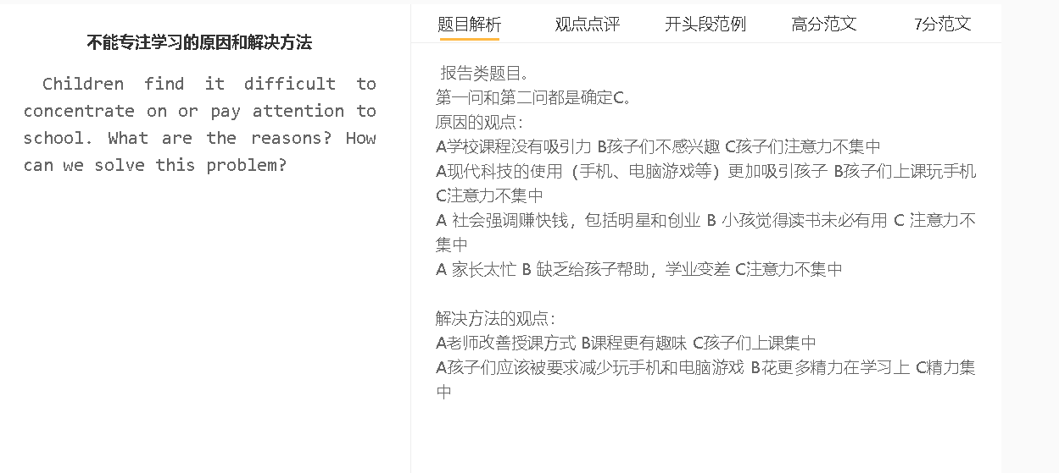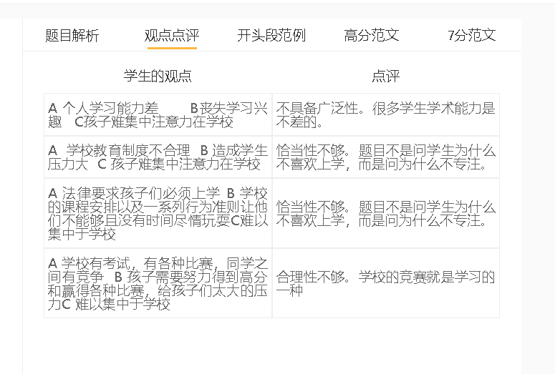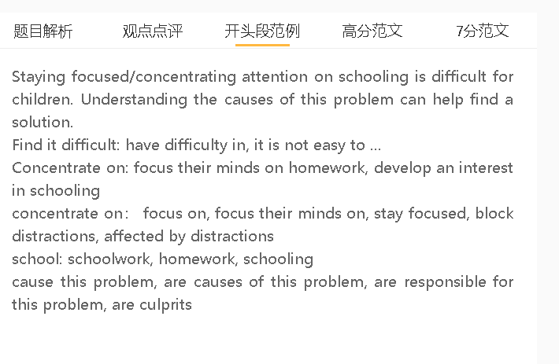

敢问

Staying focused/concentrating attention on schooling is difficult for children. Understanding the causes of this problem can help find a solution.
A课程比较枯燥 B 学生不感兴趣 C 很难专注
背景：学校以学生的成绩为准，家长关注成绩
背景：小孩的注意力时间比较短，外界需要不断给新的刺激，才会专注
解释：课堂都是理论和练习，比较重复，没有新意
One reason is that teachers fail to deliver interesting lessons that hold the attention of students. Schools have become exam-oriented as the academic performance of students is regarded as a benchmark/standard/criterion to evaluate the excellence of an educational institution. Teachers are trained to design class activities that improve exam scores. The problem of this mindset is that children normally have a short attention span and cannot stay focused without constant external stimuli. If a lesson teaches theories and prepares drills only, children will gradually lose interest in repetitive and uninteresting tasks and content.

A 电子产品增加多 B 很容易分神 C很难专注
背景：信息时代，手机很普遍
背景：自控能力差
解释：更能带来成就感，更加轻松和容易
举例：有一些奖励，刺激小孩去玩
举例：检查信息，看小视频

Another reason is that electronic devices have become distractions. Children live in the informal age, when smartphones and computers have become ubiquitous. Due to a lack of self-discipline, they may be addicted to different phone-related activities, which can give them a sense of achievement and pleasure easily. Some phone games, for example, attract young players by offering rewards frequently to keep them interested, while checking messages and watching videos on the phone are also a source of happiness to them. These activities can be highly addictive as they are easier to grasp and master than schoolwork.

A 有意思的课程 B 保持兴趣C 提高注意力
背景：课程比较长，老师要注意变化
背景：利用学生的好奇心
举例：利用多媒体，增加内容的丰富性
举例：丰富课堂一些活动，增加学生的参与度

To ensure that students can maintain enthusiasm for studies, schools can pay more attention to course design. While shortening study time is virtually impossible, teachers should consider the variety of the learning process. The diversification of academic activities can explore the curiosity of the young on a varied learning experience, such as absorbing the information presented by multimedia, rather than reading books and listening to the instructions of teachers during the lesson. Some enrichment activities, such as games, group discussions and role play, can also be devised to increase engagement and make electronic products less attractive, thereby retaining the attention of participants.

In conclusion, course designs and the access to electronic devices have been responsible for the fact that children fail to concentrate on studies. Restructuring lessons by introducing some enrichment activities can be a viable solution.

