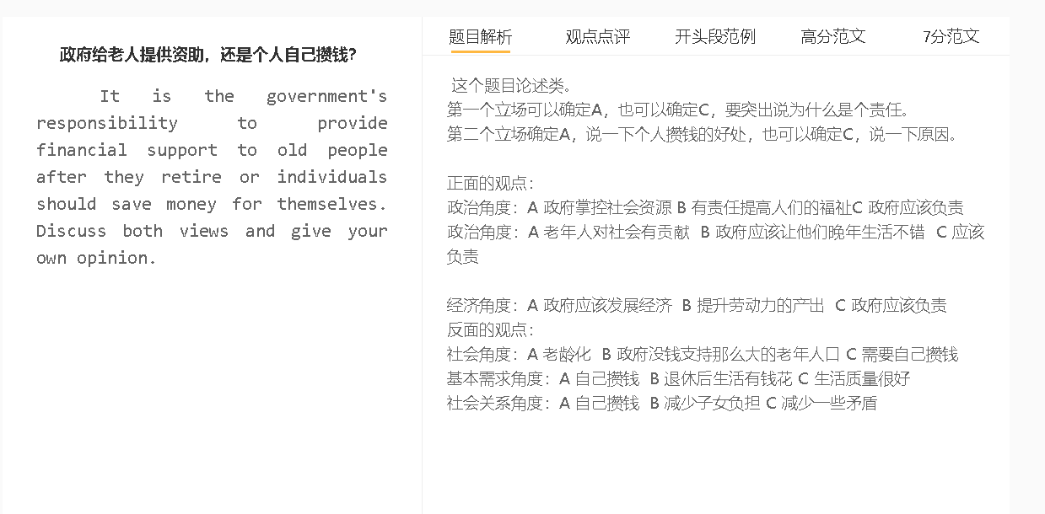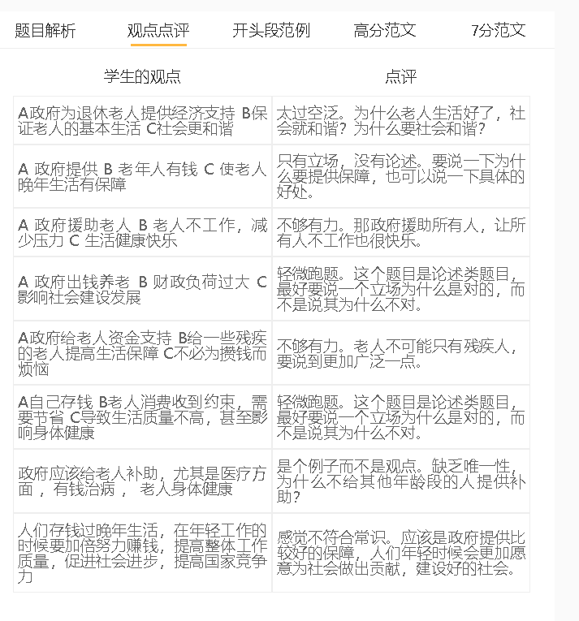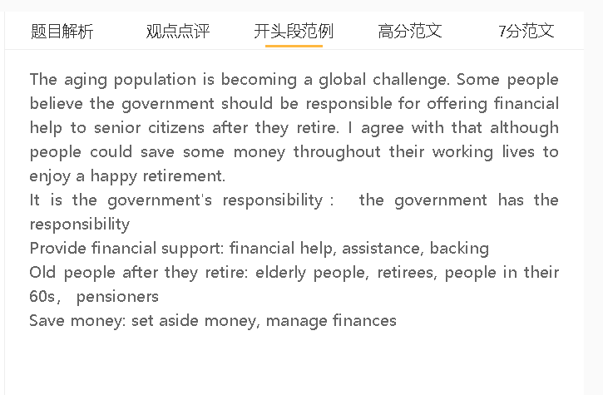

高分范文

The aging population is becoming a global challenge. Some people believe the government should be responsible for offering financial help to senior citizens after they retire. I agree with that although people could save some money throughout their working lives to enjoy a happy retirement.

A 老年人对社会有贡献 B 政府应该让他们晚年生活不错 C 应该负责
背景：老年人很多生活不能自理，有些还生病
解释：工作的时候，交税对社会是贡献，很多工作岗位，为社会的进步贡献自己的劳动力还有智慧
举例：科研，建筑，公务员
对比：个人的储蓄不够； 生活成本很高，普通的工薪阶层储蓄很少

Government, the state, the country, authorities, policymakers, political leaders

Some people believe that the responsibility/onus/duty of supporting the elderly falls on the government since most senior citizens make contributions to society when in the workforce. The financial assistance from the state is particularly important in cases where retirees cannot be self-reliant either physically or financially due to ageing-related health problems. They contribute to a country not only with the tax they pay, but also with the wisdom and labour they provide in their occupations, either as civil servants or as builders or scientists. These people may not have sufficient personal savings to cover expenses in later life, given that the cost of living is extremely high in some societies.

A 老龄化 B 政府没钱支持那么大的老年人口 C 需要自己攒钱
背景：经济发展和医疗水平的进步延长了人的寿命
解释：对医疗服务和养老金有巨大的需求，而政府还有很多公共项目
对比：自己攒钱，有充足的资金，养老金少也不怕
Support, feed, set aside money, put aside money, hoard money
Population ageing the expansion of the older population
Economic growth/progress/development/expansion/prosperity
Medical advances/technology improve life expectancy/lifespan/lead to longevity
Fuel the demand/ driven the demand…
Public projects ..

This problem

On the other hand, hoarding money is perceived as a sound decision because few countries can afford to support their fast-ageing populations. This situation is certain to worsen in the future as life expectancy will be improved substantially by rapid economic progress and enormous medical advances. The government does not have the budget to cope with the growing demand for health services and pensions, as driven by the number of pensioners, when other public projects are also competing for funding. The meagre pension will not constitute a challenge to the quality of life of elderly people, if they have sufficient money in the bank.

A 个人和政府都负责一部分 B 钱更多 C 晚年的生活更好
背景：容易生病，需要医疗服务； 社会观念改变，没有家人照顾
解释（A-B）：个人攒钱，做好财务规划，避免浪费
解释（A-B）：政府的养老金系统运营很好，增加发放给老人的钱
解释：看医生，旅游，可以购买营养的食物，负担得起养老院的费用

In my view, the government and citizens should be jointly responsible for addressing retirement-related challenges to ensure that every retiree has sufficient cash to live a happy life in the old age. Ageing is an inescapable part of life, and people are prone to health problems in the last life stage and in need of medical care, especially when they live apart from family members. If they know they cannot rely entirely on the government, they will manage their finances more carefully and avoid unnecessary expenses that could affect their standard of living later on. Likewise, if the government does not shirk from its responsibility of looking after pensioners, they will run the pension scheme prudently to yield financial returns. Personal savings, together with a regular supply of pensions, afford medical costs, nourishing food, the charges of nursing homes and even the expenses of travelling.

In conclusion, I would argue that it is the shared responsibility of the government and people in the workforce to manage money wisely for the demands of an ageing society, as neither of them can deal with the issue alone.

