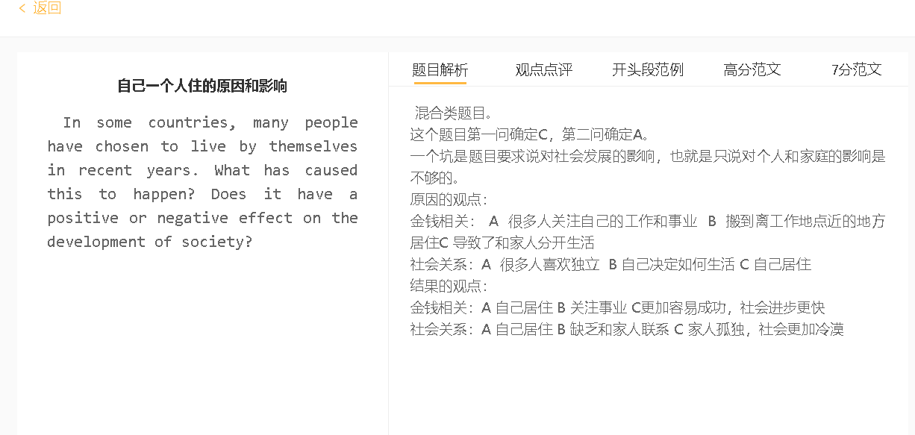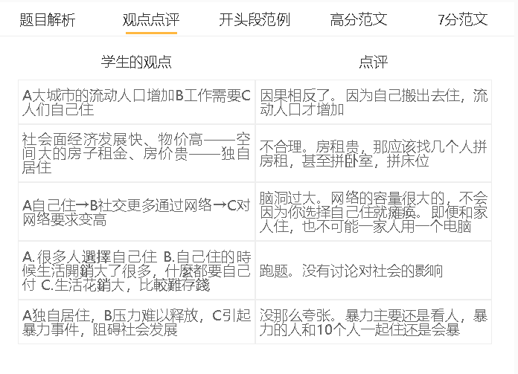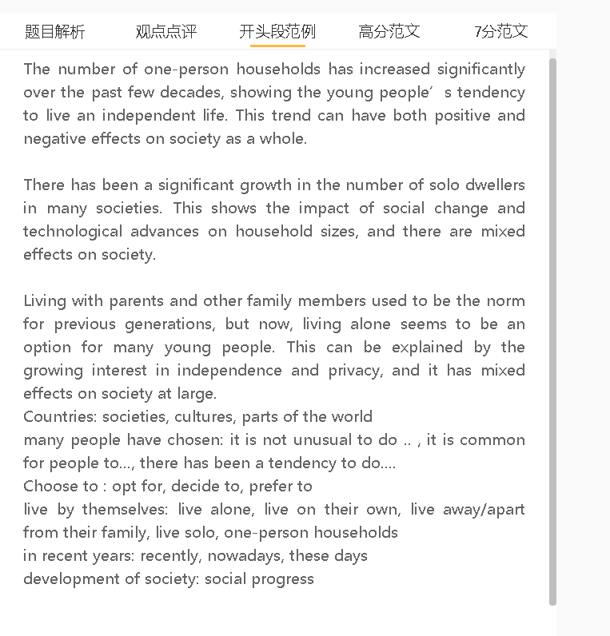

范文

It is common for many people to live alone in some societies these days. This trend may have some adverse effects on public well-being, despite the contribution to economic progress.

A 专注事业 B 对家庭生活不感冒 C 独居
背景（解释A）：竞争激烈，生活压力大
解释（A-B）：花费大量时间精力 对家庭生活投入少
解释（B-C）： 觉得家庭生活是一种负担或者分散注意力
一个可能的原因是人们越来越以职业为导向，对家庭生活的关注也越来越少。他们生活在竞争激烈的社会中，他们必须优先考虑自己的职业生活，赚取更多的钱来应对经济压力，要么付账单，要么抵押贷款。这种高节奏的生活方式需要大量的时间和精力，使他们很难与爱人共度美好时光，例如外出就餐、一起看电影和购物。他们最终选择搬出家独自生活，因为他们认为家庭是一种负担或分心。
One possible reason is that people are increasingly career-oriented and pay less attention to family life. They live in competitive societies, where they have to give priority to their professional life and earn more money to cope with economic pressure, either paying bills or mortgage. This high-paced lifestyle takes enormous time and energy, making it difficult for them to spend quality time with loved ones, such as eating out, watching films together and going shopping. They finally choose to move out of their home and live alone, as they see family as a burden or distraction.

A自己居住 B 产出更高 C 对经济有帮助
解释（A-B）：无人打扰，更加专注
解释（B-C）：产品质量更好，有更多新的特点，成本更低，企业更有竞争力，帮助公司创收
解释（C为什么好）：有更多资金帮助社会发展
随着整个劳动力生产力的提高，独居生活可以从经济角度造福社会。那些独居的人可以把更多的时间花在工作上，而不受家庭事务的干扰。他们可以积累专业知识，为雇主带来竞争优势，包括更好的产品质量、最新的功能和更低的成本，并提高收入。这可以在社会福利、公共服务和基础设施建设方面为一个国家创造财富，从而促进社会进步。

Solo living can benefit a society from an economic perspective as the productivity of the whole workforce improves. Those who live alone can dedicate more time to their work without being disturbed by family matters. They can build expertise, which can give competitive advantages to their employers, including better quality products, up-to-date features and lower costs, and boost the revenue. This can create wealth for a country in terms of social benefits, public services, and infrastructure construction, thereby promoting social progress.

A 自己居住 B减少了和家人的接触时间 C 社会的医疗费用提升
解释（A-B）：自己和家人距离变远
解释（B-C）：无人照顾，容易生病；无人陪伴，容易孤独 ；可能有些小病没有及时发现，导致病情加重
解释（C为什么是个问题）：本可以用到更加需要的公共服务，给经济造成负担
另一方面，独居的一个可能问题是，随着与家庭的互动减少，独居可能会增加社会的医疗费用。他们住得很远，几乎不去看望家人。那些与家人疏远的人在生病或心情不好时往往感到孤独和无助，这可能会导致抑郁症、睡眠困难、饮食失调和其他健康问题。为了满足日益增长的医疗服务需求，必须为相关设施分配更多的预算，这将耗尽公共资金，并增加整个国家的经济负担。
On the other hand, one possible problem of living alone is that it may increase a society’s medical costs as interactions with family dwindle. They hardly visit their family, as they live far away. Those who are estranged from family tend to feel lonely and helpless when they fall ill or are in bad mood, which can cause depression, sleeping difficulties, eating disorders and other health problems. To meet the growing demand for medical services, more budget has to be allocated to relevant facilities, using up public money and adding an economic burden on the whole country.

In conclusion, one-person households have increased because of people’s obsession with their career objectives. This could have mixed effects on society.

