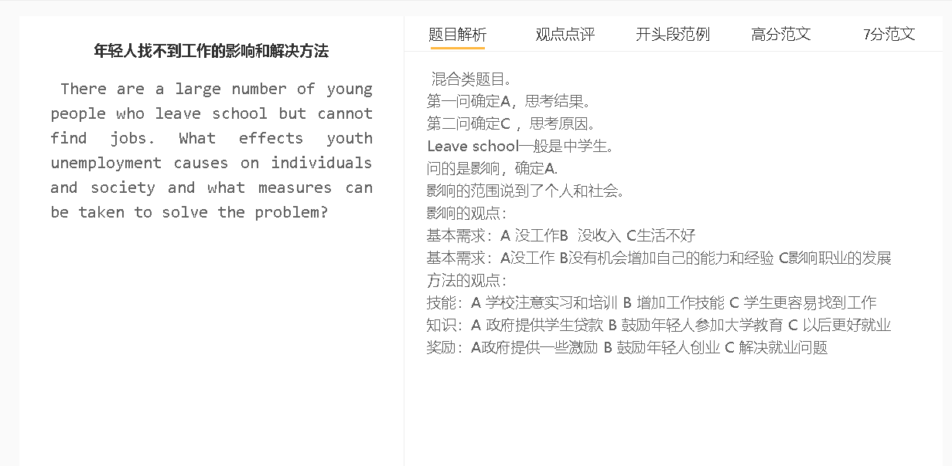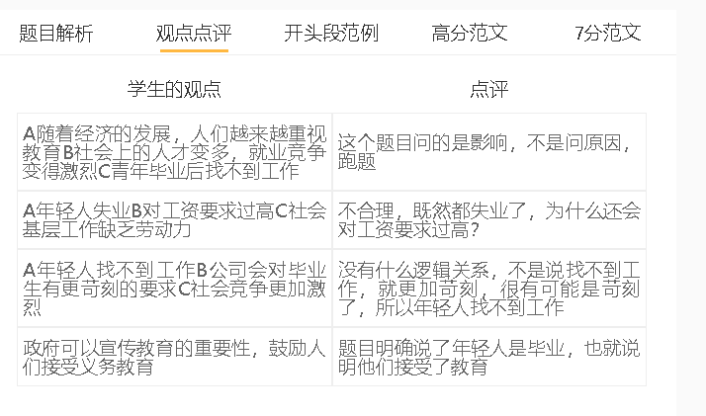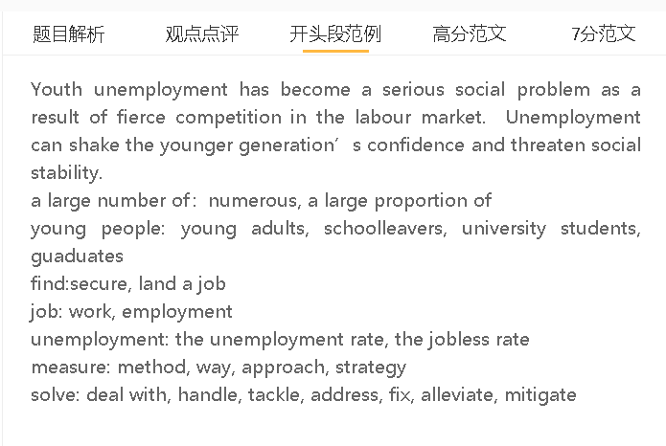

高分范文

Many young adults graduating from school fail to find employment. I think this can have a negative impact on their well-being and social stability, and there is something schools and the government can do to help solve the problem.
A 年轻人失业 B 没有收入去生活 C 整个社会也经济受损
解释：没有失业补助，父母的支持
解释：整个社会的消费比较低
解释：经济劳动力产出也低，因为年轻人少
拓展结果：政府税收少，整个社会的生活标准都会下降
年轻人的高失业率可能会影响他们的收入，也会从经济角度影响社会。如果失业者得不到失业救济金或家庭的经济支持，他们很难支付基本生活费用，如食物、房租和账单。失业还会限制整个社会的公共消费，包括家庭用品和娱乐支出，从而损害经济。年轻人的短缺也可能对经济构成威胁，因为劳动力的生产率（人们可以处理的繁重工作量和他们可以开发的创新）很低。经济增长缓慢可能导致政府预算下降，从而影响每个公民的生活质量。
The high jobless rate among young people can affect their income and also the society from an economic perspective. The jobless can hardly afford basic living costs, such as food, rent and bills, if they do not receive any unemployment benefit or financial support from family. Unemployment can also limit public consumption of the entire society, including the spending on household goods and entertainment, thereby damaging the economy. The shortage of young adults can also pose a threat to the economy because productivity of the workforce (the heavy workload people can handle and innovations they can develop) is low. Slow economic growth can lead to a drop in the government budget, which can affect the quality of life of every citizen.
A年轻人失业 B伤害自尊心C造成社会动荡
解释： 觉得得不到认可
解释： 通过一些不好的行为去发泄自己的情绪
解释： 去犯罪获得钱
拓展结果：大家没有安全感，不能够正常生活
另一个与失业相关的问题是社会动荡，因为长期失业会损害年轻一代的自尊。他们沉溺于自我怀疑，因为他们认为自己的才能没有得到劳动力市场的认可。失业的年轻人可能会通过一些非法行为来发泄他们的负面情绪，例如故意破坏和抢劫。为了挣钱，他们可能会犯下抢劫、盗窃和欺诈等罪行，这可能会威胁到社会稳定。这会削弱社区的安全感，妨碍人们过上正常的生活，无论是享受户外活动还是晚上购物。
Another unemployment-related problem is social unrest as a long period of unemployment can undermine younger generations’ self-esteem. They indulge in self-doubt as they think their talent is not recognised by the labour market. Young people who are out of work may let off their negative emotions by some unlawful acts, such as vandalism and looting. In order to get money, they may commit crimes, like robberies, thefts and frauds, which can threaten social stability. This can erode the sense of security in communities and prevent people from living a normal life, either enjoying outdoor activity or going shopping at night.

A 政府提供更多的资金和政策支持 B 年轻人有更多机会就业C 解决问题
背景：政府有立法权，可以动用社会的资源
解释：政府对于招聘年轻人的公司给予一定的资助， 开放公务员的岗位，提供一些免息贷款可以让年轻人创业，还有提供实习机会增加实践能力
解释: 可以解决带来的经济和社会问题
为了解决上述问题，政府可以拨款并实施创造就业的政策。政府的不同部门有权通过法律或汇集财政资源为公共利益服务。政策制定者可以为招聘年轻员工的企业提供补贴，为年轻申请人创造更多的公务员职位，为希望创业的年轻企业家提供无息贷款。这将解决青年失业引起的经济和社会问题。
In order to address the above-mentioned problems, the government can allocate money and implement policies for job creation. Different branches of the government are empowered to pass laws or pool financial resources to serve public interests. Policymakers can offer subsidies for enterprises which recruit young employees, create more civil servant positions for young applicants, provide interest-free loans for young entrepreneurs who desire to start up business. This will solve the economic and social problems that arise from youth unemployment.

In conclusion, youth unemployment has its ramifications either for individuals or for the whole society. The onus of addressing this issue falls upon the state.

