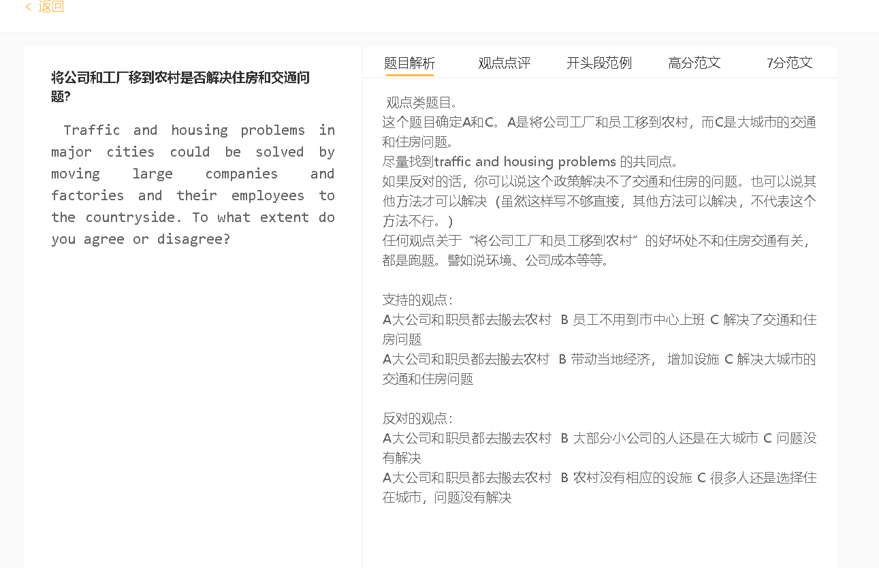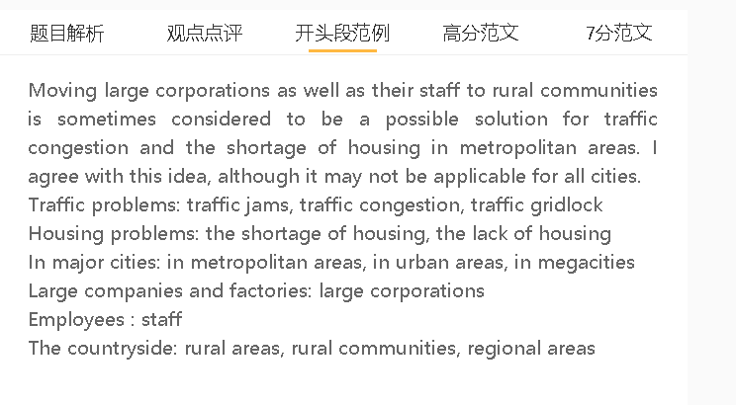

范文

Moving large corporations as well as their staff to rural communities is sometimes considered to be a possible solution for traffic congestion and the shortage of housing in metropolitan areas. I agree with this idea, although it may not be applicable for all cities.

A大公司和职员都去搬去农村 B 员工不用到市中心上班 C 解决了交通和住房问题
背景：中央商务区拥挤不堪，因为这里有许多公司。
举例：由于人们努力购买靠近办公室的房子，住房供应不足，城市道路每天在上下班高峰时段都挤满了汽车，而住在远郊的人则开车去上班。
解释（B-C）：为这些企业工作的大部分员工将选择搬离城市地区，因为他们喜欢就近办公。

Moving big businesses out of the urban centre can alleviate the pressure on housing and traffic links since there are fewer employees working and living in the central area. The central business district is crowded as it is home to numerous companies. Housing is in short supply as people strive to buy homes close to the office, and city roads are congested with cars during rush hour every day, when people living on outer suburbs drive to work. Both problems can be mitigated if companies shift operations to countryside. A large proportion of employees working for these businesses will choose to move away from urban areas for they favour proximity.

A大公司和职员都去搬去农村 B 带动当地经济， 增加设施 C 解决大城市的交通和住房问题
背景：一个地区的经济繁荣直接影响到它的人口增长。
解释：企业纳税人的钱可以投资在吸引潜在居民的设施上。
举例：学校、医院、道路系统
解释（B-C）：那些以前住在市中心的人将搬到这些地区，因为他们可以为大雇主工作，同时享受类似的生活水平。
The long-term effect is that the arrival of corporations can bring in investment and generate revenue that boosts the rural economy, thereby speeding up the movement of urban dwellers to these places. Economic prosperity of a region has a direct impact on its population growth. The payment from corporate taxpayers can be invested in schools, hospitals, road systems and amenities that attract prospective residents. Those people who previously live in the urban centre will move to these regions, as they can work for big employers while enjoying a similar standard of living. The urban population can thus be distributed reasonably.

反对的观点：
A大公司和职员都去搬去农村 B 大部分小商业的人还是在大城市 C 问题没有解决
背景：一些大型企业的搬迁并没有明显改变商业格局
解释：不同行业的小公司会选择留在CBD，在那里他们可以更方便的为客户服务。
举例：一些城市可能有大量的小型科技公司或金融机构在中部地区雇佣了很高比例的人。
扣题：如果这些公司在同一个地方运营，住房短缺和交通拥堵问题就不会得到解决。
On the other hand, this strategy may not be effective in cases where small businesses contribute to the largest proportion of the urban economy. The relocation of some large-sized enterprises does not alter the business landscape significantly, and perhaps, small companies in different industries choose to stay in the CBD, where they can serve their clients more conveniently. For example, some cities may have numerous small technology firms or financial institutions in central areas hiring a high percentage of people. Housing deficit and traffic congestion would not be addressed if these companies operate in the same place.

In conclusion, I agree that the changes in the location of some major corporations can help overcome the challenges of high population density in urban areas, although this is not a universal solution.

