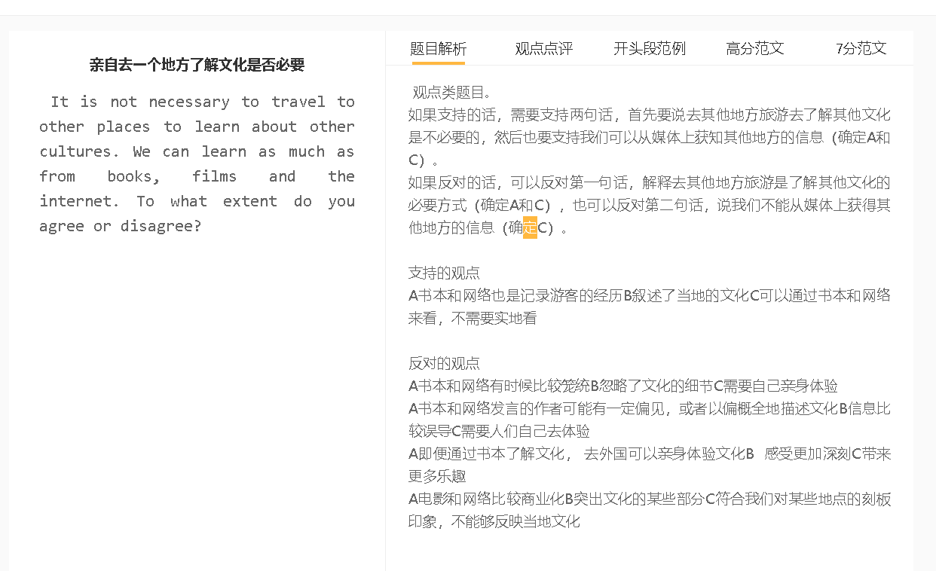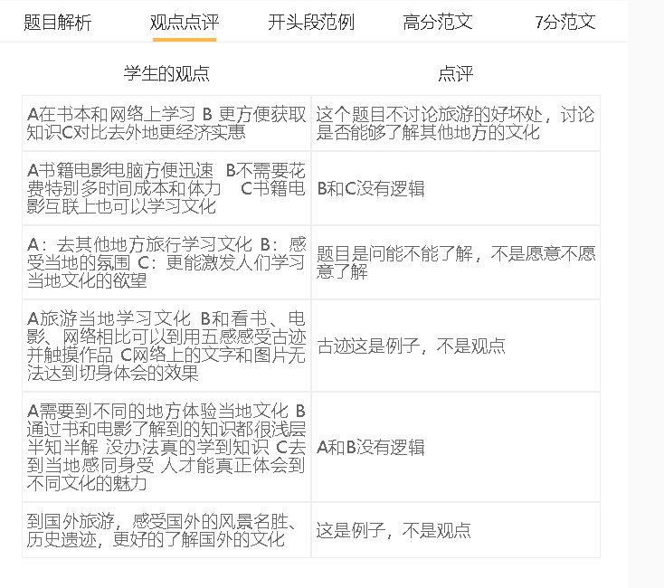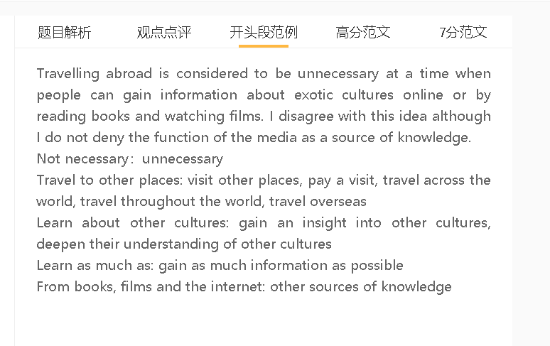

范文

Travelling abroad is considered to be unnecessary at a time when people can gain information about exotic cultures online or by reading books and watching films. I disagree with this idea although I do not deny the function of the media as a source of knowledge.

A 阅读书和看电影 B 没有亲身体验当地文化、生活习惯和习俗 C 对文化理解不深
解释：文字和图像很难体现文化的独特性，体验还有听觉、嗅觉、触觉、味觉
举例：食品，festival
对比：当地去体验，终身难忘

Experience local life, experience an exotic culture
A deep understanding of …
Uniqueness, distinctive features, defining features of ..
Flavor, and smell,
Joy and excitement brought ..
Memorable cultural experiences
读书和看电影的人不会对其他文化有深刻的理解，因为这些方法不能复制自己沉浸在这些文化中的体验。文字和图像并不能传达一种文化的所有信息，因为一种文化体验不仅包括视觉输入，还包括其他感官，包括听觉、嗅觉、触觉和味觉。除非人们亲自品尝当地的食物，听当地的音乐或语言，接触当地社区的工艺品、艺术品和纺织产品，否则他们无法感受到文化差异。
People who read books and watch films will not have a deep understanding of other cultures because these approaches do not replicate the experience of immersing themselves into these cultures. Words and images cannot convey all information about what makes a culture distinct, as a cultural experience consists not only of visual input but also of other senses, including hearing, smell, touch and taste. People cannot sense cultural differences unless they sample local food themselves, listen to local music or language and come into contact with artefacts, artworks and textile products of the host community.

A 阅读书和看电影B 可能会对一个国家或者地区产生偏见C 对文化形成错误的理解
背景：对文化习惯和传统的理解和解读因人而异
解释：比较概括，作者有个人的喜好
举例：宗教活动，让人觉得很落后，但是未必
对比： 当地人交流，生活，文化多元性
Shape or Reinforce stereotypes
Misconceptions, develop some wrong ideas about …
Personal preferences, make generalisations
Religious practices, host community,
Wrongfully believe that
Religious belief
Integrate with, communicate with locals, cultural diversity, richness of cultures..
依靠媒体了解文化的另一个缺点是，它可能会导致对异国文化的一些误解。社会规范或文化传统的解释取决于一个人的教育水平、文化背景和个人偏好。制作纪录片或旅行日记的作者或人可以做出大概的描写，可能是因为他们个人关注一种文化的某些方面，而忽略其他方面。他们可能对某些在别人看来是正面的习俗感到不满。例如，生活在世俗社会的作家以负面的方式描绘一个宗教国家的一些仪式，这种偏见可能会给读者造成错误的印象。与当地人交谈，体验当地文化是克服这种偏见的有效方法。

Another drawback of relying on the media to learn about cultures is that it can lead to some misconceptions about an exotic culture. The interpretation of a social norm or a cultural tradition hinges on one’s educational level, cultural background and personal preferences. Authors or people who produce documentaries or write travel diaries can make generalisations possibly because they personally pay attention to some aspects of a culture while ignoring others. They may resent some customs which are viewed positively by others. Writers living in a secular society, for instance, portray some rituals of a religious country in negative ways, and this kind of preconception may make a false impression on readers. Talking to locals personally and experiencing the local culture are an effective way to overcome such bias.

A 阅读书和看电影B 通过别人的经历和知识了解一个地区 C 也可以了解文化
背景：作者可能是喜欢旅游的人，对文化花了时间了解
背景：很多人没时间出国，即便出国，旅程也很短，还有语言等问题，很难深入了解
解释：阅读文章，看纪录片可以增加知识
例子：特别是本土部落，偏僻地区，一般游客很少去的
另一方面，阅读书籍或看电影是可以接受的，如果这些材料是由熟悉一种文化的人准备的。作者可能是游历甚广的人，也可能是花费时间和精力分析一个社区或国家的学者。他们的知识对那些没有时间出国旅行或在东道国探索文化时遇到语言障碍或时间限制的人很有价值。旅游书籍和纪录片可以扩展他们的知识，特别是当涉及到生活在远离正常行程的地方的部落生活时。
On the other hand, reading books or watching films can be acceptable if these materials are prepared by people who are conversant with a culture. The authors may be well-travelled people or scholars who have expended time and energy in analysing a community or country. Their knowledge is of value to those who have no time to travel abroad or those who struggle with language barriers or time constraints when exploring a culture in the host country. Travel books and documentary films can extend their knowledge, especially when it comes to the life of tribes living in far-off locations beyond normal itineraries.

In conclusion, I would defy the notion that travelling abroad is unnecessary even though the information about a foreign country is available in the media.

