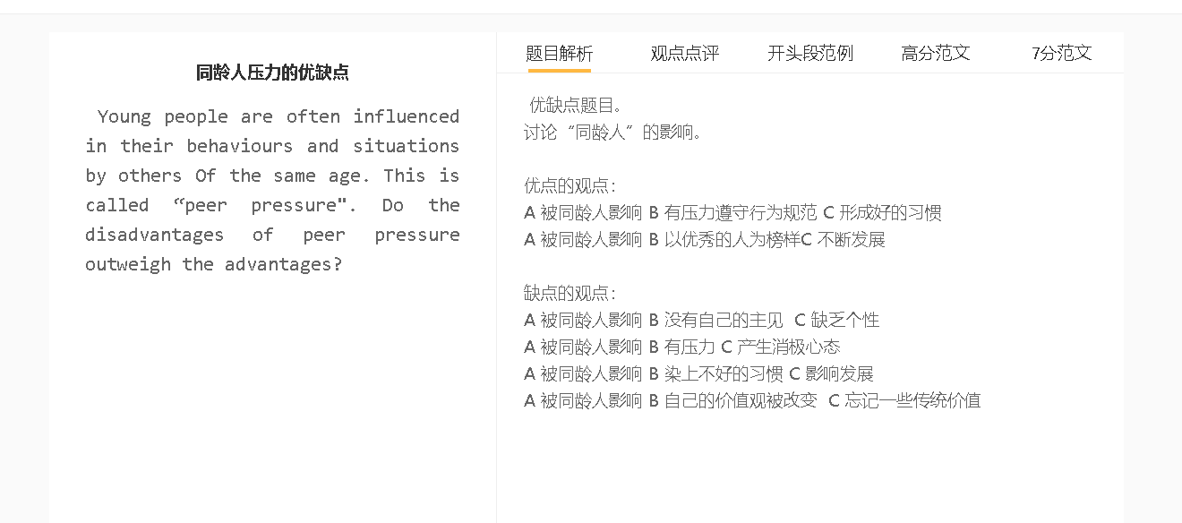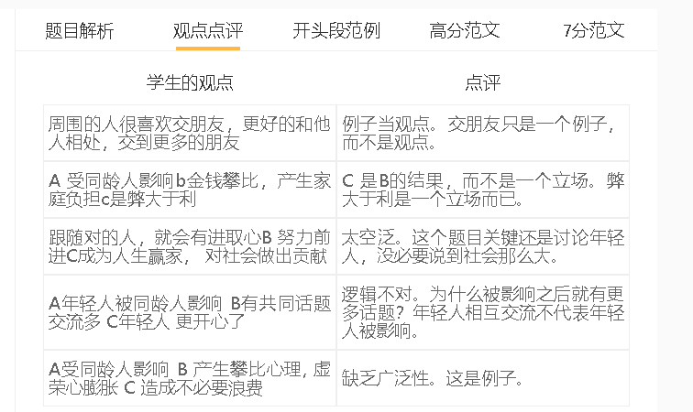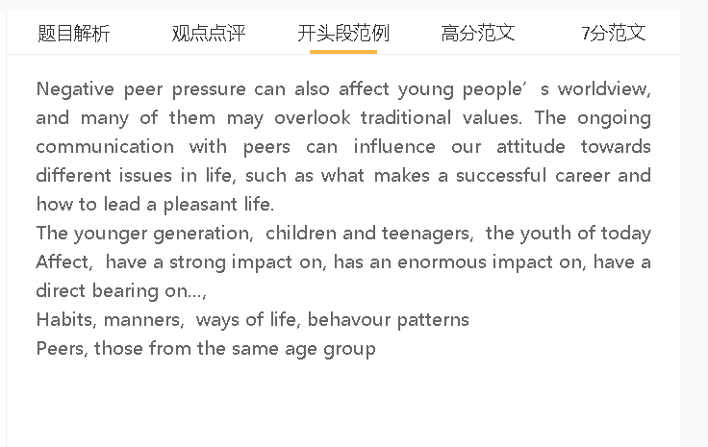

范文

Of external factors/forces, peer pressure is the most influential for younger generations. I think its overall effect is negative.

A peer pressure B 迫于压力模仿不好的行为 C 对自己有伤害
解释（A-B）： 人们希望可以扎堆，担心如果不和别人一样，自己会被孤立
解释（B-C）：年轻人有比较强的身份认同感，希望做一些事情和父母不一样
具体化：打游戏，使用药物，浪费钱买东西
解释C的影响：影响学习，职业和生活质量
同伴压力可能会对年轻人的发展产生不利影响，因为他们可能会重复同伴的不良行为。这是他们融入社会努力的一部分，因为他们担心如果自己的行为方式与其他人不同，他们可能会被排斥在外。他们可能会玩游戏，使用非法药物，在奢侈品上挥霍金钱，并表现出其他类型的不良行为，因为他们有时倾向于做一些父母不同意的事情来获得认同感。这些行为会对他们的学习、职业发展和生活质量产生负面影响。
Peer pressure may have a detrimental effect on young people’s development since they may repeat bad behaviour of their peers. This is part of their effort to fit in, because they fear that they could be excluded if they do not act in the same ways as others. They may play games, use illegal substances, squander money on luxuries and show other kinds of misbehaviour, as they sometimes tend to do something (that) their parents disapprove to gain a sense of identity. These acts have a negative impact on their studies, career progression and quality of life.

A peer pressure B 随波逐流 C 没有自己的选择和判断
解释（A-B）：担心不好的后果
解释（B-C）：对自己的决定缺乏自信
解释C的影响：失去一些机会
Follow the crowd, make them conformists, herd mentality
同伴压力的另一个问题/缺点是人们有从众心理，选择不行使自己的判断。他们倾向于模仿同龄人的行为，因为他们担心不同的行为可能会产生负面后果。他们的决策能力很难发展，因为他们没有信心或经验。他们可能会像同龄人一样错过一些机会或犯错误，例如，学习一门他们认为很受欢迎的学科，尽管他们并不擅长。
Another problem/drawback of peer pressure is that people have herd mentality and choose not to exercise their own judgment. They tend to copy the behaviour of their peers, as they are afraid that behaving differently could have negative consequences. Their decision-making ability is hardly developed, since they have little confidence or experience. They may miss some opportunities or make mistakes as their peers do, for example, studying a subject that they think is popular even though they do not excel at it.

A peer pressure B 符合行为规范 B 提升自己
解释（A-B）：担心自己得不到认可
具体化：学习更勤奋，形成一些好的习惯
解释C的影响：收益终生
另一方面，当一个人感到要遵守群体规范的压力时，同伴有时会迫使他或她提高自己的能力。这些人会这样做，包括刻苦学习、长时间工作、广泛阅读和去健身房，相信自己可以被朋友、同学或同事接受或欣赏。这些习惯或生活方式可能会让他们受益终生。
On the other hand, peers can sometimes push one to improve his or her capability as he or she feels pressured to conform to group norms. These individuals do this-including studying assiduously, working long hours, reading extensively and going to the gym-believing that they can be accepted or appreciated by their friends, classmates or colleagues. These habits or ways of living may benefit them for a lifetime.

In conclusion, I believe peer pressure is mostly harmful to younger generations, although sometimes, young people can benefit from the contact with hardworking, self-disciplined peers.

