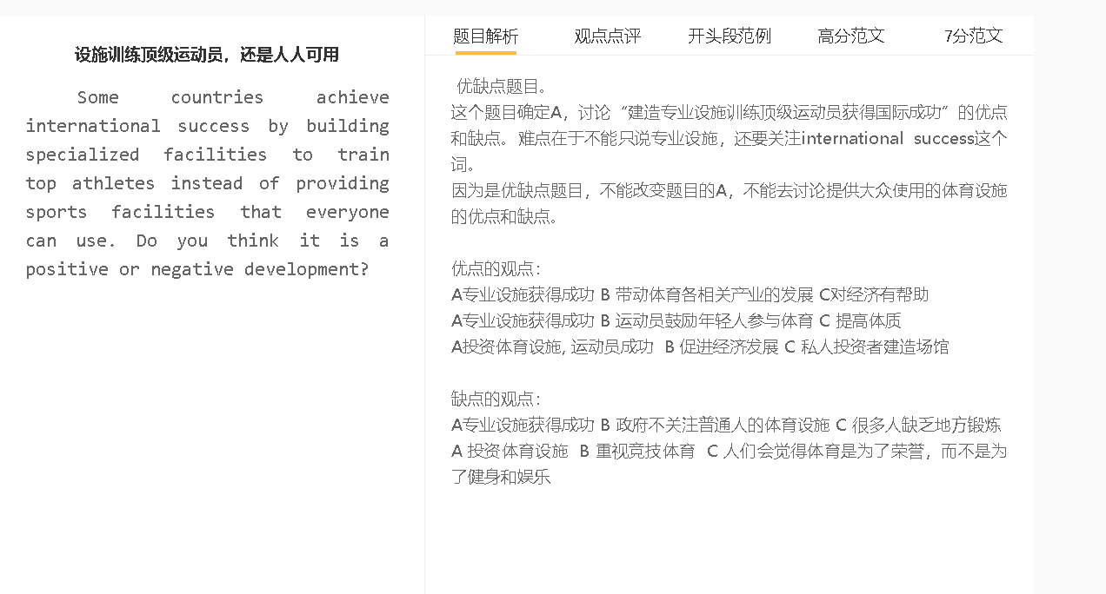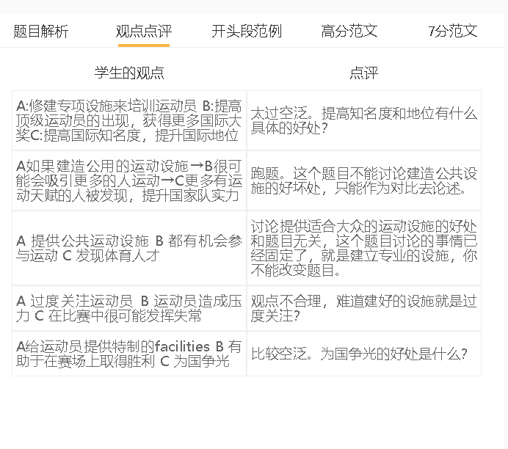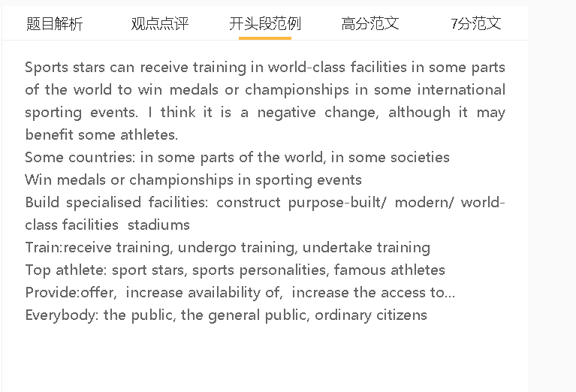

范文

Modern facilities have been constructed in some parts of the world to allow sports personalities to receive training to win medals or championships in some international sporting events. I would consider it to be a negative development, although it can help some athletes achieve success.
A 投资体育设施 B 适合大众的设施减少 C 大家没地方锻炼，健康影响
背景：这可能会恶化公共卫生问题，由于不运动的生活方式已成为普遍的公共健康问题，因为人们每天都面临繁重的工作
解释：考虑到体育专业人士的训练设施需要巨额投资，资金匮乏的城市几乎没有钱来建造普通人可以锻炼的运动场、公园和体育中心
解释：没有有利于运动的环境，人们可能每天呆在室内，长期不活动会造成伤害。人们面临着更高的健康风险，如心血管疾病，这可能会影响他们的幸福感。
Investment in, spending on, suitable for , sports facilities, exercise, harmful effect on health, health problems
Limited budget, the budget is tight, budget deficit, budget constraints
Fall ill, suffer poor health, endure suffering, feel the pain, struggle with distress, well-being

Investment in purpose-built facilities can be a threat to public health because it will use up money otherwise earmarked for sports facilities for the masses. This can worsen the public health problems that have become widespread due to an inactive lifestyle-as people face a heavy workload every day. Cash-stripped cities have little money to build playgrounds, parks and sports centres where ordinary people can exercise, considering that training facilities for sports professionals demand astronomical investment. Without an environment conducive to sport, people may stay indoors every day and inactivity takes its toll in the long term. People face higher health risks, such as cardiovascular diseases, which can affect their well-being.

A投资体育设施 B 这些设施利用率很低 C 很难发现和培养好的苗子
背景：有天赋的运动员可能不会在很小的时候就被发现，因为他们可能没有条件来发展天赋，或者他们没有发现自己对一项运动的热情
解释：一种有针对性的训练一些运动员的方法可能会把这些天才儿童排除在职业运动之外，所以更好的选择是为每个人增加使用体育设施的机会
举例：足球场
解释：这可以提高将更多的人才接触运动中，提升发展技能和体力的前景，为他们的运动生涯做准备
拓展结果：这可以扩大人才库，可以从中发现和训练一些世界著名的运动员
Underused， remain idle, discover a new generation of talented athletes
Unpopular, ordinary people , open to the public
Public facilities, talented athletes
Athletic talent , exercise, develop skills, reach potential
Difficult to maintain, sustainable

Another problem is that the country may not be able to discover a new generation of talented athletes as many specialised facilities are underused while other facilities are not available. Talented athletes may not be spotted at the early age, as they may not have conditions to develop talents or they haven’t discovered their enthusiasm for a sport. A targeted approach to training some athletes can exclude these gifted children from professional sport, so a better alternative is to increase the access to sports facilities, such as football grounds, for everyone. This can raise the prospect of exposing more talent to sports, developing skills and physical strength that prepares them for a sporting career. This can broaden the talent pool from which some world-famous sportspeople can be found and trained.
A 投资体育设施, 运动员获得很好的表现 B 成为很多人的偶像 C 鼓舞更多年轻人运动
解释（A-B）：给国家带来自豪感
解释（B-C）：年轻人被运动员折服，譬如说体育精神，觉得运动使人非常有魅力
解释（B- C ）: 锻炼，以后也出名
Perform well, deliver exceptional performance, Idols, role models, inspire …
A source of pride, take pride in, gain a sense of pride
Captivated by， stunned by, attracted by, sportsmanship
Sportsmanship, determination to win, fighting spirit,
charming, glamorous, physically attractive
practise sport, become famous, achieve fame
On the other hand, the availability of world-class facilities may enable some athletes to perform well in sports competitions, which may inspire young people to engage in physical activity, because these athletes are idols for the public. The achievement of these sports personalities is a source of pride. These Young people are captivated by the sportsmanship shown by athletes and motivated to play sport as well, as they believe that sports can make them as physically attractive as those top athletes. Some young viewers may practice sport from a young age in an attempt to become as successful as these sports stars in the future.

In conclusion, I do not think focusing on sports stars is a sensible decision although the success of these se sports celebrities can generate interest in sport.

