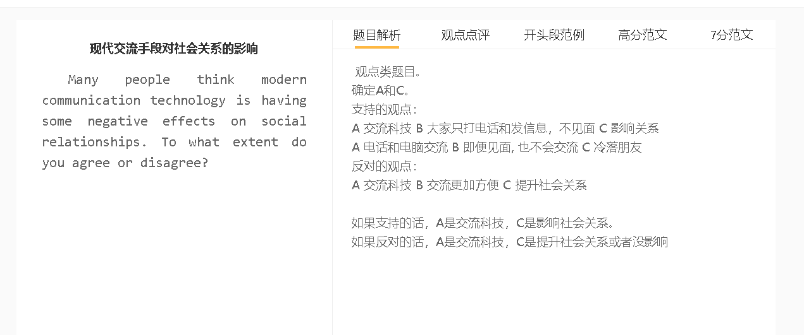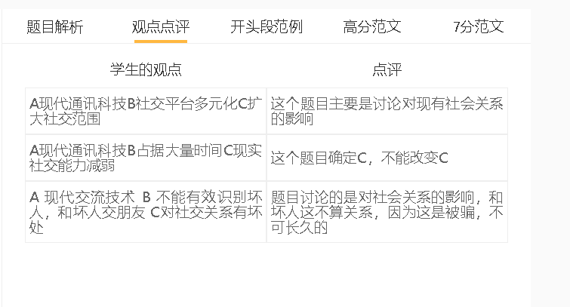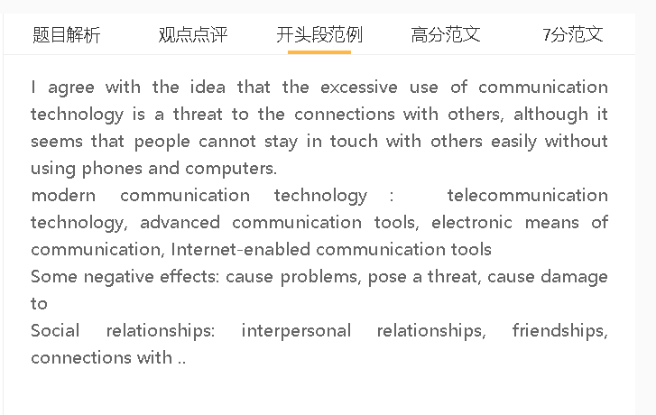

范文

I agree with the idea that the excessive use of communication technology is a threat to the connections with others, although it seems that people cannot stay in touch with others easily without using phones and computers.

A 电话和电脑交流 B 很少见面 C疏远
背景：人们生活忙碌，很少有时间见面
解释：比较方便
解释：缺乏共同的经历，不能在一起分享开心，没有亲密感
解释：如果不见面，人们可能不好意思分享生活中的问题，朋友也觉察不了这个问题，给与帮助，相互之间就建立不了很好的relationship
A sense of closeness, feel connected, feel close
Communication technology can damage interpersonal relationships since people are less willing to set up personal meetings. Face-to-face communication has diminished in the modern world, where people lead a hectic life. This problem has been exacerbated by technology for the simple reason that it has reduced the need for face-to-face interactions. They do not feel a sense of closeness, if they lack shared experiences, such as a special occasion they celebrate together. Those who talk on phone or email may feel embarrassed to ask for support on some personal matters. They cannot feel the strength of a friendship if their emotional distress is not dected by friends. They feel estranged from each other over time.

A 电话和电脑交流 B 即便见面, 也不会交流 C 冷落朋友
解释1：更加喜欢和网络的朋友交流，志趣相投，而且压力不那么大，不会担心得罪别人，对网络关系的期望也不那么高
解释2：手机的媒体有很多的信息，不断看信息，回复别人
解释：交流技能下降，不知道聊什么
Even when people visit friends personally, they may continue to gaze at the screen rather than engage in conversations. They find enjoyment in talking to online friends as the stake is low for a transient virtual relationship. It is easy to find common topics with like-minded friends on the Internet by using social networking apps, while real-life social gatherings are merely seen as a necessary part of maintaining the friendship. They cannot resist the temptation to check their phone notifications and messages even in a party or during a dinner, as they have been accustomed to it. This is a vicious cycle: the less communication they have with friends, the less they can talk about. Their relationship has been damaged rather than strengthened by face-to-face interactions.

A 电话和电脑交流 B 信息交流更加方便 C 保持联系和社会关系
背景：距离远，交通发达让大家离开家乡去工作和生活
解释：信息发送、视频电话都可以让人们马上沟通
解释：表示关心和问候，是面对面交流的取代
解释：知道相互之间的近况，保持关系
One the other hand, modern communication gadgets can help people keep in touch with one another since It makes communication easier. This is important in a world where technological advances in transportation have encouraged people to work and live far away from their hometowns. Text messaging and video chatting programmes allow for real-time communication, so they can send greetings for special events and offer moral support for friends who are in trouble. These communication tools enable them to keep informed about what happens to their friends, thereby maintaining their relationships.

In conclusion, I would agree that technological progress in communication has a negative effect on social relationships in most cases, although it is a blessing for those who live far away each other and intend to keep the relationship alive.

