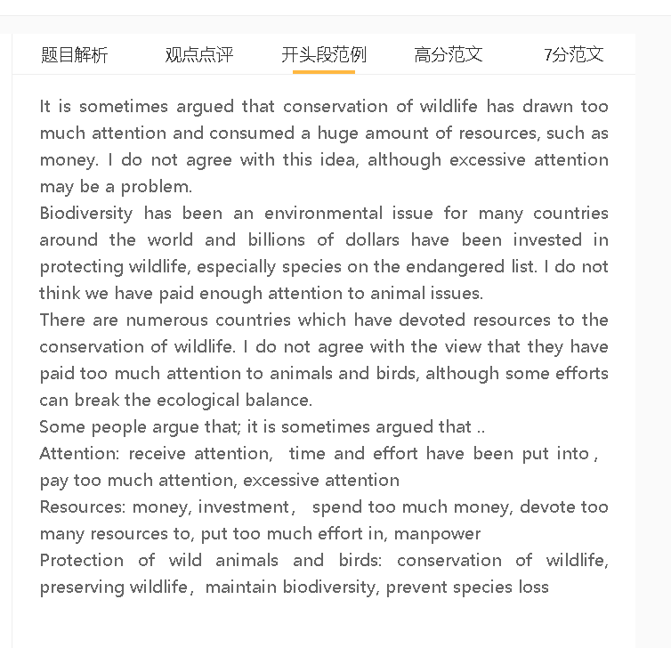

高分范文

Animals and birds play a significant role in our planet’s ecosystem, so countries throughout the world have paid close attention to biodiversity and allocated resources, including capital and manpower, to wildlife preservation. In my opinion, more effort should be put in this initiative, although diversity loss is sometimes inevitable.

A 人们关注自己的生存 B 做一些对动物不利的事 C 资源投入不够
解释（A-B）：人类发展使用资源, 砍伐树木，开垦土地等不断破坏动植物栖息地
解释（A-B）：人类杀害动物，在黑市里买卖
解释（B-C）：法律没有很好约束这些行为， 也没有执法系统去打击非法的活动
所以说，资源远远不够。
Allocate resources, provide resources, use resources
Hurt wildlife, to the disadvantages of animals, threaten wildlife, harmful wildlife
Kill animals, hunt animals, for food, for consumption, earn money, make profit
Population growth, population expansion, population explosion
Cut down trees, clear land , land clearance , destroy habitat, destruct habitat
Conservation efforts deserve more investment and attention as there are human activities that continue to harm wildlife for profit-making and other purposes. Human beings are still driven by self-interest, especially in deprived communities where they struggle to afford basic necessities. They take all means of satisfying their own needs and pay no heed to environmental consequences. They engage in farming, housing development, logging and industrial activity, all of which accelerate the habitat destruction of animals, while the black market for the trading of animal organs and fur is still brisk. Countries do not have strict laws to restrict or ban these activities, nor do they have sufficient law enforcement agencies to clamp down on illegal hunting.

A 人们对动物保护还有争议 B 认为动物保护没必要 C资源投入不够
背景：有人觉得动物灭绝是无可避免，是地球进化的周期，生态系统会自我调节
解释：保护动物只是政客和媒体的说辞，吸引注意，并不是一个现实的需要
解释：保护动物的budget很少
Another reason why conservation effort is far from enough is that people are divided on this issue. There is a notion that the extinction of some species is no more than an inevitable part of the earth’s evolution. Whatever effort we take, it does not make a substantial difference to the survival of these animals. Even in cases where a species dies out, the ecosystem has sufficient resilience to achieve an equilibrium and some new species can fill the gap of the food chain. Those who hold this view tend to argue that the urgency of wildlife conservation is a political rhetoric or a theory embraced by the media to grab public attention, rather than a reality. That’s why any conservation project cannot receive funding easily.

A 人类不断努力地、有目的地保护动物 C影响生态平衡C人关注和保护过多
解释(A-B)： 动物园和培育中心想保护动物，但是其实这些动物在野外生活更好
解释 (B-C): 某些动物保护过多，种群过多，最终会影响其他物种（天敌或者是猎物）
Make a tremendous effort to, try their best to, make a conscious effort to
Intentionally, concentrate effort in
Break disrupt the ecological balance
Breeding centres, in the wild
Overpopulation
On the other hand, in some regions, the effort made by people to conserve wildlife has been more than necessary, and some practices have presented challenges to the ecosystem. It is vulnerable to any external disturbances as every species has formed a complex, interdependent relationship. Any attempt to increase conservation efforts, such as the operation of zoos and captive breeding centres can be counterproductive, and some animals could have survived and thrived in the wild without human intervention. In some instances, the targeted effort to protect one species has led to the underpopulation of its prey or predator, and disrupted the ecological balance.

In conclusion, we have not yet done our utmost to protect the world’s wild animals, even though we should ensure our actions do not cause excessive disturbances to wildlife.

