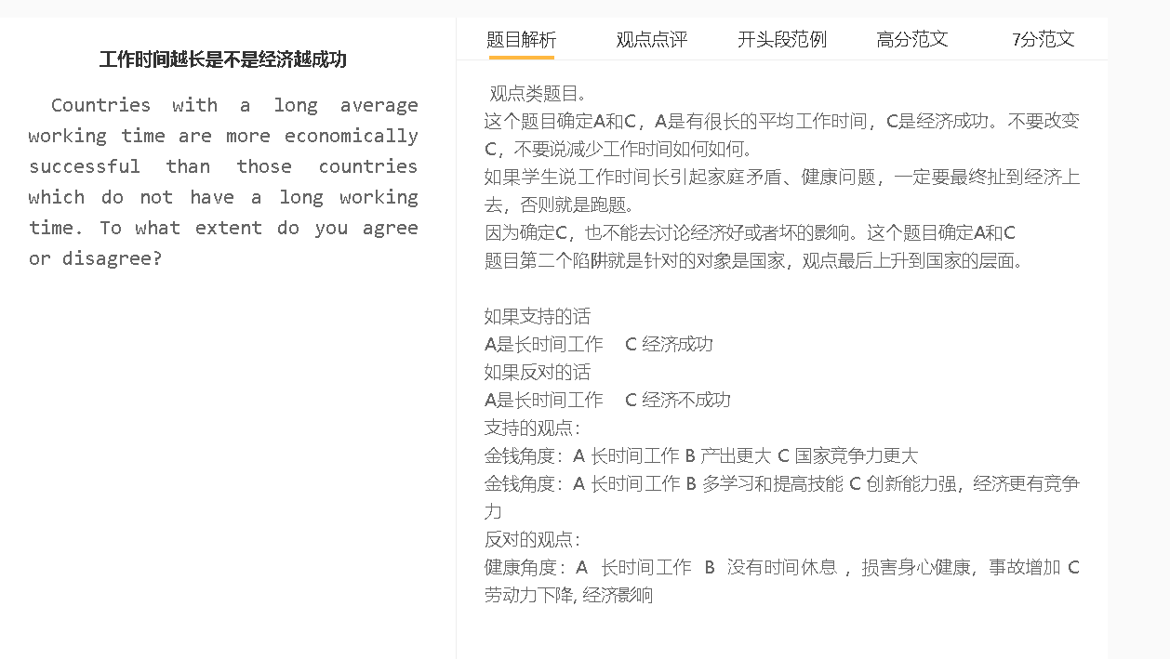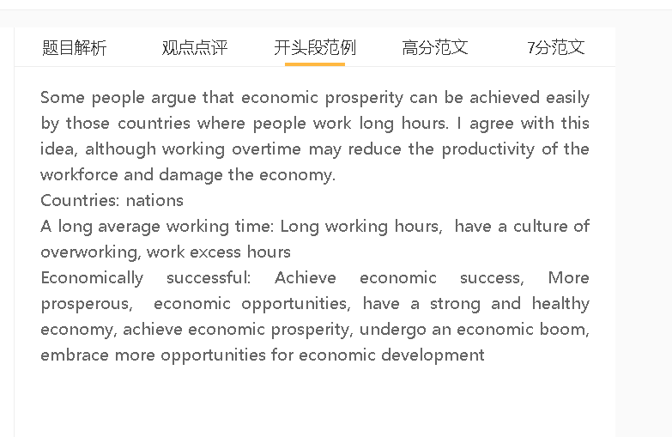

高分范文

Longer working hours are sometimes believed to be a key factor contributing to national wealth. I agree with this idea although unlimited working time may be counterproductive.

A 原因工作时长 B 结果 产出更高 C 结果的结果 促进经济
解释（A-B）：完成很多任务
具体化：生产出更多产品，制定更多的计划，解决更多客户的问题
解释（B-C）：销售额上升，利润更高，增加就业，提高税收
长时间工作可以促进经济，因为劳动力的生产率更高。那些加班的人可以完成更多的任务，例如增加产量，更详细的工作计划以及解决更多的客户投诉。他们的辛勤工作可以显着增加雇主的销售额和收入，从而为整个经济创造更多的就业机会和更高的税收收入。
Working long hours can boost the economy since productivity of the workforce is higher. Those who work extra hours can complete a larger number of tasks, such as increased production, more detailed planning for work, and addressing more customer complaints. Their hard work can increase sales and revenue of their employers significantly, thereby adding jobs and generating higher tax income for the whole economy.

A 原因工作时长 B 结果 经验增加 C 结果的结果 促进经济 since/ because ….
解释（A-B）：不断遇到问题寻找解决方法，不断阅读材料，参加培训，吸收意见 thereby….
解释（B-C）：工作的效率更高，借鉴不同学科的知识最后可以有创新，满足一些潜在的需求，促进销售 who…
另一个原因是人们通过长时间工作积累了相关经验。他们在工作中遇到的问题比普通人多，并且有更强的动力阅读材料以寻找解决方案，接受培训并向高级同事寻求建议，从而逐步建立专业知识。拥有丰富经验的人可以更有效地完成工作，并从不同的学科中汲取灵感，创造性地满足消费者未满足的需求。这可以促进经济成功。
Another reason is that people accumulate relevant experience by working long hours. They encounter more problems at work than average people and have stronger motivation to read material to find solutions, undergo training and consult senior colleagues for advice, thereby building expertise gradually. People who have extensive experience can complete work more efficiently and draw inspiration from different disciplines to satisfy unmet needs of consumers creatively. This can contribute to economic success.

A 原因工作时长 B 结果 健康有问题 C 结果的结果 影响经济 since/as/because
解释（A-B）：休息时间不够，人容易疲劳，容易发生事故受伤；压力比较大，容易导致心脏问题 which, thereby doing…
解释（A-B）：缺乏休闲，人会变得不开心，有一些负罪感，没有陪伴家人。 Who….
解释（B-C）：产出会下降，经常请假，工伤也会影响公司的运作 thereby
另外一方面，过多的工作时间可能会对经济产生负面影响，因为它会导致健康问题。较长的工作日可能会扰乱睡眠模式，从而导致疲劳，工作场所事故和压力引起的心血管疾病。与此同时，那些没有时间休闲或家庭生活的人会感到不快乐或内疚。身体状况和情绪障碍可能导致产量下降和病假增加，从而影响运营并破坏经济。
On the other hand, excessive work time may have a negative effect on the economy as it can cause health problems. Longer working days may disrupt sleep patterns, which cause fatigue, workplace-accidents, and stress-induced cardiovascular disease. Meanwhile, those who have little time for leisure or family life will feel unhappy or guilty. Physical conditions as well as emotional disorders can lead to a decrease in output and a rise in sick leave, thereby affecting operation and wrecking the economy.

In conclusion, I agree that countries that have a culture of working overtime are more likely to succeed in economic terms, although the effect of working excessively long hours can be detrimental.

