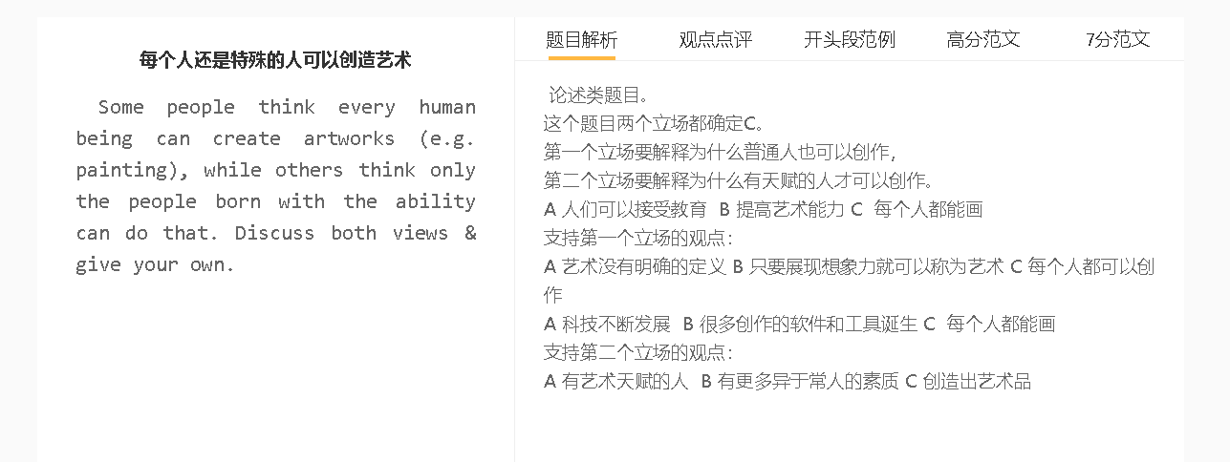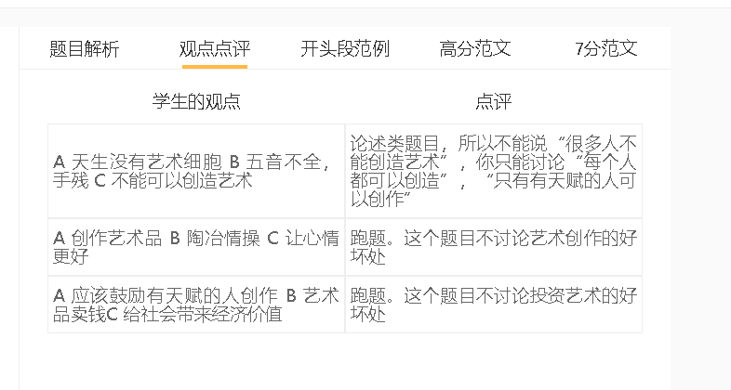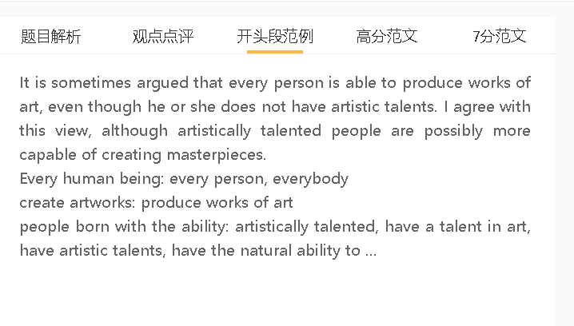

高分范文

It is sometimes argued that everybody is capable of making works of art, such as paintings. I agree with this view, although there is a view that this can be only achieved by those with artistic talents.
A 艺术很难定义 B 一个人的作品都可以称为艺术品 C 每个人都创造艺术
解释A：艺术比较主观，并不是自然世界的产物，不同的地方对于艺术形式的看法有不同
解释（B-C）：参加艺术培训，具备一定的能力和技巧，就可以创作艺术
具体化：颜料、brushes
每个人都能创作艺术作品，因为没有明确的艺术定义，每一件作品都可能在一定程度上具有艺术价值。艺术是主观的，由于艺术品不是由自然世界产生的，而是由人类基于个人兴趣和偏好而创造的，因此各国什么算是艺术品的感知也有所不同。任何接受艺术训练获得相关技能（如绘画和雕塑）的人都能够创作艺术创作。
Everybody is able to create works of art because there is no clear definition of art and every creation can be of artistic value to some degrees. Art is subjective and the perception of what constitutes a piece of artwork varies from country to country due to the fact that artworks are not generated by the natural world but created by human mind based on personal interests and preferences. Any person that receives artistic training to acquire relevant skills, such as drawing pictures and making sculptures, is able to create artistic creations.
A 具备艺术天赋 B 艺术学习和表现能力更强 C 可以创作艺术
解释（B-C）：对于艺术的元素比较敏感
解释（B-C）：具备创造性，具备想象力
另一方面，一些人认为只有那些具有艺术天赋的人才能创造出具有审美价值的东西，因为他们在艺术活动中表现出非凡的能力。他们天生对美学细节有敏锐的洞察力，比如增加物体视觉吸引力的特殊颜色。他们的作品也展现了艺术杰作的独创性和独特品质，这在普通人中是不存在的，即便普通人经过训练来提高视觉素养。
On the other hand, some people think only those with a natural aptitude for art can create something with aesthetic values since they exhibit exceptional abilities in artistic expression. They have an innate eye for aesthetic detail, such as a special colour that adds the visual appeal of an object. Their works also show originality and unique qualities of masterpieces, which are not found among ordinary people, even trained to improve visual literacy.

A 科技发展 B 有很多软件和工具都可以做设计用 C 每个人都可以创作
解释（B-C）：画图软件或者3D设计软件可以让人们选择颜色、图样、线条去绘画还有做雕塑等等，不一定需要掌握相关的技能
解释（B-C）：人工智能，通过机器学习，分析艺术品的特点，然后进行有效的结合和模仿，按照用户的目的和要求创作出艺术品
在我看来，每个人都可以成为艺术品的生产者，特别是当他们由于技术发展而配备了创新工具时。一些先进的绘图应用程序和3D设计软件为他们提供了各种颜色、图案和线条的选择，以设计艺术品，无论他们是否擅长使用传统材料，如油漆和粘土。人工智能已经发展到这样一个地步，人们可以向机器人设计师发出制作他们想要的艺术品的指令，这些艺术品也显示出相当的独创性。
In my view, everybody can be a producer of artworks especially when they have been equipped with innovative tools as a result of technological development. Some advanced drawing apps and 3D design software offer them a great variety of choices in colours, patterns and lines to design works of art, whether or not they are personally expert at using traditional materials such as paints and clay. Artificial intelligence has developed to a point where people can give robotic designers instructions about making works of art they desire, which also show considerable originality.

In conclusion, while creating a masterpiece may demand rare talent, education and technology has empowered every person to create works of art, whose definition is elusive.

