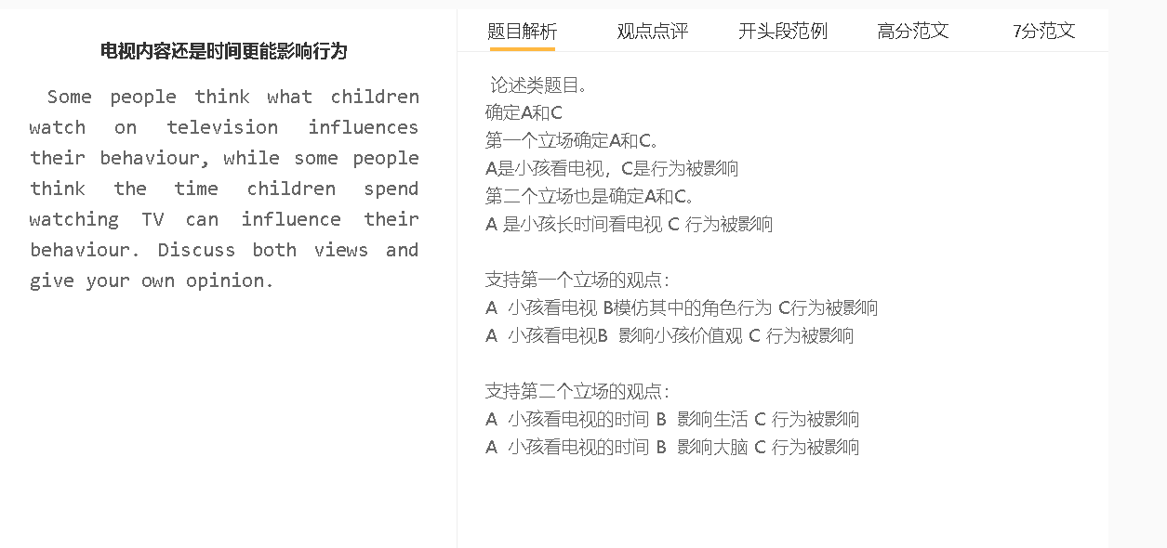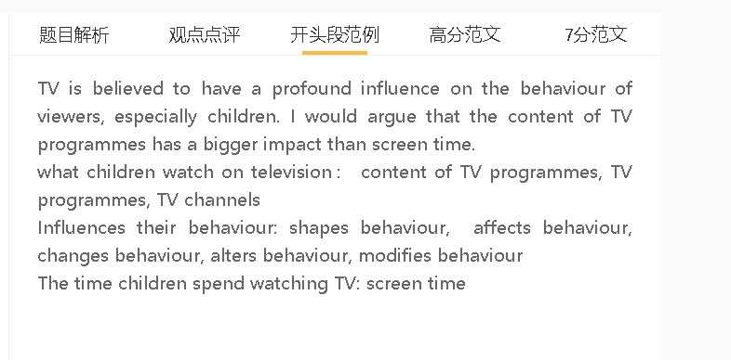

高分范文

TV is believed to have a profound influence on the behaviour of viewers, especially children. I would argue that the content of TV programmes has a bigger impact than screen time.

A 小孩看电视 B模仿其中的角色行为 C行为被影响
背景：小孩缺乏批判思维和社会经历，以为电视的行为代表着社会的真实行为
背景：里面一些可以带来快乐的行为
唯一性：重复观看，没有大人指引
举例：暴力，性，消费，饮食
TV programmes can shape children’s behaviour since these young viewers may copy what they see on TV. They lack criticial thinking and social experience to distinguish fiction from realities. They do not know that the acts of characters of some TV series or dramas are neither acceptable nor normal in real life. Instead, they perceive this kind of behaviour as exciting, admirable and pleasurable, including violence, sexual acts, compulsive consumption and overeating. They may behave in similar ways without knowing the consequences that ensue. This is particularly evident when they are exposed to such content constantly without the guidance of adults.

A 小孩看电视的时间 B 影响生活 C 行为被影响
背景：时间有限
背景：轻松，不用动脑，情节很有趣，有大家喜欢的影星，有趣的卡通人物
背景：小孩缺乏自制力
举例：户外活动，课外活动，社交，学习，睡觉
Other people, by contrast, point to the effect of long screen time on the lives of the audience. The after-school time is limited for every child: the longer hours they spend in front of TV, the less time they can allocate to other parts of lives. Watching TV is highly addictive as it requires minimal mental effort and never fails to engage the attention of viewer with interesting plots, physically attractive figures and amusing cartoon characters. Children who lack self-discipline can indulge in watching their favourite TV programmes without devoting time to outdoor exercise, extracurricular activities, socialisation, academic tasks and even sleeping. It seems that watching TV itself as a pastime can affect the ways of life of children.
A 小孩看电视的时间 B 影响小孩价值观 C 行为被影响
背景：电视让小孩看到更大的世界
解释：电视节目让人们知道生活的各种可能，不同生活方式或者行为的结果
解释：电视可以加深也可以改变小孩的世界观和不同情况下不同事情的看法
举例：看了家庭生活的纪录片可能改变孩子对家庭生活的理解
In my opinion, TV progammes can make a significant impact on children’s behaviour within minutes. TV opens a window on the world and disseminates knowledge and information by showing children a bigger world beyond their home, school or community. A TV drama, advertisement, documentary or news report can inspire and enlighten younger generations by showing them different possibilities in their lives and the outcomes of choosing different ways of life and performing different acts. TV programmes can either reinforce or challenge children’s world views and perception of what they should do in different contexts. A well-crafted, inspirational and thought-provoking TV documentary about family life, for example, lasts possibly twenty minutes but makes a lasting impact on children’s attitude towards the loved ones.

In conclusion, while long screen time can alter one’s behaviour, I would argue that it is not as powerful as content.

