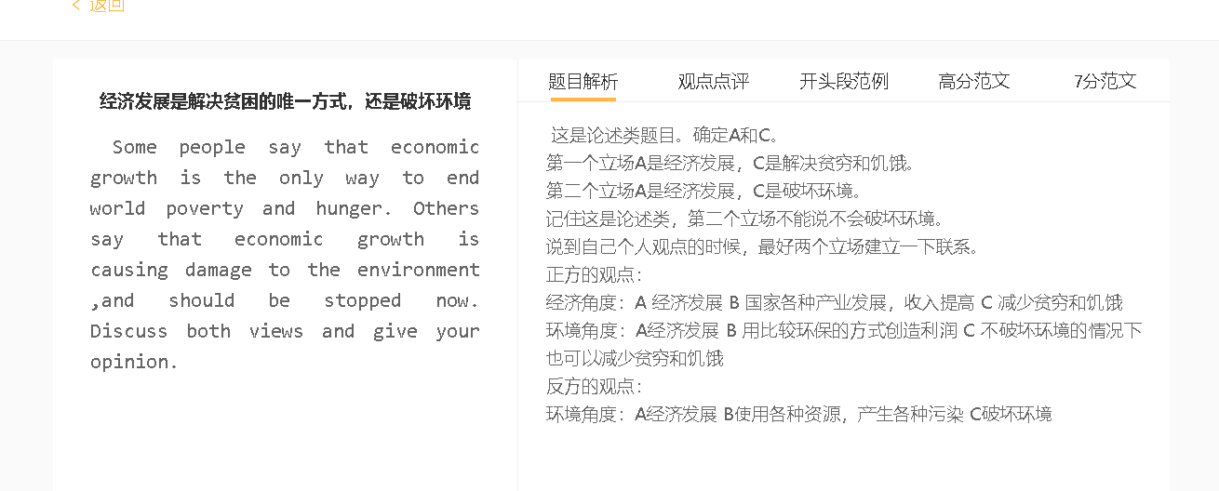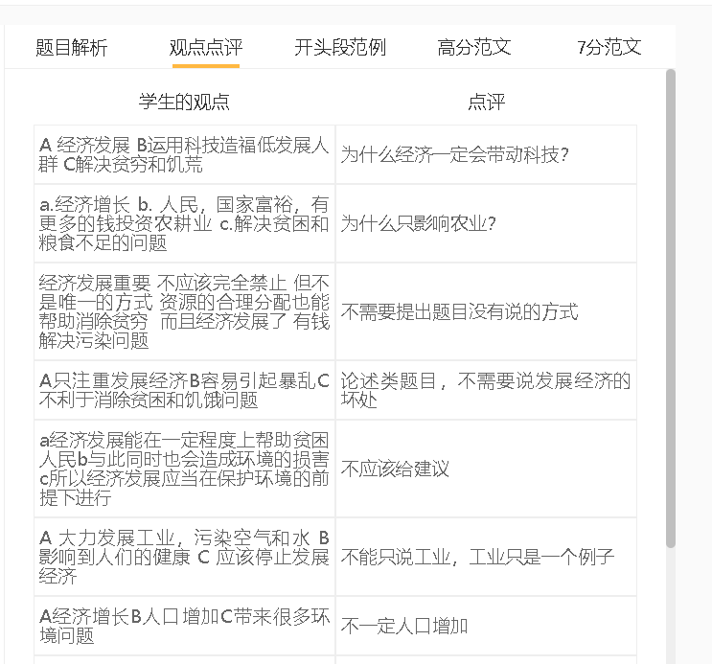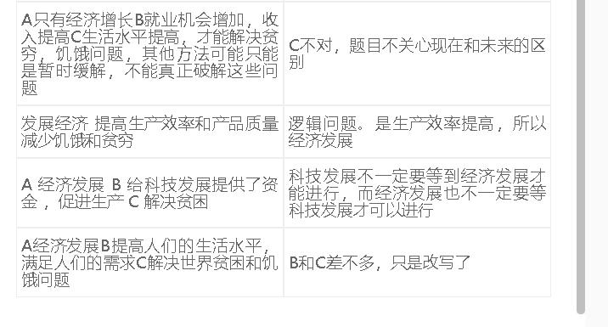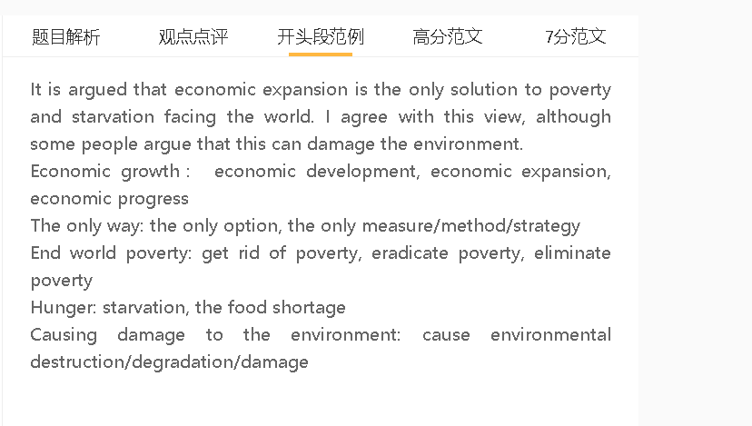

范文

Some people argue that the only way to solve poverty and hunger problems around the world is to develop the economy. I agree with this idea, although it might cause some environment problems if not managed well.
A 经济发展 B 国家各种产业发展，收入提高 C 减少贫穷和饥饿
解释：经济发展，提供就业机会，人们有钱购买生活用品和食物
解释2：政府有钱，可以将钱花在贫穷人口，包括教育，提供生活补助，解决贫穷问题
解释3：经济发展，政府和企业有钱提高科技，提高生产力，增加工业生产和农业生产
Economic progress is perceived as the key in eliminating hunger and poverty because people in a fast-developing economy can earn higher salaries and have money to satisfy their basic needs. Economic expansion encourages businesses, large or small, to hire more employees to increase output, and salaried people can afford basic necessities, including food. The government can also gain more revenue from taxation, and spend more money on poor people, including social benefits for housing, food, medicine and transportation, to solve the problem of poverty. Meanwhile, a robust economy provides capital for government bodies as well as private companies for innovations in technology, thereby manufacturing more products to keep pace with the demand.

A经济发展 B使用各种资源，产生各种污染 C破坏环境
解释1：经济发展 更多的资源被开采 破坏生态环境
解释2：工业发展需要开厂，生产导致废水废气
解释3：农业发展需要使用化肥，化学物会污染水源
解释4：人们生活水平提高，使用各种产品，造成大量垃圾

On the other hand, a strong economy can be a huge threat to the environment as it involves exploitation of resources and genarates different kinds of pollution. In an increasingly rich country, the demand for resources increases and the surge in activities such as mining, oil drilling and logging can damage the environment. In order to fill the growing demand, more and more factories are established but the production process, which relies on machines running on fuel, creates waste water and fumes. Similarly, to increase yields, farmers have to rely on massive use of fertilisers, which contain chemicals polluting water and degrading soil. Greater economic prosperity also improves the standard of living and encourages people to purchase numerous products, which sooner or later end up in landfills and have dire environmental consequences.

A经济发展 B 用比较环保的方式创造利润 C 不破坏环境的情况下也可以减少贫穷和饥饿
背景：大家更有环保意识，对生活环境的要求增加，推动政府立法
解释：迫使企业和农业用环保的方式去生产东西

In my view, it is possible for a country to achieve economic growth to tackle poverty and food shortages without causing environmental damage. As the economy advances, people are better-educated and more aware of the importance of protecting the environment, thereby calling for the enforcement of tougher environmental laws. Stringent laws pressure manufacturers and farmers to adopt green technology to maintain their production in environmentally-friendly ways.

In conclusion, I agree that economic development offers solutions to poverty and food security issues,and environmental problems arising from economic expansion can be solved if technology is introduced.

