A类Task1数据类图表作文

准确度(如何借助**数据**描述、对比趋势或特征)+速度

时间安排：5分钟审题及首段写作+10分钟主体段及结尾段写作+2至3分钟检查。

推荐字数范围：160-180，字数不宜过多。

**图表类型：**

Line Chart / Line graph 动态图（线形图比较特殊，是由无数连续的点构成的动态图）

Bar Chart 动态图或静态图

Pie Chart 动态图或静态图

Table 动态图或静态图

**All of these charts represent numbers and the task is to describe these numbers.**

通过数据描述图表，所以要重视数据！对数据的观察和处理同对图表本身的观察一样重要。这也是为什么柱图、饼图和表格可以相互转换。

* 有时间变化的图表，即动态图。

该类图表主要展示的是动态数据的特征，往往呈现出某种/些趋势。写作核心：结合数据描述、对比趋势(Trends)

注意：拿到图表后要立刻判断趋势的个数、描述顺序(描述的顺序体现对比的有效性)。

* 无时间变化的图表，即静态图。

该类图表主要展现出一定的数据对比，往往呈现某种/些对比而来的特征。写作核心：结合数据描述、对比差异及相似的特征(Features)

注意：拿到图表后要立刻确定可对比差异性，并根据此来确定分段及数据描述的逻辑。

**评分标准：**

Task Achievement

Coherence and Cohesion

Lexical Resource

Grammatical Range and Accuracy

**常用文章结构 (注意根据图表具体情况调整)：**

**Paragraph 1 Introduction + Overview (if it is necessary)**

Sentence 1- Paraphrase Question

Sentence 2- Overview of main feature(s)

Make general comparison, if appropriate

An [overview](https://www.ieltsadvantage.com/2015/05/13/ielts-task-1-overview/) is a general statement, highlighting the most important information in the graph. The examiner is testing your ability to identify the most important information and then summarize it. Important information could include general trends, increases/decreases, differences, comparisons etc.

**Paragraph 2 (Details of significant feature 1)**

Sentence 1- Supporting details

Sentence 2- Supporting details

Sentence 3- comparison details/ exceptions, if appropriate

The examiner is looking for your ability to choose the correct data and ability to describe data, trends, comparisons etc.

**Paragraph 3 (Details of significant feature 2)**

Sentence 1- Supporting details

Sentence 2- Supporting details

Sentence 3- comparison details/ exceptions, if appropriate

There may also be three significant features, in which case you can adjust the structure slightly.

**Paragraph 4 Summary**

To summarize the main features but do not repeat the second sentence in the first paragraph

**Identifying Main Features**

Candidates need to prioritize the information, which means candidates should choose two or three significant features and just write about these.

The examiner expects you to do this and the question will often specifically say ‘select main features.’ There should be 2 or 3 main features for you to comment on.

**Things that candidates should be looking for include:**

High/low values

Regular/irregular values

Biggest increase/decrease

Unchanging/changing data

Biggest majority/ minority (pie charts)

Biggest difference/ similarities

Major trends

Notable exceptions

**Common Problems**

Not knowing which information to include in your answer.

Not using an appropriate structure.

Writing one long paragraph.

Failing to write an effective [overview](https://www.ieltsadvantage.com/2015/05/13/ielts-task-1-overview/).

Failing to support descriptions, trends, and comparisons with accurate data.

Including opinion and drawing conclusions.

Not using appropriate grammar for describing data, trends and making comparisons.

Not using a wide variety of appropriate vocabulary.

Copying words and phrases from the question.

**动态图**

Number of full-time teachers of regular schools (in millions) in China (1960~1990)

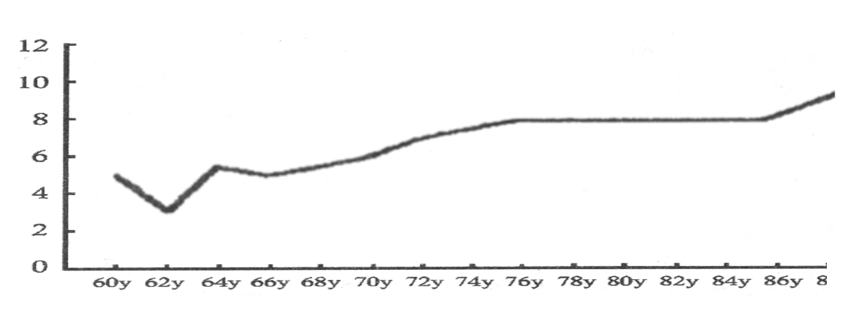

第一段：

The line graph describes changes/variation in the number of full-time teachers of regular schools in millions in China from 1960 to 1990. 首段第一句：简介图表 主句谓语用一般现在时

As can be seen, although there were some fluctuations in earlier years, the overall trend indicated the growing number of teachers in this 30-year period. 第二句：整体趋势，有时可省略。



第二段：

According to the figure, there was a sharp decrease in the number of teachers from 5 million in 1960 to 3 million in 1962, followed by a rapid increase over the next two years.

= The number of teachers decreased sharply from 5 million in 1960 to 3 million in 1962, which was followed by a rapid increase over the next two years.

The number dropped again from almost 6 million in 1964 to 5 million in 1966 and then went up gradually to 8 million in 1976. 并列谓语

Afterwards, the number remained unchanged for the next ten-year period.

The years from 1986 to 1990 saw/witnessed/experienced a steady rise in the number of teachers, ending at 10 million.

Besides, it can be noticed that in 1962 the number reached the bottom, while /whilst /whereas 1990 saw the peak during this period.

第三段：

In conclusion, more teachers were in Chinese regular schools in 1990 than 30 years before.

**The graph below shows radio and television audiences throughout the day in 1992.**

Radio and television audiences in the UK, October-December 1992

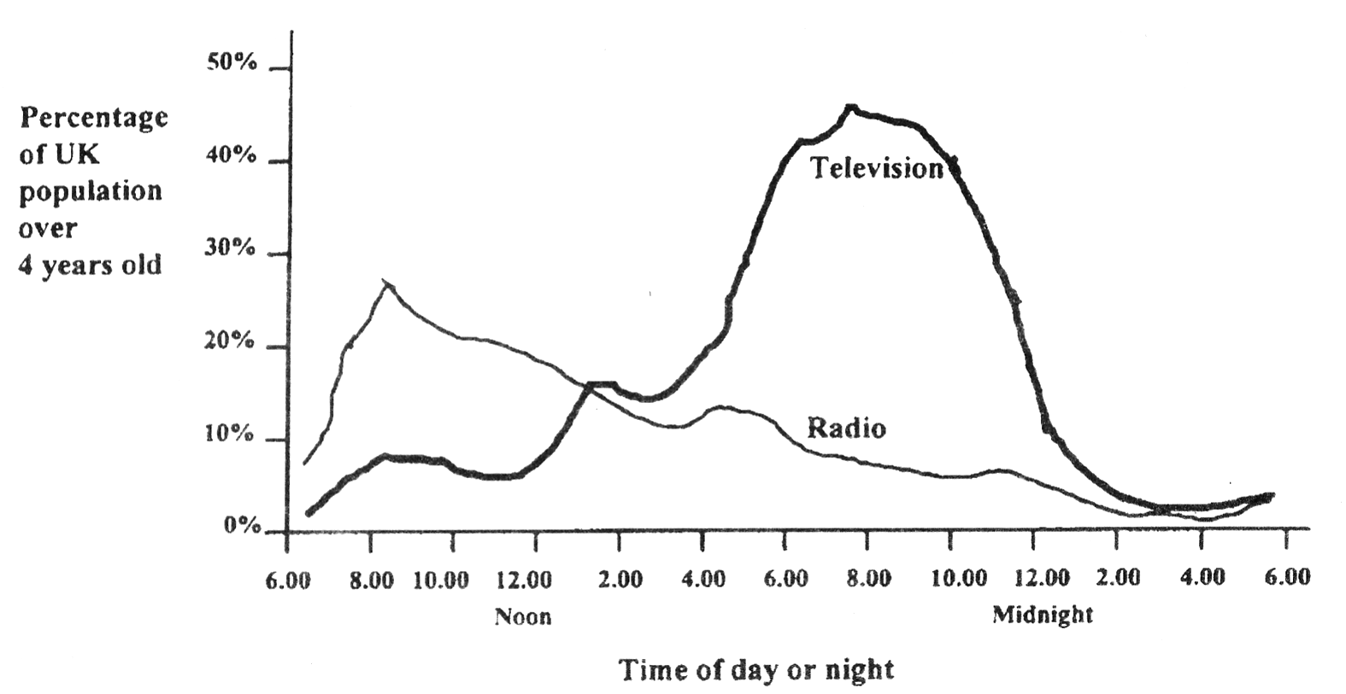

The line graph show**s** changes in the percentage of radio and television audiences over 4 years old in the UK throughout the day from October to December in 1992. The figure reveal**s** that before 2:00 pm there **were** more radio audiences, while after 2:00 pm more people turn**ed** to television. 线型图中交点意味着趋势的转变

广播听众

The data indicate**s** that **radio listeners** increased substantially before 8:00 am**, when** the percentage reached the peak**, at** 27%. The percentage then declined steadily to 11% at 4:00 pm**, which was followed by** a slight increase to 15% at 5:00 pm. However, **from then on**, there was **again** a gradual decrease to 2% until 4:00 am**, when** the percentage bottomed out. The period from 4:00 am to 6:00 am saw **another** slight rise to 4% **in radio listeners**.

电视观众

As for TV viewers, the percentage went up from 6:00 am to 8:30 am**, when** there was **a leveling off at 8%** until 10:00 am. **After a slight decrease,** the percentage rose sharply to 15% between 12 pm and 2 pm**, before it** dropped slightly. The peak (45%) was reached at 8:00 pm **after** a massive rise from 14% since 3:00 pm. However, the period between 8:00 pm and 3:00 am saw a slump in television viewers. The percentage reached the bottom of 3% at 3:00 am**, when** there was a slight rise afterwards.

主体段两根线分开写，以上两段是为了展现句式表达，所以写得比较细致，考试描述的可以更简略。

The general trend was that the percentage of both radio and television audiences rose first and then decreased, **while the total number of the latter was bigger than the former.** In addition, the prime time for radio and television was 8 am and 8 pm**, respectively.** 结尾段可补充其他趋势特征

剑桥7

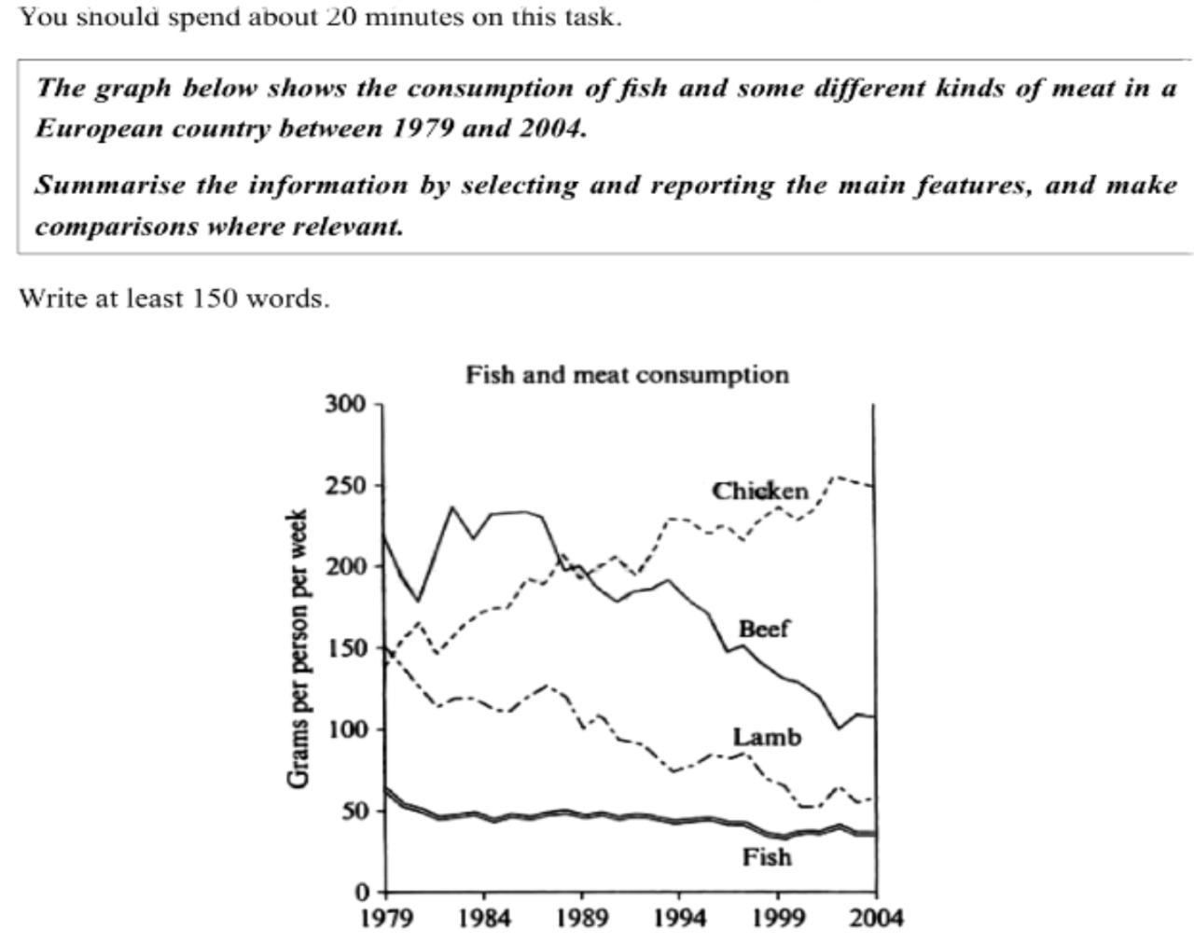

审题时确定topic 描述语言，切忌脱离话题描述图表。

第一段：简介图表 (+ 整体趋势或特征介绍)

show, describe, illustrate, demonstrate, outline, give information about ...

范文：

The line graph illustrates changes in the amount of beef, lamb, chicken, and fish consumed in a particular European country between 1979 and 2004.

In 1979, beef was by far the most popular of these foods with about 225 grams consumed per person per week. Lamb and chicken were eaten in similar quantities (around 150 grams), while much less fish was consumed (just over 50 grams).

However, during this 25-year period, the consumption of beef and lamb fell dramatically to approximately 100 grams and 55 grams, respectively. The consumption of fish also declined, but much less significantly to just below 50 grams, so although it remained the least popular food, consumption levels were the most stable.

The consumption of chicken, on the other hand, showed an upward trend**, overtaking that of** lamb in 1980 **and that of** beef in 1989. By 2004, it had soared to almost 250 grams consumed per person per week.

Overall, the graph shows **how** the consumption of chicken increased dramatically **while the popularity of** these other foods decreased over the period.

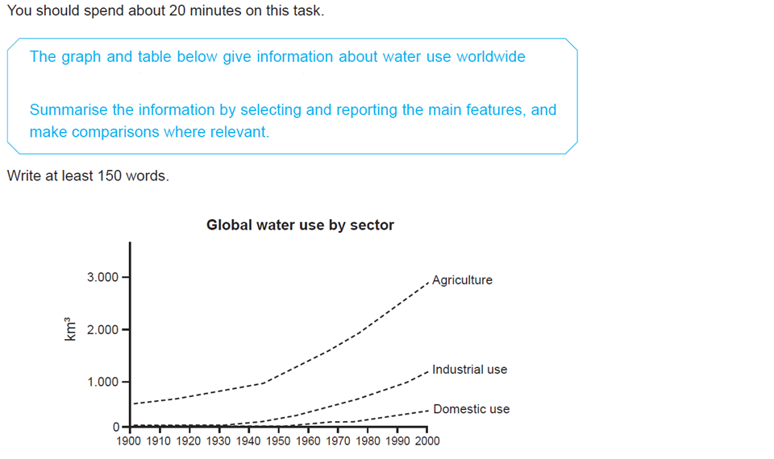

选自Cambridge 6 Test1的混合图，此处重点讲解第一幅线图，完整的混合图及范文请参考剑6

The line graph describes changes in the amount of water used worldwide in different sectors from 1900 to 2000.

Throughout the century, the largest quantity of water was used for agricultural purposes, and this increased dramatically from about 500km3 to around 3,000 km3 in the year 2000.

Water used in the industrial and domestic sectors **also** increased**, but** consumption was minimal until mid-century.

From 1950 onwards, industrial use grew steadily to just over 1,000km3, while domestic use rose more slowly to only 300km3, both far below the levels of consumption by agriculture.

**剑5 Test1 Task1**

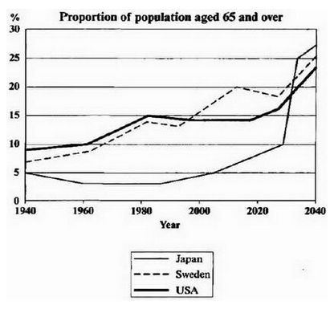

The line graph describes **the increase in** the aging population in Japan, Sweden, and the USA from 1940 to 2040.

In 1940 the proportion of people aged 65 and over stood at only 5% in Japan, approximately 7% in Sweden, and 9% in the USA.

The figures for Sweden and the USA then grew up to below 15% in around 1982. Afterwards, the population aged 65 and over in Sweden experienced a slight decrease and continued increasing to 20% in around 2012, and after some obvious fluctuations, the figure **is predicted to** reach 25%. In contrast, the figure for the USA remained just below 15% since 1996 until around 2017, and then it **is expected to** increase to below 25% in 2040.

The situation in Japan was different from 1940 to 2008, and the population aged 65 and over was below 5% during this period. Afterwards, the figure for Japan **is projected to** increase dramatically to above 25% in 2040.

Overall, the line chart indicates that the percentage of people aged 65 and over in all three countries **is estimated to** increase to almost 25% of the respective populations by the year 2040.

**图表作文将来时谓语：**

**is expected to**

**is estimated to**

**is projected to**

**is predicted to**

**is forecast to**

**剑9 Test4 Task1**

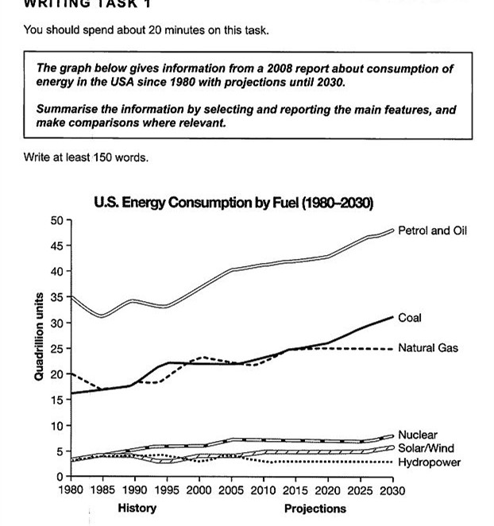

The line graph shows energy consumption in the US from 1980 to 2020 and projected consumption to 2030.

Petrol and oil have been and will continue to be **the dominant fuel sources** throughout this period, with 35 quadrillion (35q) units used in 1980. Despite some initial fluctuations, from 1995 there was a steady increase. This is expected to continue, reaching 47q in 2030.

Consumption of energy **derived from** natural gas and coal has been and will continue to be similar over the period. From 20q and 15q respectively in 1980, gas illustrated an initial fall and coal demonstrated a gradual increase, with the two fuels equal between 1985 and 1990. Consumption has fluctuated since 1990 but both now provide 24q. Coal is predicted to increase steadily to 31q in 2030, whereas after 2014, gas will remain stable at 25q.

In 1980, energy from nuclear, hydro power, and solar/wind power **was equal at** only 4q. Nuclear has risen by 3q and solar/wind has increased by 2q. After slight increases, hydro power has fallen back to the 1980 figure. It is expected to maintain this level until 2030, while the others would rise slightly after 2025.

Overall, the US will continue to rely on fossil fuels, with sustainable and nuclear energy sources remaining relatively insignificant.

**The chart below shows the percentage of commuters using different modes of transport in London in 1960, 1980, and 2000.**

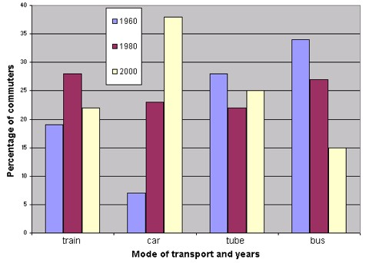

动态图 描述、对比趋势 tends

对比趋势的关键是——趋势描述的顺序

审题：

1. 确定topic：确定描述的语言language

4 modes/means of transport

popular, popularity

use, prefer, choose ...

commuting bus ...

2. 确定数据所指代的对象：一般作句子主语

commuter, people

3. 数据单位

%

percentage

proportion

注意ratio意思不一样

首段：

The bar chart describe**s** variation/changes in commuting by train, car, tube, and bus for commuters(=the percentage/number of commuters/people using train, car, tube, and bus) in London in the years 1960, 1980, and 2000. 简介图表的句子主句谓语用一般现在时

第二段：

The number/proportion of people using *trains* at first rose from just under 20% in 1960 to about 28% in 1980 but then fell back to about 23% in/by 2000.

并列谓语结构(rise & fall)

非谓语动词之分词的用法：using

体现出对比的词汇表达： back，again

体现准确度的副词： about, around, roughly, approximately; just under/over/above/before/after

Conversely, the use of *tube* was relatively stable, falling from around 27% of commuters in 1960 to 22% in 1980 but climbing back to 25% in/by 2000.

= Conversely, the use of *tube* was relatively stable, which fell from around 27% of commuters in 1960 to 22% in 1980 but climbed back to 25% in/by 2000.

By/In contrast,… = Conversely,.... 主要用于段落之间、句子之间的对比！表示情况基本相反！

Similarly,... 同上，表示情况基本相似！

**分词作伴随状语**

第三段：

On the other hand, the use of *cars* increased steadily from just over 5% in 1960 to 23% in 1980, reaching almost 40% by 2000, while/whilst/whereas **the popularity of** *buses* had declined since 1960, falling from just under 35% in 1960 to 27% in 1980 and only 15% by 2000.

by 到...， 经常搭配完成时态使用

达到 v. ：

reach + 数据

amount to +数据

arrive at + 数据

对比句型：

while/whilst/whereas 尽管

While A... , B... = A... , while B...

结尾段：

*In 1960*, tubes and buses were the most popular means of commuter transport, between which the latter was of greater popularity, whereas cars substituted them *in 2000* to become the first mode of transport used by people.

数据类图表作文重点句法： 1.介词和介词短语的使用 2.并列谓语 3.非谓语动词(分词) 4.对比句型

**The graph below shows the different modes/means of transport used to travel to and from work in one European city, in 1950, 1970, and 1990.**

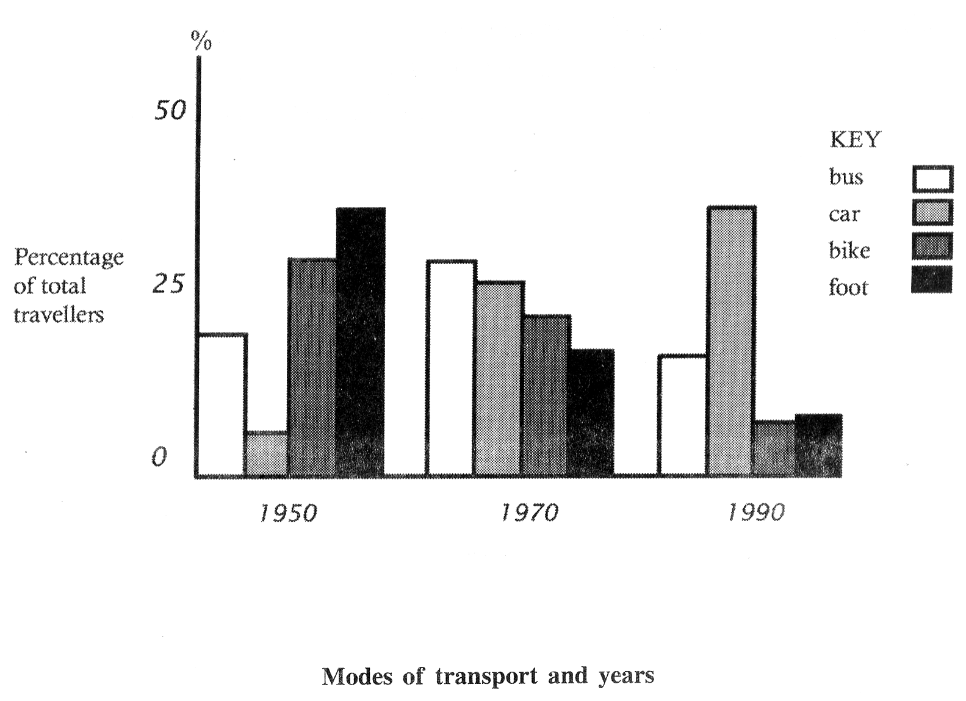

The bar chart indicates changes in the percentage of travelers using different modes of transport among total travelers in one particular European city in 1950, 1970, and 1990.

A very noticeable trend was the steady decrease in transport by bicycle and on foot. In 1950, more than 50% people traveling to work preferred these methods. However, by 1990, less than 25% travelers were cycling or walking to work.

During the same period, there was a large increase in the use of cars. In 1950, only a few people traveled to work by car. By 1970, approximately one out of every four travelers drove to work. This proportion increased again, until 1990, when one in three travelers drove to work.

The number of people taking the bus increased from 1950 to 1970(reaching just above 25%), but then decreased back to 1990.

In 1950, walking to and from work was the most popular means of transport, but cars took its place in 1990.





The bar chart shows the increase in the number of people living in cities in three continents over three time periods, as a percentage of the overall population.

In 1950, 30% of the people were urban residents across the world. Compared to this, both Asia and Africa had fewer city-dwellers than the world average (Asia failing to reach 20%, with Africa not far behind it). In Latin America and the Caribbean, meanwhile, 40% of the population lived in cities. This general trend continued in 2000.

In 2000, urban migration increased worldwide, with almost 50% of the world’s population living in cities. Following the general pattern outlined above, around 40% of the Asians and Africans lived in cities, while Latin America and the Caribbean outstripped the world average by a clear 20%——nearly 70% of their population had moved to cities.

By 2030, city-living is expected to be the norm for 60% of the humanities. Africa and Asia are predicted to finally tip over the 50% mark, with marginally more Asians living in cities than their African counterparts. On the other hand, nearly 80% of people in Latin America and the Caribbean are forecast to have moved to urban areas by 2030.

Overall, the graph indicates that most of the people (over 50%) in these continents are estimated to live in urban areas by the year 2030.

**剑9 Test2 Task1**

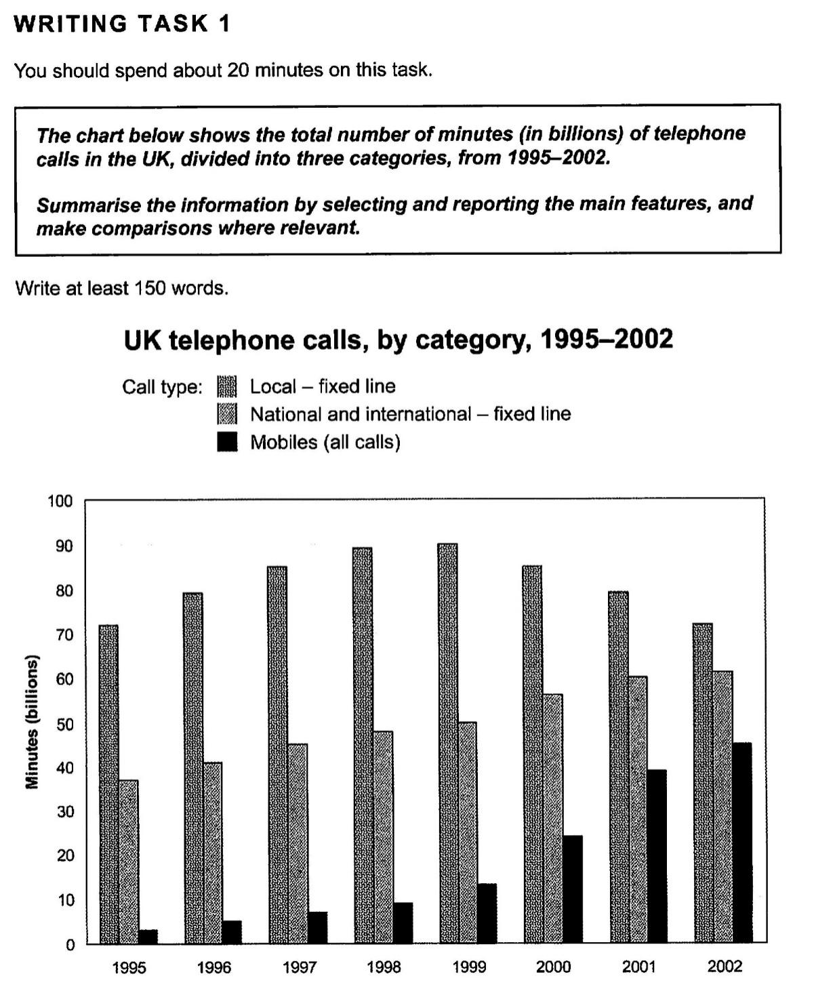

The bar chart shows the time spent by UK residents on different types of telephone calls between 1995 and 2002.

Local fixed line calls were the highest throughout the period**, rising from** 72 billion minutes in 1995 to just under 90 billion in 1998. After peaking at 90 billion the following year, these calls **had fallen back to the 1995 figure by 2002**.

National and international fixed line calls grew steadily from 38 billion to 61 billion at the end of the period in question**, though the growth slowed over the last two years.**

There was a dramatic increase in mobile calls from 2 billion to 46 billion minutes. **This rise was particularly noticeable between 1999 and 2002, during which the time used on mobile phones tripled.**

To sum up, **although local fixed line calls were still the most popular in 2002, the gap between the three categories had narrowed considerably over the second half of the period in question.**

**静态图**

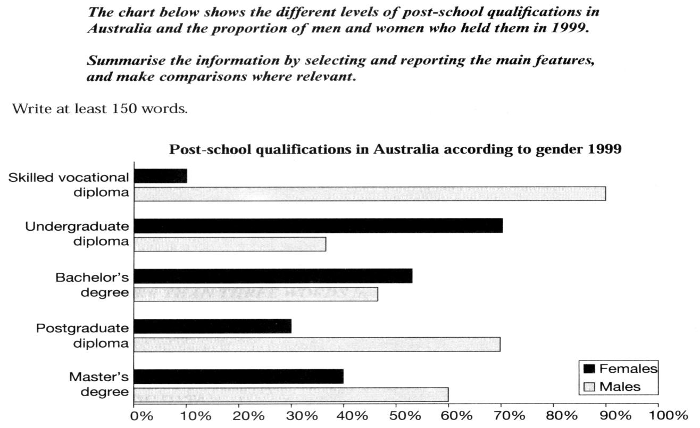

The bar chart **compares** the difference in the percentage of post-school qualifications in terms of different levels of further education reached by men and women in Australia in 1999.

The biggest gender difference was at the lowest post-school level, where 90% of those who held a skilled vocational diploma were men, compared with only 10% of women. The disparity差异性 at the higher levels of education was also noticeable, although not that significant, with the fact that men who successfully received postgraduate diplomas clearly outnumbered their female **counterparts对比对象** (70% and 30%, respectively) and also constituted 60% of Master’s graduates.

**=**The disparity差异性 at the higher levels of education was also noticeable, although not that significant. Men who successfully received postgraduate diplomas clearly were more than females (70% and 30% respectively). Besides, men constituted 60% of Master’s graduates.

By contrast, more women held undergraduate diplomas (70%) and marginally more women reached degree level (55%).

Thus, we can see that more men than women held qualifications at the lower and higher levels of education, while more women reached undergraduate diploma level than men. The gender difference was the smallest at the level of Bachelor’s degree.

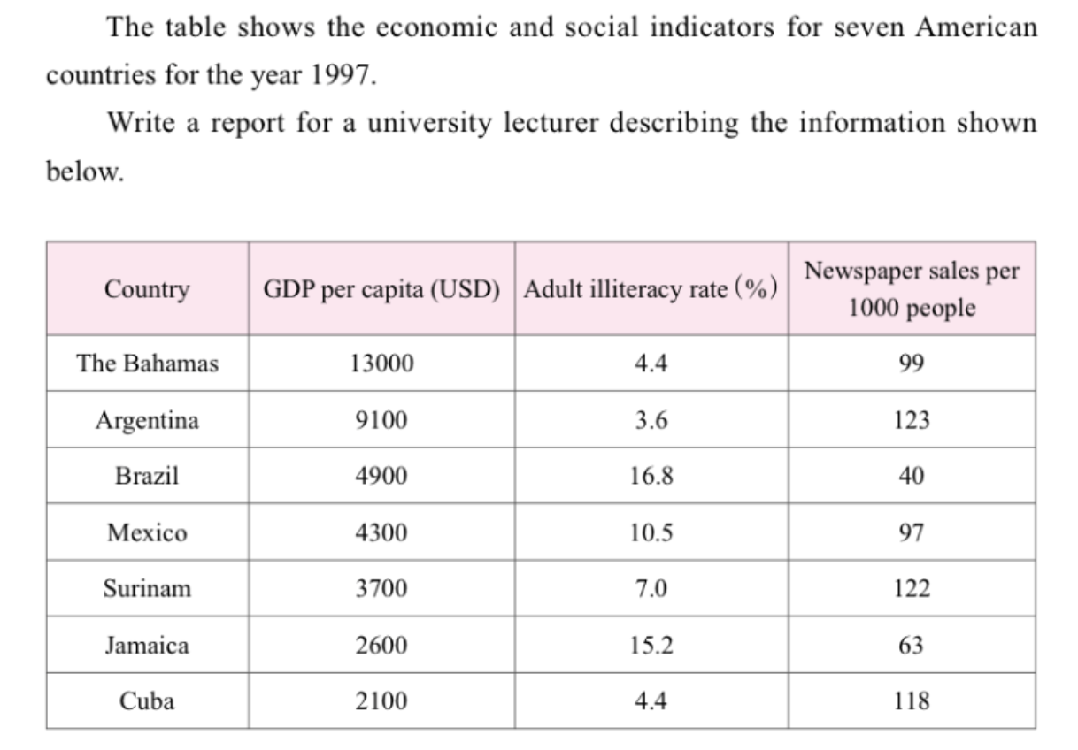

The table compares changes/variation in the GDP per capita, adult illiteracy rates, and newspaper sales per thousand people of seven countries in 1997.

As can be seen, GDP per capita varied substantially from 2100 USD in Cuba to 13000 USD in the Bahamas, with 5 of the 7 countries below 5000 USD per capita GDP.

The illiteracy rates also differed considerably. The highest illiteracy rates were for Brazil (16.8%) and Jamaica (15.2%), whilst Argentina had the lowest rate, at 3.6%. ~~Mexico (10.5%) and Surinam (7%) lay in the middle.~~ Surprisingly/Interestingly, the adult illiteracy rate for Cuba and the Bahamas were the same, at 4.4%.

Newspaper sales per thousand people were also diverse. Argentina had the lowest illiteracy rate and the highest newspaper sales per thousand people (123/1000). Surinam (122/1000) and Cuba (118/1000) had similar rates. ~~The Bahamas (99/1000) and Mexico (97/1000) had relatively high levels, too.~~ Jamaica (63/1000) and Brazil (40/1000) had the lowest levels and had the highest illiteracy rates.

From the table, we can see the relative connection between these three social and economic indicators.



The table compares changes/variation in the percentage of expenditure of 5 countries on 3 categories of items.

People in Turkey (32.14%) and Ireland (28.91%) spent relatively high amount on food/drinks/tobacco, whilst consumers in Spain (18.80%), Italy (16.36%), and Sweden (15.77%) spent roughly half of their proportions.

The percentage for spending on clothing/footwear differed to a lesser degree. Consumers in Turkey (6.63%), Spain (6.51%), and Ireland (6.43%) spent around 6.5% of their household expenditure on clothing/footwear. People in Sweden spent a lower proportion (5.40%) and people in Italy spent relatively more (9.00%).

Spending on leisure/education was relatively low in all five countries, though there were marked differences. People in Turkey spent the highest percentage on this category of items (4.35%). Those in Sweden and Italy spent almost exactly the same percentages (3.22% and 3.20% respectively). In Ireland, the figure was 2.21% and in Spain it was 1.98%, which was less than half of the figure for Turkey.

Overall, we can see that spending on food/drinks/tobacco was always greater than spending on clothing/footwear, which in turn was always higher than expenditure on leisure/education.

**The pie charts show the amount of oil production and consumption measured in million barrels per day (MB/D) in seven regions in the year 2001. Write a report for a university lecturer describing the information shown below.**

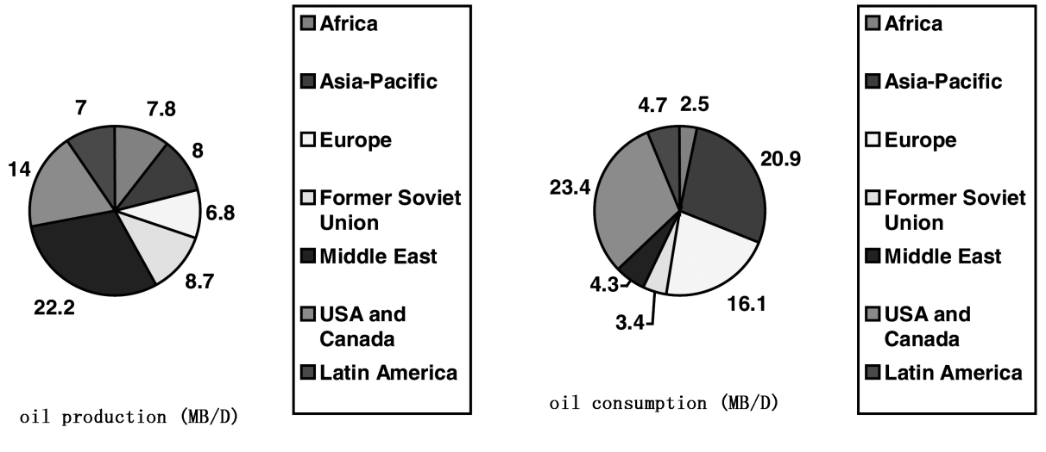

The pie charts show the world divided into seven regions and the amount of oil produced and consumed in those regions in MB/D in 2001. In total, the amount of oil consumed **exceeded** that produced by 0.8MB/D.

The regions can be divided into two groups—one where production **outpaced** consumption and the other where the reverse was the case. The former group consisted of Africa, the Former Soviet Union, the Middle East, and Latin America. The Middle East was by far the largest producer (22.2 MB/D), but its consumption was relatively low (4.3 MB/D) – just a fifth of what it produced. Africa produced 7.8 MB/D, over three times of what it consumed (2.5MB/D).

The other group consisted of the Asia Pacific region, Europe, and the USA and Canada. The USA and Canada were the region which consumed the most oil (23.4 MB/D), though we can see that it was also the second largest producer region (14 MB/D). The Asia Pacific region was the second largest consumer (20.9 MB/D). Europe was the third largest consumer (16.1 MB/D) and the smallest producer (6.8 MB/D).

From the information above, we can see that oil production and consumption were not even around the world in 2001.

**The pie charts below show units of electricity production by fuel source in Australia and France in 1980 and 2000.**

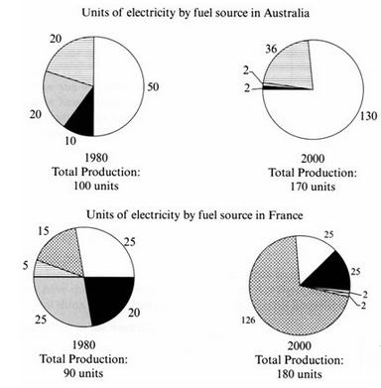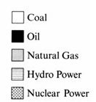

The pie charts **compare** the sources of electricity in Australia and France in the years 1980 and 2000. Between these years electricity production almost doubled**, rising** from 100 units to 170 units in Australia, and from 90 units to 180 units in France.

**澳大利亚：**  
In 1980, Australia used coal (50 units) as the main electricity source, and the remainder was produced from natural gas, hydro power (each producing 20 units), and oil (which produced only 10 units). By 2000, coal had become the fuel for more than 75% of electricity produced, and only hydro continued to be another significant source, supplying approximately 20%.

**法国：**  
In contrast, France used coal as a source for only 25 units of electricity in 1980, **which was matched by** natural gas. The remaining 40 units were produced largely from oil and nuclear power, with hydro contributing only 5 units. But by 2000 nuclear power, which was not used at all in Australia, had developed into the main source, producing almost 75% of electricity, at 126 units, while coal and oil together produced only 50 units. Other sources were no longer significant.  
  
Overall, it is clear that by 2000 these two countries relied on different principal fuel sources**:** Australia relied on coal and France on nuclear power.

饼状图表示“占”的表达：

account for

consist of

comprise

constitute

make up

take up

Task 1 questions that feature more than one graph 混合图

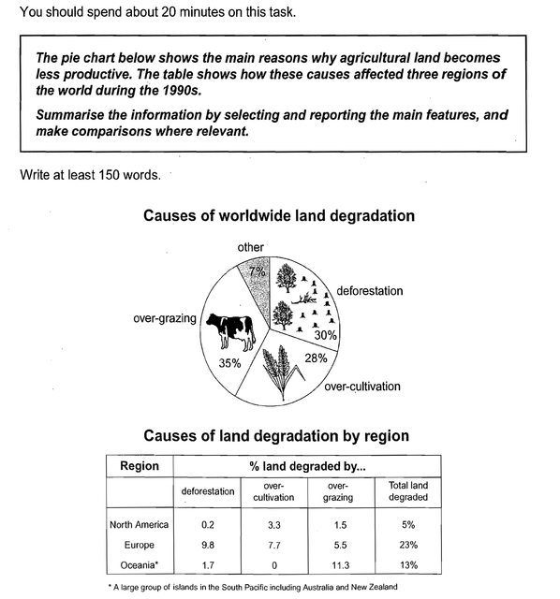

Cambridge IELTS 8

For example, in the question above we are asked to summarize both a pie chart and a table. You could also be given a line graph and a bar chart, a pie chart and a line graph, or any other combination.

**Common Problems**

**Writing too much 无信息省略**

Because there is more than one data source, candidates tend to write about everything and this causes two problems.

**Cannot find the main features 无法确定重点数据特征**

This is related to the first point.

**Not grouping information into paragraphs**

**Making comparisons**

**Structure**

This structure can be used for every question in which you are given two different graphs.

**Paragraph 1**

Sentence 1- Paraphrase question sentences.

There will normally be two question sentences and you should combine them into one sentence by using ‘and’并列句 or ‘while对比句型. This will allow you to produce a complex sentence and gain points for grammatical range and accuracy.

**Paragraph 2**

Sentence 1- [Overview](https://www.ieltsadvantage.com/2015/05/13/ielts-task-1-overview/)of 2-3 of the main features from graph number **1**.

Sentence 2- Details of **first** main feature of graph number **1**,

Sentence 3- Details of **second** main feature of graph number **1**.

**Paragraph 3**

Sentence 1- [Overview](https://www.ieltsadvantage.com/2015/05/13/ielts-task-1-overview/)of 2-3 of the main features from graph number **2**.

Sentence 2- Details of **first** main feature of graph number **2.**

Sentence 3- Details of **second** main feature of graph number **2**.

Sentence 3- Details of any comparisons (if any).

**Paragraph 4**

Overview of any comparisons if necessary (optional).

**真题解析**

The pie chart below shows the main reasons why agricultural land become less productive. The table shows how these causes affected three regions of the world during the 1990s.



**Model Answer**

The pie chart displays the principal causes why farming land **deteriorates**, while the table illustrates how three regions of the planet **were affected by these factors** in the 1990s.

We can clearly see from the pie chart that there are three primary causes of farmland degradation, and over-grazing is the major one (35%). The pie chart represents four causes, with over-grazing representing the biggest proportion, at just over a third. Widespread clearing of trees and the over-use of crops constitute nearly one third and just over a quarter, respectively.

The table shows that Europe had a far higher percentage of unproductive land (23%) compared to the other two regions in this time period. As it can be seen that nearly 10% of Europe’s entire surface had fallen victim to deforestation. The figure in Oceania was marginally lower than that in Europe, with **a value of** 13%, and the main cause was over-grazing (11.3%). By contrast, only a small proportion of North America’s total land (5%) became less productive (mainly due to over-cultivation, at 3.3%).