地图题写作：

* Different kinds of map question
* Structure
* Describing specific changes
* Describing general changes
* Describing locations
* Model essays

There are five main types of map question:

Describe one map in the present day.

Describe two maps- one in the present and one in the future.

Describe two maps- one in the past and one in the present.

Describe three maps- two in the past and one in the present.

Describe three maps- one in the past, one in the present and one in the future.

You will normally be shown two or three maps, asked to select and report the main features and make comparisons where relevant. You will obviously be using corresponding tenses to describe the maps and how the place has developed. Besides, as this is a man-made process, we will use the passive.

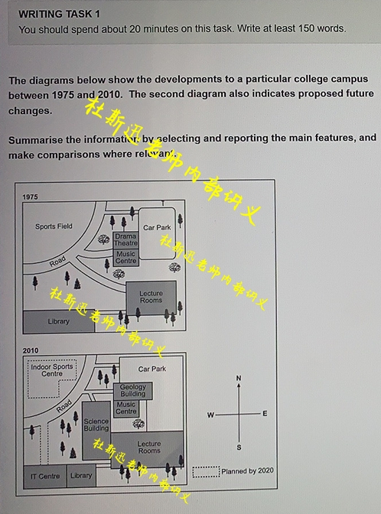

本题难度系数较大

The maps demonstrate the layouts of a campus site in 1975 and 2010 and the planned one in 2020. It is easy to notice that many facilities had been constructed during the first 35-year period, and some more are predicted to be established in 2020.

In 1979, a sports field of relatively great coverage was in the northwest corner of the campus, while a small car park with trees surrounding by could be noticed to the northeast corner. There was a path connecting the ring road of sports field to the car park, to the south of which a drama theater and a music center were sited in order on the west of the car park, with a track leading to the ring road for access. Additionally, some lecture rooms occupied the southeast corner of the campus with trees nearby**, and** two paths directing to the sports field and to the library (which was situated in the southwest corner) were constructed respectively.

In 2010, the car park was expanded its size to all the directions and connected the lecture rooms (which almost doubled its former size) on the south. The former drama theater was converted to a geology building with a bigger size**, and** its path to the ring road of the sports field led to the track to the science building which was established right on the west of the lecture rooms. In addition, the former library gave away 2/3 of its space in the southwest corner of the campus to the construction of the IT center.

In 2020, some possible construction plans are expected to be conducted. An indoor sports center is projected to be establish in the sports field**, and** a link rood is estimated to be build, connecting the ring road of the sports field to the IT center for easier access.

Overall, despite the apparently significant changes outlined above, the campus retains its basic elements of threes and plants.

**杜斯迅老师的原创参考范文 仅供学习使用**

* Structure

Paragraph 1 简介图表信息 + 概括整体变化

Paragraph 2- Main Body 1完整描述第一个地图，重点是描述的逻辑、方法，以及句式结构。

Paragraph 3- Main Body 2对比第一个地图，描述出变化。

Paragraph 4结尾段补充说明，如要总结变化特征避免与首段重复。

* How to Describe Specific Changes

Buildings– demolished, knocked-down, flattened, replaced, renovated, built, constructed, reconstructed, developed, extended, expanded, relocated, converted, or modernized.

Examples:

The government demolished the industrial estate and developed a sports ground.

They removed the shops and replaced it with a skyscraper.

A port was constructed at the edge of the river.

The factory in the city center was demolished and relocated to the north of the city.

The old warehouses were replaced with new hotels.

The factory was converted into apartments.

Trees and Forests- cleared, cut-down, chopped-down, removed, or planted.

The forest was cut-down and replaced with a shopping center.

The trees were cleared to make way for houses.

Roads, bridges, and railways lines- constructed, built, extended, expanded, or removed.

The main road was extended and a new bridge was built over the river.

Leisure facilities- opened, set up, or developed.

A skate park was set up next to the swimming pool.

A park was developed beside the forest.

* How to Describe General Changes

Below are some examples of general statements we could use to describe change in towns and cities.

Over the period, the area witnessed dramatic changes.

From 1995 to 2005, the city center saw spectacular developments.

The village changed considerably over the time period.

During the 10-year period, the industrial area was totally transformed.

Over the past 20 years, the residential area was totally reconstructed.

Over the time period, the old docks were totally redeveloped.

Between 1995 and 2005, the old houses were rebuilt.

The central business district was completely modernized during the time period.

* How to Describe Locations

Examples:

The forest to the south of the river was cut down.

A golf course was constructed to the north of the airport.

The houses in the southwest of the town were demolished.

The green fields to the northwest of the city were redeveloped **as** a park.

The airport in the center of the city was relocated to the northeast of the river.

The school to the southeast was knocked down and a new one was built to the east of the forest.

Examples:

Dramatic changes took place in the city center.

To the south of the town, there is a golf course **surrounded** by trees.

A new school was built next to the swimming pool.

The old road **running** from north to south was replaced by a new motorway.

A marina was built on the banks of the river.

The first potential /possible /suggested location /site is…

A is sited just **off** the main road to … (“A 位于通向……的马路旁边”，其中to可替换为leading to)

A is **in** the east /south/ west/ north of B ( “in”表示 “A在B的内部”)

A is **on** the east /south/ west/ north of B ( “on”表示 “A与B接壤”)

A is **to** the east /south/ west/ north of B ( “to”表示 “A与B不接壤”)

A is situated /located 100 km southeast of B. (A位于B的东南方100公里处。)

倒装句在地图写作中的应用：

1. 表示方位的短语放在句首。比如：West of the lake lies the village.
2. 表语置于句首时，倒装结构为“表语+系动词+主语”。
3. 过去分词+系动词+主语 比如：Located in the east of the park was a parking area.
4. 介词短语+be+主语 比如：In the south lies a shopping mall.

* Model essay

真题一：

**The maps below show the site of a school in 2020 and the planned one in 2025.**

**Summarize the information by selecting and reporting the main features, and make comparisons where relevant.**

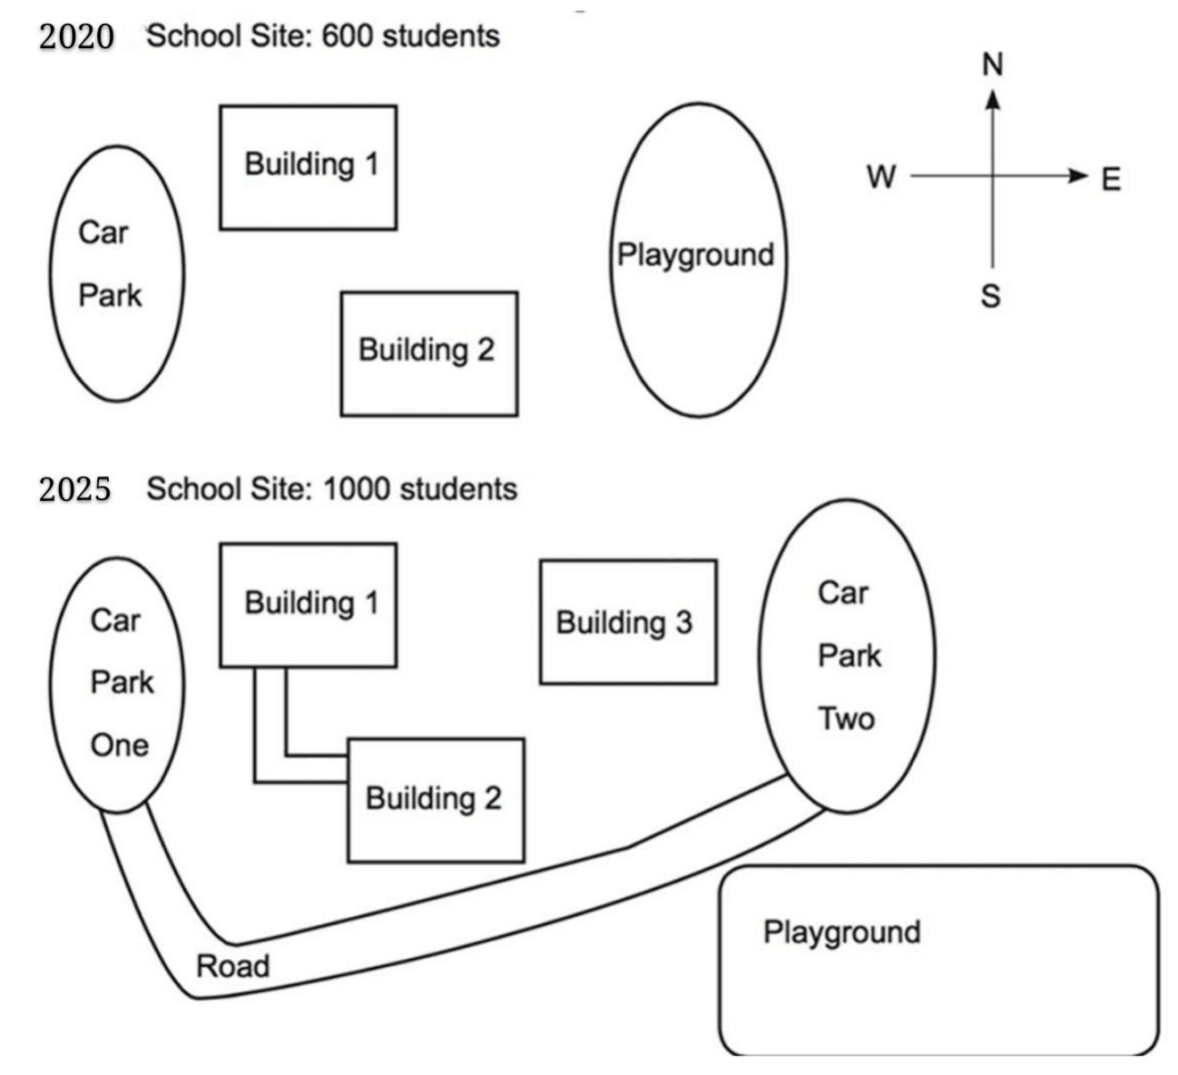

The maps demonstrate the school site in 2020 and the planned one in 2025. It can be seen that the school in 2025 is projected to have more infrastructures than in 2020 because the number of its students is expected to increase from a recent 600 to a height of 1,000.

In 2020, we can see that there are two buildings on the layout of the school site, one in the north and the other in the south. In the west of the school, there is a small car park which is close to Building 1, while a playground is located in the east part, next to Study Building 2.

In 2025, as the second map shows, more facilities are planned to be constructed to accommodate 400 more students to be enrolled. A new building (Building 3) is forecast to be built in the proximity of the old ones which will then be connected by a new road. A more dramatic change can be noted as for the car park and playground. The school is expected to have another much larger parking area (Car Park2) which is planned to substitute the old playground**, and** a connection road between the two parks **for easier access** is predicted to be built. Meanwhile, a new playground that almost doubles the former size is estimated to be built to the south of the old one.

Overall, the maps above witness some developments to a particular school site over 5-year period.

表示将来时态的谓语：

is expected to

is projected to

is predicted to

is estimated to

is forecast to

真题二：

**The maps below show a public park when it first opened in 1920 and the same park today.**

**Summarize the information by selecting and reporting the main features, and make comparisons where relevant.**

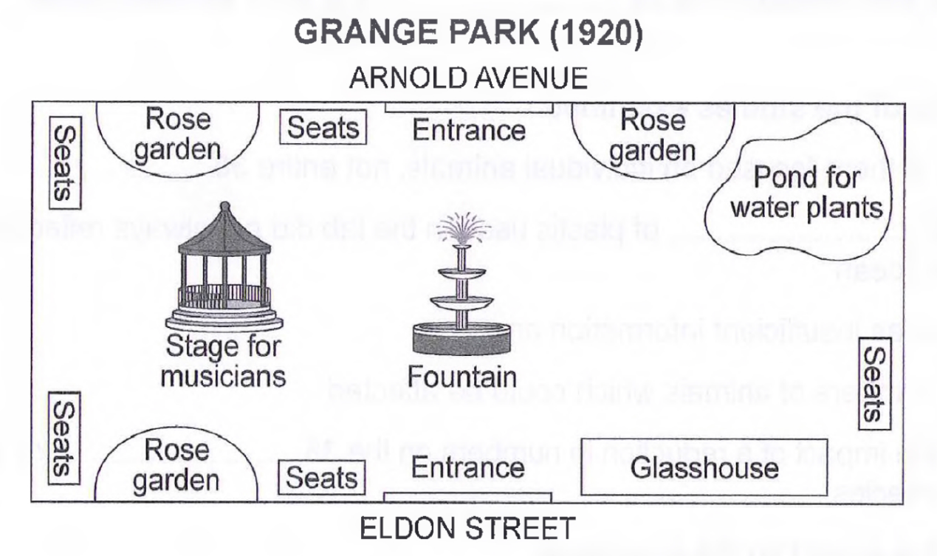

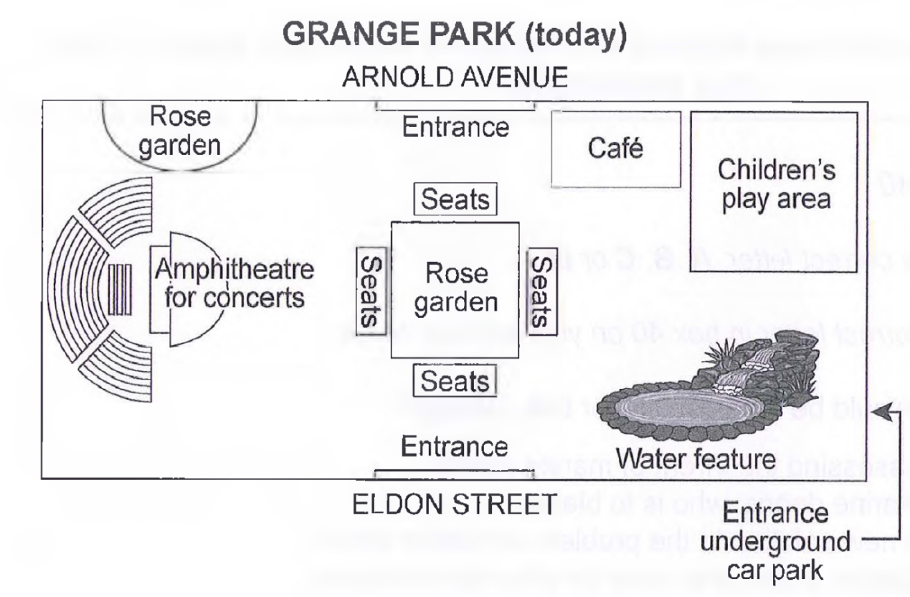

Grange Park was opened in 1920, a rectangular area with access from Arnold Avenue on the north side and from Eldon Street on the south side. There was a fountain in the center, with a stage for musicians situated center left, a glasshouse to the right of the Eldon Street entrance, and a pond for water plants in the north east corner opposite. Around the edges of the park, there were three rose gardens, with seats nearby for people to smell the flowers and listen to music.

The park has altered considerably since then. Now there is one larger rose garden, occupying the central area where the fountain stood, with seats all around it. One of the smaller rose gardens remains on the north side of the park. The stage for musicians has also been replaced by an amphitheatre for concerts and associated seating. The glasshouse has gone and in its place is a water feature; similarly, where the pond for water plants stood, there is now a children’s play area with a café nearby. Access to the park is still via the two original entrances, but there is now a third entrance near the water feature from an underground car park.

Despite the apparently significant changes, the park retains the basic elements of flowers, water, seating, and music, with the addition of a café and a children’s play area.

延伸练习题：

**The two maps below show an island, before and after the construction of some tourist facilities.**

**Summarize the information by selecting and reporting the main features, and make comparisons where relevant.**

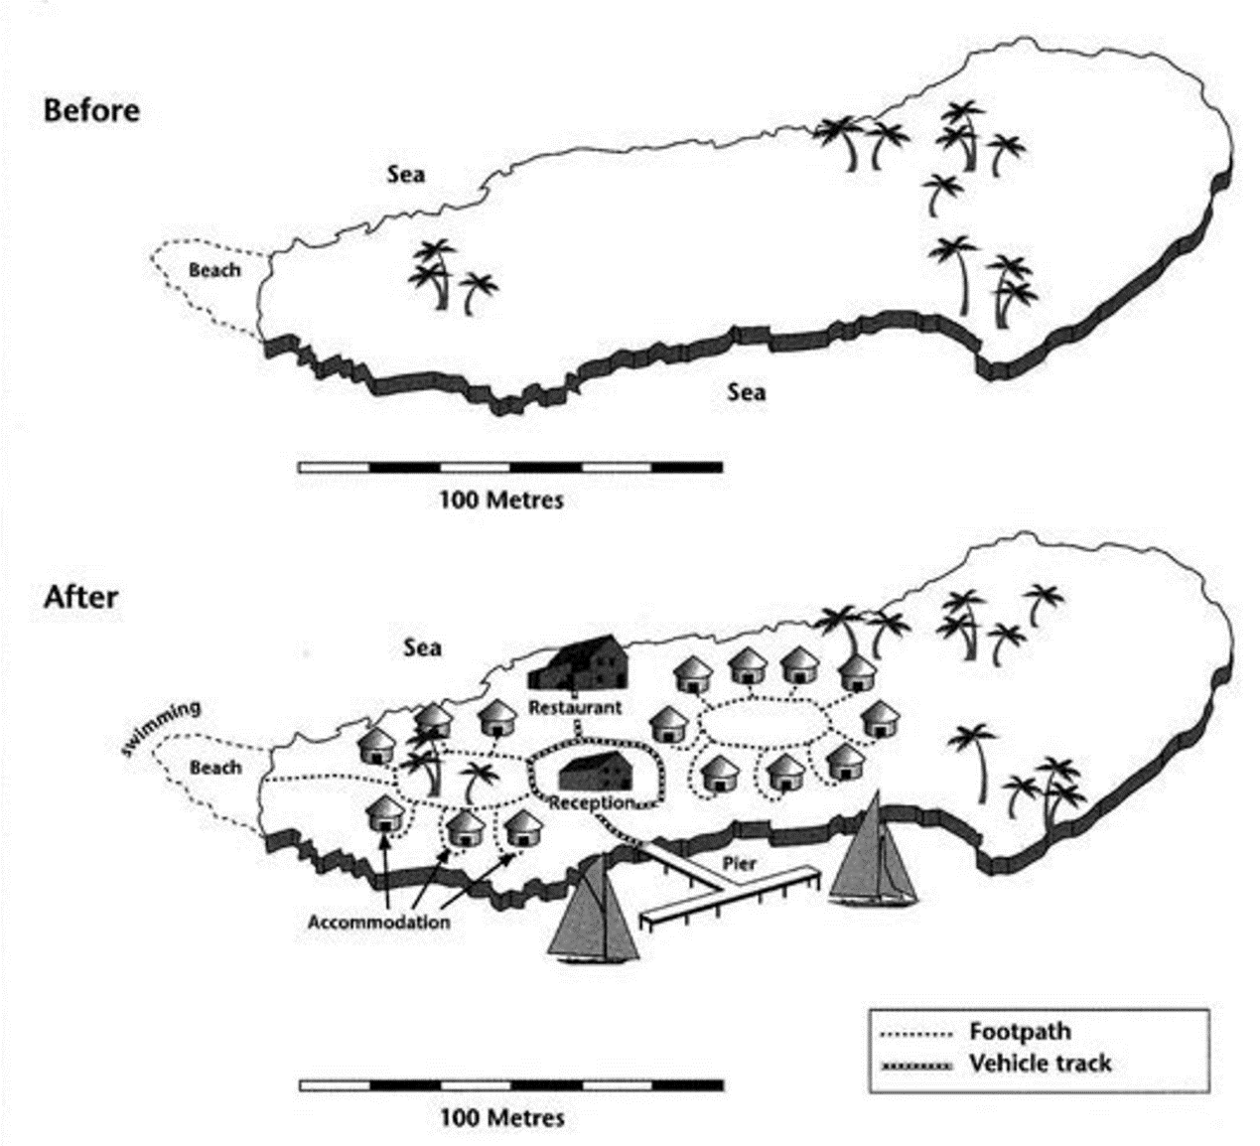

The maps show the same island before and after the construction for tourism.

The island is approximately 250 meters long with palm trees dotted around it and it is surrounded by ocean and has a beach to the west. Over the period, the island was completely transformed with the addition of some tourists’ facilities; however, the eastern part of the island appears to have been left undeveloped.

The most noticeable additions are the hotel rooms. 6 buildings, surrounding some trees, have been built in the west of the island and 9 buildings have been constructed in the center of the island. Between the two accommodation areas, a reception building and a restaurant have been developed.

A pier has also been built on the south coast of the island, allowing yachts access to the resort. Apart from the trees, the beach remains the only natural feature to remain relatively untouched; however, it does appear that it is now used for swimming.

**The map below shows the development of the village of Rye mouth between 1995 and present.**

**Summarize the information by selecting and reporting the main features, and make comparisons where relevant.**

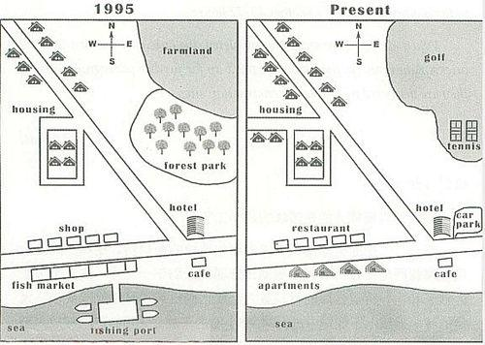

The two maps illustrate the different developmental changes of the village of Rye mouth between 1995 and present.

In 1995, in the southern part of the village, there was a fishing port on the sea and a fish market north to the port. Opposite to the market, there was a block of shops sitting on the other side of the road. East to the shops, a hotel and a cafe were built at the joint of two major roads. Additionally, the northwest part was basically a residential area. Moreover, a farmland of great coverage occupied the northeast corner, while a forest park was established south to the farmland.

Currently, the fishing port has disappeared and the fish market has been replaced by a block of apartments. In addition, several restaurants have taken up the place of the shops. A car park has been built on the east of the hotel. In the residential area, more houses have been constructed along a newly built road. Finally, a sports field for tennis and golf has occupied the place of the previous farmland and the forest park.

**The three pictures show the changes of a public building in Hartford between 1985 and 2005.**

**Summarize the information by selecting and reporting the main features, and make comparisons where relevant.**

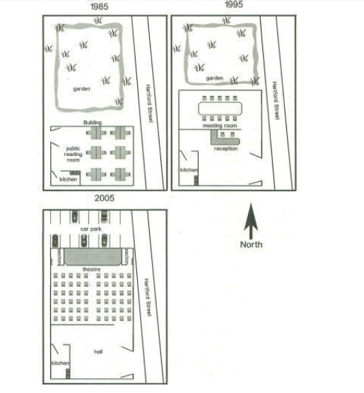

The maps demonstrate various changes of a public building in Hartford Street in the years of 1985, 1995, and 2005.

In 1985, the public building located at the side of Hartford Street with a big garden in front of it. A small kitchen lied on the southwest corner of the building and the major part of the public building was just a public reading room with several desks.

In 1995, the public building took some part of the garden and expanded about 40% in acreage. The newly developed area was used as a meeting room, whilst the old public reading room was replaced by a reception area.

Ten years later, the public building further enlarged its area for another 20% space by taking up more area of the garden and it eventually occupied the final inch of the garden by building a new car park on it. In the rebuilt construction, a theatre took up the area for the meeting room and the new added area. It was a spacious theatre with a large stage and two sections as well as a number of audience seats. Additionally, the reception was replaced by a roomy hall.

**The diagrams below show the development of the village of Kelsbey between 1780 and 2000.**

**Summarize the information by selecting and reporting the main features, and make comparisons where relevant.**

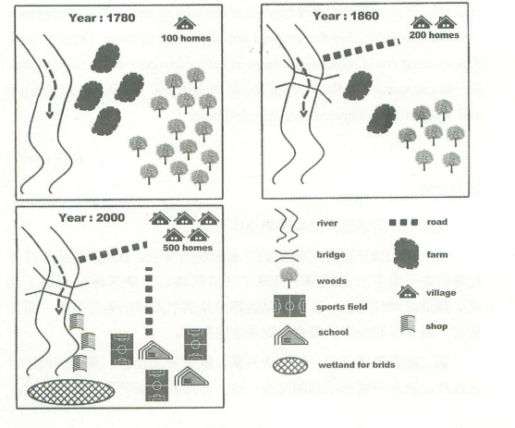

The three maps demonstrate a series of changes of the village of Kelsbey for the period between 1780 and 2000.

In 1780, Kelsbey only had 100 households on the northeast corner. Near the residential area, there was a flourished forest in great acreage to the east. Between the forest and the river located four stretches of farmland exploited by the villagers.

80 years later in 1860, the households doubled in size and a road was to connect the residential area and the river bank. Additionally, a bridge was built on the river whilst the farmland decreased by half in quantity, and so did the old forest.

In the year of 2000, the number of the houses in village was up to 500. The farmlands and the forest had been fully removed in order to build several schools and sports fields. Another road was made to connect the school region and living area. There were also great changes along the river. A block of shops had been opened on the river bank; meanwhile a wetland for birds was also set for environment protection.

**The three maps below show the development of a village over two centuries.**

**Summarize the information by selecting and reporting the main features, and make comparisons where relevant.**

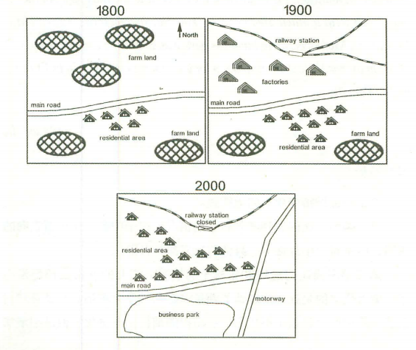

The maps illustrate the development of a village over two hundred years.

In the year of 1800, there was a main road crossing this village from east to west. On the south side of the road sit a few houses, which was the village’s residential area. There were also several stretches of farmland scattering around the village.

100 years later, a railway passed this village in the north and a railway station was built. The stretches of farm land on the north of the main road were replaced by many factories. On the opposite side of the road, the number of the houses was nearly doubled during the past century.

In 2000, the railway station was closed and one branch route was removed. In addition, the residential area moved to the north side of the old main road with a much greater scale. The previous factories moved out of the village. Moreover, a big business park was established on the south side of the main road. Next to the park, a long motorway was newly built in the east of the village.

**The two maps below describe the changes taking place in an area and proposed changes in future.**

**Summarize the information by selecting and reporting the main features, and make comparisons where relevant.**

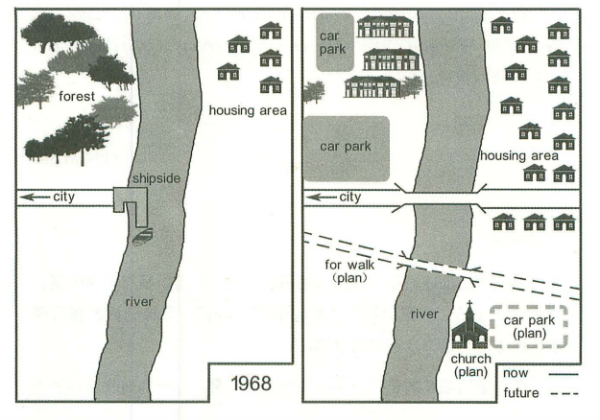

The maps show the differences of an area between 1968 and now, as well as other expected changes in the future.

As can be seen in the picture, this is a suburban area near a river. In 1968, this area was quiet underdeveloped, with only one road oriented to the city and a shipside on the west river bank. All else on the western bank was nothing but a flourished forest on the northwest corner. Opposite to the woods, there was a small-scaled residential area on the east bank.

Currently, the forest area has been developed into several apartments and two car parks. Additionally, the shipside has been rebuilt to be a bridge which extends the city road to the east river bank. The residential area has almost tripled the size and expanded across the newly built road to the east bank.

In the future, a walking bridge will be built south to the existed one. Besides, a southwest corner of the area will be occupied by a church with a car park as planned.

**The map below shows the city settings nowadays and 50 years ago of M town. 很少出现，可忽略**

**Summarize the information by selecting and reporting the main features, and make comparisons where relevant.**

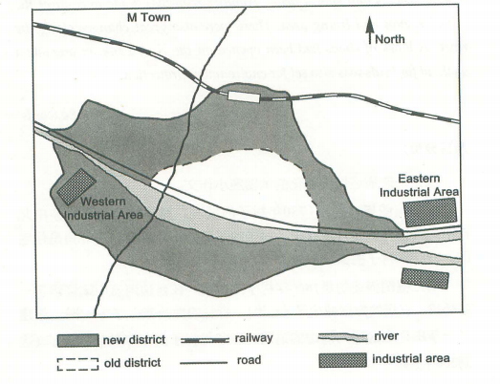

The map demonstrates some major changes which happened to M Town in a time span of 50 years.

As can be observed in the picture, the previous district was just a limited zone along the river side. Two main roads with different directions of north-south and east-west intercrossed with each other in the west of the old district, whist a railway was built in the north of M Town.

However, the old district gradually expanded its size and finally formed a new district during the 50 years. Compared with its old counterpart, the new district almost doubled its size and expanded to the opposite side of the river. Moreover, industrial areas emerged both in the east and west of M Town. Specifically, the western industrial area is within the new district whereas the eastern ones are located beside the river branches.

Overall, the improvement of transportation, such as roads and railways has significantly enhanced the development of M Town. Meanwhile, the river, as the major geographical advantage, gave contributions to the boom of industrial areas.

**Chorleywood is a village near London whose population has increased steadily since the middle of the nineteenth century. The map below shows the development of the village. 很少出现，可忽略**

**Write a report for a university lecturer describing the development of the village.**

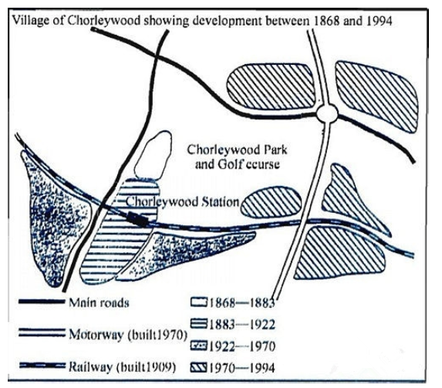

This map illustrates in four stages the development of Chorleywood, a small London village, from 1868 to 1994.

According to the map, the first period was from 1868 to 1883. At this time, Chorleywood only had one small area and two crossing main roads. The next period was from 1883 to 1922. Dur­ing this time, there emerged another habitation to the south of the original small area, which was almost twice bigger than the former one. In 1909, a railway, parallel with the eastbound main road, came into being. It went through the new habitation and formed an intersection with another main road as well. Next, from 1922 to 1970, along the western part of the newly- built railway, two large areas took shape. Finally, 1970 saw another great change in Chorley­wood. A southbound motorway was built linking the railway and the eastbound main road. Since then, another five living areas were founded, scattering along the motorway.

Therefore, the map shows that thanks to the construction of the railway and the motorway, the land of Chorleywood expanded significantly from 1868 to 1994.

**The map below is of the town of Garlsdon. A new supermarket (S) is planned for the town. The map shows two possible sites for supermarket. 近几年没出过此类选址题，可忽略**

**Summarize the information by selecting and reporting the main features, and make comparisons where relevant.**

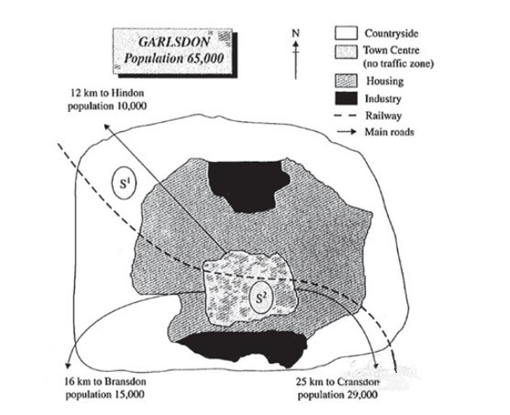

The map indicates two possibilities about where a new supermarket(S) will be built in the Garlsdon.

In the first case (S1), the supermarket is planned to be set up in the northwest of the town in countryside. This site is close to Hindon with the population of 10,000 and housing area. In addition, there are railways and a main road passing by the site, which means the people in Bransdon and Cransdon can go shopping in that place conveniently.

In contrast, the second possible site (S2) locates in town center, where three main roads stretch to three different districts. It seems that the people living in Hindon, Bransdon and Cransdon can arrive at the town center easily. However, there is no traffic zone. In other words, they cannot park their cars near the supermarket. Fortunately, the railway across there might bring some customers to this place.

Overall, S1 looks more advantageous for the people who are living in the three different zones compared with S2.