**流程图写作**

1. The different types of process question
2. A 5-step plan for answering any process question
3. How to write an introduction
4. How to pick out the main features and write an overview
5. How to write about each stage in detail
6. How to sequence your language

* **Different Types of Process Question**

There are generally two different types of process question: natural and man-made.

Natural processes include things like the life cycle of a butterfly or the water cycle.

You might also be asked to describe a man-made process like how smoked fish is made, how cement or bricks are produced or how a machine works.

* **Writing Task 1 Process Questions: 5 Step Plan**

To understand the task and quickly make a plan to answer process questions you should follow the steps below:

1. Understand the process. Find the start and the end of the process. Count how many stages there are and understand what each stage does and the relationship it has with the stage before and after it.
2. Paraphrase the question.
3. Describe what is happening generally.
4. Divide the process in two or more separate paragraphs detailing each stage of the process.
5. Check your work.

* **Understand the Process**

One of the most challenging things about these questions is having to write about something you have never seen or heard of before.

The key is to remember two things.

First, the examiner knows that you have probably never seen this process before and you have only 20 minutes to write about it. They do not expect a perfect answer. Just pick out the main features and report them accurately.

Second, you can quickly understand any process by asking yourself these questions:

1. Where does the process start and where does it end?
2. How many stages are there?
3. Is it a man-made process or natural process?
4. Is it a cyclical (in a circle) or linear (one start point and one end point) process?
5. What does each stage of the process do?
6. What are the relationships between each stage?

* **Paraphrase the Question**

Every process question follows the same format. First, it tells you some general information about the process and then it instructs you to ‘Summarize the information by selecting and reporting the main features.’

For example:

**Question 1**: The diagram below shows the process of photosynthesis.

**Paraphrased**: The illustration demonstrates how plants produce energy from sunlight.

**Question 2**: The diagram below shows how electricity is produced in a nuclear power station.

**Paraphrased**: The illustration shows the process of how nuclear power plants make electricity.

The process diagram shows how/ that there are ... stages/ steps/ phases in...

* **Overview of Process**

Overviews for process questions can be done quite easily by asking yourself a few questions. The answers to these questions will allow you to form 1 overview sentence.

1. Is it a man-made or natural process?
2. How many stages are there?
3. What is produced?
4. Where does it start and where does it end?
5. Is it cyclical or linear?

You might not be able to answer all of these for each process question, but you will always be able to answer enough of them to be able to write a good overview.

* **Detail Each Stage of the Process**

Now that we have paraphrased the question and provided an overview, we need to tell the examiner about each stage in more detail.

You can:

1. say what each stage does
2. what it produces
3. **and/or discuss the relationship with the previous or subsequent stages.**

* **Sequencing the Process**

Try to sequence your language and make your details easier to read by using language like:

表达流程图的起点：

The process starts from ...

At the first/ initial stage/ step/ phase, ...

At the beginning of the cycle, ...

The beginning of the whole process is marked by ...

... is the first step in ...

Firstly, First of all etc.

表达后续阶段：

The next stage/ step/ phase in the process is ...

... is the last stage/ step/ phase in the procedure.

This stage/ step/ phase lasts for ... until ...

Secondly, After that, From this, Where, Following that, Subsequently, Before that, In turn, Then etc.

Make sure you know the meaning and grammar of the words and phrases above before you use them. Do not use them if you are not 100% sure about how they should be used in a sentence.

* **Check Your Essay**

You should try to leave 3-4 minutes at the end to check and improve your work. Many students do not do this because they feel they do not have enough time; however, it is better to try and get everything done in 15 minutes and then check and refine your work, than do everything in 20 minutes.

Things that you should check are:

1. Are there any spelling or punctuation mistakes?
2. Are the verbs the correct tense?
3. Does the process I describe make sense? Does it match the diagram?
4. Is there any vocabulary repetition we could remove with synonyms?
5. Did I write over 150 words?
6. Have I included the main features in the overview?

流程图写作注意事项：

1. 读图、确定描述的步骤；
2. **谓语动词的选择；**
3. **被动语态的使用；**
4. **词性转换；**

**5. 句式结构。**

真题一:

**The diagram shows the process of recycling rainwater.**

**Summarize the information by selecting and reporting the main features, and make comparisons where relevant.**



To begin with, rain falls upon a roof and is channeled into the .... where it drains into a water *filtration system*.

... then the water travels into a water storage tank where it is held before treatment.

In the water treatment stage, the water is allowed to flow into a contained area where...

Following this, the water ...

谓语：discharge into, be discharged into, pour into

真题二：

**The diagram below shows how a central heating system in a house works.**

**Summarize the information by selecting and reporting the main features, and make comparisons where relevant.**

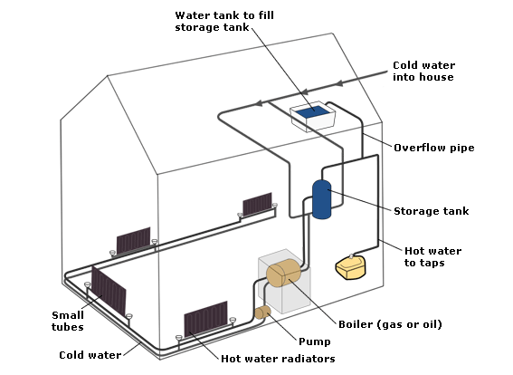

This diagram provides an overview of a domestic central heating system. It shows how the tanks, boiler, pump, and pipes ensure a constant flow of hot water to both the radiators and the taps.

The cold water enters the house and is stored in a water tank in the roof. From there, it flows down to the storage tank which is linked to the boiler, located on the ground floor of the house.

The boiler which is fueled by gas or oil heats up the water as it passes through it. The hot water is then pumped around the house through a system of pipes and flows into the radiators, located in different rooms. The water circulates through the radiators which have small tubes inside them to help distribute the heat, and this warms each of the room. Some of the water is directed to the taps to provide hot water for the house.

Once the water has been through the pipes and radiators, it is returned to the boiler to be re-heated and circulated around the house again.

真题三：

**The diagram below shows how used bottles are recycled and made into new ones.**

**Summarize the information by selecting and reporting the main features, and make comparisons where relevant.**

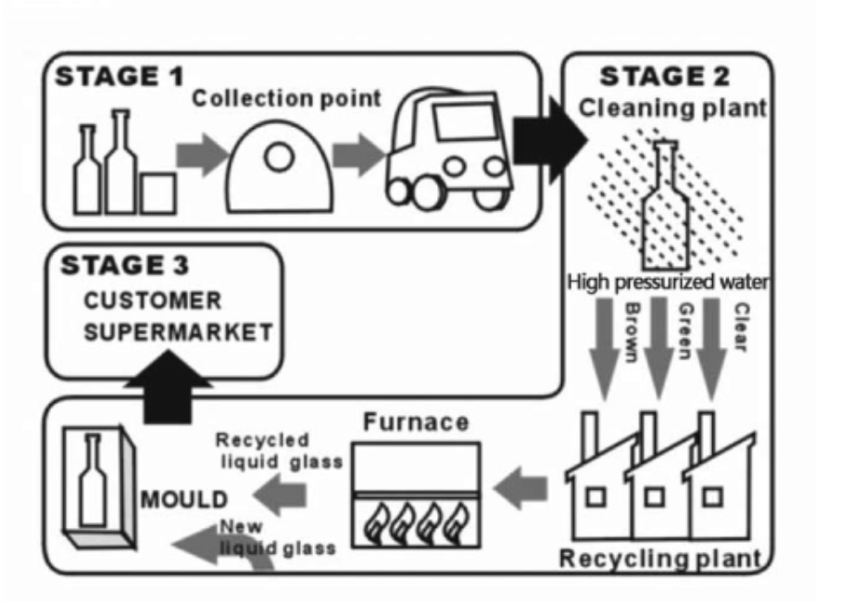

The flow chart demonstrates that there are three main stages in the production of new bottles for everyday use. =... how new bottles are produced ...

Stage 1 involves the collection of used bottles at collection points where they have been deposited by consumers.

These bottles are taken to a cleaning plant where stage 2 begins with the bottles being cleaned using water sprayed onto the bottles under high-pressure. (=These bottles are taken to a cleaning plant. In the cleaning plant, stage 2 begins. In this process, bottles are cleaned with high pressurized water.) The bottles are then sorted by color into brown, green, and clear glass and taken to a recycling plant. In the plant, they are put into furnaces which melt the glass in preparation for molding. The recycled liquid glass is then mixed with a certain amount of new liquid glass before being poured into molds for the manufacture of fresh bottles.

When the new bottles are ready for use, they are taken to the supermarkets at the 3rd stage.

真题四：

**The flow chart illustrates the production of coloured plastic paper clips in a small factory.**

**Write a report for a university tutor describing the production process.**

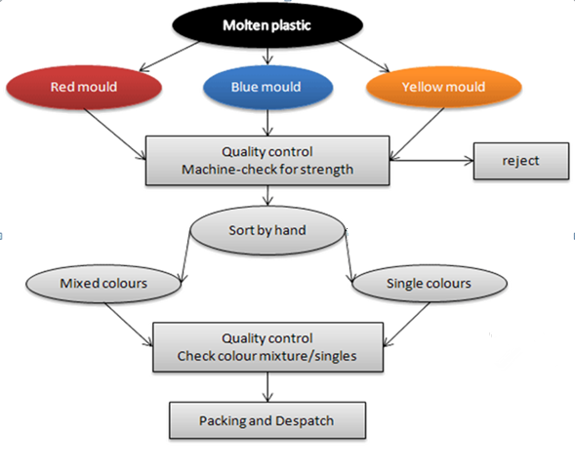

There are several stages in the production of plastic paper clips from this small factory. Two of these stages involve actual preparation of the clips, while the other two consist of quality control before the clips are sent out from the factory to the retailers to be sold to the public.   
  
To begin with, molten plastic is poured into three different molds depending on the color required: the colors are red, blue, and yellow. Once these clips emerge from the molds, a quality control machine checks them for strength. Unsatisfactory clips are rejected. In the third stage in the process, the clips are sorted by hand into two groups, mixed and single colors. When this stage is complete, the groups are checked a second time to ensure that the color mixtures are divided correctly into single colors and mixed color batches. Finally, the clips are packed and dispatched to the markets.

Overall, the stages illustrated above outline how plastic paper clips are made.

延伸练习题：

**The diagrams below show the stages and equipment used in the cement-making process, and how cement is used to produce concrete for building purposes.**

**Summarize the information by selecting and reporting the main features, and make comparisons where relevant.**

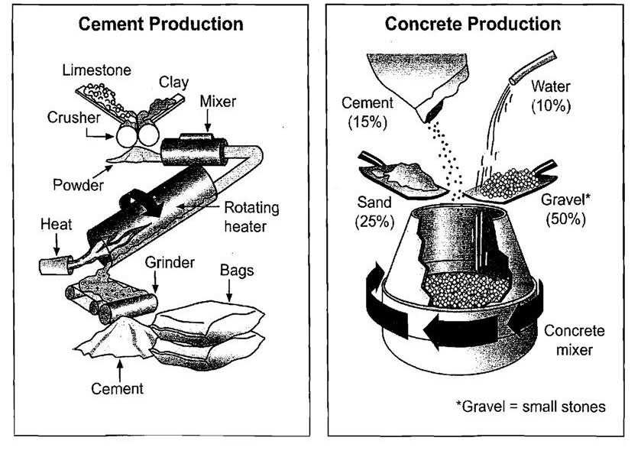

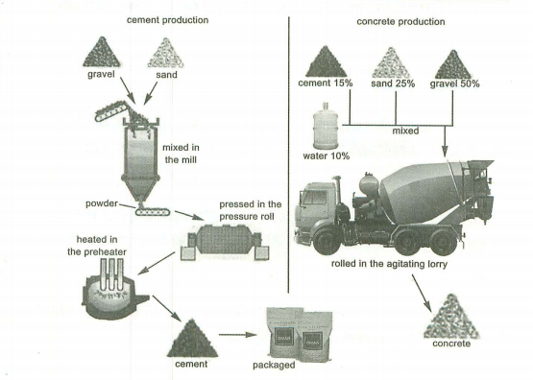

版本一：

The process given by the flow charts is about the detailed steps and facilities which are utilized in the production of cement and concrete.

As for the first chart, cement production involves the following certain steps. At first, limestone and clay are set into a crusher, by which they become powder. After being mixed, the powder is transmitted into the next rotating process and it will be heated. Next, the mixture goes into a grinder where the cement comes out. Finally, the cement can be packed in bags.

In terms of concrete production, in the first step, 25% sand and 50% small stones are put together, with a combination of 15% cement and 10% water. In the next stage, the mixture can be poured into a concrete mixer. Finally, the production of concrete is successfully completed.

All in all, it is clear to see that compared with the production of cement, that of concrete is rather simple.

版本二：

The diagrams illustrate the way in which cement is made and how it is then used in the process of making concrete. Overall, limestone and clay pass through four stages before being bagged ready for use as cement which then accounts for 15% of the four materials used to produce concrete. While the process of making cement uses a number of tools, the production of concrete requires only a concrete mixer.

In the first stage of making cement, limestone and clay are crushed together to form a power. This power is then combined in a mixer before passing into a rotating heater which has constant heat applied at one end of the tube. The resulting mixture is ground in order to produce cement. The final product is afterwards put into bags ready to be used.

Regarding the second diagram, concrete consists of mainly gravel, which is small stones, and this makes up 50% of the ingredients. The other materials used are sand (25%). Cement(15%) and water(10%). These are all poured into a concrete mixer which continually rotates to combine the materials and ultimately produces concrete.

**The diagram below shows how chocolate is produced.**

**Summarize the information by selecting and reporting the main features.**

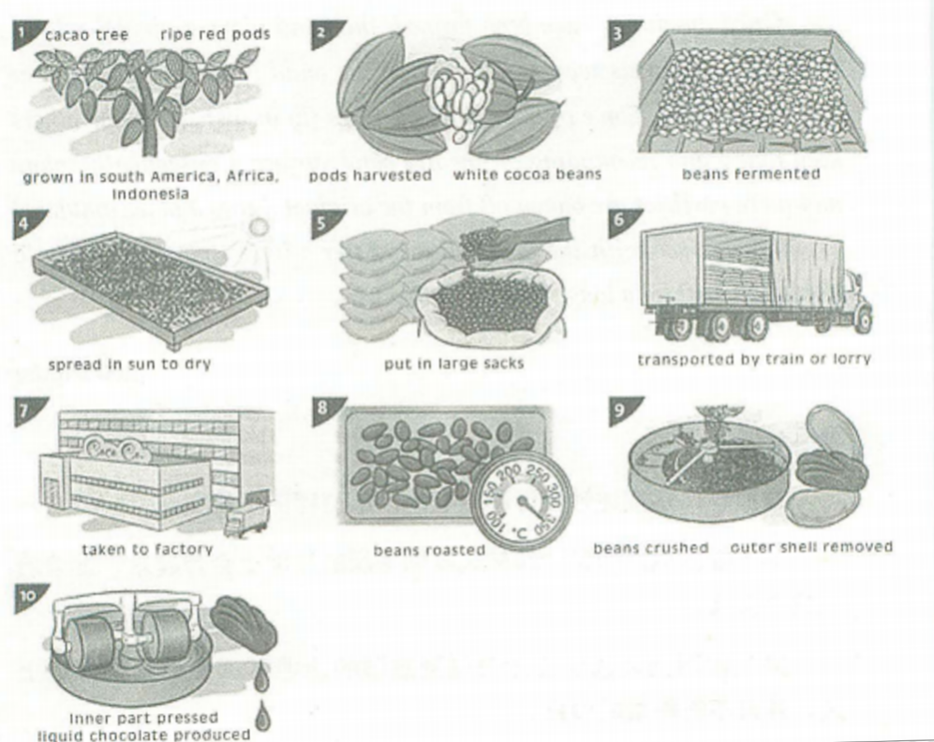

The flow chart shows the process of producing chocolates.

As is shown in the diagram, first of all, the raw material of chocolates is ripe red pods in the cacao trees grown in South America, Africa, and Indonesia. To produce chocolates, the white cocoa beans are initially picked out of harvested red pods before they get fermented. As soon as the beans are well fermented, they are spread in the sun to dry. And then the prepared dry beans are put in large sacks. Later, the well packed sacks are transported by train or lorry and taken to the factory for further process. In the factory, beans are roasted in an oven at 350 degrees centigrade. When brought out of the oven, the beans are sent into a crushing machine to remove the outer shells. Finally, the inner part of the beans is pressed to produce liquid chocolate.

The above is the whole process of making chocolates; as we can see, it involves various producing techniques.

**The flow chart below shows the production technique of red wine.**

**Summarize the information by selecting and reporting the main features.**

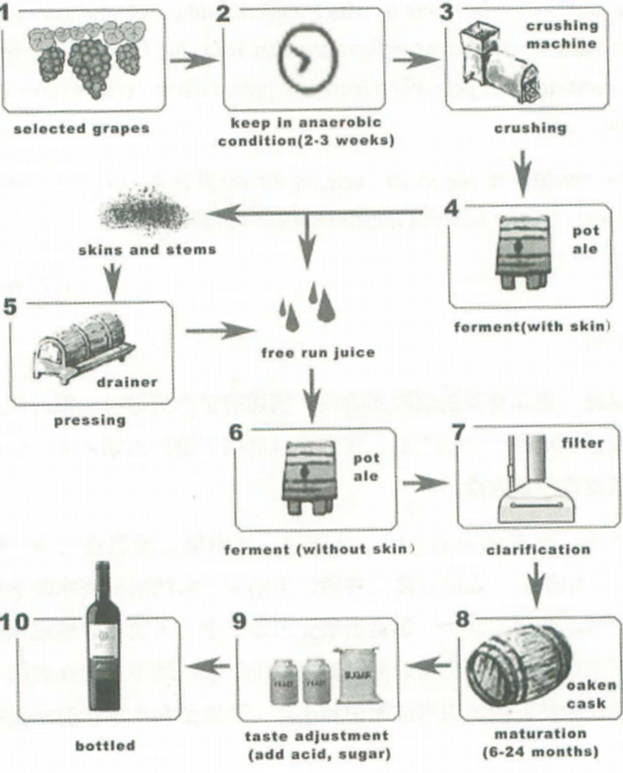

The flow chart illustrates the whole process of making red wine.

To begin with, grapes, as the raw material, are strictly chosen according to a series of rules. Later, all the selected grapes are kept in the anaerobic condition for 2-3 weeks before they are sent into the crushing machine. After being crushed, the grapes are put into pot ale for with-skin ferment. When the ferment is finished, free run juice is filtered out of skins and stems which are pressed in a drainer to obtain more free juice. And the extra free juice also gets the second ferment. The outcome of the second ferment is poured into a filter for clarification. After that, people use an oaken cask to restore the semi-product for 6-24 month for its maturation. When it is ready, taste adjustments, such as acid and sugar, are added to satisfy various needs of customers. Finally, the liquid is well bottled and ready for sale.

To conclude, the process diagram shows how red wine is made.

**The flow chart below shows how bricks are produced.**

**Summarize the information by selecting and reporting the main features.**

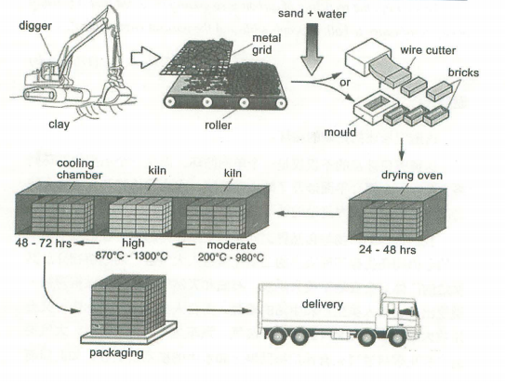

The process by which bricks are manufactured for the building industry can be outlined in seven consecutive steps.

First the raw material, clay, which lies just below the surface of soil in certain clay-rich areas has to be dug up by a digger. Then the lumps of clay are placed on a metal grid, in order to break up the big chunks of clay into much smaller ones, which fall through the metal grid onto a roller, whose motion further segregates the bits of clay. Sand and water are added to make a homogenous mixture, which is then either formed in molds or cut into brick-shaped pieces by means of a wire cutter.

These fresh bricks are then kept in a drying oven for at least 24 and a maximum of 48 hours, several dozens if not hundreds of bricks at a time. The dried bricks are then transferred to an also-called kiln, another type of high temperature of 200℃- 980℃, then at a high temperature of 870℃ - 1300℃. This process is followed by cooling down the finished bricks for 48 to 72 hours in a cooling chamber.

Once the bricks have been cooled down and have become hard, they get packaged and delivered to their final destination, be it a building site or storage.