雅思7分写作讲义

主讲：宗鹏

欢迎使用新东方在线电子教材


雅思写作—图表描述

图表类型
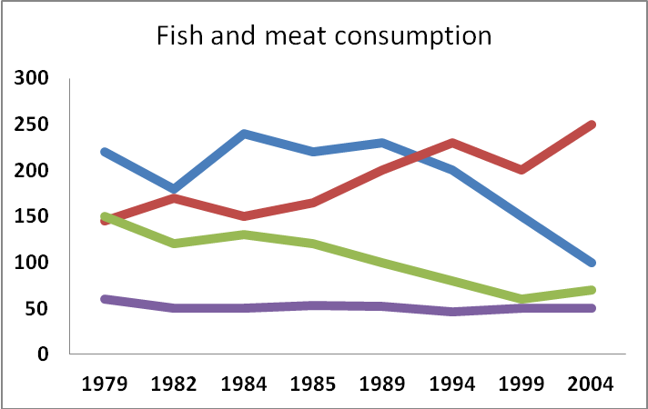
 | 1912 | 1935 | 1977 | 2001
Male | 230 | 1022 | 8127 | 12936
Female | 417 | 2716 | 1372 | 21672
Total | 647 | 3738 | 9499 | 34608

写作要求
Summarize the information by selecting and reporting the main features, and make comparisons where relevant.
内容概括——整体趋势，大小关系
关键特征——起点、终点、极值点、特殊点
数据比较——数值大小、比例高低
The graph below shows the proportion of the population aged 65 and over between 1940 and 2040 in three different countries.
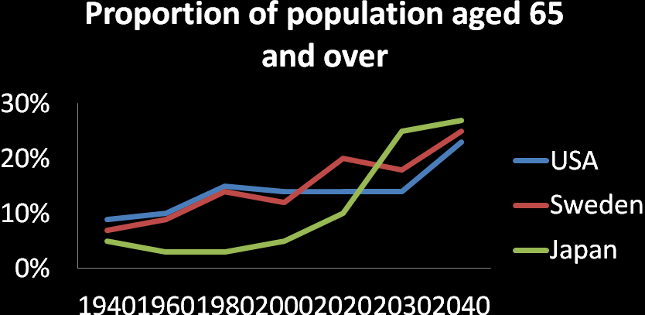

评分标准
 | Task Achievement
7 | - Presents a clear overview of main trends, differences or stages  - Clearly presents and highlights key features
6 | - Presents an overview with information appropriately selected  - Presents and adequately highlights key features
5 | - Recounts detail mechanically with no clear overview; there may be no data to support the description  - Presents, but inadequately covers key features

Task 1—图表作文

如何根据评分标准写作
The graph below shows the consumption of fish and some different kinds of meat in a European country between 1979 and 2004.
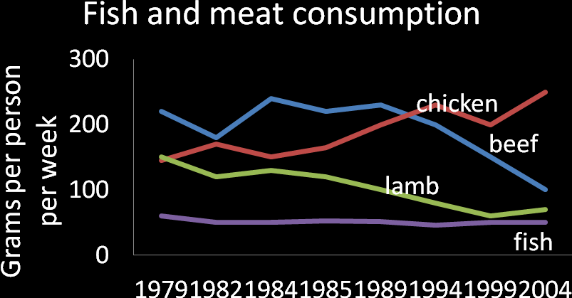
The graph illustrates changes in the amounts of beef, lamb, chicken and fish consumed in a particular European country between 1979 and 2004.
In 1979 beef was by far the most popular of these foods, with about 225 grams consumed per person per week.
Lamb and chicken were eaten in similar quantities (around 150 grams), while much less fish was consumed (just over 50 grams)
However, during this 25-year period the consumption of beef and lamb fell dramatically to approximately 100 grams and 55 grams respectively.
The consumption of fish also declined, but much less significantly to just below 50 grams, so although it remained the least popular food, consumption levels were the most stable.
The consumption of chicken, on the other hand, showed an upward trend, overtaking that of lamb in 1980 and that of beef in 1989. By 2004 it had soared to almost 250 grams per person per week.
Overall, the graph shows how the consumption of chicken increased dramatically while the popularity of these other foods decreased over the period.

饼状图
60%的钱被用来交房租：
- 60% of money is spent on rent.
- There is 60% of money spent on rent.
- The percentage of money spent on rent is about 60%.
- Money spent on rent accounts for 60% of all.
occupy, constitute, take up, make up
- 单饼图
According to the pie chart, more than half of electricity is used for heating rooms and water (52.5%). In marked contrast, the percentage of electricity consumed in ovens, kettles and washing machines is only 17.5%, and the electricity used for lighting, TV and radio accounts for 15% collectively, which is equal to the consumption of other household devices (vacuum cleaners, food mixers and electric tools).
如何做比较？
- 比较级(倍数)、最高级
A is more than B
Tom’s eyes are bigger than Jerry’s.
The eyes of Tom are bigger than
A is twice as many / much as B.
The number of females was twice as many as that of males in 1912.
- 罗列数据+转折连接
- 多饼图
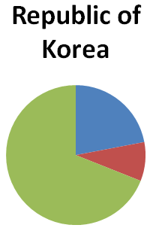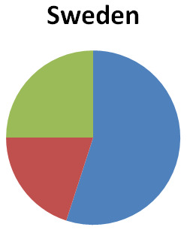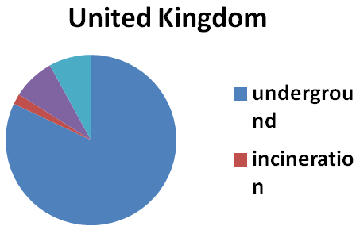
According to the charts, three treating methods are generally applied in both Korea and Sweden.
Specifically, nearly 70% of dangerous waste is recycled in Republic of Korea, while landfill is the most widely used treatment for hazardous trash in Sweden (55%).
The percentage of waste products which are incinerated in Sweden is about twice as large as that in Korea (20% and 9% respectively).
Obviously, both United Kingdom and Sweden are dependent on landfill in the disposal of hazardous products, whereas the proportion of waste recycling is the highest in Korea.

柱状图
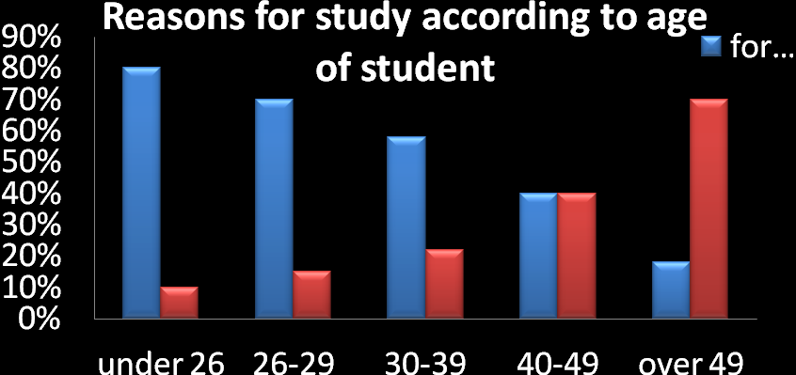
The first graph shows that there is a gradual decrease in study for career reasons with age. (总趋势)
Nearly 80% of students under 26 years, study for their career. This percentage gradually declines by 10-20% every decade. (起点+变化情况)
Only 40% of 40-49yr olds and 18% of over 49yr olds are studying for career reasons in late adulthood. (特殊点+终点)
Conversely, the first graph also shows that study stemming from interest increases with age. (总趋势)
There are only 10% of under 26yr olds studying out of interest. The percentage increases slowly till the beginning of the fourth decade, and increases dramatically in late adulthood. (起点+变化情况)
Nearly same number of 40-49yr olds study for career and interest. (特殊点)
However 70% of over 49yr olds study for interest in comparison to 18% studying for career reasons in that age group. (终点)
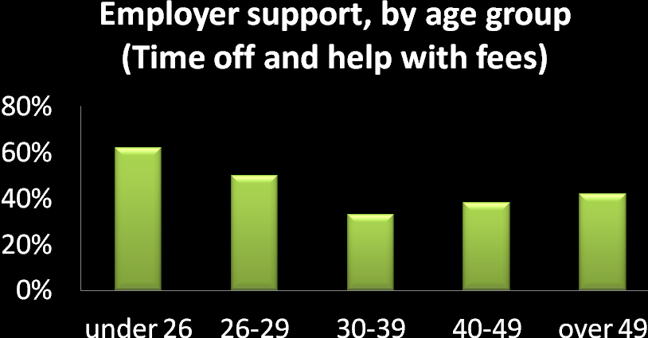
The second graph shows that employer support is maximum (approximately 60%) for the under 26yr students. It drops rapidly to 32% up to the third decade of life, and then increases in late adulthood up to about 44%
It is unclear whether employer support is only for career-focused study, but the highest level is for those students who mainly study for career purposes.
The chart below shows the different levels of post-school qualifications in Australia and the proportion of men and women who held them in 1999
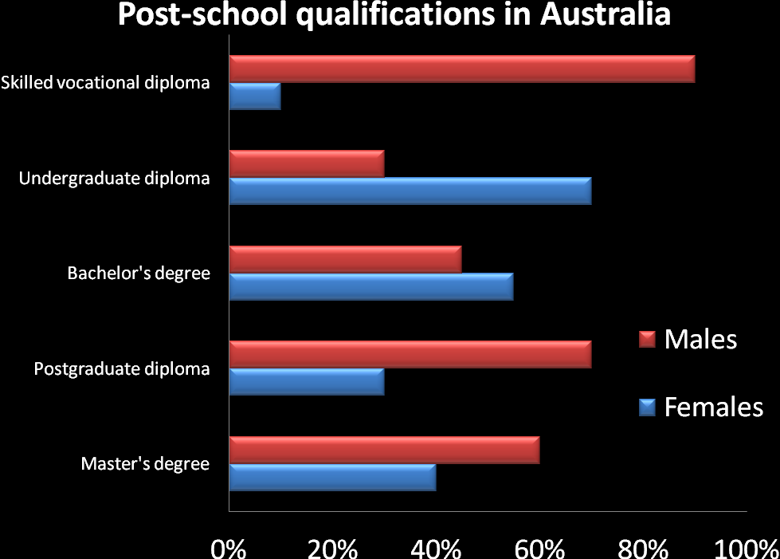
The chart gives information about post-school qualifications in terms of the different levels of further education reached by men and women in Australia in 1999.
We can see immediately that there were substantial differences in the proportion of men and women at different levels.
The biggest gender difference is at the lowest post-school level, where 90% of those who held a skilled vocational diploma were men, compared with only 10% of women.
By contrast, more women held undergraduate diploma (70%) and marginally more women reached degree level (55%).
At the higher levels of education, men with postgraduate diplomas clearly outnumbered their female counterparts (70% and 30%, respectively), and also constituted 60% of Master’s graduates.
Thus we can see that more men than women hold qualifications at the lower and higher levels of educations, while more women reach undergraduate diploma level than men.
The gender difference is smallest at the level of Bachelor’s degrees.

The bar chart shows what the UK students did after graduation (excluding full-time employment) in 2008.

表格图
The table below gives information about the underground railway systems in six cities.
The table shows the details regarding the underground railway systems in six cities. London has the oldest underground railway systems among the six cities. It was opened in the year 1863, and it is already 140 years old. The tube in Paris is the second oldest, and it has served citizens since 1900.This was then followed by the opening of the railway systems in Tokyo, Washington DC and Kyoto. Los Angeles did not construct underground systems until the year 2001.
In terms of the size of the railway systems, London, for certain, has the largest underground railway systems. It has 394 kilometers of route in total, which is nearly twice as large as the system in Paris. Kyoto, in contrast, has the smallest system. It only has 11 kilometers of route, which is more than 30 times less than that of London.
Interestingly, Tokyo, which only has 155 kilometers of route, serves the greatest number of passengers per year, at 1927 million passengers. The system in Paris has the second greatest number of passengers, at 1191 millions passengers per year. The smallest underground railway system, Kyoto, serves the smallest number of passengers per year as predicted.
In conclusion, the underground railway systems in different cities vary a lot in the size of the system, the number of passengers served per year and in the age of the system

流程图
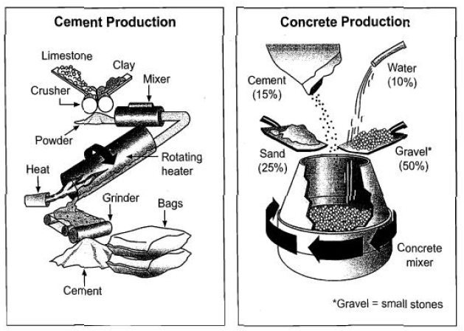
- Cement Production
- 搞清任务
- 读懂每个工序内容及目的
- 寻找合适动词
put / mix ---transform / create / produce
send / go through---heat
grind (ground)---pack
The process of cement production consists of three main stages.
The first stage in cement production is to mix two substances limestone and clay—through a crusher to create powder.
Next, this powder goes through a mixer and is then heated in a rotating heater.
Finally, it is ground and the cement is packed into bags.
- Concrete Production
The diagram on the right hand side tells us that concrete is a mixture of four ingredients in differing proportions.
Cement makes up 15% of the mixture, water constitutes 10%, sand 25% and gravel (i.e. small stones) 50%.
These ingredients are mixed in a rotating concrete mixer to make concrete.
In summary, the production of cement and the production of concrete appear to be fairly simple processes.

地图题
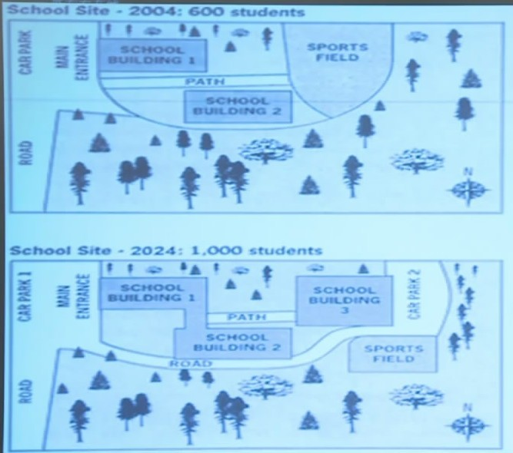
The diagrams show the site of a school in 2004 and the plan for changes to the school site in 2024.There were 600 students enrolled in this school.
According to the diagrams, the main entrance which was opposite a car part, faced the west side.In that school, two school buildings were located on the north and south sides of the main path.
An expanse of sport field was constructed at the end of the path. The rest of areas were occupied by a large stretch of woods. After two decades, construction alternations will be made to accommodate for the expected increase in the number of students.
Specially, two school buildings will be linked together for the convenience to students, and the sports field is likely to be replaced by a new school building.
In the east of this building, another car park is planned, which will be connected with the first one, via a newly-built road. In addition, the sports field will be reduced in size and relocated in the south of its previous location.
These changes to the school buildings, road, path, car parks and sports field aim to house the extra 400 students planned to be attending this school in 2024

雅思考试写作总述



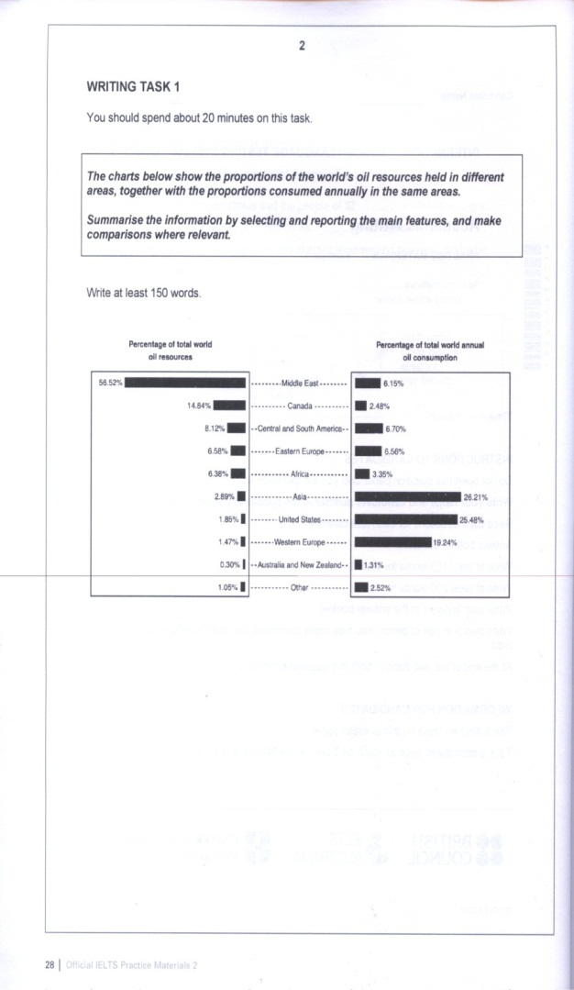

Task 2——议论文

题型介绍
- There is a tendency that news reports in the media focus on problems and emergencies rather than positive developments, which is harmful to the individual and to society.
To what extent do you agree or disagree?
- Governments should give financial support to art projects such as theaters and museums, while others suggest that the money should be spent on health care and education.
Discuss both views and give your own opinion.
- In the future, there will be a higher proportion of elderly people than younger people in many countries.
Do you think the advantages outweigh the disadvantages?
- In most cities and towns, the high volumes of road traffic have become a problem.
What are the causes of that and what actions could be taken to solve this problem?

评分标准
 | Task Response | Coherence and Cohesion
7 | - Addresses all parts of the task  - Presents a clear position throughout the response  - Presents, extends and supports main ideas | - Logically organizes information and ideas  - Uses a range of cohesive devices appropriately  - Presents a clear central topic within each paragraph
 | Lexical Resource | Grammatical Range  and Accuracy
7 | - Uses a sufficient range of vocabulary to allow some flexibility and precision  - Uses less common lexical items with some awareness of style and collocation  - Occasional errors | - Uses a variety of complex structures  - Produces frequent error-free sentences  - Has good control of grammar and punctuation


写作步骤
- 准确理解题意 （题材+题型）
- 勾画关键词
- 双方构思
- 确定结构

- 题目分析(1)
There is a tendency that news reports in the media focus on problems and emergencies rather than positive development, which is harmful to the individual and to society.
To what extent do you agree or disagree? (2012-04-14 )
- 双方构思
- 报道社会问题 / 紧急情况有害
引起恐慌
对社会发展失去信心
- 报道社会问题 / 紧急情况有益
唤起重视，提高意识
发现问题才能解决问题
- 范文赏析
Traffic and housing problems in major cities would be solved by moving big companies, factories and their employees to the countryside.
Do you agree or disagree?
In major cities, problems with transportation and living conditions are problems most people have to face every day.
Some people hold that the principal reason for these problems lies with the big companies and factories located in the city proper. They believe that these companies, factories and even their employees should be moved to the countryside.
This is not a satisfactory solution, though.
Like anyone else, people engaged by big companies and factories do cause some traffic jams if they drive cars on their way to and from work, and some of them also have difficulty finding an ideal house to dwell in. Great as the number of such employees is, they only constitute a small proportion of the entire population, which consists of more people living in the cities and working in other sectors, such as small firms and schools. In consequence, moving those in big companies and factories to the countryside may ease the transportation and living conditions to a certain extent, but it will not lead to a radical change of the already-existing situation.
Moreover, the real cause of traffic and housing problems is that the infrastructure at the moment cannot meet the demand of the rapid development of the cities. Moving companies and employees out only brings about a temporary solution, but does not affect a long-lasting cure. Policies should be made to allow more roads, overpasses, and skyscrapers to be built so as to accommodate the increasing number of automobiles and citizens.
In conclusion, actions to implement the improvement of the current traffic and housing problems should await the participation of governments, big and small companies and factories, and people from all walks of life rather than that of a small proportion of employees.

- 典型结构——同意与否

- 开头段写作
In major cities, problems with transportation and living conditions are problems most people have to face every day.
Some people hold that the principal reason for these problems lies with the big companies and factories located in the city proper. They believe that these companies, factories and even their employees should be moved to the countryside.
This is not a satisfactory solution, though.
- 话题引入+主要观点+作者观点
A criticism often heard these days is that the subjects taught in schools tend to be too academic, and contribute little to preparing a young person for the real-life tasks.
They say that academic subjects are rooted in the past, and are not useful for solving modern problems.
I disagree with this point of view for three reasons.
- 话题引入+主要观点+作者观点
- 开头段写法：
- 简单的背景介绍引入话题
- 双方对立观点或一方主要观点
- 作者观点引起下文
- 开头段写作举例
- There is a tendency that news reports in the media focus on problems and emergencies rather than positive development, which is harmful to the individual and to society.
- For many people, news is a regular part of life, but today, it is important to note that content of different news including national, local, politics and traffic news tends to be full of negative information instead of positive progress.
It has been argued that news reports about social problems and emergencies should be minimized or even restricted.
I agree on this suggestion based on the following concerns.
- 主体段写作
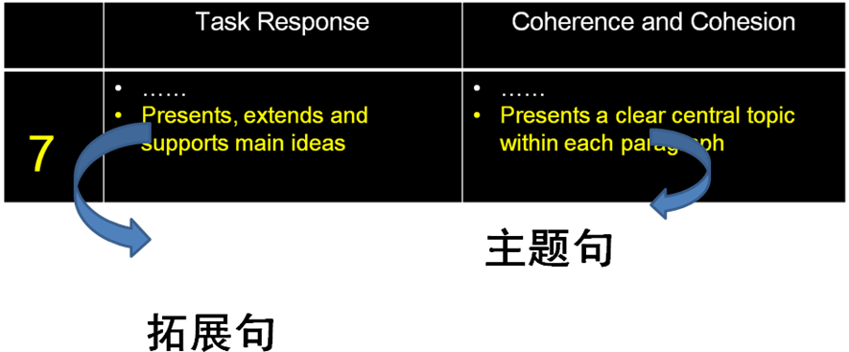
From the time they are little girls, females learn about nurturing.
First with dolls and later perhaps with younger brothers and sisters, girls are given the role of career. Girls see their mothers in the same roles and so it is natural that they identify this as a female activity.
Boys, in contrast, learn competitive role far removed from what it means to nurture. While boys may dream of adventures, girls conditioning means they tend to see the future in terms of raising families.
In addition, we needn’t directly associate clothes with our cultural heritage.
China’s glorious civilization can be illustrated in many different ways, and some of them are vanishing.
For example, in order times, the Spring Festival was always accompanied by the sound of firecrackers. But now, many cities have banned them. Tradition, including clothing, is changing.
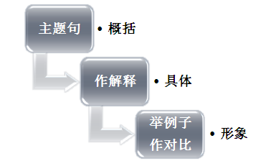
- 主体段拓展
- Individuals are more likely to be pessimistic when they frequently receive negative information.
News report concerning emergency and severe social problems will inevitably give rise to panic and negative attitude; because they are anxious about the possibilities that similar events may appear around them, which have harmful effects on their normal life.
- For example, when citizens saw thousands of crocodiles leave their heads away the water, they concern about the possibility of earthquakes rather than enjoying their vacation, due to a recent report about minor earthquake in news programs.
- 结尾段——重申观点+简单总结
All in all / to sum up
To eliminate possible and unnecessary panic caused and address the deficiency of positive attitude towards future development, television and radio programs should lay more emphasis on spreading good news.

- 题目分析(2)
Governments should give financial support to art projects such as theaters and museums, while others suggest that the money should be spent on health care and education.
Discuss both views and give your own opinion. （2012-05-26）
- 双方构思
- Support art projects
人们需要艺术，但负担不起
有助于文化和思想的传播
促进经济发展
- Support health care and education
人们最基本的需求
改善生活，摆脱贫困
衡量政府成败的标准
- 范文赏析
Successful sports professionals can earn a great deal more money than people in other important professions. Some people think this is fully justified while others think it is unfair.
Discuss both views and give your own opinion.
As a result of constant media attention, sports professionals in my country have become stars and celebrities, and those at the top are paid huge salaries. Just like movie stars, they live extravagant lifestyles with huge houses and cars.
Many people find their rewards unfair, especially when comparing these super salaries with those of top surgeons or research scientists, or even leading politicians who have the responsibility of governing the country.
However, sports salaries are not determined by considering the contribution to society a person makes, or the level of responsibility he or she holds. Instead, they reflect the public popularity of sport in general and the level of public support that successful stars can generate. So the notion of ‘fairness’ is not the issue.
Those who feel that sports stars’ salaries are justified might argue that the number of professionals with real talent is very few, and the money is a recognition of the skills and dedication a person needs to be successful.
Competition is constant and a player is tested every time they perform in their relatively short career.
The pressure from the media is intense and there is little privacy out of the spotlight.
So all of these factors may justify the huge earnings.
Personally, I think that the amount of money such sports stars make is more justified than the huge earnings of movie stars, but at the same time, it indicates that our society places more value on sport than on more essential professions and achievements.
- 典型结构—讨论双方
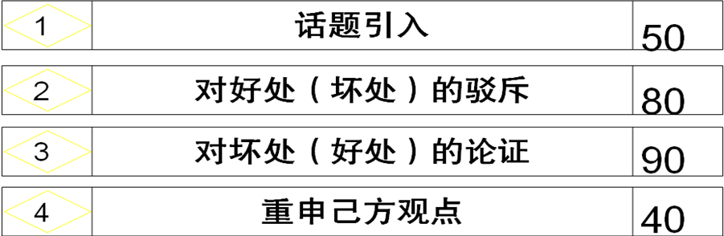
- 驳斥反方观点的方法

- 驳斥反方观点举例
- Many people argue government budget should be allocated to art.
- Everybody needs some beauty in their life, but not everyone can afford a Picasso or a piece of music, so governments should provide money for museums or concert halls to citizens.
- However, art projects are more likely to attract the investment of the private sectors and artists should realize if there is a demand for their music or sculpture, then they will be wealthy.
- Therefore, financial supports from governments seem unnecessary and should be put into more important projects.
- 对己方观点论证的方法

- 己方观点论证举例
- Government interference in education and medical services is highly recommended.
Providing sufficient education opportunities and eliminating illiteracy can allow citizens to hunt a job and earn regular income, thereby improving their standard of living and shaking off poverty. For a country as a whole, education is linked to skilled workforce and to high productivity, affecting both prosperity and stability.
- In addition, access to health care is a basic human right and a measure to ensure a decent standard of living.
People feel assured living and working in a country where they can be given medical service when unemployed, sick, injured or retired, so offering the needy people with affordable medical service is the fulfillment of the government’s responsibility to its members and can make government win the loyalty of citizens.

- 题目分析(3)
In the future, there will be a higher proportion of elderly people than younger people in many countries.
Do you think the advantages outweigh the disadvantages?
- 典型结构—利弊比较

- 题目分析(4)
A large number of young people cannot find a job when they leave university.
What are the main causes of this problem?
Give some measures to help reduce unemployment. （2012-08-11）
- 构 思
- 毕业生找不到工作的原因：
经济不景气，就业岗位少
缺乏经验，缺乏培训
对劳动力市场不够了解，期望过高
- 解决方法：
刺激手段，鼓励企业招聘毕业生
提供咨询指导和岗位培训
摆正态度
- 范文赏析
Nowadays we are producing more and more rubbish.
Why do you think this is happening?
What can governments do to help reduce the amount of rubbish produced
I think it is true that in almost every country today each household and family produces a large amount of waste every week. Most of this rubbish comes from the packaging from the things we buy, such as processed food. But even if we buy fresh food without packaging, we still produce rubbish from the plastic bags used everywhere to carry shopping home.
The reason why we have so much packaging is that we consume so much more on a daily basis than families did in the past. Convenience is also very important in modern life, so we buy packaged or canned food that we can be transported from long distances and stored until we need it, first in the supermarket, and then at home.
However, I think the amount of waste produced is also a result of our tendency to use something once and throw it away. We forget that even the cheapest plastic bag has used up valuable resources and energy to produce. We also forget that it is a source of pollution and difficult to dispose of.
I think, therefore, that governments need to raise this awareness in the general public. Children can be educated about environmental issues at school, but adults need to take actions. Governments can encourage such action by putting taxes on packaging, such as plastic bags, by providing recycling services and by fining households and shops that do not attempt to recycle their waste.
With the political will, such measures could really reduce the amount of rubbish we produce. Certainly nobody wants to see our resources used up and our planet poisoned by waste.
- 典型结构—原因方案
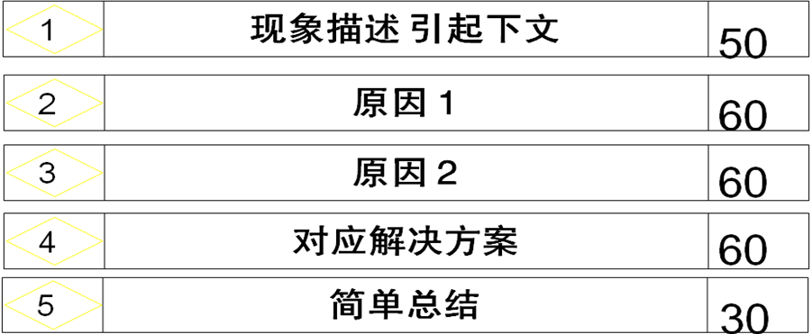
- 开头段写法举例
The young adults’ unemployment is a troubling issue preoccupying many governments across the world.
A growing number of university graduates complain about the difficulties in job hunting. Apart from economic recession, there are some other forces that foster the consistency of young adults’ unemployment.
This essay will present an overall view of these causes and feasible solutions.
- 原因分析写法举例
The main cause of rising unemployment among university graduates is their deficiency of work experience and qualifications.
After leaving college, young jobseekers generally have little practical experience. Besides, most of the knowledge they have acquired is from text, which is not satisfactorily consistent with the general practice in the work place.
This weakness can be fatal at a time when the market has a strong preference on skilled and experienced applicants, who are ready to fill vacancies without requiring any job training.
Secondly, young adults know little of the situation of the labour market. ……
- 解决方案写法举例
Tackling this problem requires the commitment of both society and youngsters themselves.
The government can provide employers with taxation incentives for recruiting young workers.
Low-cost courses, especially job training courses, should be made available for the young unemployed.
Consultancy services can be provided free of charge, giving youngsters instruction on job-seeking and helping them make proper adjustment from university to work.
- 结尾段写法举例
As suggested above, this is a complex problem, and lack of work experience and inappropriate attitudes toward employment are two main reasons that account for youngsters’ unemployment. However, I am convinced that the steps mentioned above would be helpful.

