雅思7分口语讲义

主讲：王冬
欢迎使用新东方在线电子教材


雅思口语概述
Part 1 | General Intro 20-30”
Part 1 | Daily Qs 4-5’
Part 2 | Topics Cards 3-4’
Part 3 | 2 Way Discussion 4-5’

考试流程及评分标准介绍
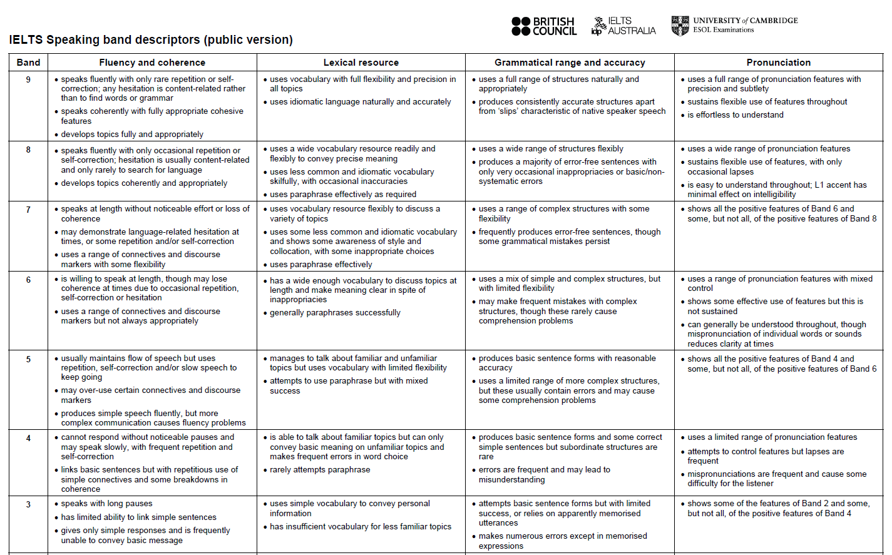
- Fluency &Coherence
speak at length
RED Answers
Reason: ……
Example: ……
Details: ……
speak at length
Part 1: 2 sentences+
Part 2: 30 sentences+
Part 3: 3 sentences+
Do u have any brothers or sisters？
Yes, I have a little brother. He’s…
No, I’m the only child of my family. But I have a cousin with whom I grew up, so I never felt lonely.
Do you like watching films？
Yes + ?
No + ?
- Lexical Resource
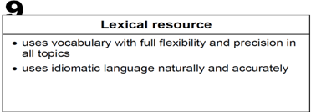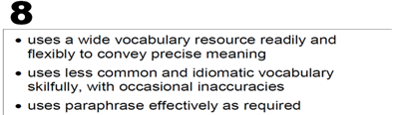
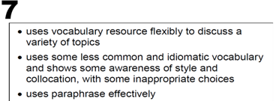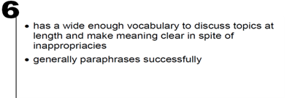
- idiomatic vocabulary:
A group of words that are used together, in which the meaning of the whole word group is different from the meaning of each individual word, e.g.:
She felt under the weather means She felt ill.
busy as a bee
It’s a once in a blue moon chance.
Less Common words
Do Not Use Plain Words!
I don’t like traffic congestion…
It’s too pricey for me …
给出符合评分标准的有营养的答案
Do you like junk emails?
No, I don’t. Spam emails are annoying. All I got are ads from crappy websites, which came in out of the blue.
Do you like eating fruits?
Yes. It’s a kind of healthy diet. For example, pineapple packs in fiber, which helps with digestion.
No, I’m on diet, the fructose can fat me up.
- Grammatical Range and Accuracy
Use Error-Free Sentences
No Simple Sentences All The Time
- Pronunciation
9: a full range of pronunciation features
8: a wide range of pronunciation features
7: …
6: a range of pronunciation features
5: …
bus stop…
let it go…
just now
what time is it…
nice to meet you…
I need you …
- How to Practice My Pronunciation?
Copy and Paste
- 答案的丰富程度发音的准确性
www.yasi9.com

雅思口语Part One
- 核心考题之Study
1） Do you work or are you a student?
2）What subject are you studying?
I’m doing arts in …university. The subject is not what I’m concerned about. I focus on the campus life.
knowledge-oriented
job-oriented
theoretical things
practical things
hands-on ability
tutors are learned
learning atmosphere
3）Why did you choose to study that subject?
hunting a job in China.
it’s very demanding.
… is my motivation.
4）Would you say your university is a good one?
promoting lasting knowledge…
getting a degree but acquiring skills for life…
My University is a dynamic, innovative and forward-looking institution…
5）Why are you taking the IELTS test?
study abroad…
broaden my horizon
to experience new education system
get to know western culture
critical thinking, creative thinking
- 核心考题之Hometown
1）Where do you come from?
2）What kind of place is it?
tropolis with profound history
vibrant city …
coastal city, I like the oceanic climate
3）What's the most famous place in your hometown
____________ is worth a visit…
____________ is a must-see.
____________ is a best kept secret.
dragon tower
fragrant hill
egg tower
4）What do you think needs to change in your hometown?
Traffic in my hometown is overly bad.
change of traffic situation is a must.
5）What benefits are there to live in a big city?
better health care…
more working opportunities
better education systems
it’s posh, more luxury brands: Burberry...
6）How’s the weather in your hometown?
clear division of the climate…
extremely hot in summer…
very cold in winter (freezing)
the water is crystal clear…
blooming flowers…
- 核心考题之Accommodation
1）What kind of housing do you live in?
at home: house, flat
on campus: dormitory
2）Describe the place you live?
environment: natural surroundings
location: downtown, suburban
people: friendly, aloof, warmhearted
3）Do you know your neighbors?
R.E.D Answer
Yes. Miss. Lee…a gossip hen （举例子）
No. I’m too busy…（给原因)
4）Please describe the room you live in.
My room is peachy pink & Paris themed
I have white fancy furniture
bright and spacious…
I like the layout, it’s a studio.
5）What kind of decorations does it have?
it’s well furnished…
it’s decorated to my taste
concert posters
photos, my guitar
plain white…
6）Have you thought of moving to a different place?
I'm very settled in the area so have no plans on moving any time soon.
Yes. I have been living here for ages. I’m actually burned out. (diversity)
- 核心考题之Clothes
1）What styles of clothes do you like to wear?
casual clothes (tee + jeans pants)
formal clothes (shirt + smart pants)
hip-hop clothes (baggy pants + hoodies)
cardigans, low rise pants, cheongsam
2）Do you think it's important what clothes a person wears?
I could care less about brands. I need something that is comfortable and satisfies my tastes.
Yes. it can reflect: status, taste…quality
3）Do you think the clothes a person wears leaves an impression on others?
should be well-dressed …
seem friendlier, more approachable
don't overdo it! inner-beauty
handsome is as handsome does.
4）Is it important what clothes you wear at your job?
I think people should be _____________at work. It’s working time not ____________. You can never wear clothes which are too casual or ________. Uniforms are important for company morale.
well-dressed
leisure time
informal
5）Do you wear the same clothes both at work and after work?
It’s OFF with the uniform & ON with the "home" clothes. It's not comfy, it's not appropriate.
Even will have a nap in it, or I will put on pajama pants and leave my uniform top on.
6）Are you very interested in fashion?
find clothes that flatter your specific shape
a good sense of personal style
it’s trendy to "look like a million bucks" without "breaking the bank."
- 核心考题之Cars
1）Do you like cars?
limousine, truck, van, wagon etc
Sports Utility Vehicle + it’s multi-functional.
5 leather seats + an enlarged sky window.
a GPS system was installed in it
Yes, I like cars. There are different types of cars, such as limousine, truck, van, wagon etc. but I like SUV most. It’s because it was my first car and it’s multi-functional. It has got 5 leather seats and an enlarged sky window. The flashiest thing is that a GPS system was installed in it, so I do not need to locate the route.
2）Do you like travelling by car?
It is a cheap way when you need to travel to the cities nearby. Also I can enjoy the view during the travel.
public transport is environmental-friendly, I don’t like to focus on the traffic.
3）Do you (or your family) have a car?
My father knows driving backwards and forwards. He drives to work on weekdays.
4）Do you often drive it?
I drive it occasionally
maybe once in a blue moon
I can take them for a ride during rush hours.
Finding a place to park my car is a pain
5）Do you have a driver’s license?
I am really into driving, so I learnt it once I was legally eligible to drive.
handle the steering wheel properly
I am bad at locality
the last thing I want to do
6）If you wanted to buy a car, what kind of car would you choose?
I would have to choose a limousine because it is comfortable and there are plenty of spaces inside the car. It is so flashy when I am sitting inside the car. Everyone would be jealous of me.
7）Do you like to take a long trip in a car?
No, I don’t think so. Driving for a long time is no picnic. It takes lots of energy concentrating on the road condition. Also, traffic congestion is a norm in my country.
Let’s Go Back &Have a Try
8）Do you often drive it?
No. driving is no picnic to me cos the heavy traffic is a pain. I seldom drive simply because the traffic congestion is a norm in my city.
- 核心考题之Shopping
1）Do you like shopping?
release my pressure
I’m a shopping freak
I’m a shopaholic
go window shopping
2）Is there anything you don't like about shopping?
traditional shopping is time-consuming
too crowded…
long queue at the cashier
hate to bargain
3）In what ways do you think people's present and past shopping habits are different?
they had to physically go into stores.
just stay in and do e-shopping. (free delivery)
4）Do you prefer shopping alone or with others?
I am not a good decision maker… other people’s opinions.
It’s very difficult for me to make up my mind of which garment fits me best.
5）Where do you like to shop?
retail shops like Walmart, IKEA…
some outlets, boutiques, drugstore…
department stores, shopping centres, you can find almost all designer brands
6）What do you think are the advantages of buying things on the internet?
online shopping / cable shopping
have a better selection and price
place an order at home
It’s convenient to check the comments
- 核心考题之Reading
Do you like reading?
What kinds of books do you read?
How many hours a day would you say you spend on reading?
Do you think children like reading?
What sorts of books do children like to read?
I adore it…
I’m really into it…
I’m crazy about it…
I’m fond of…
I’m keen on…
I’m a big fan of…
I’m an avid reader
science fiction
non-fiction books
mystery ＆ thrillers
autobiography
novel
ancient history
text book
books are learning tools:
it can relieve stress
I’ve become self-educated
my knowledge far outdid my degree
it opens your imagination
it opens up a whole new world
communicative skills
it fosters imagination
it fosters writing skills
good for my vocabulary growth
gives deeper understanding of life
- 核心考题之Arts
1）Do you like art?
I could be always refreshed. I love sketching... I also love graffiti art. It clears my mind, purifies my heart and soul.
2）What form of art do you like the most?
visual arts…(painting, printmaking, sculpture)
decorative arts
performing arts
3）In your childhood, what experience of art did you have?
We took a field trip to a museum to see Chinese artifacts. (excursion to an exhibition).
4）Do you think art is an important part of life?
5）What benefits does art bring to kids? 艺术对人/孩子的好处
Arts are thought-provoking.
If you know how to appreciate it, then I believe it is meaningful to you.
Life would be dull without art.
it is a great form of human expression
it can broaden their minds and outlooks
It can also inspire them to be more creative, and to be inventive.
it can spark new interests
early exposure to visual art promotes activity in the brain.
Art helps kids understand other subjects
self-esteem, self-discipline, cooperation, and self-motivation
develops creative problem-solving skills
improves aesthetic standard
- 核心考题之Films
comedy (tragedy)
horror film
detective film
romantic film
swordsmen film
cartoon film
blockbuster (big budget film, box office hit)
1）Do you like to watch films?
2）What types of films do you like?
When I’m free, I’m parked in front of TV. There's a handful of movies I would watch over and over by myself, and those include movies that I've cherished all my life, and movies that just blow me away.
3）How often do you go to the cinema?
Never!
The spoilers are annoying. They speak aloud in the cinema, releasing the plot.
4）Are there any types of films that you dislike?
Horror films, too spooky. Might be thinking about the creepy stuff long after the movie was seen.
too much blood and guts in the film.
I really hate teen romance movies; it's a load of crock. Love at first sight, blah, blah, blah & they are together forever & everyone gets a happy ending. It's really unrealistic. Unexpected ending will spice things up.
5）Do you prefer to watch films in the cinema or at home?
visual and special effect/ large screen
you become engrossed in it easily
a lot more comfortable, flexible (play forward, backward..pause it)
- 核心考题之Bags
1）What types of bags do you use?
handbag
purse
shoulder bag
backpack
shopping bag
briefcase
book bag
attaché case
computer bag
tote bag
purse/ hand bag
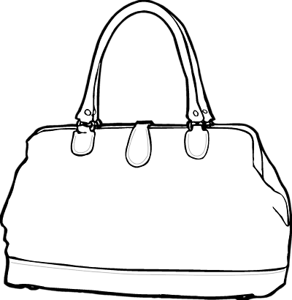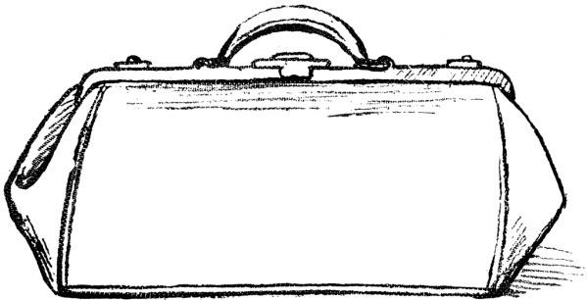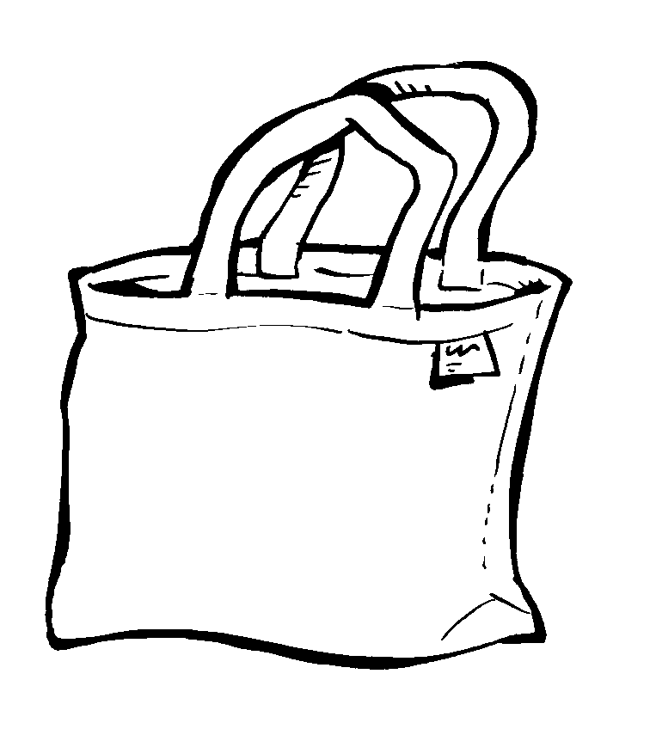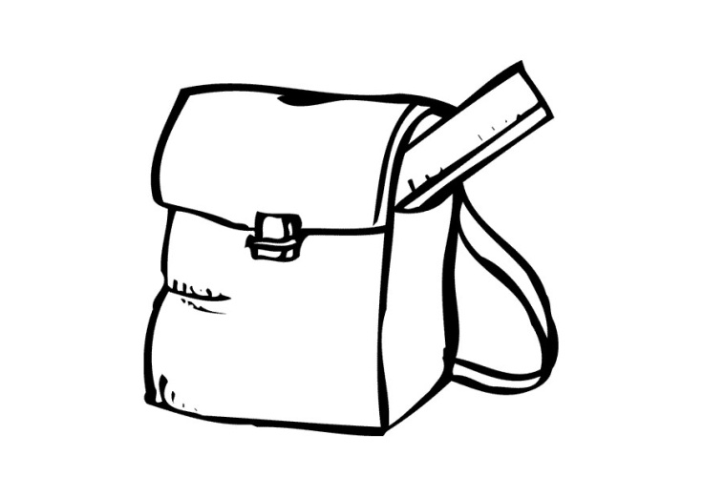
tote bag shoulder bag Backpack
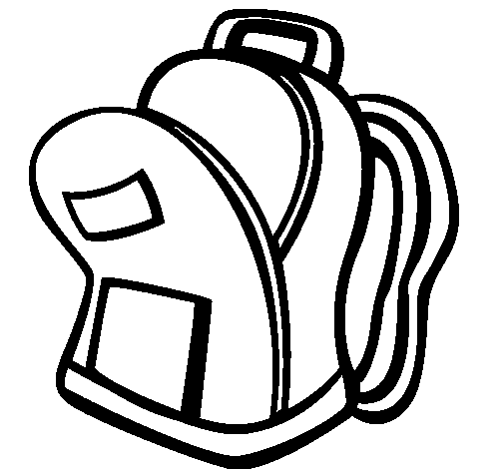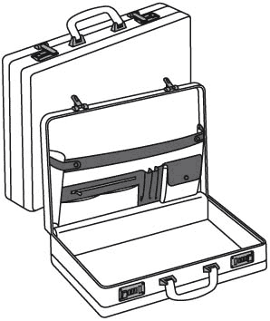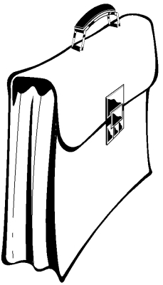
attaché case Briefcase
Well, when it comes to bags, I can think of backpack, tote bag, document case and key bag. I often use the traditional plain red Jansport backpack. If it’s special occasion, I will switch to a purse.

I use a suitcase with flexible wheels on a regular basis.
Sometimes I use a small backpack if I need extra space. it’s lightweight and expandable with high quality.
2）What do you put in these bags?
I carry the most needed things (belongings) with me: mobile phone, keys & two or three packets of napkin…
3）What sorts of bags do women like to buy?
Office ladies like to purchase structured handbags. While party animals like to buy dinner bags.
4）Many others are big fan of name-brand bags.
When you are buying a bag, what factors do you consider?
The practicality comes first: large capacity.
An uncomfortable bag kills my desire.
Besides, a high price ratio counts, should be within my price range.
Style is another consideration.
5）Do you think the style of a bag is very important?
Girls are always demanding about the exterior when buying things, and bags are no exception. Backpacks can never find themselves suitable on parties or balls.
6）Do you have a bag for special occasions?
backpacks or suitcases for trips
document cases or tote bags in working occasions
exquisite or even luxurious dinner bags
for some social reasons
- 核心考题之Health
1）What do you do to keep healthy?
It refers to the combination of fruits and vegetables
junk food are filled with preservatives
…is indispensable to my diet
2）How do people maintain good health?
go to gyms to do work out
do aerobics or pilates (pi-lah-teez)
some vegans keep healthy diet
3）What would you say is a "healthy lifestyle"?
I would define it as…determinants like:
appropriate diet, proper exercises…
… is the ideal lifestyle
nutrigenomics
“you are what you eat”
4）What activity that promotes good health?
Power walking is a good option…
speeds up your metabolism
helps burn calories
5）Is there any sport that you would like to try in the future?
I'm pretty much up for any sport.
Lax (lacrosse)
aggressive & competitive
- 核心考题之Relatives
1）Do you live with your family?
No. keep a foothold in big cities.(the outsider)
homesickness was my biggest problem
Yes. nuclear family… extended family
chances of family reunion or gathering
2）What do you do with your family together?
I’m quite tied up with my work. So, quality time with my parents when I’m off duty means a lot to me share and exchange our ideas
taking a stroll nearby
3）Do you often go out with your friends?
listening to soft music, lounging on a sofa, having a chit-chat with each other, everything is just perfect.
4）Do you prefer to spend time with your family or with your friends?
it’s really a tough question…
family members stand by my side all the time… Blood is thicker than water.
Family members cannot be regained.
5）Do you have many relatives?
my uncles and aunts both from my father’s side and my mother’s side
We have family party at regular interval
it feels so great that you surround yourself with people who really care about you, no hypocritical smiles or talking.
6）When you were a child, which of your relatives did you see most often?
All I can recall is that…
- 核心考题之Weather
1）What's the weather usually like in your hometown?
It’s quite extreme
humid and scorching in summer
freezing cold in winter
____& ___are rather mild & delightful but too short to notice
2）What season do you like best? Why?
夏天：
It‘s less tormenting outside so I can do some outdoor sports.
I don’t have to squeeze myself into the bloated clothes that make me look plump.
I can always bathe in the sea in hot weather.
It's just amazingly refreshing to stay in the seawater on sweltering days.
冬天：
I feel more at ease on cold days.
I don’t sweat much on chilly days.
The hot beverages make me cozy even if the weather is freezing.
Inspiration comes to me on cold days when I am better calmed down.
3）scribe the four seasons in your hometown.
we have distinctive weathers here
everything is covered in white
flowers are in bloom.
summer sucks here because it’s too …
4）Is there any season you dislike?
it’s unbearable
hands and feet are always freezing cold
I feel miserable
5）How does weather affect people?
it affects people’s mood…
it brings allergens such as pollen…
I’m allergic to pollen/pets.
6）Do you always pay attention to the weather forecast?
use Yahoo widgets, which sits on my desktop all the time.
it’s totally unreliable! I predict myself.

雅思口语Part Two
人物 地点
物品 事件
Part2 话题卡的准备
合理串联
丰富素材
准确发音
Describe a family member
Describe an old person
Describe an interesting person
Describe someone you admire
连词成句：retell the story

Part Two核心话题之人物题
- 老人话题：An Old Person You Admire
Describe an old person you admire.
You should say:
what he/she looks like
what kind of person he/she is
how you knew this person
explain why you admire this person .
1）对普通人的描述：
- appearance
My grandmother is getting on a bit.
She’s nearly 80 years old.
She's around 60.
She's over 60.
She’s in early 60s, but doesn’t look like her real age.
She’s quite tall and slim.
She's got a fair skin, wears quite heavy glasses.
She's got a nice wide smile.
She likes smiling from ear to ear.
He has medium height and build, a clean shaven face.
I still could remember what she looked like; she had deep dimples, narrow eyes and always tied a pony tail.
My teacher was not handsome, with a simple crew cut and in average size.
Mrs. Wu, who was a mid-aged lady, out of fashion and always tied her hairs in a bun.

The man with receding hairline is my favorite childhood teacher.
He has a round face
He has an oval face
double chin
full lips
he has a smile like a rotten apple
- Personality
She keeps active and sociable with her energy of a woman half her age.
I admire my grandmother mainly because of her inner-strength.
She radiates cheerfulness and optimism whenever I’m with her.
I hope that I can live my life with the same gusto.
- Influence
She never yelled at you.
He makes jokes about different issues.
She has been my source of inspiration.
I like to talk to her about daily events, even just to share a moment of silence after a busy day.
She has been my teacher, role model, and friend for the past 21 years.
Her approachable nature makes it easy for me to open up my heart to express my true opinions.
She remained optimistic about life.
She is the backbone and guiding light of our family.
She always pushes me to succeed & encourages me to work harder.
- use key words to retell
let me （开门见山）
nearly, but…fair skin, dimples, pony, ear to ear
sociable, inner-strength, optimism
share moment, open up my heart, pushes me.
admire （结尾点题）

2）老人话题part 3相关问题
1．At is the attitude towards old people in China?
Chinese people are highly respectful of their elders. There is a deep-rooted sense of respect for age and experience in this country. Old people are held in high regard because of the wisdom and experience.
2．Do you think should take responsibility for looking after old people?
Kids. Old people raised their children and brought them up, so the children should re-pay their parents.
3．Here any advantages to being old?
One enjoyable aspect of old-age is that one is generally not required to work. (lots of free-time without the pressures of a career or earning money). Many old people take up hobbies such as Tai Chi. (a lot of time to enjoy socializing)
4. Why do old people today live longer than in the past?
It is due to the improvements in diet and health.
Now it is much easier to find healthy food and get access to medicine.
Many illnesses that used to be fatal can now be treated safely and cheaply.

- 名人话题：A Famous Person
Describe a famous person you’d like to meet.
You should say:
who this person is (was)
how you first learnt about him or her
why this person is famous
explain why you would like to meet this person.
1）对名人的描述
- personality
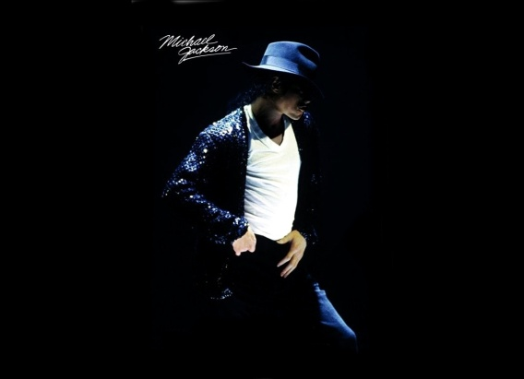
开门见山: Let me talk about…a pop icon
Kristen Stewart seems like a really cool person and she really inspires me.
She's my role model because she actually is quite talented.
I like his songs very much because they are full of energy and very melodic.
She's a bubbly girl, and not even grumpy at all.
She doesn't pick roles for the sake of it, because she's an ACTRESS, not just a celebrity.
She stays grounded and down to earth.
She's good to her fans and she doesn't let the fame go to her head.
She'll rock up to the airport in jeans and a t-shirt unlike most celebrities who will act like it's a fashion show.
He sacrificed a lot to get this done.
We don’t know much about his personal life because Michael avoids publicity.
He seems to be full of contradictions.
- Career
She is an American singer and songwriter. Born and raised in .
She is the hottest recording artist now.
Her vocal abilities captured the attentions of the audiences.
She's a normal person who's made it in Hollywood.
She is best known for playing Bella Swan in The Twilight Saga. She has starred in other films, including……
Jackson became a dominant figure in popular music.
- achievement
She came to prominence as a recording artist following the release of her debut album.
Her most recent album: topped the charts of most major markets.
She earned her first Grammy Award nomination & became one of the best-selling singles worldwide.
He achieved a greater unexpected success.
MJ, often referred to as the King of Pop, he is recognized as the most successful entertainer of all time.
Most of his albums rank among the world's best-selling.
He’s the most-awarded recording artist in the history of popular music.
Besides his/her music(film) career, he/she’s also keen on charity.
He is very charitable . He has founded the Charity Foundation and announced he would donate half of his assets to the foundation when he dies.
Kristen has helped African young people with better medical services and aided disaster-stricken victims.
He often performed to raise money for Africa.
She set up the …Fund, which is aimed towards the kids who lost their schools.

2）名人话题part 3相关问题
1. What are some of the advantages and disadvantages of being a celebrity?
more people recognize your talents.
everyone knows you and you have die-hard fans
you make a lot of money
you get to travel the world
you can get paid to do what you love
you can get some kind of privilege
Being criticized constantly no matter what you do.(Being worst dressed, having cellulite, getting fat, plastic surgery, pregnant, sexuality…)
People are expecting a certain image from you.
having cameras stuck in your face all the time? No thank you.
having people talk gossip about you that isn't true? Nope!
I just live my life and have no one else making my decisions for me.
being recognizable everywhere you go and not having privacy as an normal citizen.
no longer have any privacy
paparazzi everywhere
less time for family and friends
attract all types of people who are posing as friends
lot's of people hating you
lot’s of pressure and stress
2. In general, how do people become famous?
If persistence and talent don't work, people tend to become an internet sensation. Any talentless schmuck can become famous on YouTube, because the entire world has instant "direct" access to you. (sensationalization)
3. Do you think fans should be forbidden from asking for autographs?
People used to just gift celebrities with little trinkets or flowers instead of getting something from them. Afterwards, an autograph is the easiest way to get some proof that you actually met that person. It doesn’t matter how rare it is or how famous the celeb is.
4. How to become a famous singer?
Stay true to yourself and write catchy songs. Play small time gigs and then get exposure. DO NOT duet with any rubbish pop stars. DO NOT go on American Idol or ANY Idol show.

Part Two核心话题之地点题
地点： 室外场所、室内场所
- 室内场所：
Describe a Library
Describe a Home You Like
Describe Your Ideal Room
Describe a Hotel
Describe a Restaurant
Describe a Shopping Place
- 室外场所：
Describe a Garden
Describe a Tourist Attraction
Describe Public Place for Relaxation
Describe a City
Describe a Place Near Water
Describe a Natural Beauty
- 公园话题：A Garden
Describe a beautiful park or garden you visited.
You should say:
where it was
when you saw it
what you did there
and explain why you thought it was beautiful.
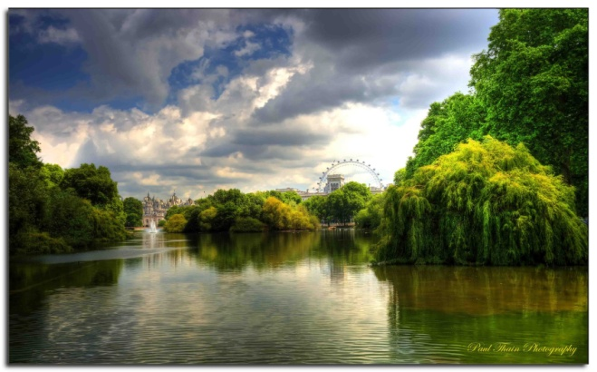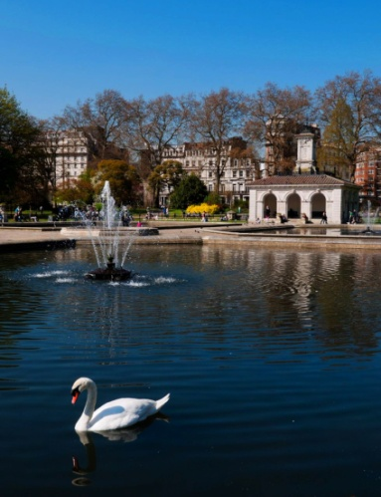
St.James Park Hyde Park
- 地理位置
St James's Park is at the heart of ceremonial London. It’s surrounded by some of the country's most famous landmarks including Buckingham Palace, Clarence House, St James's Palace and Westminster.
The park lies at the southernmost tip of the St James's area.
It’s located in the city center, just 10 mins drive to the railway station.
There’s a great location: 2 mins walk to Subway Line 10.
The Summer Palace, located northwest of Beijing’s center is mainly dominated by Longevity Hill and the Kunming Lake.
Hyde Park is open all year round and is readily accessible by public transport.
- 风景
Hyde Park is one of London's finest landscapes and covers 350 acre.
The park attracts a large number of wildfowl into the park, many of which are winter visitors to the park.
The lake is well-used by friendly ducks and other avian visitors and it is possible to select sitting places where all the surrounding buildings are obscured by trees.
Much of the wildlife in the park goes unnoticed by the majority of visitors. This includes a large number of 'minibeasts' such as beetles, bees…
The trees, shrub beds and herbaceous plantings provide rich habitats for song birds including the robins, dunnocks and…
Although the Park has foxes, wood mice and brown rats these are largely active at night and it is the grey squirrel is the most likely mammal for visitors to see.
St James's Park is a really great place to watch bats as dusk falls.
- 运动
Hyde Park was created to satisfy a royal passion for hunting. But over the years it became a place where people have pursued many other pleasures.
The lake is a lovely place to spend time in both winter and summer and there is always an activity going on there.
Over 7 million visitors visit Hyde Park each year. There's something for everyone in Hyde Park, from swimming and boating to concerts and exhibitions.
The paths and grass areas in Hyde Park are used extensively for walking, jogging and running.
- 个人感觉
I love St James's Park which is very handy if you are staying at Rubens Hotel.
The park is full of wildlife and I love watching the squirrels dashing up trees and eating!
Also, it is just big enough to stretch the legs or, more likely, to sit and relax away from the bustle of central London.
The floral displays are lovely, which create an amazing atmosphere.
Even though you will never get away from the noise of the cars, you at least do not have to look at them for a while!
What can I say? I enjoyed a quiet Sunday there, feeding the ducks , watching the kids sailing their paper boats…
HYDE PARK is a great example on how should the Park be, it’s a wide green area, you can walk, play with ducks, enjoy the sun in the sunny day.
If you find yourself at London in a sunny day, don't hesitate and go to take a walk there.
What a respite it is to be able to enjoy the out-of-doors in a place like Hyde Park.
For anyone coming to London, I'd encourage you to spend some time in a Hyde Park so you can get away from the traffic and buildings of the city.
some words:
classical-style
architectural
halls and pavilions
splendid sceneries
eye-catching
extraordinary
some words
picturesque
landscape
breath-taking nature
getaway
ideal place
natural beauty
公园话题part3相关问题
1. Do you think there are different types of tourists?
There are sightseeing fanatics. They must see everything, go everywhere, and taste every significant meal in a city or they will miss out on something. Then there are the more laid back tourists that travel in order to relax.. They enjoy a more relaxing atmosphere away from all the pressures of work and home
2. What is the impact of tourism on a country?
There are both negative and positive. Today, tourism is one of the largest and most dynamically developing sectors of external economic activities. It positively contribute to the social and economic development of the country as a whole. A negative impact is that it can lead to over consumption and lack of resources.
3. Are there any disadvantages from living in a popular tourist destination?
Cost of living rises in almost every aspect from food to rent to fuel.
Homelessness is at a higher rate as there is higher job competition.
Resources diminish and areas become trashed with litter, because many tourists do not respect an area as the people that live there do.

- 房间话题 Your Home (Room)
Describe your favorite room in your house
You should say:
where is your house
how long you have lived there
what furniture your room has
and explain why you like it.
- 地理位置
It is located in a quiet neighborhood.
It’s located in the city center, just 10 mins drive to the railway station.
There’s a great location: 2 mins walk to Subway Line 10.
- 装修、装饰
It’s facing west so I can get a view of the sunset. My home is fairly spacious; lots of space and fairly white and bright and clean.
There is a big picture window overlooking the water that perfectly captures the rising sun. Lots of big windows opened to let the fresh salty sea winds blow into the house.
lots of posters into a picture frame to hang on a wall
As you come into my room, you can find the ______________in the center.
我喜欢那个大落地窗，透过它我可以看到美丽的景色. (french window, landscapes)
- 个人感觉
My room is a safe heaven. A place where I can snuggle under thick comforters, and read by candlelight. Where the light colors of the walls and ceiling calm me, while the vibrant colors of the bedding revive my worn spirits. It's a comfortable place.
A cozy heaven away from the noise, hustle & bustle of the outside world! It has luxurious green, cream & aubergine colors, I feel safe there & the colors make me feel creative.
It’s great to sip our tea or coffee and talk about our plans for the day every morning in the dining room.
I hate being in a dark cramped room with a low ceiling, I will be hyperventilating.
The blue walls make me think of the calming vast seas that relax me. The base boards and shutters are white which remind me of the pure white clouds in the sky. The white in my room helps me to have pure and clean thoughts.
- 宾馆话题 A Hotel
Describe a hotel you visited or have seen.
You should say:
where it was
what the name of the hotel was
what the hotel looked like
and explain why people like to stay at this hotel.
- 地理位置
Let’s go back to Room & Park
St James's Park is at the heart of ceremonial London. It’s surrounded by some of the country's most famous landmarks including Buckingham Palace, Clarence House, St James's Palace and Westminster.
The park lies at the southernmost tip of the St James's area.
It’s located in the city center, just 10 mins drive to the railway station.
There’s a great location: 2 mins walk to Subway Line 10.
Hyde Park is open all year round and is readily accessible by public transport.
The hotel is located in the New Town but within walking distance to all the main tourist attractions in the Old Town.
- 装修、装饰
It’s facing west so I can get a view of the sunset. My home is fairly spacious; lots of space and fairly white and bright and clean.
There is a big picture window overlooking the water that perfectly captures the rising sun. Lots of big windows opened to let the fresh salty sea winds blow into the house.
lots of posters into a picture frame to hang on a wall
As you come into my room, you can find the ______________in the center.
我喜欢那个大落地窗，透过它我可以看到美丽的景色. (french window, landscapes)

Holiday Inn, Edinburgh
- 个人感觉（服务）
We’ve stayed for 4 nights and liked the place very much, especially the service. We enjoyed our stay there and would recommend to other guests.
Included breakfast is good, and abundant.
The excellent daily cleaning service kept the kitchenette stocked with tea, coffee, yogurt, bagels, fruit, etc. They also cleaned the dishes.
The staff were really helpful and friendly and assisted us with our enquiries.
We would highly recommend this hotel as excellent value and will most definitely be staying here on our next trip to London.
Almost everyone speaks highly of it.
The free access to the internet was very useful.
We had expected a budget hotel with few amenities, but the hotel exceeded all of our expectations.
The staff were friendly and the breakfast was more than adequate with lots to choose from.
The staff were friendly and efficient. We were shown to a really large family room which was clean, bright and tidy. The atmosphere was relaxed and family friendly.
The staff were amazing and responded within minutes when we needed more pillows, towels etc.
Well, it's a Holiday Inn Express, and it does exactly what it says on the tin.
Highly recommended and good value for money.
Great stay, great trip, well worth the money we spent.
宾馆话题part3相关问题
1．What are the different types of hotels?
budget hotel, motel, youth hostel, inn or campsite…
2．What are the different types of hotels?
Internationally, we used to concern them with stars. 0-star-hotel is usually the government hotel. 1-star, private owned hotel, is in bad service and relatively cheap. As for 2-star, it would be a little bit better in quality but more expensive. It’s a common sense that 5-star hotel is the most exclusive and unaffordable, but has excellent service.
3．Which hotel would you recommend people stay in?
Cost effective should be the first position. That is to say, somewhere cheap but still pretty nice. Luxury hotels with 5-star have the best service, awesome conditions, but also cost you much. The youth hostel is good, especially for students since they are in quite reasonable price as well as big beds, cozy rooms, free breakfast, WIFI…
4．What are the differences in quality between the different types of hotels?
Generally, high price leads to a high quality hotel. The embassy suite may be spacious, private, sterile and with good value service. But one night will cost you several thousands. Most people choose to accommodate in some inns, not pricy, but safe and easy living. So I think, it’s the price totally makes the quality.
5．When judging the quality of a hotel, what’s the most important thing to consider?
First, location. Next, what kind of service they offer me. Then I second cleanliness. Actually before I make the decision, I will search the track records, cause I won’t get a hotel doesn’t have a good reputation.
6．How important do you think the service is?
Hotel service is very important in order to accommodate well its customer according to their needs, because their purpose is to achieve peaceful and quiet environment. Hospitable and friendly service at a minimum price must be the best choice for the costumers. That’s the goal of a successful and ideal hotel in every guest’s hope.

Part Two核心话题之物品题
- 歌曲 A Meaningful Song
Describe a song that has special meaning.
You should say:
what song it is
when you first heard it
what the song is about
and explain why this song has special meaning.
- Adele <Someone Like You>
Emotional: sorrow and love

it goes like this:
I heard, that you settled down.
That you, found a girl and you married now.
I heard that your dreams came true.
Guess she gave you things, I didn't give to you.
It ain't like you to hold back or hide from the lie.
I hate to turn up out of the blue uninvited.
But I couldn't stay away, I couldn't fight it.
That for me, it isn't over.
Never mind, I'll find someone like you.
I wish nothing but the best, for you too.
it’s something about …
it tells a story about…
it relates to…

Adele's ‘someone like you' is about how she couldn't get over her ex-boyfriend and she loved him so much that it hurt her deeply to split up with him.
The main idea of that song is: sometimes it lasts in love, but sometimes it hurts instead.
I was devastated…
I just couldn't move on…
I started to listening to it as everybody with a broken heart would do.
What's done is done…
Maybe all that repetition of “never mind I'll find someone like you ” worked.
it brainwashed me, I finally let go.
Someone Like You was the cure for me.
It’s very therapeutic, every time it puts me in good mood.
I was pessimistic.
This song means the world to me.
It changes my mood for the better.
It’s a highlight of the album and the lyrics are moving.

- childhood melody: laughter
it goes like this:
Doe, a deer, a female deer.
Ray, a drop of golden sun.
Me, a name I call myself.
Far, a long long way to run.
Sew, a needle pulling thread.
La, a note to follow Sew.
Tea, a drink with jam and bread.
That'll bring us back to Doe
it’s something about …
it tells a story about…
it relates to…

"Do-Re-Mi" is a show tune from the musical The Sound of Music. Within the story, it is used by Maria to teach the notes of the major musical scale to the children who learn to sing for the first time.
When you know the notes to sing, you can sing most anything.
It’s cheerful and playful.
It brought me happiness and laughter.
It taught me every single musical note.
It reminds me of my childhood.
I would burst into song & dance out of the door.

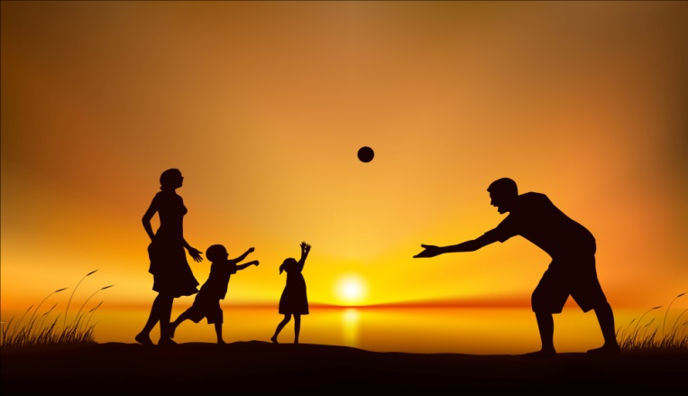
- 照片话题 A Photograph
Describe a photograph that you like.
You should say:
where you saw this photograph
what (or who) is in the photograph
why this photograph was taken
and explain why you like this photograph.

Ok, let me talk about an old family photograph.
It was a photo of my family.
From the plain background of the photo, I remembered that we took the photo in a studio and it was taken by a professional photographer.
I was not photogenic.
Well, although it worn out a bit, I still see everyone’s faces in the photo clearly.
I would like to reprint it and frame it.
Every time a nice photo can give me a sense of satisfaction and achievement.
It was a memorabilia for me and my family.

Couple Photo
- 开门见山
I’m going to talk about a photograph I took with my girlfriend when we were on vacation in Bali. Phuket, Saipan, Maldives , Santorini, the Alps, Trinidad and Tobago…
- 谁拍的
Actually, I took the photo myself, I put a self-timer on my car and ran back to pose with my girlfriend. You know I’m bit of an amateur photographer myself, so I know a thing or two about cameras.
- 哪拍的
The photo was taken about two years ago when we decided to go to Bali during the spring festival. Bali is a great getaway during the winter time because of its wonderful geographical location. It’s summertime all round the year in Bali.
The picture was taken from the balcony of our hotel room, the background of the picture was the beautiful blue sea and the white beaches of Bali. Although we weren’t exactly very photogenic in the picture, the view was awesome.
- 个人感觉
I really like this photo because it is a souvenir of the first trip I made with my girlfriend, it marks one of those important milestones in our relationship, and every time I see the photo I get a good laugh because we were making silly faces in the picture, so it’s a fun little memorabilia.

Many people of my age spend lots of money and effort getting into photography, and it becomes a trend.

Most of my friends are amateur photographers, they organize shooting sessions during the weekends, which really pulled me into it.Many people of my age spend lots of money and effort getting into photography, and it becomes a trend.

I prefer to take pictures of portrait. I also love document scenery. I am lucky enough to live in Beijing and could never get bored looking at my hometown.

Photography gives people a chance to document every detail of the surroundings they are in during a trip. The small snapshot or photograph can enrich and refresh the memories of the travelling.

Some people believe that the best moments should be stored in your mind rather than in photos. In some other cases, people don’t like being in a photo might because that they are camera-shy, not photogenic I mean.
Several elements make a good photograph such as angles, backgrounds and the kind of camera. Obviously, it is more fantastic to take a great picture with a digital single Lens Reflex (DSLR) camera than with a point-and-shoot.


照片话题part3相关问题
1．Do you like taking photographs?
I like taking photographs. It is a great way to keep memories. I take my camera everywhere and take pictures with every good opportunity. My mother has been keeping a scrapbook for me since I was a baby. I now continue to fill my scrapbook on my own.
2．Why do some people dislike taking photographs?
Some people are just not photogenic. They do not think that they look good in photos, thus refuse to take them. I like to try and catch them when they are not paying attention/acting natural. I think most photos of people are usually better when they are in natural settings.
3．Compare the photos you take with those that professional photographers take.
The photos I take are no where close to the quality of professional photos. This is mainly because:
Professional photos are touched up with computer programs. （涉及到）
Professionals also set up there scenes with quality lights and artificial scenery. They make sure that they remove all reflections and other interferences.
When I take photos I don’t take all the preparations that professionals do.

Part Two核心话题之事件题
Describe a Wrong Decision
Describe an Occasion When You Got Angry
Describe a Traffic Jam
注意时态的使用
- 经历话题 A Traffic Jam
Describe a time when you were caught in a traffic jam.
You should say:
when it happened
where it happened
how you passed the time while waiting
and explain how you felt when you were in it.

我遇到了塞车!
I was tied up(held up) in traffic.
早晚上下班时间, 大都市freeway的车速比一般道路还要慢, 无数车辆拥上来,造成 bumper-to-bumper traffic(车的保险杆相互碰撞的交通状况),这时的车速叫snail-paced traffic(蜗牛速度的交通);或者干脆slows to a halt(动弹不得).这种塞车现象可以叫做traffic jam或traffic congestion;更严重的交通状况称为gridlock(严重塞车,僵局)
I was caught in a traffic jam.
I was stuck in a traffic jam.
I was tied up in a traffic jam.
I got stuck in a heavy traffic.

- 开门见山
I wanna tell you sth about a traffic jam I met last summer.
- 时间
It was in rush hour in the morning, when I was heading to city center, I was stuck in the snail-paced traffic…
- 感觉
……………………………………..
I lost my cool. Blew my horn, leaned out the window and screamed at the drivers ahead of me, gave everyone the finger, drove on the shoulder.
It was the pain in the neck.
It drove me nuts.
I got really impatient and nervous.
I chain smoked talked on the phone.
I truly detest the heavy traffic, there’s no way I can tolerate it.
It cost economy and everyone involved, meaning you and I, lot of money for god’s sake!
经历话题part3相关问题
1．What are the causes of traffic jams?
rush hour, slow moving trucks, construction on the roads, cars with trailers, crash incidents, many pedestrians walking across a street after some sort of large meeting, bad weather, traffic lights malfunctioning, bike gangs, traffic control…
2．Do you think the problem of traffic congestion will be eased in the future or will it become worse?
Population is increasing, children they get older to drive. People are relying on cars too much, this problem will become more and more serious. It depends on the authorities anyway, don’t leave the problem.
3．What would you suggest as possible solutions to the congested traffic?
When you drive a car, DO NOT act like a herded animal doing what other people are doing. Be Polite!
Build more overpass/underpass for pedestrians
Restrict buses, jeepneys and tricycles from highways or main roads.

备考建议 Some Tips
- Don't Give One Word Answers
Remember your job is to give the assessor something to assess. assessor won't prompt you to speak. If you don't say enough he/she will go onto the next question. If you continue not to say enough, the interview could be very short!
- Stay On The Topics
Don't go off topic and don't talk about anything that comes into your head, but speak as much as you can. The assessor will stop you when he is ready.
- Tell White Lies
Don‘t worry about lying - this is not a test of if you are a good person. Tell white lies. Make up the wildest story you can imagine.
- Speak Logically
While taking this test, many non native english speakers do not properly join 2 small sentences. The proper use of connectives mentioned below will be helpful.
Ok right then, well the group activity I’d like to talk about was actually an English speaking competition …………..
But anyway, as for what we had to do, well, ……………..
So regarding how..
- Retell ≠ Recite
To recite a well-prepared presentation is inappropriate because it sounds robotic. Try to write some key words on a piece of paper then retell the well prepared essay.

Where You Can Find Me


雅思9分网：www.yasi9.com
苹果 APP： 雅思9:
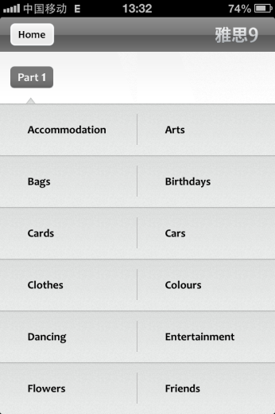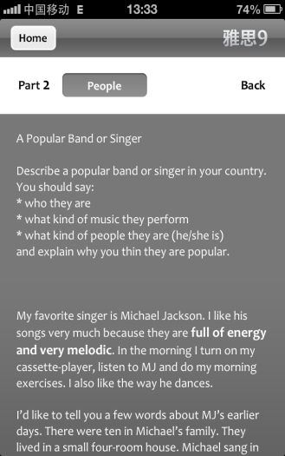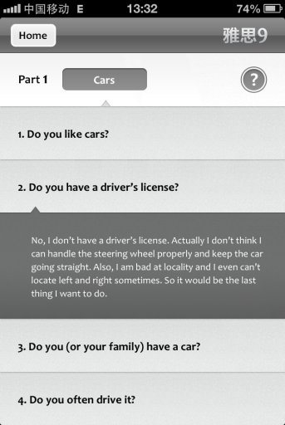

www.koolearn.com

