雅思口语讲义

主讲：王煦 北京新东方学校

欢迎使用新东方在线电子教材


雅思口语考试简介
Speaking test format
- Part 1 Everyday English 4-5’
Q: Do you like doing sports?
Do you like dancing?
Do you like watch TV?
- Part 2 Topics Cards 3-4’
Describe a foreign film that you recently enjoyed watching. You should say:
what film it was
who the actors were
what the film was about
and explain why you enjoyed this film.
- Part 3 Two-Way Discussion 4-5’
Q: What kinds of films are most popular in your country?
Q: What are the difference between Chinese movies and western movies?
Grading Criteria
- Pronunciation
- Grammatical Range
- Lexical Resource
- Fluency and Coherence
Fluency & Coherence 6分
- is willing to speak at length, though may lose coherence at times due to occasional repetition, self-correction or hesitation
- uses a range of connectives and discourse markers but not always appropriately.
Fluency & Coherence 5分
- usually maintains flow of speech but uses repetition, self-correction and/or slow speech to keep going
- may over-use certain connectives and discourse markers.
Q: What do you think is the most popular type of hobby in China?
A: Mahjong!
A: For male Chinese, I think its sports, like basketball, and for female, it’s probably shopping.
Q: What do you think of the social benefits of having a hobby?
A: I think it surely has some social benefits.
A: It depends on what your hobby is. If you like hiking or climbing alone where you don’t meet anybody, that’s not a big social factor I would say… but if you do it with a group, like soccer or basketball, then you will meet new friends who are already interested in some of the same things that you like.
Lexical Resource 6分
- has a wide enough vocabulary to discuss topics at length and make meaning clear in spite of inappropriacies .
Q: Do you like watching movies?
A: Sure I do, it is so interesting！Enjoyable/ entertaining/ relaxing/amusing/ awesome
Lexical Resource 5分
- manages to talk about familiar and unfamiliar topics but uses vocabulary with limited flexibility
Grammatical Range 6分
- uses a mix of simple and complex structures, but with limited flexibility
- may make frequent mistakes with complex structures, though these rarely cause comprehension problems
Grammatical Range 5分
- produces basic sentence forms with reasonable accuracy
- uses a limited range of more complex structures, but these usually contain errors and may cause some comprehension problems
Pronunciation 6分
- uses a range of pronunciation features with mixed control
- can generally be understood throughout, though mispronunciation of individual words or sounds reduces clarity at times
6 分到底什么样子？
- F&C: keep talking & use linkers
- LR: make meaning clear
- GR: right verb tenses & complex sentences
- Pronunciation: can be understood

Speaking Part One
- 4-5 minutes
- general questions about everyday situation
- 3 topics
Accommodation | Birds | Birthdays | Children
Colors | Dancing | Driving | Emails & Letters
Films | Family & Friends | Hometown | Handicrafts
Happiness | Internet | Languages | Leisure Time
Meals | Mobile Phones | Noise | Names
Numbers | Photograph | Studies | Schools
Swimming | Sport | Television | Weather
Weekends | Work | Fashion
Accommodation
- Do you live in a house or a flat?
- Flat/ apartment / studio/condo/loft
- In school Dorm/ on campus
I live in a condo with my parents.
It is the top floor, so we got great view!
- Can you describe the place where you live?
Locations:
- City center/ Heart of the city/ downtown
- Suburb/ outskirts/ residential area/
- country
- Upper east side/ upper west side
Home style
- Bedroom / bathroom
- living room/dining room/Kitchen
- study/ office
- Balcony/ terrace
- Two bedroom flat/ Three bedroom flat
- Six- story building
- I gotta go.
- I got an idea.
- We got an amazing garden view
Develop the topic
- recently built
- decorated in an old-fashioned style
- comfortable/cozy
- spacious
- charming
I live in a recently built apartment with my parents, but it is decorated in an old-fashioned style. Our rooms are not spacious, but we find it very cozy to live in.
Develop the topic
- Low-rise building
- Beachfront
- Carpeted
- Furnished /unfurnished
- Well-appointed
I live in a beachfront low-rise condo outside the city. And the decor is well-appointed. Also, we carpeted the whole house, and it is so comfortable for me.
- What kind of decorations does it have?
- Traditional style/ modern style
- Elegant European style
- Lavish Chinese-style living room
- Cozy country style
- Tasteful Retro style
- Simple IKEA style
Home Decoration
- Hot pink wall paper
- dark wooden floors
- Huge bay windows
- oil paintings
- Chinese calligraphy
Well, we have lavish Chinese-style decor at home cos my parents love it! In our large living room, we have lots of traditional furniture, which matches with the dark wooden floors.
I just don’t really care about decoration stuff at home as long as I got a bed, a television and a computer, so I can chill and relax/relax and hang out/ loosen up after a long day at school.
My house has a great FENG SHUI! My parents are so into（=like）FENG SHUI. Like painting our rooms green is good for our health.
Tai-chi  Shanghai | Kung Fu  Chop-chop | Oolong  Mahjong
- Which part of your home do you like the most?
Bedroom
- King size bed / queen size bed
- Bunk bed
- Large wardrobe
- Dresser
- Nightstand
- Bookshelf
I really love my bedroom! Cos I got a large wardrobe and in my free time I like to try on my clothes and look in the mirror. Sometimes I even take photos of myself and post them online.
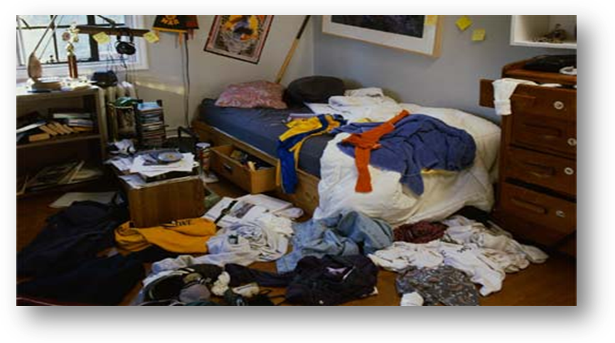
- Do you like your neighborhood?
Neighborhood: community
- Loud and over-crowded
- Affordable and convenient
- Great traffic
- Not a neighborhood but a town
- Walkable
- Quiet and peaceful neighborhood
- Mostly are elders
- They walk their dogs or play tai-chi in the morning
- it is pretty laid-back.
part 2 话题： Your ideal home
Describe the ideal home that you would like to live in.
You should say:
where it would be
what type of house it would be
how would you decorate it
and explain why you would like to live in this home.
School
- Do you work or are you a student?
- I’m a high school student at…
- I’m a university student/college student…
- I’m an undergraduate student at…
- I’m a graduate student at…
- Bachelor degree
- Master degree
- PhD
- I’m a junior one/ senior one
- A freshman/ sophomore/junior/ senior
- I’m an incoming freshman…
- What school/university do you go to? And why?
- I go to XXX high school.
- I study at XXX University/ college.
Develop your answer…
- I picked/chose my school because it has a great Arts/science program.
- The thing that drew me to … was that it had a good reputation.
- The … program is ranked number 1 and I'm going into a career that needs to have an elite degree.
- What subject do you study?
- I major in
- I take
- I’m doing…
- International business
- Finance
- Computer science
- Medical science
- Civil engineering
- …is a practical major and I have no problem finding jobs
- I showed interests in ……
- It is a "play it safe" major
- The demand for Business majors is high
- It is a promising major and I can see myself doing it
- How do you get along with your classmates? And what do you usually do together?
Sure/ absolutely/ totally/ of course/ definitely/ Not really/ Nope/ I don’t know…
Sure! I like to blend in the crowd. And I’m actually pretty popular in school.
I like to hang out with them and play board game.
I like to hang out with the guys at the gym. Lifting weights is a great way to build our muscles.
We have such busy schedules at school, so we just grab a quick bite to eat at the restaurants while catching up with each other.
- What do you usually do together?
- Friends
- Family
- Weekend
- Leisure time
- Meal
- Children
- Visitors
- What do you usually do together?
- Poker card/ UNO/ mafia
- Do Karaoke
- Get a hair-cut / get a manicure
- Sleepover at my classmate’s house
- Play tennis
- Camping in the weekend
- Eat out in a restaurant
- Just play the arcade games after lunch in the mall
- I facebook my friends and play games on
- work out in a gym
- window shopping at boutique/shops
- have a big meal in a restaurant/ buffet
- enjoy the happy hour in a restaurant
- catch a movie with my besties/ BFF
- go to the karaoke with my classmates
- gardening with my mom
part 2 话题: A good friend
Describe your best friend.
You should say:
how (and when) you first met this person
how often you see this person
what kind of character he or she has
and explain what you usually do together
part 2 话题: A group activity
Describe a group activity you often do.
You should say:
what the activity is
who you do it with
where you do it
And explain why you do this activity in a group.
Bird
- How do you feel about birds?
I enjoy watching birds. I especially like birds with colorful feather/ Fur/ hair and twittering sound.
- Twitter / microblog/ blogger
- Tweet
- You can tweet me… n./v.
- You can post the tweets.
- You can msg / facebook me…
I am annoyed/ annoying when birds poop on my car window. I just know they do it on purpose.
- Do any birds have any particular significance in China?
- White cranes : longevity
- Eagle: power and courage
- Owl: wisdom and mystery --“Night Eagles”
- Mandarin Ducks: love birds and always paired up
- Peacock: drop dead gorgeous
- Magpie: joy, celebration and happiness
- Crow : misfortune
- Doves: peace
The white crane is symbol of long life and elegance, because of its long lifespan.
The Eagle is a symbol of/represent / stand for power and courage.
The Owl symbolizes /represent / stand for wisdom and mystery, and they are also called “Night Eagles”.
- Do Chinese people like raising pet birds?
- Honestly I don’t really know why but I guess… it’s part of the tradition. People in the past did that a lot.
- It depends! Some do, some don’t….
It depends! Some do, some don’t. I personally believe that the elderly like it better cos young people are more into keeping dogs or cats.
Sure we do! We believe birds would bring a lot of life in the house, also they are low- maintenance and don’t take much space. we can just leave them in the balcony.
- low- maintenance
- high-maintenance / picky / demanding
- This girl is so high-maintenance, and I don’t know how to make her happy.
part 2 话题: A Wild Animal
Describe a time when you saw a wild animal.
You should say:
what animal it was
where you saw it
what happened when you saw it
And explain how people in your country feel about this animal.
Film
- What types of films do you like?
Action | Adventure | Animation | Biography
Comedy | Crime | Documentary | Drama
Horror | Fantasy | Thriller | Game-show
History | Sci-Fi | Western | Musical
Mystery | War | Reality-TV | Romance
- Chick flick/ girly movie/ romantic love story
- Blockbuster
- Small movies /Low-budget films
I’m not totally crazy about blockbuster movies, actually I’m more into small movies. They have better plots and stories into it.
I love girly films, and I can’t have enough of it. Whenever I have some time to kill, I would watch them.
I go for/ like blockbuster movies because of many reasons. Like the mind-blowing /exciting special effects, dazzling celebrities and breathtaking views.
- 1. What types of films do you like?
I love blockbuster cos I know there is always a sequel after that. Like the lord of the ring trilogy.
- Do you prefer to watch films at home or in a cinema?
Cinema/ theatre:
- Wow factor and special effect
- caramel popcorn
- Tie-in store
- Giant screen
Definitely in a cinema! The relaxing atmosphere and giant screen really attract me. Also, I enjoy going to the tie-in store to look at my favorite character after a movie.
Home:
- Flexible : pause a movie anytime
- I have cool home cinema system
- Low price
- Comfortable : lay down in bed
Definitely at home! Cos I feel like lying down in bed while watching a film is a lot more relaxing. Plus I can pause the movie at anytime. Cinema doesn’t do that.
- Do you like watching foreign movies?
Yep! Hollywood/ Bollywood movies are my favorite! The last one I watched was … it was so good and I just have to watch it again sometime.
I love foreign films! Especially English ones. I can just loosen up and have fun, but also learn more English. It is easier to listen to a film than some boring English study book.
- Do you think watching English movies can help you learn English?
- get lots of correct English sentences into my head.
- imitate
- making progress.
Sure! I only watch English films cos I get lots of correct English sentences into my head. Then I can imitate them and make my own sentences. Actually, I can see myself making progress.
It works.
It is exciting to understand the movie without looking at the Chinese subtitles.
Of course! It works the best. I’m not actually a big movie person but I do watch a lot of English films. Simply because it is a great way to improve my English. It is very exciting to understand the movie without looking at the Chinese subtitles.
part 2 话题: A foreign film
Describe a foreign film that you recently enjoyed watching.
You should say:
what film it was
who the actors were
what the film was about
and explain why you enjoyed this film.

Dancing
Ballet  Breaking  Popping  Jazz | Latin dance  Tango  Cha cha cha  Tap | Hip Hop  Belly dance  Folk dance
- Do you like to dance?
Of course I do! Dancing is my passion. I feel weightless on the dance floor. Plus, it’s good and low-impact exercise, especially the belly dance.
I am not all that into dancing and I always feel shy when I dance in front of the people.
Maybe I would enjoy it more if I learned more moves…
- How did you learn how to dance?
My friend is a talented dancer. She taught me many moves to use on the dance floor.
I took dancing lessons at college.
I never took formal dancing lessons but that's because I am a natural at it. I practiced many dance moves with friends.
I’m a natural at math.
You are a natural for this job.

- Do you like to watch dance performances?
I love watching ballet performances. The dancers are so elegant and graceful.
Dancing is not really my thing/it’s not something I enjoy
I am just not that interested in dancing.
Yes and no. I don’t really watch dance performance but I do watch a lot of “high school musical”. It teaches me a lot of new dance styles.
- When was the last time you danced?
Last time I danced was about one week ago. It was great! I learned a new Tango dance move. I can’t wait to try it out/ help out/print out/try out/ come over the next time I go dancing.
I have not danced for a long time. It’s been a while/ it’s been a long time. So I don’t really remember when it was.
- When do Chinese people like to dance?
It is a tradition for Chinese people to dance in the morning, like Chinese folk dance. A group of elders dance in the park with folk music on. They even dress up and hold the big fans.
They dress up and go to the prom.
I dress down for such a casual occasion.

Evenings and weekends are popular
times to dance.
Other good times to dance are during
festive holidays/ festives and special occasions/ important days.
Speaking Part Two
- 1 minute to prepare
- 2 minutes to talk
- 1 topic card
a place near water you enjoyed | a type of sport you like
your childhood room | a useful website that you like to visit
an old person you admire | a subject that you thought was interesting
a famous person you would like to meet | Something that made you a little angry.
a good friend | a piece of furniture in your home
a festival in your country | an important letter (that) you received
a wedding you attended | a wild animal
a useful practical skill that you learned | a foreign film
a gift you received | an advertisement
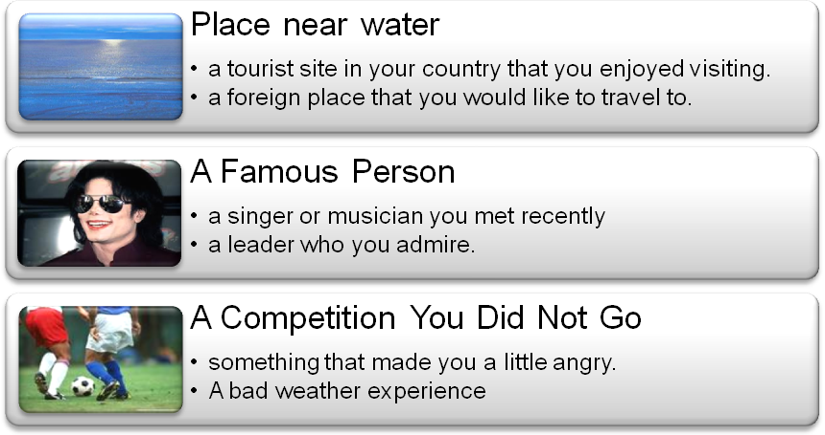
A Wedding
Describe a wedding you attended.
You should say:
whose wedding it was
who was there
where it was
and explain how you felt at this wedding
- Whose wedding it was
- It was my cousin’s wedding.
- It was my best friend’s wedding.
- Actually I’ve never attended a wedding, so I would like to talk about my own dream wedding…
- who was there
- immediate families / distant relatives
- relatives / families
- closest friends
- colleagues
- It was not a wedding, it was a town.
- Since it was a small wedding, the couple only invited their immediate families and closest friends.
- It was a big fat Chinese wedding! And the whole place was packed! They had like over 200 guests to the reception, mostly were relatives and friends.
A Wedding
the big day  ceremony  reception  bride  groom  maid of honor | best man  bridesmaid  Usher  flower girl  band  the in-laws
- Aisle Carpet / walk down the aisle
- Bouquet / toss the bouquet
- Tuxedo/ Tux
- Wedding gown / wedding dress
- Wedding vows
- wedding march
- where it was
- garden wedding
- beach wedding
- gold coast
- oceanside / lakeside / riverside
- crystal blue sea water
- Beach wedding
About the location, It was a fabulous beach wedding, so they had the ceremony on the gold coast.
They had their cceanside ceremony on the beach and said “I do” by the crystal blue sea water.
- in-door weddings
The wedding was held in the grand ballroom in an elegant hotel.
The ceremony took place in a church because it was a perfect place for a fairytale wedding.
- grand ballroom
- boutique hotel
- church / cathedral
- clubhouse
- Explain how you felt at this wedding
- The wedding was ……
- romantic
- emotional
- elegant
- joyful
- unique
- classic
The wedding was joyful and unique!
I felt flattered and thrilled to be the maid of honor at the wedding. Although I worked like a bee to make sure everything was under control. You know, in case the bride gets a cold feet and runs away. I was just glad it went smoothly.
- bustling
- lively
- festive
- wedding feast
I was so excited for the new couple.
And it is amazing to see them finally tie the knot.
The wedding was bustling, lively and festive, and there were double happiness symbols everywhere in the hall.
链接手段：
- 开头三个问题+ 解释部分
开头：
- I’d like to talk about….
- Let me talk about ….
- I’d like to talk about a wedding, which was my cousin’s wedding.
- Cousin’s wedding
- Immediate family and closest friends
- Beach wedding
- Speaking of how I felt about her wedding, well
- I felt flattered and thrilled
- so excited for them
- I had mixed feelings
解释部分（重点）：
- Speaking of the reasons why I liked…
- Speaking of how I felt about …
- Speaking of how I felt about her wedding, well …
- I’d like to talk about a wedding, which was my cousin’s wedding.
- Cousin’s wedding
- Immediate family and closest friends
- Beach wedding
- Speaking of how I felt about her wedding, well
- I felt flattered and thrilled
- so excited for them
- I had mixed feelings
Some traditions in western countries:
- Bridal shower -is a gift-giving party held for a bride-to-be in anticipation of her wedding.
- Rehearsal dinner –dinner before the wedding day
- bachelor party
- bachelorette party
- What are some wedding customs from your country?
- Chinese people are very picky when it comes to choosing the date for the wedding - it should be a lucky one, or is called the red letter day. We choose the date according to the lunar calendar.
- What age do you think is the most suitable for marriage?
- It really depends! Some people like to marry young, and some like to settle down first. Personally, I think that 30 would be an ideal age.
- There is no 'best age' for people to get married.
- You just get married when you find your Miss or Mr. Right.
- Which do you think is better, a large wedding or a small one?
- Well, in fact I believe I’ll only get married once. I want to have a big fancy wedding, because it is a “once in a lifetime” deal. It means the world to me!
- I want a small wedding because it's not the smartest idea to spend an arm and a leg on just one day. I'd rather have a low cost wedding and save that extra money for something like a honeymoon. Plus I want to keep it low profile.
Shopping place
- Shopping mall
- Road
- Public place
- A day off
Describe a place where you often go shopping
You should say:
where this place is
what this place sells
how often you go there
and explain why you like to shop at this place.
Describe a street/road in your hometown.
You should say:
where it is
what the main buildings are on that street/road
what you usually do on that street/road
and explain how you feel about this street/road.
Describe an interesting public place in your hometown or city.
You should say:
what place is
who usually goes there
why people go there
and explain why people think it is an interesting place to visit.
Describe what you would do if you had a day off, free from work or study.
You should say:
where you would go
what you would do there
who you would go with
and explain how you think you would feel at the end of this day.
Where this place is
- Joy City is a shopper’s paradise for almost everyone.
- Wal-mart is one of the biggest supermarkets in the world.
- It is located in the heart of Beijing/ downtown area.
- It is only ten minutes walk/driving from where I live
- It is in Xi'dan! One of a favorite shopping area among locals, especially young people
What this place sells
- Mall  - Outlet  - Department store  - Flagship store  - Fashion boutique | - Convenience store  - Drug store  - specialty store  - Supermarket  - Chain store
- It is really hard to list what it sells, because Joy city has ten floors of shops.
- Joy city is a fantastic place for shopping, dining and entertainment. It really gives us a one-stop shopping experience.
- Joy City offers a wide variety of/various trendy brands. What’s more, flagship stores and fashion boutiques of different luxury brands are available.
- Joy city is very fancy but not like top-of-the-line. I find good brands that are affordable and the quality is top-notch.
- Joy city is best known for accessible mid-range stuff.
top-notch 高质量，高水准
One of a kind 只此一家，独一无二
Everything in this hotel is top-notch，the room, food and view.
He is really one of a kind…
How often you go there
- I come here a lot! Like at least once a week! I’ve lived in this area my whole life. But I usually avoid the weekend to beat the crowd.
twice a week
once every two weeks
beat the crowd: avoid the rush hour
- Once every two months maybe, I don't go shopping a lot.
- Not often! Whenever they have sales! Like Christmas, New year and end of the summer. I usually save my money for it and then blow it on shoes, shirts, especially bags.
Sales
On sale
For sale
Discount
20% off
Explain why you like to shop at this place.
- Personally, I enjoy the square footage平方英尺and store layout. It is large enough to never feel overcrowded and it's pretty easy to get around随意走走 绕开.
I really enjoy the square footage of this book store. It is spacious and very bright.
They have escalators/ elevator here and there, which saves a lot of walking.
- It is an entertainment complex. The mall is incredible and has anything you could want.
Other than the shops, they also have cineplex, swimming pool, and lots of eateries and quality restaurants where you can also enjoy the panoramic view of the city.
This is such a cool entertainment complex, and it got everything I want, like a cineplex, spa and even a casino.
- It is good for all types of people with different needs and interests. It offers upscale designer outfits, sports and casual wear and outdoor clothing.
outfit/ wear/ clothing/ clothes

- This place is more like an indoor downtown than a shopping mall. I really enjoy the atmosphere.
It is really worth my time.
- Actually, you can find everything under the same roof. Great for one stop shopping. Plus, there are more opportunities for exercise. It's a highly entertaining/ interesting/ amusing way to spend an afternoon.
under the same roof- in the same place
- I find the services very thoughtful.
- I find + adj. … - I think….
- Great parking / free parking
- Free mini-bus for shoppers
- Good customer service
- Flexible return policy
- Mobile battery charging
- I’d like to talk about a shopping mall, which is…
- shopper’s paradise and it is located in Xi’dan
- a wide variety of brands/ hard to list
- come Whenever they have sales
- Speaking of why I enjoy shopping here, well
- enjoy the square footage and store layout
- entertainment complex
- services very thoughtful
- Indoor downtown, enjoy the atmosphere.
Part Three: Shopping Place
- What do you think are the pros and cons of shopping online?
Pros and cons – advantages and disadvantages
pro-con list
- Pros:
- Convenience (time-saving)
- Variety
- Discount / special offer
- Easy exchanging and returning
- Easy comparison
- Flexible (time/location)
- Cons:
- Loss of private information
- Fitting problem (in respect to clothes/ shoes): some are true to the size, some are not
- Authentic problem/Knock-off products
- Slow refunds
- Shipping cost
The best part about Internet shopping is the convenience, and you just have to sit in front of a computer and search for the stuff. Also, they will be delivered right to your doorstep.
As for the disadvantage, I would say the loss of private information. your address is always available to those sellers.
- What influence does advertising have on consumers?
Advertising can influence consumer’s decision making/ misleading in many ways. I believe it is brainwashing.
- Compare big shops such as supermarkets and department stores with small shops.
Small shops provide better services and usually within walking distance.
People come to small shops for the considerate customer service.
While big supermarkets are able to provide competitive prices/bigger discounts and better shopping environment.

- Sina 微博 王煦煦
- Renren：王煦 ☆

