**雅思阅读讲义**

**主讲：孙吉芯**

**欢迎使用新东方在线电子教材**



雅思考试介绍

**What is IELTS?**

IELTS is the International English Language Testing System. It measures ability to communicate in English across all four language skills – listening, reading, writing and speaking – for people who intend to study or work where English is the language of communication.

IELTS mirrors real lives.

剑桥大学考试委员会 英国文化协会 澳大利亚教育国际开发署

icon-3.gificon-1.gificon-2.gif

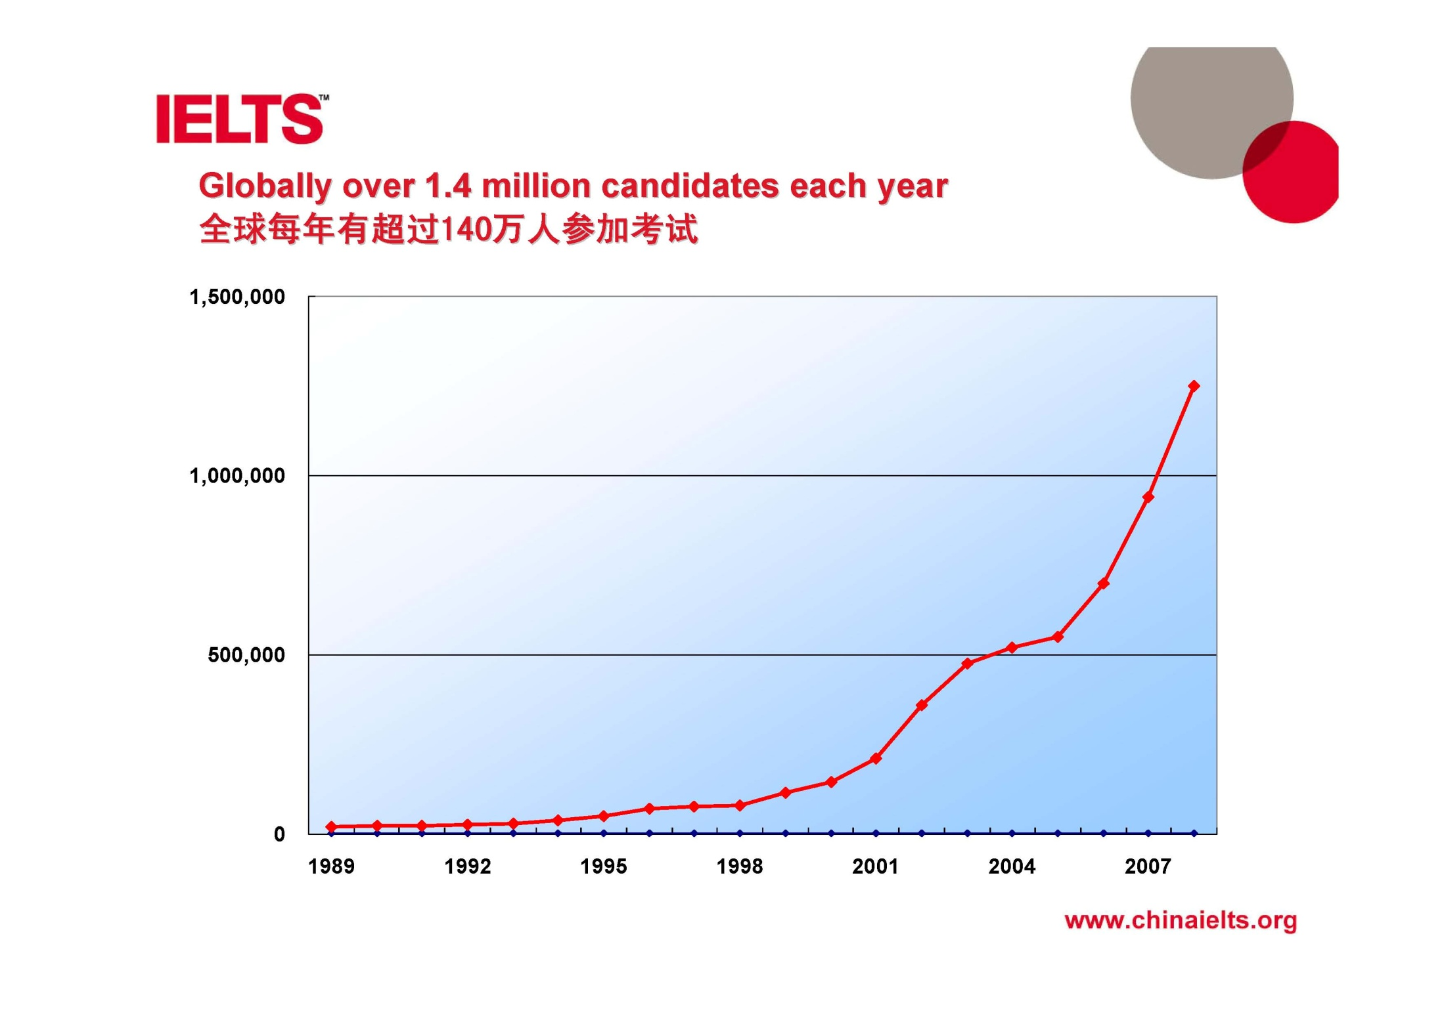

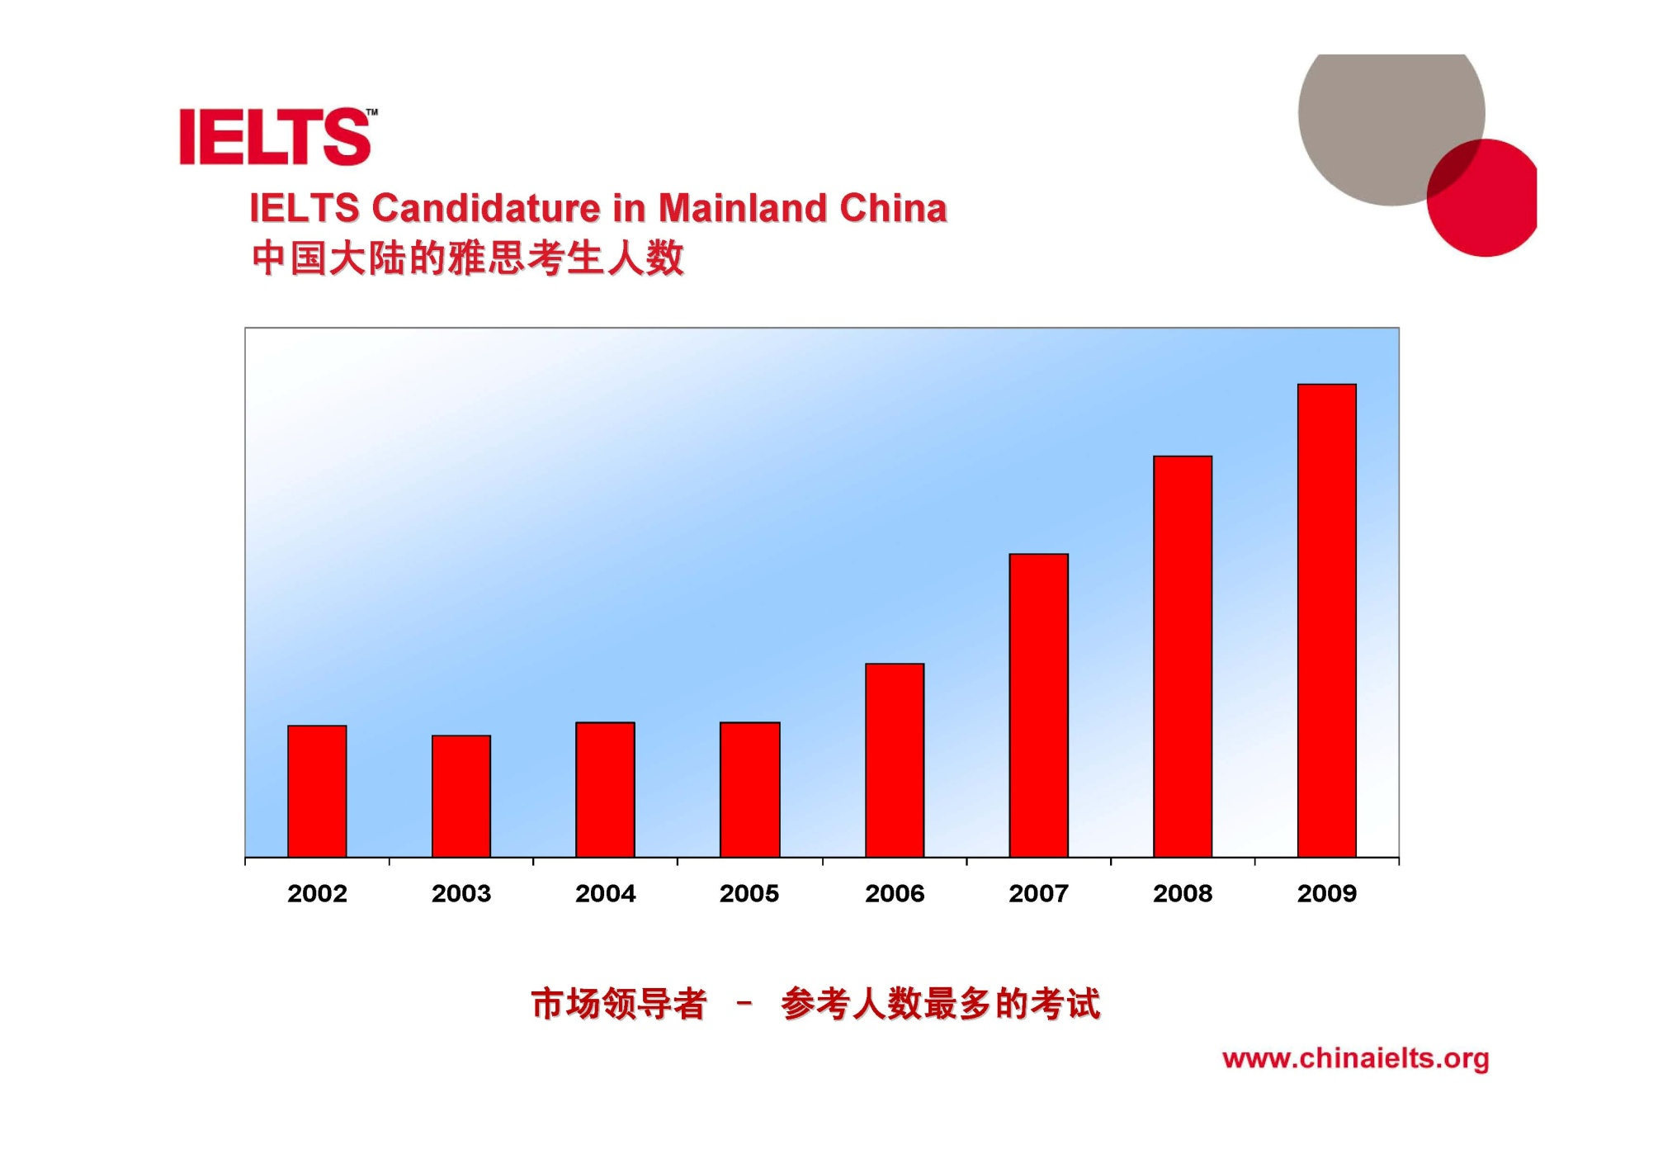

**Mean band score for the most frequent countries or regions of origin (Academic)**

|  |  |  |  |  |  |
| --- | --- | --- | --- | --- | --- |
| **Academic** | **Listening** | **Reading** | **Writing** | **Speaking** | **OVERALL** |
| **Bangladesh** | 5.8 | 5.6 | 5.5 | 5.8 | 5.7 |
| **Brazil** | 6.8 | 6.9 | 6.2 | 6.8 | 6.7 |
| **China** | 5.7 | 5.9 | 5.2 | 5.3 | 5.6 |
| **Colombia** | 6.3 | 6.5 | 5.7 | 6.4 | 6.3 |
| **Cyprus** | 6.4 | 5.9 | 5.7 | 6.3 | 6.1 |
| **Egypt** | 6.3 | 6.1 | 5.8 | 6.3 | 6.2 |
| **France** | 6.9 | 7.2 | 6 | 6.4 | 6.7 |
| **Germany** | 7.5 | 7.3 | 6.5 | 7.2 | 7.2 |
| **Greece** | 7.2 | 7 | 6.1 | 6.5 | 6.8 |
| **Hong Kong** | 6.8 | 6.7 | 5.8 | 6 | 6.4 |
| **India** | 6.3 | 5.8 | 5.7 | 6 | 6 |
| **Indonesia** | 6.3 | 6.4 | 5.6 | 6 | 6.2 |
| **Iran** | 5.8 | 5.7 | 5.7 | 6.3 | 6 |
| **Iraq** | 5.7 | 5.5 | 5.3 | 6.2 | 5.7 |
| **Italy** | 6.4 | 7 | 5.8 | 6.3 | 6.4 |
| **Japan** | 6 | 6 | 5.3 | 5.7 | 5.8 |
| **Jordan** | 5.7 | 5.5 | 5.2 | 5.9 | 5.6 |
| **Kazakhstan** | 5.8 | 5.9 | 5.6 | 6 | 5.9 |
| **Korea, South** | 6.1 | 6.1 | 5.3 | 5.7 | 5.9 |
| **Kuwait** | 5.3 | 5 | 4.9 | 5.7 | 5.3 |
| **Libya** | 5.2 | 5.1 | 5.1 | 5.8 | 5.4 |
| **Malaysia** | 7.2 | 7 | 6.2 | 6.6 | 6.8 |
| **Mexico** | 6.5 | 6.7 | 5.9 | 6.4 | 6.4 |
| **Myanmar** | 6.2 | 6.2 | 5.7 | 6 | 6.1 |
| **Nepal** | 6.3 | 5.8 | 5.7 | 5.9 | 6 |
| **Nigeria** | 6.2 | 6.1 | 6.3 | 7.1 | 6.5 |
| **Oman** | 5.1 | 5 | 4.9 | 5.6 | 5.2 |
| **Pakistan** | 5.9 | 5.7 | 5.8 | 6.1 | 5.9 |
| **Philippines** | 7 | 6.6 | 6.2 | 6.8 | 6.7 |
| **Qatar** | 4.8 | 4.6 | 4.5 | 5.3 | 4.9 |
| **Russia** | 6.6 | 6.6 | 5.9 | 6.6 | 6.5 |
| **Saudi Arabia** | 5 | 4.9 | 4.7 | 5.7 | 5.1 |
| **Spain** | 6.6 | 6.9 | 6 | 6.4 | 6.5 |
| **Sri Lanka** | 6.4 | 6 | 5.9 | 6.4 | 6.3 |
| **Sudan** | 5.8 | 5.7 | 5.6 | 6.2 | 5.9 |
| **Taiwan** | 5.8 | 5.9 | 5.4 | 5.8 | 5.8 |
| **Thailand** | 5.9 | 5.9 | 5.3 | 5.8 | 5.8 |
| **Turkey** | 6 | 6 | 5.5 | 6 | 5.9 |
| **United Arab Emirates** | 5 | 4.8 | 4.7 | 5.4 | 5.1 |
| **Vietnam** | 5.9 | 6.1 | 5.6 | 5.7 | 5.9 |

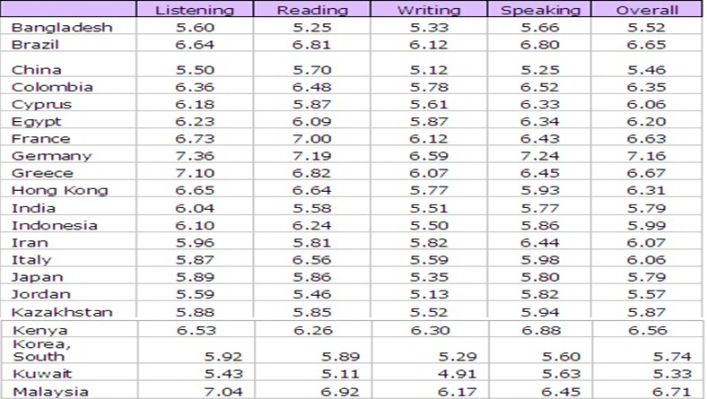

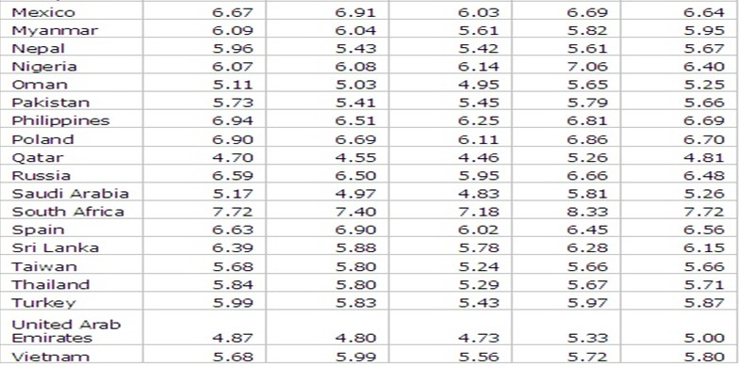

|  |  |  |  |  |  |  |
| --- | --- | --- | --- | --- | --- | --- |
| Rank | Country | Listening | Reading | Writing | Speaking | OVERALL |
| 1 | Germany | 7.5 | 7.3 | 6.5 | 7.2 | 7.2 |
| 2 | Greece | 7.2 | 7 | 6.1 | 6.5 | 6.8 |
| 3 | Malaysia | 7.2 | 7 | 6.2 | 6.6 | 6.8 |
| 4 | Brazil | 6.8 | 6.9 | 6.2 | 6.8 | 6.7 |
| 5 | France | 6.9 | 7.2 | 6 | 6.4 | 6.7 |
| 6 | Philippines | 7 | 6.6 | 6.2 | 6.8 | 6.7 |
| 10 | Hong Kong | 6.8 | 6.7 | 5.8 | 6 | 6.4 |
| 23 | Korea, South | 6.1 | 6.1 | 5.3 | 5.7 | 5.9 |
| 23 | Japan | 6 | 6 | 5.3 | 5.7 | 5.8 |
| 28 | Taiwan | 5.8 | 5.9 | 5.4 | 5.8 | 5.8 |
| 33 | China | 5.7 | 5.9 | 5.2 | 5.3 | 5.6 |
| 34 | Jordan | 5.7 | 5.5 | 5.2 | 5.9 | 5.6 |
| 35 | Libya | 5.2 | 5.1 | 5.1 | 5.8 | 5.4 |
| 36 | Kuwait | 5.3 | 5 | 4.9 | 5.7 | 5.3 |
| 37 | Oman | 5.1 | 5 | 4.9 | 5.6 | 5.2 |
| 38 | Saudi Arabia | 5 | 4.9 | 4.7 | 5.7 | 5.1 |
| 39 | UAE | 5 | 4.8 | 4.7 | 5.4 | 5.1 |
| 40 | Qatar | 4.8 | 4.6 | 4.5 | 5.3 | 4.9 |

**全球男性考生平均成绩**

|  |  |  |  |  |  |
| --- | --- | --- | --- | --- | --- |
|  | **听力** | **阅读** | **写作** | **口语** | **总分** |
| 学术类 | 5.83 | 5.69 | 5.37 | 5.69 | 5.71 |
| 培训类 | 6.05 | 5.66 | 5.73 | 6.17 | 5.9 |

**全球女性考生平均成绩**

|  |  |  |  |  |  |
| --- | --- | --- | --- | --- | --- |
|  | **听力** | **阅读** | **写作** | **口语** | **总分** |
| 学术类 | 6.01 | 5.92 | 5.53 | 5.87 | 5.89 |
| 培训类 | 6.20 | 5.80 | 5.90 | 6.28 | 6.11 |

**考试的时间**

* 雅思考试时间是在每周的周末，也就是周六周日两天。周六上午笔试8:30-12:00,考察的依次顺序是听力，阅读，写作。
* 口语原则上根据姓名顺序安排早在周六周日两天完成，有部分考生在周五参加口试，每半天为一个场次，题目始终在流水更换

**IELTS Modules**

* Listening
* Reading
* Writing
* Speaking

**考试的地点**

* 各大主要城市都有考点，根据考生需求量的不同考点的考试次数也有差距
* 同一时间内不同地点内：  
  1.笔试部分内容完全相同  
  2.口试部分完全不同

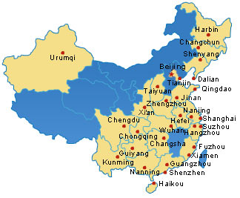

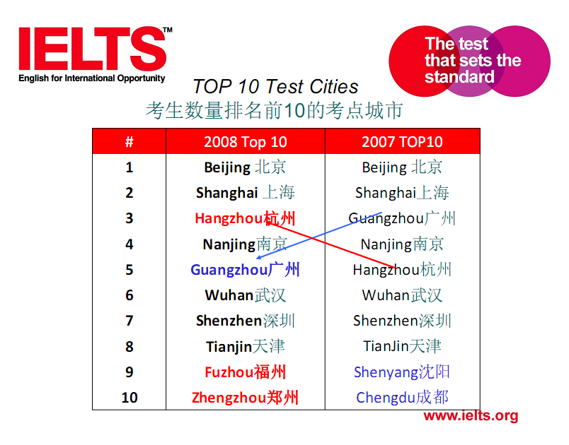

**雅思阅读题目情况**

* 题目数量：60分钟/40道题（包括誊写答案的时间）
* 文章长度：1000字左右/每篇
* 文章来源：简单的说是学术文章
* 期刊：newscientist scientificAmerican

**Result-based留学**

* Undergraduate school
* Overall 6 ,no less than 6 in each subject
* Graduate school
* Overall 6.5 ,no less than 6 in each subject

|  |  |  |  |  |
| --- | --- | --- | --- | --- |
| **听力** | **阅读** | **写作** | **口语** | **总分** |
| 6 | 6 | 6 | 6 | 6 |
| 6 | 7 | 6 | 6 | 6.5 |
| 7.5 | 7.5 | 6 | 6 | 7 |
| 6.5 | 7 | 6 | 5.5 | 6.5 |

**评分标准**

|  |  |
| --- | --- |
| **16-18：** | **5分** |
| **19-22：** | **5.5** |
| **23-25：** | **6 57.5%** |
| **26-28：** | **6.5 65%** |
| **29-31：** | **7 72.5%** |
| **32-35：** | **7.5** |
| **36-37：** | **8** |
| **38-39：** | **8.5** |
| **40：** | **9** |

**雅思阅读的主要困难**

* A. 时间

|  |  |  |  |
| --- | --- | --- | --- |
| Module | Total time | Questions | Time for each question |
| Listening | 30 min | 40 | 0.75 min |
| Reading | 60 min | 40 | 1.5 min |
| Writing | 60 min | 2 | 30 min |
| Speaking | 11-14 min | N/A | N/A |

* B.阅读习惯
  + 一定要改掉逐字逐句阅读的习惯，学会skimming & scanning 简单的说就是跳读和逐字逐句阅读结合的方式。
  + 练习瞬间记忆的能力，保证不会回头看。
* C. 词汇量：7000-8000

实际为常用词汇+1000学术词汇

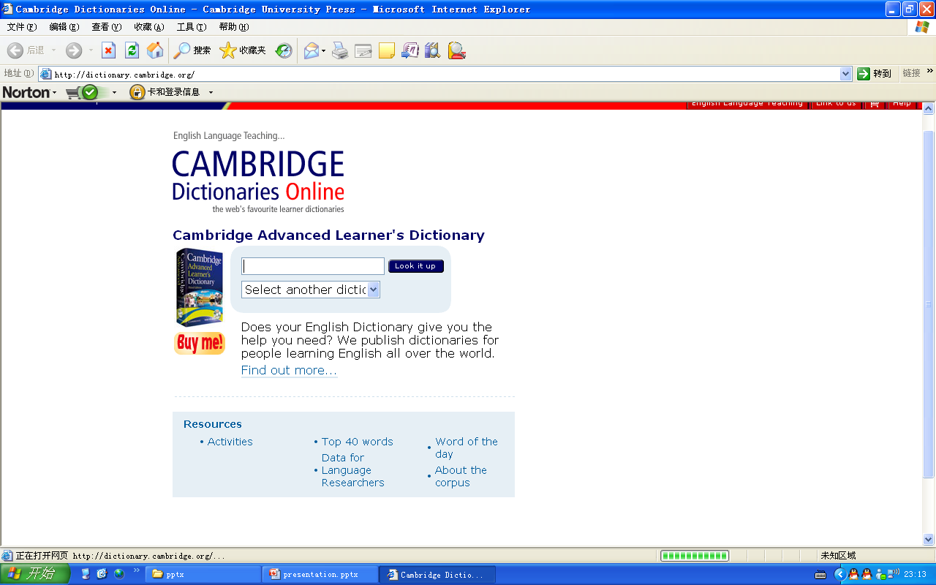

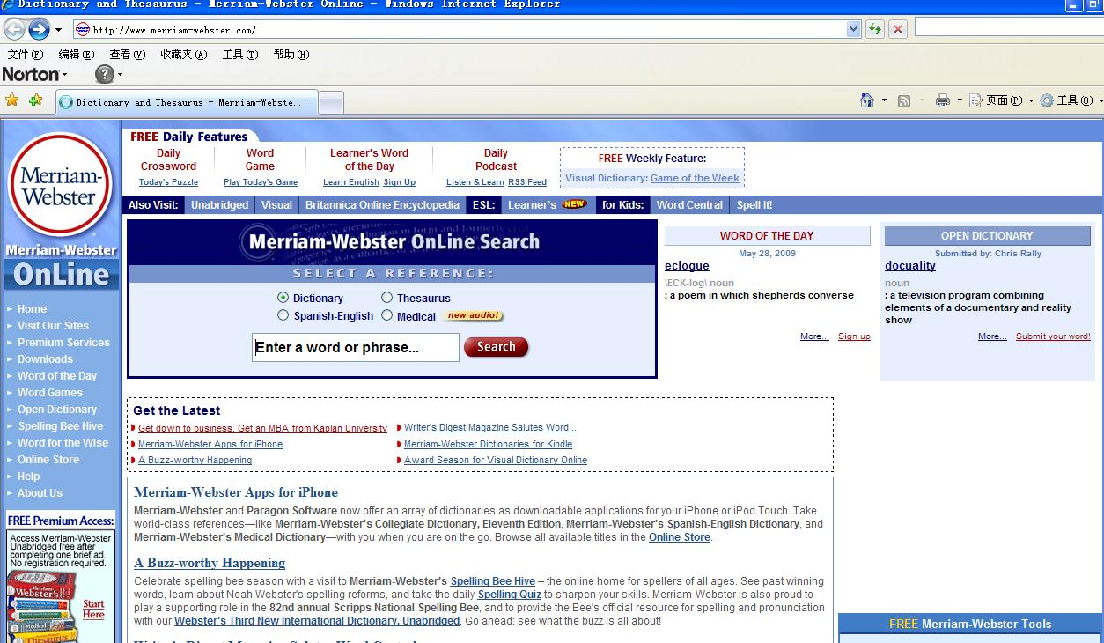

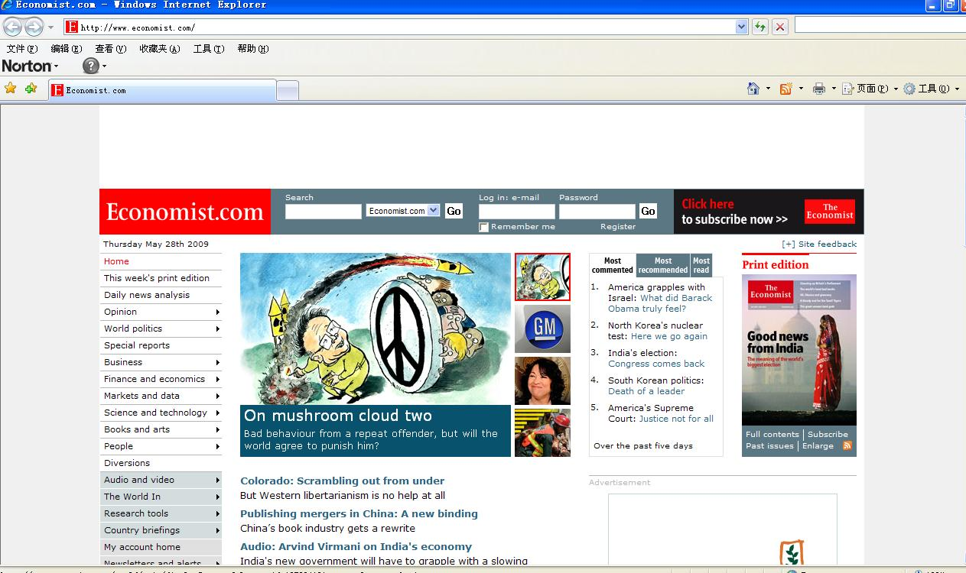

True/False/Not Given题型

Do the following statements agree with the information given in Reading Passage 1?

In boxes 1–8 on your answer sheet write

TRUE if the statement agrees with the information

FALSE if the statement contradicts the information

NOT GIVEN if there is no information on this

1. The plight of the rainforests has largely been ignored by the media.

*（In the face of the frequent and often vivid media coverage, it is likely that children will have formed ideas about rainforests）*

1. Children only accept opinions on rainforests that they encounter in their classrooms.

*（In the face of the frequent and often vivid media coverage, it is likely that children will have formed ideas about rainforests-what and where they are, why they are important, what endangers them-independent of any formal tuition.）*

1. It has been suggested that children hold mistaken views about the ‘pure’ science that they study at school.

*(Many studies have shown that children harbor misconceptions about ‘pure’, curriculum science.)*

1. The fact that children’s ideas about science form part of a larger framework of ideas means that it is easier to change them.

*（These misconceptions do not remain isolated but become incorporated into a multifaceted, but organized, conceptual framework, making it and the component ideas, some of which are erroneous, more robust but also accessible to modification）*

1. The study involved asking children a number of yes/no questions such as ‘Are there any rainforests in Africa?

*（The study surveys children’s scientific knowledge and attitudes to rainforests. Secondary school children were asked to complete a questionnaire containing five open-form questions.）*

1. Girls are more likely than boys to hold mistaken views about the rainforest’s destruction.

*（Some children also gave more general locations, such as being near the Equator. Responses to question three concerned the importance of rainforests. The dominant idea, raised by 64% of the pupils，was that rainforests provide animals with habitats. ）*

1. The study reported here follows on from a series of studies that have looked at children’s understanding of rainforests.

*（These observations are generally consistent with our previous studies of pupils’ views about the use and conservation of rainforests, in which girls were shown to be more sympathetic to animals and expressed views which seem to place an intrinsic value on non-human animal life. ）*

1. A second study has been planned to investigate primary school children’s ideas about rainforests.

17、Between 1983 and 1990 the numbers of patients visiting alternative therapists rose to include a further 8% of the population.

*（In a 1983 national health survey, 1.9% of people said they had contacted a chiropractor, naturopath, osteopath, acupuncturist or herbalist in the two weeks prior to the survey. By 1990, this figure had risen to 2.6% of the population.）*

18、The 1990 survey related to 550,000 consultations with alternative therapists.

*（The 550,000 consultations with alternative therapists reported in the 1990 survey represented about an eighth of the total number of consultations with medically qualified personnel covered by the survey.）*

19、In the past, Australians had a higher opinion of doctors than they do today.

*（The high standing of professionals, including doctors, has been eroded as a consequence.）*

20、Some Australian doctors are retraining in alternative therapies.

*（Rather than resisting or criticizing this trend, increasing numbers of Australian doctors, particularly younger ones, are forming group practices with alternative therapists or taking courses themselves, particularly in acupuncture and verbalism.）*

21、Alternative therapists earn higher salaries than doctors.

22、The 1993 Sydney survey involved 289 patients who visited alternative therapists for acupuncture treatment.

*（In 1993, Dr Laver and his colleagues published a survey of 289 Sydney people who attended eight alternative therapists’ practices in Sydney.）*

23、All the patients in the 1993 Sydney survey had long-term medical complaints.

*（These practices offered a wide range of alternative therapies from 25 therapists. Those surveyed had experienced chronic illnesses, for which orthodox medicine had been able to provide little relief.）*

1、Modern official athletic records date from about 1900.

*（Since the early years of the twentieth century, when the International Athletic Federation began keeping records, there has been a steady improvement in how fast athletes run, how high they jump and how far they are able to hurl massive objects.）*

2、There was little improvement in athletic performance before the twentieth century.

*（Since the early years of the twentieth century, when the International Athletic Federation began keeping records, there has been a steady improvement in how fast athletes run, how high they jump and how far they are able to hurl massive objects.）*

3、Performance has improved most greatly in events requiring an intensive burst of energy.

*（For the so-called power events — that require a relatively brief, explosive release of energy, like the 100-metre sprint and the long jump — times and distances have improved ten to twenty percent. ）*

4、Improvements in athletic performance can be fully explained by genetics.

*（No one theory can explain improvements in performance, but the most important factor has been genetics.）*

5、The parents of top athletes have often been successful athletes themselves.

*(‘The athlete must choose his parents carefully’, says Jesus Dapena, a sports scientist at Indiana University, invoking an officiated adage.)*

6、The growing international importance of athletics means that gifted athletes can be recognized at a younger age.

*（Over the past century, the composition of the human gene pool has not changed appreciably, but with increasing global participation in athletics — and greater rewards to tempt athletes — it is more likely that individuals possessing the unique complement of genes for athletic performance can be identified early.）*

32、For the earliest tribes, the concept of sufficiency was more important than the concept of quantity.

*（Our ancestors had little use for actual numbers; instead their considerations would have been more of the kind ‘Is this enough?’ rather than’ How many?’ ）*

33、Indigenous Tasmanians used only four terms to indicate numbers of objects.

*（The indigenous peoples of Tasmania were only able to count one, two, many; those of South Africa counted one, two, two and one, two twos, two twos and one, and so on.）*

34、Some peoples with simple number systems use body language to prevent misunderstanding of expressions of number.

*（But in real situations the number and words are often accompanied by gestures to help resolve any confusion. For example, when using the one, two, many type of system, the word many would mean, Look at my hands and see how many fingers I am showing you.）*

35**、**All cultures have been able to express large numbers clearly.

*（The lack of ability of some cultures to deal with large numbers is not really surprising.）*

36、The word 'thousand' has Anglo-Saxon origins.

*（The ancient Gothic word for ten, tachund, is used to express the number 100 as tachund tachund. By the seventh century, the word teon had become interchangeable with the tachund or hund of the Anglo-Saxon language, and so 100 was denoted as hund teontig, or ten times ten）*

37、In general, people in seventh-century Europe had poor counting ability.

*（The average person in the seventh century in Europe was not as familiar with numbers as we are today. In fact, to qualify as a witness in a court of law a man had to be able to count to nine!）*

38、In the Tsimshian language, the number for long objects and canoes is expressed with the same word.

*（The numeration system of the Tsimshian language in British Columbia contains seven distinct sets of words for numbers according to the class of the item being counted: for counting flat objects and animals, for round objects and time, for people, for long objects and trees, for canoes, for measures, and for counting when no particular object is being numerated.）*

39、The Tsimshian language contains both older and newer systems of counting.

*（It seems that the last is a later development while the first six groups show the relics of an older system.）*

40、Early peoples found it easier to count by using their fingers rather than a group of pebbles.

**解题步骤**

* STEP 1：定位，找出题目在原文中的出处。

（1）该题型一般为细节题。首先需要找到题目中的定位词。

定位词一般选择特殊名词。

特殊名词>一般名词>动词

（2）根据所选定位词，在原文中找出相应的出处，找到出处后，阅读本句及相关句子与题目比较 ，做出选择。

（3）要注意顺序性，即题目的顺序和原文的顺序基本一致。依靠顺序原则排除或验证NG

* STEP 2：判断，确定TFNG或者YNNG

1．True

第一种情况：题目是原文的同义表达。通常用同义词或同义结构。

第二种情况：题目是根据原文中的几句话做出合理的归纳或同意替换。

2. False

第一种情况：题目与原文直接相反。通常用反义词、反义结构。

第二种情况：原文是多个条件并列，题目是其中一个条件（出现must或only）原文是两个或多个情形（通常是两种情形）都可以.

第三种情况：原文和题目中使用了表示不同范围、频率、可能性的词。原文中常用many（很多）、sometimes（有时）及unlikely（不太可能）等词。题目中常用all（全部）、usually（通常）、always（总是）、及impossible（完全不可能）等词。

第四种情况原文中某些结果是建立在一定条件基础上的，题目中去掉了这些条件。

3. Not Given

第一种情况：题目中的某些内容在原文中没有提及。题目中的某些内容在原文中找不到依据。

第二种情况：题目中涉及的范围小于原文涉及的范围，也就是更具体。原文涉及一个较大范围的范筹，而题目是一个具体概念。也就是说，题目中涉及的范围比原文要小。

第三种情况：原文是某人的目标、目的、想法、愿望、保证、发誓等，题目是事实。原文中常用aim（目的）、purpose（目的）、promise（保证）、swear（发誓）及vow（发誓）等词。题目中用实意动词。

第四种情况：题目中有比较级，原文中没有比较。

**NOTICE**

1．题目中若出现must、only、all及always，答案一般不会是True。

2．答案选择有一定的规律。

* Any street child can set up their own small business if given enough support.
* In some cases, the families of street children may need financial support from S.K.I.
* Only one fixed loan should be given to each child.
* The children have to pay back slightly more money than they borrowed.

1. Sales representatives like Kim Schaefer work to a very limited budget

*（But on any given day what Schaefer can offer is typical for today’s drug rep- a car trunk full of promotional gifts and gadgets, a budget that could buy lunches and dinners for a small county hundreds of free drug samples and the freedom to give a physician $200 to prescribe her new product to the next six patients who fit the drug’s profile.）*

1. Kim Schaefer’s marketing technique may be open to criticism on moral ground.

*（Selling Pharmaceuticals in a daily exercise in ethical judgment.*

*They work in an industry highly criticized for its sales and marketing practices.）*

1. The information provided by drug companies is of little use to doctors.

*（Salespeople provide much-needed information and education to physicians. ）*

1. Evidence of drug promotion is clearly visible in the healthcare environment.

*（Rarely do patients watch a doctor write with a pen that isn’t emblazoned with a drug’s name, or see a nurse use a tablet not bearing a pharmaceutical company’s logo.）*

1. The drug companies may give free drug samples to patients without doctors’ prescriptions.

*（Free samples of new and expensive drugs might be the single most effective way of getting doctors and patients to become loyal to a product.）*

1. It is legitimate for drug companies to make money.

*（But as the medical world continues to grapple with what’s acceptable and what’s not, it is clear that companies must continue to be heavily scrutinized for their sales and marketing strategies. ）*

List of Headings题型

Questions 28—31

Reading Passage 3 has five sections A—E. Choose the correct heading for section A and C—E from the list of headings below. Write the correct number i—viii in the boxes 28—31 on your answer sheet.

List of Headings

i The connection between health-care and other human rights

ii The development of market-based health systems

iii The role of the state in health-care

iv A problem shared by every economically developed country

v The impact of recent change

vi The views of the medical establishment

vii The end of an illusion

viii Sustainable economic development

The problem of how health-care resources should be allocated or apportioned, so that they are distributed in both the most just and most efficient way, is not a new one.

However, at exactly the same time as this new realization of the finite character of health-care resources was sinking in, an awareness of a contrary kind was developing in Western societies: that people have a basic right to health-care as a necessary condition of a proper human life. Like education, political and legal processes and institutions, public order, communication, transport and money supply,

Although the language of ‘rights’ sometimes leads to confusion, by the late 1970s it was recognized in most societies that people have a right to health-care (though there has been considerable resistance in the United States to the idea that there is a formal right to health-care). It is also accepted that this right generates an obligation or duty for the state to ensure that adequate health-care resources are provided out of the public purse.

As a consequence, during the 1980s a kind of doomsday scenario (analogous to similar doomsday extrapolations about energy needs and fossil fuels or about population increases) was projected by health administrators, economists and politicians. In this scenario, ever-rising health costs were matched against static or declining resources.

* 1.去掉例子中的heading
* 2.浏览Headings，找出关键词Key Words (KW)
  + 双胞胎型的headings中必有正确答案
  + 人名、地名尽量不选
  + 用词一样的不选
* 3.通读段落，寻找段落主题句TOPIC SENTENCE

首句

二句

末句

* 注意文中的But yet However
* “”?
* 定义句型必是主题句

This is…That is… it is

A is called

A is known as

A is defined as…

* 例子：如for example/instance
* 4.回到heading 中,对比主题句与heading中的关键字，寻同义词，或者概括词
* 5.如果没有,再次返回浏览段落。

如果段落比较短,一般需要浏览全段,推测段意 ;

如果段落很长,则直接再次浏览首二末句

“” ? :

要注意频繁在段落中出现的名词。

**NOTICE**

* 如果答案不确定，先将可能的选项全部选出。
* 干扰选项的特点是：段落中未展开说明的细节。
* 正确答案应是主题句的改写，所以与主题句特别一致的选项应引起怀疑。
* 如果需要阅读整个段落，应重点阅读该段落中的重点词句  
  A． 反复出现的词  
  B． 问号里的词  
  C． 引号里的词  
  D． 黑体字
* 1． 起始选项  
    文章标题
* 2．结尾选项

名词+of+文章主题  
 Summary, conclusion, Effect, impact, influence, long-term, Future

* 选项对应数字重复出现段落

Data, figure, calculation, statistic demography

* 选项对应百分比较多段落  
   percentage, proportion , rate
* 对应金钱较多段落

Revenue, budget, cost

List of Headings

i Effects of irrigation on sedimentation

ii The danger of flooding the Cairo area

iii Causing pollution in the Mediterranean

iv Interrupting a natural process

v The threat to food production

vi Less valuable sediment than before

vii Egypt's disappearing coastline

viii Looking at the long-term impact

Up to now, people have blamed this loss of delta land on the two large dams at Aswan in the south of Egypt, which hold back virtually all of the sediment that used to flow down the river.

The farms on the delta plains and fishing and aquaculture in the lagoons account for much of Egypt's food supply. But by the lime the sediment has come to rest in the fields and lagoons it is laden with municipal, industrial and agricultural waste from the Cairo region, which is home to more than 40 million people. 'Pollutants are building up faster and faster,' says Stanley.

Write the correct number, i-xi, in boxes 14-20 on your answer sheet.

List of Headings

1. Scientists' call for a revision of policy
2. An explanation for reduced water use
3. How a global challenge was met
4. Irrigation systems fall into disuse
5. Environmental effects
6. The financial cost of recent technological improvements
7. The relevance to health
8. Addressing the concern over increasing populations
9. A surprising downward trend in demand for water
10. The need to raise standards
11. A description of ancient water supplies

14 Paragraph A

Example: Paragraph B Answer iii

15 Paragraph C

16 Paragraph D

17 Paragraph E

18 Paragraph F

19 Paragraph G

20 Paragraph H

At the height of the Roman Empire, nine major systems, with an innovative layout of pipes and well-built sewers, supplied the occupants of Rome with as much water per person as is provided in many parts of the industrial world today.

Yet there is a dark side to this picture: despite our progress, half of the world's population still suffers, with water services inferior to those available to the ancient Greeks and Romans. As the United Nations report on access to water reiterated in November 2001, more than one billion people lack access to clean drinking water;

some two and a half billion do not have dequate sanitation services. Preventable water-related diseases kill an estimated 10,000 to 20,000 children every day, and the latest evidence suggests that we are falling behind in efforts to solve these problems.

The consequences of our water policies extend beyond jeopardising human health. Tens of millions of people have been forced to move from their homes - often with little warning or compensation - to make way for the reservoirs behind dams. More than 20 % of all freshwater fish species are now threatened or endangered because dams and water withdrawals have destroyed the free-flowing river ecosystems where they thrive.

At the outset of the new millennium, however , the way resource planners think about water is beginning to change.

Fortunately - and unexpectedly - the demand for water is not rising as rapidly as some predicted.

What explains this remarkable turn of events? Two factors: people have figured out how to use water more efficiently, and communities are rethinking their priorities for water use. peak in 1980.

On the other hand, dams, aqueduct s and other kinds of infrastructure will still have to be built, particularly in developing countries where basic human needs have not been met . But such projects must be buil t to higher specifications and with more accountability to local people and their environment than in the past

**Cambridge IELTS 6**

**List of Headings**

1. The reaction of the Inuit community to climate change
2. Understanding of climate change remains limited
3. Alternative sources of essential supplies
4. Respect for Inuit opinion grows
5. A healthier choice of food
6. A difficult landscape
7. Negative effects on well-being
8. Alarm caused by unprecedented events in the Arctic
9. The benefits of an easier existence

Example Answer: Paragraph A viii

27 Paragraph B

28 Paragraph C

29 Paragraph D

30 Paragraph E

31 Paragraph F

32 Paragraph G

In Canada, where the Inuit people are jealously guarding their hard-won autonomy in the country's newest territory, Nunavut, they believe their best hope of survival in this changing environment lies in combining their ancestral knowledge with the best of modern science. This is a challenge in itself.

The Canadian Arctic is a vast, treeless polar desert that's covered with snow for most of the year. Venture into this terrain and you get some idea of the hardships facing anyone who calls this home.

It would cost a family around £7,000 a year to replace meat they obtained themselves through hunting with imported meat. Economic opportunities are scarce, and for many people state benefits are their only income.

While the Inuit may not actually starve if hunting and trapping are curtailed by climate change, there has certainly been an impact on people's health. Obesity, heart disease and diabetes are beginning to appear in a people for whom these have never before been problems.

in recent years IQ has had much more credibility and weight.' In fact it is now a requirement for anyone hoping to get permission to do research that they consult the communities, who are helping to set the research agenda to reflect their most important concerns.

There are still huge gaps in our environmental knowledge, and despite the scientific onslaught, many predictions are no more than best guesses

**List of Headings**

1. The results of the research into blood-variants
2. Dental evidence
3. Green berg's analysis of the dental and linguistic evidence
4. Developments in the methods used to study early population movements
5. Indian migration from Canada to the U.S.A.
6. Further genetic evidence relating to the three-wave theory
7. Long-standing questions about prehistoric migration to America
8. Conflicting views of the three-wave theory, based on non-genetic evidence
9. Questions about the causes of prehistoric migration to America

x How analysis of blood-variants measures the closeness of the relationship between different populations.

Study of the origins and distribution of human populations used to be based on archaeological and fossil evidence. A number of techniques developed since the 1 950s, however, have placed the study of these subjects on a sounder an more objective footing. The best information on early population movements is now being obtained from the 'archaeology of the living body', the clues to be found in genetic material.

But was there one major wave of migration across the Bering Strait into the Americas, or several? And when did this event, or events, take place? In recent years, new clues have come from research into genetics, including the distribution of genetic markers in modern Native Americans

Thus, by comparing the Gm all types of two different populations (e.g. two Indian tribes), one can establish their genetic 'distance', which itself can be calibrated to give an indication of the length of time since these populations last interbred.

Williams and his colleagues sampled the blood of over 5,000 American Indians in western North America during a twenty-year period. They found that their Gm all types could be divided into two groups

How far does other research support these conclusions? Geneticist Douglas Wallace has studied mitochondrial DNA in blood samples.

There are two other kinds of research that have thrown some light on the origins of the Native American population; they involve the study of teeth and of languages. The biological anthropologist Christy Turner is an expert in the analysis of changing physical characteristics in human teeth

The linguist Joseph Greenberg has, since the 1 950s, argued that all Native American languages belong to a single Amerind’ family

**List of Headings**

1. Not all doctors are persuaded
2. Choosing the best offers
3. Who is responsible for the increase in promotion?
4. Fighting the drug companies
5. An example of what doctors expect from drug companies
6. Gifts include financial incentives
7. Research shows that promotion works
8. The high costs of research
9. The positive side of drug promotion
10. Who really pays for doctors' free gifts?

 A few months ago Kim Schaefer, sales representative of a major global pharmaceutical company, walked into a medical center in New York to bring information and free samples of her company’s latest products. That day she was lucky-doctor WAS available to see her. The last rep offered me a trip to Florida. What do you have? the physician asked. He was only half joking.

**List of Headings**

1. Not all doctors are persuaded
2. Choosing the best offers
3. Who is responsible for the increase in promotion?
4. Fighting the drug companies
5. An example of what doctors expect from drug companies
6. Gifts include financial incentives
7. Research shows that promotion works
8. The high costs of research
9. The positive side of drug promotion
10. Who really pays for doctors’ free gifts?

 What was on offer that day was a pair of tickets for New York musical. But on any given day what Schaefer can offer is typical for today’s drug rep- a car trunk full of promotional gifts and gadgets, a budget that could buy lunches and dinners for a small county hundreds of free drug samples and the freedom to give a physician $200 to prescribe her new product to the next six patients who fit the drug’s profile

They work in an industry highly criticized for its sales and marketing practices, but find themselves in the middle of the age-old chicken-or-egg question—— businesses won’t use strategies that don’t work, so are doctors to blame for the escalating extravagance of pharmaceutical marketing? Or is it the industry’s responsibility to decide the boundaries?

Salespeople provide much-needed information and education to physicians. In many cases the glossy education for healthcare givers.

Free samples of new and expensive drugs might be the single most effective way of getting doctors and patients to become loyal to a product.

The bottom line is that pharmaceutical companies as a whole invest more in marketing than they do in research and development.

Summary题型

**Questions 37—40**

Complete the summary of paragraph G below.

Choose **NO MORE THAN THREE WORDS** from the passage for each answer.

Write your answers in boxes 37—40 on your answer sheet.

A linguist can use a corpus to comment objectively on 37__________. Some corpora include a wide range of language while others are used to focus on a 38__________. The length of time the process takes will affect the 39__________ of the corpus. No corpus can ever cover the whole language and so linguists often find themselves relying on the additional information that can be gained from the 40__________ of those who speak the language concerned.

1. A representative sample of language, compiled for the purpose of linguistic analysis, is known as a corpus. A corpus enables the linguist to make unbiased statements about frequency of usage, and it provides accessible data for the use of different researchers.
2. Its range and size are variable. Some corpora attempt to cover the language as a whole, taking extracts from many kinds of text; others are extremely selective, providing a collection of material that deals only with a particular linguistic feature.
3. The size of the corpus depends on practical factors, such as the time available to collect, process and store the data: it can take up to several hours to provide an accurate transcription of a few minutes of speech. Sometimes a small sample of data will be enough to decide a linguistic hypo- thesis;
4. It can take up to several hours to provide an accurate transcription of a few minutes of speech. Sometimes a small sample of data will be enough to decide a linguistic hypo- thesis; by contrast, corpora in major research projects can total millions of words. An important principle is that all corpora, whatever their size, are inevitably limited in their coverage, and always need to be supplemented by data derived from the intuitions of native speakers of the language, through either introspection or experimentation.

*Choose* ***NO MORE THAN TWO WORDS*** *from paragraphs C and D for each answer*

*Write your answers in boxes 33-40 on your answer sheet.*

If you visit the Canadian Arctic, you immediately appreciate the problems faced by people for whom this is home. It would clearly be impossible for the people to engage in 33___ as a means of supporting themselves. For thousands of years they have had to rely on catching 34 ___ and 35 ___ as a means of sustenance. The harsh surroundings saw many who tried to settle there pushed to their limits, although some were successful. The 36 ___ people were an example of the latter and for them the environment did not prove unmanageable. For the present inhabitants, life continues to be a struggle. The territory of Nunavut consists of little more than ice, rock and a few 37 ___ In recent years, many of them have been obliged to give up their 38 ___ lifestyle, but they continue to depend mainly on 39 ___ for their food and clothes. 40 ___ produce is particularly expensive.

36. The Canadian Arctic is a vast, treeless polar desert that's covered with snow for most of the year. Venture into this terrain and you get some idea of the hardships facing anyone who calls this home. Farming is out of the question and nature offers meager pickings. Humans first settled in the Arctic a mere 4,500 years ago, surviving by exploiting sea mammals and fish

But around a thousand years ago, one group emerged that was uniquely well adapted to cope with the Arctic environment. These Thule people moved in from Alaska, bringing kayaks, sleds, dogs, pottery and iron tools. They are the ancestors of today's Inuit people.

37-39. Life for the descendants of the Thule people is still harsh. Nunavut is 1.9 million square kilometres of rock and ice, and a handful of islands around the North Pole. It's currently home to 2,500 people, all but a handful of them indigenous Inuit.

Over the past 40 years, most have abandoned their nomadic ways and settled in the territory's 28 isolated communities, but they still rely heavily on nature to provide food and clothing.

40. Provisions available in local shops have to be flown into Nunavut on one of the most costly air networks in the world, or brought by supply ship during the few ice-free weeks of summer. It would cost a family around £7,000 a year to replace meat they obtained themselves through hunting with imported meat. Economic opportunities are scarce, and for many people state benefits are their only income.

**Cambridge IELTS 6**

*Write your answers in boxes 33-40 on your answer sheet.*

If you visit the Canadian Arctic, you immediately appreciate the problems faced by people for whom this is home. It would clearly be impossible for the people to engage in 33___ as a means of supporting themselves. For thousands of years they have had to rely on catching 34 ___ and 35 ___ as a means of sustenance. The harsh surroundings saw many who tried to settle there pushed to their limits, although some were successful. The 36 ___ people were an example of the latter and for them the environment did not prove unmanageable. For the present inhabitants, life continues to be a struggle. The territory of Nunavut consists of little more than ice, rock and a few 37 ___. In recent years, many of them have been obliged to give up their 38 ___ lifestyle, but they continue to depend mainly on 39 ___ for their food and clothes. 40 ___ produce is particularly expensive.

**Questions 14-22**

*Complete the summary using the list of words, A–Q, below.*

*Write the correct letter; A–Q, in boxes 14-22 on your answer sheet.*

Research carried out by scientists in the United States has shown that the proportion of people over 65 suffering from the most common age-related medical problems is 14 ___ and that the speed of this change is 15 ___ It also seems that these diseases are affecting people 16 ___ in life than they did in the past.

This is largely due to developments in 17 _____, but other factors such as improved 18 ___ may also be playing a part. Increases in some other illnesses may be due to changes in personal habits and to 19 ___. The research establishes a link between levels of 20 ___ and life expectancy. It also shows that there has been a considerable reduction in the number of elderly people who are 21 _____, which means that the 22___ involved in supporting this section of the population may be less than previously predicted.

|  |  |  |
| --- | --- | --- |
| A cost | B falling | C technology |
| D undernourished | E earlier | F later |
| G disabled | H more | I increasing |
| J nutrition | K education | L constant |
| M medicine | N pollution | O environmental |
| P health | Q independent |  |

In the last 14 years, the National Long-term Health Care Survey has gathered data on the health and lifestyles of more than 20,000 men and women over 65. Researchers, now analyzing the results of data gathered in 1994, say arthritis, high blood pressure and circulation problems — the major medical complaints in this age group are troubling a smaller proportion every year.

'It really raises the question of what should he considered normal ageing,' says Kenneth Manton, a demographer from Duke University in North Carolina. He says the problems doctors accepted as normal in a 65-year-old in 1982 are often not appearing until people are 70 or 75.

Clearly, certain diseases are beating a retreat in the face of medical advances. But there may be other contributing factors. Improvements in childhood nutrition in the first quarter of the twentieth century, for example, gave today's elderly people a better start in life than their predecessors.

An increase in some cancers and bronchitis may reflect changing smoking habits and poorer air quality, say the researchers. 'These may be subtle influences,' says Manton, 'but our subjects have been exposed to worse and worse pollution for over 60 years. It's not surprising we see some effect.'

One interesting correlation Manton uncovered is that better-educated people are likely to live longer.

That represents a significant drop in the number of disabled old people in the population.

According to Manton, slowing the trend has saved the United States government's Medicare system more than $200 billion, suggesting that the greying of America's population may prove less of a financial burden than expected.

**NOTICE**

1.注意S在所有题目中的位置（SKIMMING）

* 第一大题对应全篇
* 第二大题对应中部
* 第三大题对应后部
* 局部：3-4段

2.题目要求

* 注意字数要求：
  + 一般要求最多几个字就至少有一个答案是这么多字
* 答案出处：
  + 来自文章的答案一定是原文原词
  + 来自words box 的答案可能是原文原词也可能是同义词
* 注意题目中有无答案位置 的提示

3. 浏览S，找特殊词回文章精确定位，特别注意“A” A-B。

4. 通读S，了解大意划出空前空后词（NUTCRACKER）来确定空中要填词的词性/词义.

* Up to 大数字
* At least 小数字
* A adj./ n n.

4.5

* 如果有词库，
* 扫描一下，分析词性与词义
* 纯粹Adj.，可以直接用语法猜
* 反义词twins中必有正确答案
* 动词特别要注意时态和语态

5. 返回文章

* 找寻空格前后词的同义词
* **特别注意连接词**
* 进而判断答案

6. Check

* 语法逻辑
* 时态、单复数、语态

**Ant s as farmer s**

Ants have sophisticated methods of farming, including herding livestock and growing crops, which are in many ways similar to those used in human agriculture. The ants cultivate a large number of different species of edible fungi which convert 7_____ into a form which they can digest. They use their own natural 8 _____ as weed-killers and also use unwanted materials as 9 _____

Genetic analysis shows they constantly upgrade these fungi by developing new species and by 10 _____ species with neighboring ant colonies. In fact, the farming methods of ants could be said to be more advanced than human agribusiness, since they use 11 _____ methods, they do not affect the 12 _____ and do not waste 13 _____.

A aphids B agricultural C cellulose D exchanging

E energy F fertilizers G food H fungi

I growing J interbreeding K natural L other species

M secretions N sustainable O environment

* Ants were farmers fifty million years before humans were. Ants can't digest the cellulose in leaves - but some fungi can. The ants therefore cultivate these fungi in their nests, bringing them leaves to feed on, and then use them as a source of food.
* Even more impressively, DNA analysis of the fungi suggests that the ants improve or modify the fungi by regularly swapping and sharing strains with neighboring ant colonies.
* Or have they? The farming methods of ants are at least sustainable. They do not ruin environments or use enormous amounts of energy. Moreover, recent evidence suggests that the crop farming of ants may be more sophisticated and adaptable than was thought.

**Cambridge IELTS 5**

***Questions 28-34***

*Complete the summary.*

*Choose* ***NO MORE THAN TWO WORDS*** *from the passage for each answer.*

*Write your answers in boxes 28-34 on your answer sheet.*

In Europe, modern science emerged at the same time as the nation state. At first, the scientific language of choice remained 28____ It allowed scientists to communicate with other socially privileged thinkers while protecting their work from unwanted exploitation. Sometimes the desire to protect ideas seems to have been stronger than the desire to communicate them, particularly inthe case of mathematicians and 29 ____In Britain, *moreover,* scientists worried that English had neither the 30 ____ nor the 31 ____ to express their ideas. This situation only changed after 1660 when scientists associated with the 32 ____ set about developing English. An early scientific journal fostered a new kind of writing based on short descriptions of specific experiments. Although English was then overtaken by 33 ____, it developed again in the (9th century as a direct result of the 34 ____.

* In English before the 17th century. Before that, Latin was regarded as the lingua franca for European intellectuals.
* There were several reasons why original science continued to be written in Latin. The first was simply a matter of audience. Latin was suitable for an international audience of scholars, whereas English reached a socially wider, but more local, audience. Hence, popular science was written in English.
* Fortunately, several members of the Royal Society possessed an interest in language and became engaged in various linguistic projects.
* If is estimated that by the end of the 1 8th century 401 German scientific journals had been established as opposed to 96 in France and 50 in England.
* However, in the 19th century scientific English again enjoyed substantial lexical growth as the industrial revolution created the need for new technical vocabulary, and new, specialized, professional societies were instituted to promote and publish in the new disciplines.

Multiple Choice题型

**Questions 27–29**

*Choose the correct letter, A, B, C or D.*

*Write your answers in boxes 27–29 on your answer sheet.*

27**、**In the first paragraph the writer makes the point that blind people

Amay be interested in studying art.

B can draw outlines of different objects and surfaces.

Ccan recognize conventions such as perspective.

D can draw accurately.

*（From a number of recent studies, it has become clear that blind people can appreciate the use of outlines and perspectives to describe the arrangement of objects and other surfaces in space. But pictures are more than literal representations. ）*

28**、**The writer was surprised because the blind woman

A drew a circle on her own initiative.

Bdid not understand what a wheel looked like.

C included a symbol representing movement.

D was the first person to use lines of motion.

*（To show this motion, she traced a curve inside the circle (Fig. 1). I was taken aback. ）*

29**、**From the experiment described in Part 1, the writer found that the blind subjects

A had good understanding of symbols representing movement.

Bcould control the movement of wheels very accurately.

Cworked together well as a group in solving problems.

D got better results than the sighted undergraduates.

*（Evidently, however, the blind not only figured out meanings for each line of motion, but as a group they gene- rally came up with the same meaning at least as frequently as did sighted subjects. ）*

**Cambridge IELTS 5**

**Questions 33-37**

*Choose the correct letter. A, B, Cor D.*

*Write your answers in boxes 33-37 on your answer sheet.*

33、What aspect of scientific research does the writer express concern about in paragraph 4?

A the need to produce results

B the lack of financial support

C the selection of areas to research

D the desire to solve every research problem

*（One is the lopsidedness built into scientific research. Scientific funding goes mainly to areas with many problems. That may be wise policy, but it will also create an impression that many more potential problems exist than is the case. ）*

34、The writer quotes from the Worldwide Fund for Nature to illustrate how

A influential the mass media can be.

B effective environmental groups can be.

C the mass media can help groups raise funds.

D environmental groups can exaggerate their claims.

*（Secondly, environmental groups need to be noticed by the mass media. They also need to keep the money rolling in. Understandably, perhaps, they sometimes overstate their arguments. In 1997, for example, the World Wide Fund for Nature issued a press release entitled: 'Two thirds of the world's forests lost forever'. The truth turns out to be nearer 20%. ）*

35、What is the writer's main point about lobby groups in paragraph 6?

A Some are more active than others.

B Some are better organised than others.

C Some receive more criticism than others.

D Some support more important issues than others.

*（Though these groups are run overwhelmingly by selfless folk, they nevertheless share many of the characteristics of other lobby groups. That would matter less if people applied the same degree of scepticism to environmental lobbying as they do to lobby groups In other fields. A trade organisation arguing for, say, weaker pollution controls is instantly seen as self-interested ）*

36、The writer suggests that newspapers print items that are intended to

A educate readers.

B meet their readers1 expectations.

C encourage feedback from readers.

D mislead readers.

*（A third source of confusion is the attitude of the media. People are clearly more curious about bad news than good. Newspapers and broadcasters are there to provide what the public wants. That, however, can lead to significant distortions of perception. An example was America's encounter with El Nino in 1997 and 1998. ）*

37、What does the writer say about America's waste problem?

A It will increase in line with population growth.

B It is not as important as we have been led to believe.

C It has been reduced through public awareness of the issues.

D It is only significant in certain areas of the country.

*（Yet, even if America's trash output continues to rise as it has done in the past, and even if the American population doubles by 2100, all the rubbish America produces through the entire 21st century will still take up only one-12,000th of the area of the entire United States. ）*

**Cambridge IELTS**

**Questions 27-30**

Choose the correct letter. A, B, C or D.

Write the correct letter in boxes 27 30 on your answer sheet.

27、The book Educating Psyche is mainly concerned with

A the power of suggestion in learning.

B a particular technique for learning based on emotions.

C the effects of emotion on the imagination and the unconscious.

D ways of learning which are not traditional.

*（Educating Psyche by Bernie Neville is a book which looks at radical new approaches to learning, describing the effects of emotion, imagination and the unconscious on learning. One theory discussed in the book is that proposed by George Lozanov, which focuses on the power of suggestion.）*

**NOTICE**

* 1.确定大体位置=粗略定位
* 2 确定第一小题位置

数字/时间/百分比/大/A-B型/职业/属性/身份

* 3 读题干及*四*个选项,排除混淆项
  + 切题 离题=D
  + 概括 具体
  + 深刻 肤浅:带钱的去掉
  + 客观 绝对:every only
  + 同意替换 原文原词
* 4 回文中找对应句与剩余选项比较，同义词替换，选择正确答案。如果无法判断，则马上做下一题。
* 金钱选项一定不是正确选项
* Expensive costly commercial funding
* 长得像twins的选项一定有正确选项。
* 考点集中在段落中后部

But however yet

* 填C法

27、The writer suggests that people may have difficulty sleeping in the mountains because

A humans do not prefer peace and quiet to noise.

B they may be exposed to short bursts of very strange sounds.

C humans prefer to hear a certain amount of noise while they sleep.

D they may have adapted to a higher noise level in the city.

*（In general, it is plausible to suppose that we should prefer peace and quiet to noise. And yet most of us have had the experience of having to adjust to sleeping in the mountains or the countryside because it was initially 'too quiet', an experience that suggests that humans arc capable of adapting to a wide range of noise levels.）*

Which **THREE** of the following statements are true of Johnson's *Dictionary!*

A It avoided all scholarly words.

B It was the only English dictionary in general use for 200 years.

C It was famous because of the large number of people involved.

D It focused mainly on language from contemporary texts.

E There was a time limit for its completion.

F It ignored work done by previous dictionary writers.

G It look into account subtleties of meaning.

H Its definitions were famous for their originality.

He did not expect to achieve complete originality, working to a deadline. He had to draw on the best of all previous dictionaries, and to make his work one of heroic synthesis, In fact it was very much more. Unlike his predecessors, Johnson treated English very practically, as a living language, with many different shades of meaning. He adopted his definitions on the principle of English common law -according to precedent after its publication; his *Dictionary* was not seriously rivaled for over a century.

He did not expect to achieve complete originality, working to a deadline he had to draw on the best of all previous dictionaries, and to make his work one of heroic synthesis, In fact it was very much more.

Unlike his predecessors, Johnson treated English very practically, as a living language, with many different shades of meaning.

He adopted his definitions on the principle of English common law -according to precedent After its publication, his *Dictionary* was not seriously rivaled for over a century.

He was also helped by six assistants, two of whom died whilst the Dictionary was still in preparation.

Matching题型

Match each person with the correct statement.

Write the correct letter A-H in boxes 14-17 on your answer sheet.

Brian Waldron

Trevor Ford

Graham Dodd

John Barry

**List of Statements**

**A** suggests that publicity about nickel sulphide failure has been suppressed

B regularly sees cases of nickel sulphide failure

C closely examined all the glass in one building

D was involved with the construction of Bishops Walk

E recommended the rebuilding of Waterfront Place

F thinks the benefits of toughened glass are exaggerated

G claims that nickel sulphide failure is very unusual

H refers to the most extreme case of delayed failure

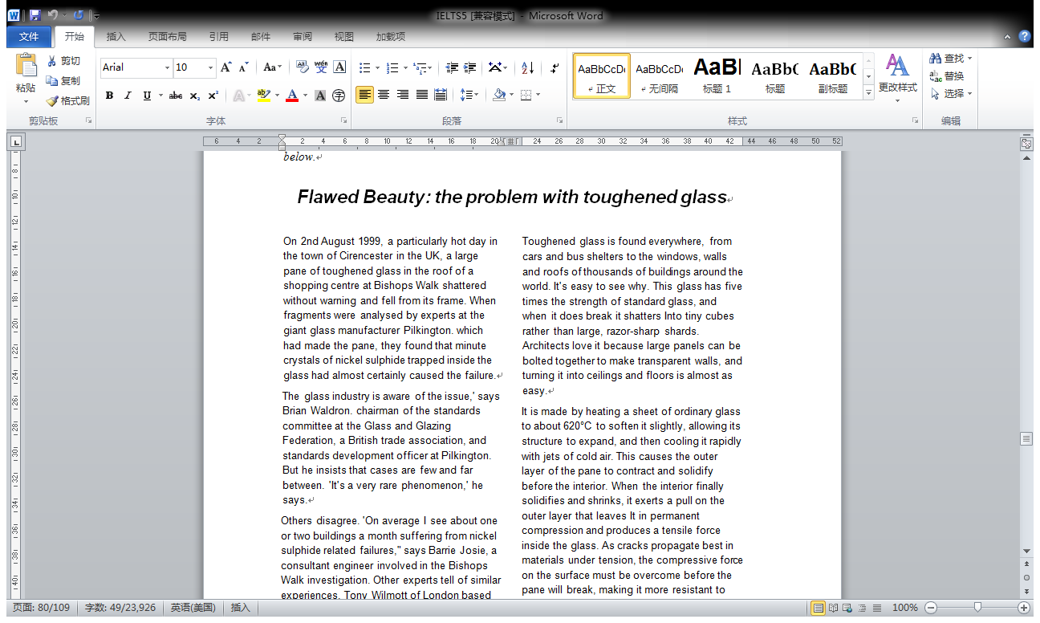

* The glass industry is aware of the issue,' says Brian Waldron. Chairman of the standards committee at the Glass and Glazing Federation, a British trade association, and standards development officer at Pilkington. But he insists that cases are few and far between. 'It's a very rare phenomenon,' he says.
* “What you hear is only the tip of the iceberg.” says Trevor Ford, a glass expert at Resolve Engineering in Brisbane. Queensland. He believes the reason is simple: No-one wants bad press.
* Ironically, says Graham Dodd, of consulting engineers Arup in London, the oldest pane of toughened glass known to have failed due to nickel sulphide inclusions was in Pilkington's glass research building in Lathom, Lancashire. The pane was 27 years old.
* John Barry, an expert in nickel sulphide contamination at the University of Queensland, analysed every glass pane in the building.

**Cambridge IELTS 4**

**Questions 36—40**

Look at the following researchers(Questions36—40)and the list of findings below.

Match each researcher with the correct finding.

Write the correct letter A—H in boxes 36—40 on your answer sheet.

36 Robert Barton

37 Marc Bekoff

38 John Byers

39 Sergio Pellis

40 Stephen Siviy

List of Findings

A There is a link between a specific substance in the brain and playing.

B Play provides input concerning physical surroundings.

C Varieties of play can be matched to different stages of evolutionary history.

D There is a tendency for mammals with smaller brains to play less.

E Play is not a form of fitness training for the future.

F Some species of larger-brained birds engage in play.

G A wide range of activities are combined during play.

H Play is a method of teaching survival techniques.

* Robert Barton of Durham University believes that, because large brains are more sensitive to developmental stimuli than smaller brains, they require more play to help mould them for adulthood. ‘I concluded it’s to do with learning, and with the importance of environmental data to the brain during development,’ he says.
* Bekoff studied coyote pups at play and found that the kind of behavior involved was markedly more variable and unpredictable than that of adults. Such behavior activates many different parts of the brain, he reasons. Bekoff likens it to a behavioral kaleidoscope, with animals at play jumping rapidly between activities.
* Take the exercise theory. If play evolved to build muscle or as a kind of endurance training, then you would expect to see permanent benefits. But Byers points out that the benefits of increased exercise disappear rapidly after training stops, so any improvement in endurance resulting from juvenile play would be lost by adulthood.
* Earlier this year, Sergio Pellis of Lethbridge University, Canada, reported that there is a strong positive link between brain size and playfulness among mammals in general.
* The idea is backed up by the work of Stephen Siviy of Gettysburg College. Siviy studied how bouts of play affected the brain’s levels of a particular chemical associated with the stimulation and growth of nerve cells. He was surprised by the extent of the activation. ‘Play just lights everything up,’ he says. By allowing link-ups between brain areas that might not normally communicate with each other, play may enhance creativity.

**MATCH**

1. 确定人名
2. 细读理论，划出关键字
3. 回文中人名定位处，寻找
   1. 引言 “ X ”
   2. 下列动词引导的宾语从句：

* Argue claim believe Deem
* discover refute conclude
* note notice remark propose
* announce point out perceive

**NOTICE**

* 有些题目中某一个选项会用两次。
* NB You may use any letter more than once.
* 注意：本题中有且仅有一个选项会被使用两次
* 人名在文章出现的顺序可以是乱序的。
* 第一题往往对应文章的后几个观点，最后一题往往对应文章的前几个观点。
* 答案出处
* 答案一定在原文作者姓名的附近出现
* 重点关注附近的词汇之后如：suggest、show或者是“”内内容
* 文章出现作者姓名后要对姓名留下一定印象
* 有时文章中作者姓名不止出现一次，往往第二次出现时只出现姓或者名而不是出现姓名，如果没有之前的印象很容易忽略。

**Cambridge IELTS**

**Questions 5-10**

Classify the following as typical of

A both Chinese and Japanese pagodas

B only Chinese pagodas

C only Japanese pagodas

Write the correct letter, A, B or C, in boxes 5-10 on your answer sheet.

5 easy interior access to top

6 tiles on eaves

7 use as observation post

8 size of eaves up to half the width of the building

9 original religious purpose

10 doors fitting loosely over each other

The multi-storey pagoda came to Japan from China in the sixth century. As in China, they were first introduced with Buddhism and were attached to important temples.

The Chinese built their pagodas in brick or stone, with inner staircases, and used them in later centuries mainly as watchtowers. When the pagoda reached Japan, however, its architecture was freely adapted to local conditions - they were built less high, typically five rather than nine storeys, made mainly of wood and the staircase was dispensed with because the Japanese pagoda did not have any practical use but became more of an art object.

Because of the typhoons that batter Japan in the summer, Japanese builders learned to extend the eaves of buildings further beyond the walls. his prevents rainwater gushing down the walls. Pagodas in China and Korea have nothing like the overhang that is found on pagodas in Japan.

The roof of a Japanese temple building can be made to overhang the sides of the structure by fifty per cent or more of the building's overall width. For the same reason, the builders of Japanese pagodas seem to have further increased their weight by choosing to cover these extended eaves not with the porcelain tiles of any Chinese pagodas but with much heavier earthenware tiles.

But this does not totally explain the great resilience of Japanese pagodas. Is the answer that, like a tall pine tree, the Japanese pagoda - with its massive trunk-like central pillar known as shinbashira - simply flexes and sways during a typhoon or earthquake? For centuries, many thought so. But the answer is not so simple because the startling thing is that the shinbashira actually carries no load at all. In fact, in some pagoda designs, it does not even rest on the ground, but is suspended from the top of the pagoda - hanging loosely down through the middle of the building. The weight of the building is supported entirely by twelve outer and four inner columns.

But the answer is not so simple because the startling thing is that the shinbashira actually carries no load at all. In fact, in some pagoda designs, it does not even rest on the ground, but is suspended from the top of the pagoda - hanging loosely down through the middle of the building. The weight of the building is supported entirely by twelve outer and four inner columns.

**Questions 5-10**

Classify the following features as characterising

A the 'Headstart'programme

B the 'Missouri' programme

C both the 'Headstart' and the 'Missouri' programmes

D neither the 'Headstart' nor the 'Missouri'programme

Write the correct letter A, B. C or D in boxes 5-10 on your answer sheet.

5 was administered to a variety of poor and wealthy families

6 continued wilh follow-up assistance in elementary schools

7 did not succeed in its aim

8 supplied many forms of support and training to parents

9 received insufficient funding

10 was designed to improve pre-schoolers' educational development

Despite substantial funding, results have been disappointing. It is thought that there are two explanations for this. First, the programme began too late. Many children who entered it at the age of three were already behind their peers in language and measurable intelligence. Second, the parents were not involved. At the end of each day, 'Headstart' children returned to the same disadvantaged home environment.

At the age of three, the children who had been involved in the 'Missouri' programme were evaluated alongside a cross-section of children selected from the same range of socio-economic

**Cambridge IELTS 5**

Look at the following cities (Questions 11-13) and the list of descriptions below Match each city with the correct description, A–F.

Write the correct letter, A–F, in boxes 11-13 on your answer sheet.

11 Perth

12 Auckland

13 Portland

List of Descriptions

A successfully uses a light rail transport system in hilly environment

B successful public transport system despite cold winters

C profitably moved from road to light rail transport system

D hilly and inappropriate for rail transport system

E heavily dependent on cars despite widespread poverty

F inefficient due to a limited public transport system

The study found that the Western Australian city of Perth is a good example of a city with minimal public transport. As a result, 17% of its wealth went into transport costs. Some European and Asian cities, on the other hand, spent as little as 5%. Professor Peter Newman, ISTP Director, pointed out that these more efficient cities were able to put the difference into attracting industry and jobs or creating a better place to live.

For example, Newman accepts it would be hard for a city as hilly as Auckland to develop a really good rail network. However, he points out that both Hong Kong and Zurich have managed to make a success of their rail systems, heavy and light respectively, though there are few cities in the world as hilly.

He considers Portland, Oregon, a perfect example of this. Some years ago, federal money was granted to build a new road. However, local pressure groups forced a referendum over whether to spend the money on light rail instead. The rail proposal won and the railway worked spectacularly well. In the years that have followed, more and more rail systems have been put in, dramatically changing the nature of the city.

**配对题**

**Questions 23-26**

Complete each sentence with the correct ending, A—H, below.

Write the correct letter, A—H, in boxes 23-26 on your answer sheet.

23 Home medical aids

24 Regular amounts of exercise

25 Feelings of control over life

26 Feelings of loneliness

A may cause heart disease can be helped by hormone treatment.

C may cause rises in levels of stress hormones

D have cost the United States government more than $200 billion.

E may help prevent mental decline.

F may get stronger at night.

G allow old people to be more independent.

H can reduce stress in difficult situations.

The increasing self-reliance of many elderly people is probably linked to a massive increase in the use of simple home medical aids.

Maintaining a level of daily physical activity may help mental functioning, says Carl Cotman, a neuroscientist at the University of California at Irvine.

In laboratory simulations of challenging activities such as driving, those who felt in control of their lives pumped out lower levels of stress hormones such as cortisol. Chronically high levels of these hormones have been linked to heart disease.

Seeman found that elderly people who felt emotionally isolated maintained higher levels of stress hormones even when asleep

Questions 27-31

Complete each sentence with the correct ending, A–G, below.

Write the correct letter A–G, in boxes 27-31 on your answer sheet.

27 A developed system of numbering

28 An additional hand signal

29 In seventh-century Europe, the ability to count to a certain number

30 Thinking about numbers as concepts separate from physical objects

31 Expressing number differently according to class of item

A was necessary in order to fulfil a civic role.

B was necessary when people began farming.

C was necessary for the development of arithmetic.

D persists in all societies.

E was used when the range of number words was restricted.

F can be traced back to early European languages.

G was a characteristic of early numeration systems.

As they began to settle, grow plants and herd animals, the need for a sophisticated number system became paramount. It will never be known how and when this numeration ability developed, but it is certain that numeration was well developed by the time humans had formed even semi­pe rmanent settlements.

But in real situations the number and words are often accompanied by gestures to help resolve any confusion. For example, when using the one, two, many type of system, the word many would mean, Look at my hands and see how many fingers I am showing you. This basic approach is limited in the range of numbers that it can express, but this range will generally suffice when dealing with the simpler aspects of human existence.

The average person in the seventh century in Europe was not as familiar with numbers as we are today. In fact, to qualify as a witness in a court of law a man had to be able to count to nine!

Perhaps the most fundamental step in developing a sense of number is not the ability to count, but rather to see that a number is really an abstract idea instead of a simple attachment to a group of particular objects.

the development of a notational system for numbers and, from there, to arithmetic.

It seems that the last is a later development while the first six groups show the relics of an older system. This diversity of number names can also be found in some widely used languages such as Japanese.

**Cambridge IELTS 5**

**Questions 24—27**

Complete each sentence with the correct ending A-G below,

Write the correct letter A-G in boxes 24-27 on your answer sheet.

One of the brain's most difficult tasks is to

Because of the language they have developed, humans

Individual responses to humour

Peter Derks helieves that humour

A react to their own thoughts.

B helped create language in humans.

C respond instantly to whatever is happening.

D may provide valuable information about the operation of the brain.

E cope with difficult situations.

F relate to a person's subjective views.

G led our ancestors to smile and then laugh.

Making a rapid emotional assessment of the events of the moment is an extremely demanding job for the brain, animal or human

The fact that jokes tap into our general evaluative machinery explains why the line between funny and disgusting, or funny and frightening, can be so fine. Whether a joke gives pleasure or pain depends on a person's outlook.

Whether a joke gives pleasure or pain depends on a person's outlook.

Humour may be a luxury, but the mechanism behind it is no evolutionary accident. As Peter Derks, a psychologist at William *and* Mary College in Virginia, says: 'I like to think of humour as the distorted mirror of the mind. It's creative, perceptual, analytical and lingual. If we can figure out how the mind processes humour, then we'll have a pretty good handle on how it works in general.'

Which paragraph contains the following information?

Write the correct letter, **A—L** in boxes 14-17 on your answer sheet.

14 a suggestion for improving trade in the future

15 the effects of the introduction of electronic delivery

16 the similar cost involved in transporting a product from abroad or from a local supplier

17 the weakening relationship between the value of goods and the cost of their delivery

* D Countries still trade disproportionately with their geographic neighbours. Over time, however, world output has shifted into goods whose worth is unrelated to their size and weight.

To see how this influences trade, consider the business of making disk drives for computers.

Computer manufacturers in Japan or Texas will not face hugely bigger freight bills *if* they import drives from Singapore rather than purchasing them on the domestic market.

This is even more true of the fast-growing information industries. Films and compact discs cost little to transport, even by aeroplane. Computer software can be 'exported' without ever loading it onto a ship, simply by transmitting it over telephone lines from one country to another

America the period of huge productivity gains in transportation may be almost over, but in most countries the process still has far to go.

Bringing these barriers down would help the world's economies grow even

NB You may use any letter more than once.

14 a cost involved in purifying domestic water

15 the stages in the development of the farming industry

16 the term used to describe hidden costs

17 one effect of chemicals on water sources

The costs included: £120m for removal of pesticides; £16m for removal of nitrates; £55m for removal of phosphates and soil; £23m for the removal of the bug Cryptosporidium from drinking water by water companies; £125m for damage to wildlife habitats, hedgerows and dry stone walls

First mechanisation, then mass use of chemical fertilisers and pesticides, then monocultures, then battery rearing of livestock, and now genetic engineering

Put it all together and it looks like a battlefield, but consumers rarely make the connection at the dinner table. That is mainly because the costs of all this damage are what economists refer to as externalities: they are outside the main transaction, which is for example producing and selling a field of wheat

Natural soil fertility is dropping in many areas because of continuous industrial fertiliser and pesticide use, while the growth of algae is increasing in lakes because of the fertiliser run-off.

Which paragraph contains the following information?

*Write the correct letter A-I in boxes 14-19 on your answer sheet.*

a biological explanation of the teacher-subjects' behaviour

the explanation Milgram gave the teacher-subjects for the experiment

the identity of the pupils

the expected statistical outcome

the general aim of sociobiological study

the way Milgram persuaded the teacher-subjects to continue

A few years ago. in one of the most fascinating and disturbing experiments in behavioural psychology, Stanley Milgram of Yale University tested 40 subjects from all walks of life for their willingness to obey instructions given by a 'leader' in a situation in which the subjects might feel a personal distaste for the actions they were called upon to perform. Specifically, Milgram told each volunteer 'teacher-subject' that the experiment was in the noble cause of education, and was designed to test whether or not punishing pupils for their mistakes would have a positive effect on the pupils' ability to learn.

The supposed 'pupil' was in reality an actor hired by Milgram to simulate receiving the shocks by emitting a spectrum of groans, screams and writhings together with an assortment of statements and expletives denouncing both the experiment and the experimenter.

“You have no other choice. You must go on. “

Prior to carrying out the experiment, Milgram explained his idea to a group of 39 psychiatrists and asked them to predict the average percentage of people in an ordinary population who would be willing to administer the highest shock level of 450 volts.

E What were the actual results? Well, over 60 per cent of the teacher-subjects continued to obey Milgram up to the 450-volt limit!

F One's first inclination might be to argue that there must be some sort of built-in animal aggression instinct that was activated by the experiment, and that Milgram's teacher-subjects were just following a genetic need to discharge this pent-up primal urge onto the pupil by administering the electrical shock

G An alternative to this notion of genetic programming is to see the teacher-subjects' actions as a result of the social environment under which the experiment was carried out.

H Thus, m this explanation the subject merges his unique personality and personal and moral code with that of larger institutional structures, surrendering individual properties like loyalty, self-sacrifice and discipline to the service of malevolent systems of authority.

I This, in essence, is the problem of modern sociobiology - to discover the degree to which hard-wired genetic programming dictates.

* 1 the location of the first cinema
* 2 how cinema came to focus on stories
* 3 the speed with which cinema has changed
* 4 how cinema teaches us about other cultures
* 5 the attraction of actors in films

The Lumiere Brothers opened their Cinematography, at 14 Boulevard des Capucines in Paris, to 100 paying customers over 100 years ago, on December 8, 1895. Before the eyes of the stunned, thrilled audience, photographs came to life and moved across a flat screen.

One effect of this realism was to educate the world about itself. For cinema makes the world smaller. Long before people travelled to America or anywhere else, they knew what other places looked like; they knew how other people worked and lived.

The ' star' was another natural consequence of cinema.

Cinema might, for example, have become primarily a documentary form.

And it has all happened so quickly. Almost unbelievably, it is a mere 100 years since that train arrived and the audience screamed and fled

**雅思考试应急方案**

**解题步骤**

* 开场1分钟
  + 审查文章标题+题型---
  + 想想机经=精神支持
* 开场5分钟
  + 从第一篇文章开始，再审查一下标题，
  + 用3-5分钟时间快速扫描文章，
  + 把握大意，开始解题。
  + KEY WORD LOCATE KEY WORD
* 第10分钟到第55分钟
  + LIST OF HEADINGS 或者
  + 段落+相关信息
  + 然后做summary或者其他填空题
  + 把MC和T/F/NG留到最后

30’是关键点

* 最后5分钟：
  + T/F/NG题型：

**T/F/NG题型：**

* 全TRUE法
* 必选FALSE的金词：
* Impossible, immediate
* only never always ,all none every
* 必选NG的金词：
* Than Other Next second
* 选TRUE的金词：
* Possible would ,could can ,Not necessarily

**单选题**

* 原文一致选项一定不对
* 金钱选项一定不是正确选项

Expensive costly, commercial funding

* 长得像的选项一定有正确选项
* 全C法

**LIST OF HEADINGS**

只读各段首二末句

* xxxxxxxxx.
* xxxxxxxxx,xxxxxx,xxxxxxx.For example,xxxxxxxxxxxxxxxxxxxxxxxxxxxxxxx.
* However,xxxxxxxxxxxxxxxxxxxxxxx.
* Despite xxxxxxxxxxxxxxxxx(让步), Vs.xxxxxxxxxxxx.
* xxxxxxxxx.
* 转折连接词后必是真正观点
* 高频词=n. >3次 引号 长
* Heading中某一词与文中
* 某一词一模一样，一定不对
* XXX---XXX

**MATCHING**

* 段落+相关信息：
* 无从下手，留到最后
* 全选文中最长段落

**答题纸正面**

**答题纸反面**

**12周以上的复习计划**

* 每天30-50*2个单词
* 每天设定一个泛读时段：
* 雅思阅读：
* 剑三上剩下的习题
* 每周做一套剑桥四、五上

**8周复习计划**

* 每周完成2-3套剑桥四或五上的题目
* 精读剑桥四五下列文章：

剑桥四

T2P1 Lost for words语言

T2P3 play is a serious business心理

T3P3 Collecting linguistic data语言

T4P3 the problem of scarce resources

剑桥五

T1P2 Nature? Nurture? 心理

P3 the truth about the environment

T2P2 humor 心理

P3 scientific English语言

T3p2 delta 环境

p3 the return of A.I.科技

先限时做题，再精读

**4周复习计划**

* 用剑桥六或者七、八上的试题冲刺
* 尽量60分钟完成一整套阅读
* 记录分数，看看自己的趋势
* 改正错题，有必要时记忆
* 错题单词

**2周复习计划**

* 剑桥八或者七上的试题考前模拟测试
* 开始看机经：

**机经如何看？**

* 看中文文章大意=精神支持
* 了解题型=纸上谈兵
* 背记个别答案如LH和M段
* T/F/NG和SUMMARY

**考试注意事项**

* 考试周周三可以查询口语考试时间
* 考试前一天下午考场公式考场安排（五五楼三楼）
* 考试当天注意必带证件:身份证 照片 （准考证）
* 考试结束后的周四晚间查询成绩，周末收到成绩单