## 

**雅思词汇课程讲义**

**主讲：梅晗**

**欢迎使用新东方在线电子教材**



大家好，欢迎大家回到我们的新东方网络课堂！

1. **雅思词汇大全**
   1. 背单词技巧1

课程介绍： briefing—tricks—root & affix

What’s IELTS

不考察：non-background, experience, logic

* 1. 背单词技巧2

被哪种词：学术类—academic

培训类—general

**第二章、雅思考试对于词汇的要求**

**2.1. 示例与熟词辟义**

W 听力内容:

Good evening. Welcome once again to criminology 201. I’m happy to see you all looking so alert and full of energy after a busy day. Tonight, and for the next few weeks, we will be looking at what is clearly a very important topic—corporate crime.

Good evening. Welcome once again to criminology 201. I’m happy to see you all looking so alert and full of energy after a busy day.

anthropology

astrology

biology

chronology

entomology

geology

meteorology

mineralogy

neology

pathology

philology

phrenology

physiology

psychology

theology

trilogy

zoology

n.人类学

n.占星术

n.生物学

n.年代学

n.昆虫学

n.地质学

n.气象学；气象

n.矿物学

n.新语；新说；新义

n.病理学

n.语言学

n.骨象学

n.生理学

n.心理学

n.神学

n.三部曲

n.动物学

Tonight, and for the next few weeks, we will be looking at what is clearly a very important topic—corporate crime.

Corporation

Key words

Reading内容

With the conclusion of a burst activity, the lactic acid level is high in the body fluids, leaving the large animal vulnerable to attack until the acid is reconverted,

via oxidative metabolism, by the liver into glucose, which is then sent back to the muscles for glycogen resynthesis.

Conclude 结束

熟词僻义

Lot ：parking lots

log 圆木 CS 日志 QQ qzone blog web log

TMD 战区导弹防御 theatre missile defense

**2.2. 如何积累单词**

1.daily life

化妆品英文扫盲词汇表

乳液、啫喱、水、露、精华、泡沫

Milk, cream, lotion, emulsion, gel, water, wash, toner, essence, foam, lather

粉、粉饼、蜜粉

Powder、pressed powder、loose powder

膜 mask

皮肤类型: 中性、油性、干性、混合

skin type: normal, oily, dry, combination

功能：防晒、抗皱、紧肤、去角质、平衡、修复、活化、保湿、遮瑕、卸妆

Function: sun-block, anti-wrinkle, firm, exfoliate, balance, repair, revitalize, moisturize, correct, remove

Herbal Essence Moisture-Balancing Shampoo

草本精华保湿平衡洗发露

Pore Minimizing Skin Refinisher

收缩毛孔护肤乳液

Eye Night Repair Essence

晚间眼部修复精华

Revitalizing Emulsion

活肤乳液

Refreshing Shower Gel

清新沐浴露

* 1. **基础词汇**

2.2300 General Service List

Via=by

You could reach me by phone or via e-mail.

<ox> 氧

Oxygen oxidative dioxide

<ox>牛

Oxford oxen

Metabolism

liver

**2.4主动词汇和被动词汇**

主动词汇: 说 写1700 2300

被动词汇（写不出的词汇）:鳏寡孤独 饕餮 魑魅魍魉 噱头

1. 00 4500 4200 5400 6700

**2.5 不同题型对于词汇的要求**

口语

I my I think I guess pardon

Word variety 公司 firm company corporation enterprise

写作

A is very important to B.

A is of great importance to B.

Important significant

Crucial red cross Tom Cruise

Vital <vit=viv=vig>life A is of vital importance to B. A is vital.

* 1. **词汇讲解1**

Vital vitalize revitalize vitamin vivid vigor vigorous

-ous dangerous famous fame porous numerous spacious clamorous loquacious assiduous

-id vivid humid <hum> human

女权运动 feminist chairman chairwoman chairperson

History herstory mankind womankind

* 1. **词汇讲解2**

Human <hum> ground humid inhume exhume humility humane humble humiliate

<man>hand manual manumit manicure manipulate manuscript manufacture emancipate

Essential essence fundamental found a 馒头

**2.8 写作对于词汇替换的要求**

Technology has addressed nearly all the crucial problems in today’s society.

Do you agree or disagree with the issue and explain why.

重要性上来排序

Important=significant<crucial, essential, fundamental

写作时候要多注意层次

**2.9 考试总体分析**

成绩统计

China 5.46

Oman 5.26

Kuwait 5.33

United Arab Emirates 5.00

South Africa 7.72

Germany 7.16

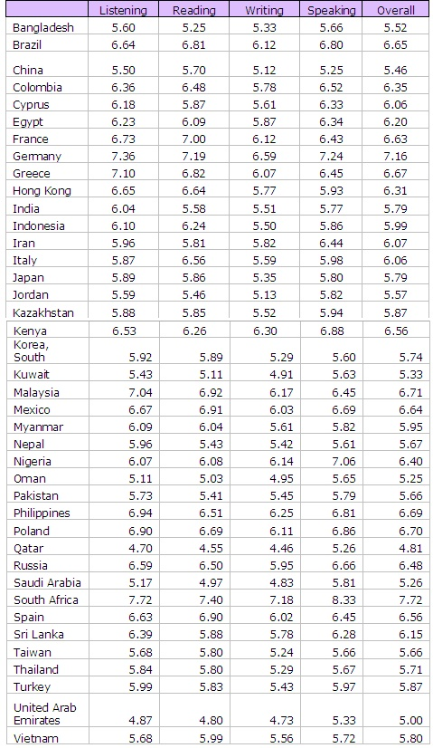



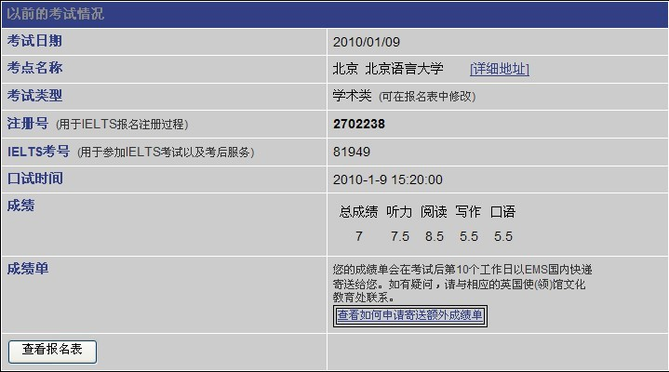

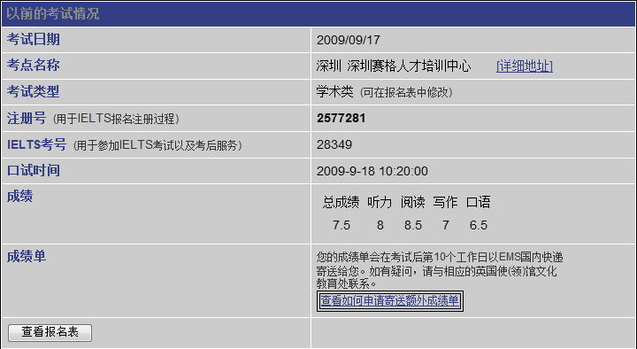

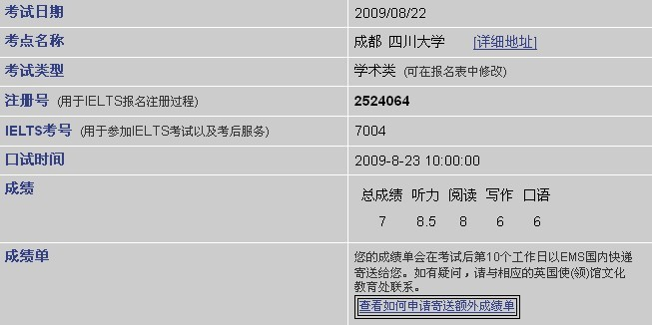

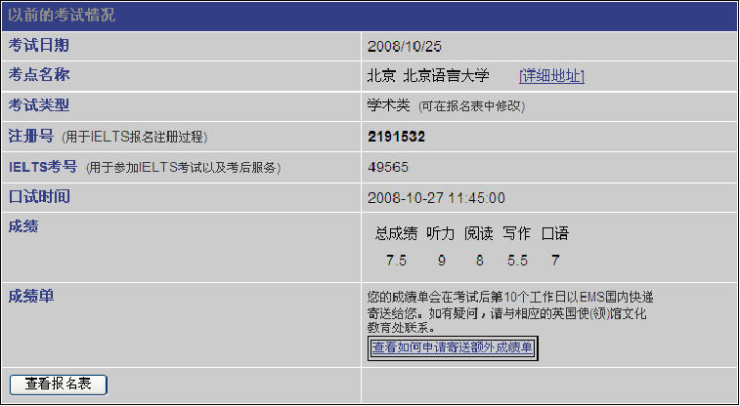

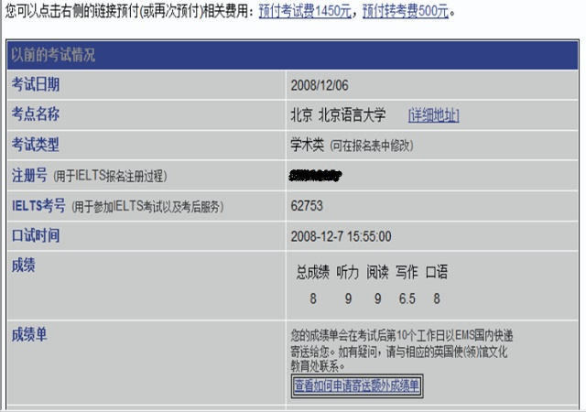

1. **词汇记忆方法总述**

**3.1 介绍**

概述：捷径、技巧

四大词汇记忆方法

1、联想记忆法

2、比较、词群记忆法

3、典故神话记忆法

4、词根词缀记忆法

**第四章、联想记忆法**

**4.1联想记忆法1**

a.邪音法

economy 经济 ambulance 救护车

ponderous 笨重的 alphabet 字母表 alphabetical larva 幼虫 lover toupee 假发

enigma 谜 bungalow 平房 illusion 幻觉 shabby 下流的; 褴褛的

dilemma 进退两难 moribund 毛病 morbid agony act on agog a gg

**4.2 联想记忆法2**

b.象形法

tilt bud taste bud loom hippopotamus bloom boom blossom loop applaud

**4.3 联想记忆法3**

c.拆分法

fiend siege franchise

meihanielts@163.com

1.specific 2.logical

Wither= with her isolate accost hostage

走火入魔

Gloom lobster slit split

Charisma 领袖气质 charismatic

**4.4 联想记忆法4**

Franchise 赋予公民权 特许经营权 John Benew

公关 PR public relations

LDOCE Longman Dictionary of Contemporary English

**4.5 联想记忆法5**

LDOCE Longman Dictionary of Contemporary English

Walking dogs, be in a temper

**第五章、比较、词群记忆法**

**5.1比较、词群记忆法1**

比较

Angle angel

HSK 魑魅魍魉 饕餮 鳏寡孤独

瓜 爪 外 处

Ingenious ingenuous

Stationary stationery

Spread to fuck the fruit 散干果 monkey peach

Willy doggy style

**5.2比较、词群记忆法2**

Discrete discreet

Biannual biennial

Hole hoe

Fragrant flagrant

地名 屯 弄 栋 甲一号

发音 hundred hunt r rose 肉丝 中国人

**5.3比较、词群记忆法3**

词群

tree

parts trunk branch leaf blossom roots (I have been rooting in this city for over ten years.) bark twig limb

一大片树 forest rainforest jungle

一小片树 wood copse thick thicket -et/-let/-ette 小 cigarette booklet droplet leaflet ringlet

**5.4比较、词群记忆法4**

Types evergreen deciduous de-低(破坏性的) deforest deforestation deface defame deform 变性（蛋白质） denaturalize破坏自然性 decry破口大骂 outcry公然抗议

Decipher cipher The Da Vinci Code decode coding

Conifer

祖坟级词汇：hardwood tree hard wood tree firewood fire wood f i r e w o o d

**5.5比较、词群记忆法5**

B.躲避 avoid escape hide (parry eschew evade) shun elude (Sorry, your name eludes me.)

Skirt 短裙，城郊 (the skirt of a forest

The old footpath skirts around the village

a disappointing speech that skirted around the main issues)

**5.6比较、词群记忆法6**

Circumvent circle + vent <circ>circle circulate circumstance circumscribe限制 circus马戏团 circuit cyclone

<it>exit initiate visit <vis>vision visual invisible

Hedge fence sidestep

1.责任 shirk goldbrick

2.dodge a 打击

3.bilk a bill/debt

**5.7比较、词群记忆法7**

4.avert <vert>turn eyesight

don doff

**第六章、典故神话记忆法**

**6.1典故神话记忆法1**

3.典故 神话记忆法

A.典故 maverick 特例独行的人 martinet 规矩严肃的人

B.神话 1.echo 回声 encore 返场演出 a.Zeus

**6.2典故神话记忆法2**

b.Hera c.curse d.Narcissus e.oracle narcissism oral

花 1.parts bloom bud leaf stem roots

2.types rose narcissus carnation lily 菊花 chrysanthemum mum daisy a bunch of

**6.3典故神话记忆法3**

2.Muse music museum -um …地方 medium <med>middle

思考: think consider muse ruminate ponder（on） meditate

3.giant 巨人 庞大的

The Stone of Sisyphus 徒劳 to do sth. is (like)…

Tantalise tan ta nai zi 逗弄 把你想要的东西放在你面前 就是不让你得到它

Tantalus tease

**6.4典故神话记忆法4**

4.Troy Helen Lady Gentleman gentle manly chivalry Achilles’ heel Pygmalion Effect

**6.5典故神话记忆法5**

5.Vulcan Venus Mars Cupid Volcano vulcanism

Venal venereal disease cupidity

Mars war martial marital status S M

<mort> mortal immortal mortify mortuary mortgage

Moribund morbid

-ary/ery/ory ..地方 factory <fact>做 manufacture factor rosary armor

**6.6典故神话记忆法6**

6.心理学 economist Oedipus Complex 恋母情节 Electra Complex恋父情节

**第七章、词根词缀记忆法**

**7.1词根词缀记忆法1**

词根词缀记忆法 Matricide 弑母 patricide

<cide>cut suicide biocide insecticide pesticide

<matr> maternal matrix <patr> patron compatriot同胞 expatriate repatriate 词根 > 前缀 > 后缀

单词三段论 字母互换规律

将单词按元音音节分成三部分 a e I o u y lot better (不发音的不算; 连续元音视作整体) love tea

Impossible im poss ible unreachable progressive pro gress ive regressive re gress ive

Congress independent conversation insecticide

**7.2词根词缀记忆法2**

beneficially

CHAMATE classmate bunkmate Inmate

单词三段论

几种情况：1.单音节

2.多音节时要判断是合成词还是词根词缀词

**7.3词根词缀记忆法3**

字母互换规律

1.元音互换 a e i o u y mechanism machine+ism baton <bat>beat

2.轻浊辅音互换 c-k-g-qu b-p t-d v-f

candle kindle

sting stink

burse/purse

3.形近字母转换 n-m u-v-w

limestone

brim brink 悬崖的边缘

nausea

4.音的脱落 h g w

arduous（替换difficult）

naught

align

**7.4词根词缀记忆法4**

5.组合变换 s-t-d p-ph-f b-p-f-v

Conclude—conclusion decide-decision preclude—preclusion

Prove proof probe

<pend, pens> <cad, cid, cas> check cheque

词根词缀法

1.ab away (a, abs)

Abstract 摘要 抽象abs <tract>拉 contract extract (remove erase) subtract distract

Amazon a <mazon>breast the Amazon

Abortion ab <or> tion <or>rise grow New Oriental School oriental 东方的 东方人 occident 欧美 西方

<cad/cid/cas> fall deciduous occident decadent incidence coincide casual

**7.5词根词缀记忆法5**

cascade occasionally=sometimes nowadays=currently

For once our wishes coincide. We both wanted a quick divorce.

Microsoft Macrohard macroeconomics microphone microwave microscope

Pissed off=be anger at

abnormal

Normal ordinary common Simple easy pure形容人很简单

**7.6词根词缀记忆法6**

2.ad 不断的to (a, a**)

Ad <tract> attract

吸引人的 attractive appealing (appeal) alluring (allure)

Enthralling极其吸引人的 梅兰芳 Forever enthralled 非诚勿扰 if you are the one…

葬礼 go go west go with tide go to the Glory glory开头字母小写代表荣誉 大写代表极乐世界

go to join his Maker

Never fish in your neighbour’s pool. 兔子不吃窝边草

此次若不是一世 请勿打扰 Never, or Forever

**7.7词根词缀记忆法7**

Ad <vent> advent 出现 到达 adventure the Advent 耶稣降临 the Creator 造物主

Amaze a <maze>迷宫 maize 玉米 （corn 美式英语）

Abandon <band>绑 husband Band-Aid bandage

bond 结合联系 band 乐队 级别 收音机波段

3.anti- against

Arctic anti- Antarctic antivirus antibiotics antibody

4.ante 前 (an ant anti)

Antique anticipate 预期

<cip/cap>拿 participate capture截图 caption标题 captivate capable capacious capacity容量，才能

Ancient ancestor an sister

Anterior 较早的

**7.8词根词缀记忆法8**

5.post 后

Posterior superior inferior

PS postscript postgraduate postdoctoral (1.noble class 2.prestigious 有威望的 reputational; 3.free )

学位相关 kindergarten primary school elementary middle high school

Bachelor –ette（后缀表示女单身汉）（学士学位或单身汉） undergraduate freshman

sophomore (sophisticated 设备的精密和人的世故 [褒])

junior

senior

**7.9词根词缀记忆法9**

Master

我是一个硕士 I’m a graduate. postgraduate

Doctor

doctor of philosophy D.Phil Ph.D 永久性脑损伤 head damage permanent PR residence

**7.10词根词缀记忆法10**

6.de 低 加强

Describe <scribe>写 inscribe conscribe ascribe

Deliberate liberate <liber> liberty liberal libertine

-er -ee employer employee 已知/易掌握的 --- 未知的 To be a fucker every day, to be fuckee one day.

7.ex

a.out of b.超越

exit export

<port>carry transport portable deport passport airport

expose <pose> Compose composition composer Position posture composed

exposure to noise / gas

exclaim <claim>call declaim acclaim reclaim clamorous大喊大叫的

Exalt <alt> 高 tall Alto 阉伶男高音 tenor

Altimeter micrometer voltmeter

Altitude 高 Attitude determine

**7.11词根词缀记忆法11**

地理学 Latitude 纬度 Longitude 经度

Core mantle crust Valley canyon basin pole delta shelf 大陆架

Vegetation 植被Vegetarian vegan 重度素食主义者

Magma 岩浆 lava 熔岩

Volcano eruption <rupt>break bankrupt corrupt abrupt

Exhilarate <hilar>happy Hilary hilarious 欢闹的（重音在第二个音节）

仝 昶 杲

Conversation Conservation Renovation Beneficial

**7.12词根词缀记忆法12**

8.con together

词根首字母 Bpm 前缀尾字母 m

Communicate compose <pose>摆

Combat <bat>beat baton

词根首字母 R L 前缀尾字母r l Corrupt 腐烂 腐败 Collaborate

Comfort Con in syn

9.in im ir il a.no b.in

ingenious genius impose inbox outbox sent draft draftman

option <opt>choose optional optimistic pessimistic optimum adopt

**7.13词根词缀记忆法13**

impart inbreathe include <clude>close conclude preclude 预先排除 exclude exclusively

impossible incautious illegal违反道德

replace Irreplaceable indispensible Irresistible

**7.14词根词缀记忆法14**

en em no no

encourage enjoy encase enlarge enable enlighten enact enlist enclose endanger ensure enroll enrollment entitle

10.inter intel

Internet Interview Interface 界面 Interrogate <rog>ask abrogate arrogant

<claim>call <vok>convoke invoke irrevocable revoke vocation job career occupation

**7.15词根词缀记忆法15**

11.dia

Diameter radius Dialogue monologue Dialect Japanese bugger Diagnosis

Diabolic 恶魔般的 DIABLO

di- bi- 2

dioxide monoxide diploma 文凭（学位证）

**7.16词根词缀记忆法16**

degree 毕业证

It is quite a dilemma to choose from a and b. Without any hesitation, I would, however, vote for a.

bicycle bilingual <lingu> linguist linguistics trilingual sublingual 舌下的 bisexual

tri- triple trilingual tripod triangle

<lingu>linguist linguistics linguistic trilingual sublingual

oct- 8 October octagonal-shaped octopus y=x+2

dec-10 decade decimeter

Sept-wolves

Cent- 100 century centimeter Centipede

**7.17词根词缀记忆法17**

12.dis 散开 从有到无

Dispose distract

Disappear Disaster <astr>astrology astronomy Astronaut astro boy

Discount sale promotion Outlets

Unlike dislike 区分：disinterested uninterested disable unable

**7.18词根词缀记忆法18**

打牌

Discard Aboveboard Deceive 欺骗 <ceive>receive Suspect <spect> spectacle –s 远景（+s是眼镜的意思）

Spectrum circumspect Inspect introspect

Discourage discover dislike disregard displease discomfort dissatisfy distaste

**7.19词根词缀记忆法19**

13.ob a.against b.to

Oppose Opposite Disagree with Be opposed with Vote/argue against Object to

同意Agree with Favour Be in favour of Vote/argue for Uphold

Object objective subjective Biased

<ject>扔 Injection interjection reject refuse decline(turn down) eject 感情色彩重到轻

omit <mit/miss> 放 Missile emit emission 尾气排放

**7.20词根词缀记忆法20**

Emit eject Result consequence

Attain obtain gain acquire（后天习得）

14.per 贯穿 每一个都

Percent peruse Perplex Complex plait braid

Perennial Biennial <ann/enn>year Annual annuals 年鉴 Anniversary

**7.21词根词缀记忆法21**

Perjure <jur>swear Perjury jury abjure conjure

Perspective

In my opinion / from my perspective / viewpoint / point of view / stance

15.pro 前

propose Prolong Prospect

Profound <found> base fundamental Foundation fund

Proceed exceed Exceedingly excess More than = exceed = in excess of

**7.22词根词缀记忆法22**

16.pre 前

Prepare Preface prejudice Prescribe prescription Predict <dict> dictionary dictation Indicate indict

Preclude Prelude interlude postlude Prehistoric prehistorically prehistoricly prehistorical

**7.23词根词缀记忆法23**

17.re

a.back return regressive repatriate b.again repeat replay reboot restart

recover reheat recall recollect reimburse invoice receipt

refine repay recyclable research

**7.24词根词缀记忆法24**

renovation renew <nov>new Lenovo Legend Innovation Novice 新手 expert

refresh refreshing Replace displace Rehearse 排练 预演 模考

Remark评注 Remarkable Noticeable Considerable considerate

Be Considerate Be Considered

18.se apart/away

Secure Public security sense of insecurity <cure>care curious Curator manicure pedicure Accurate precise

Select <lect>choose intellectual election

**7.25词根词缀记忆法25**

19. uni- U N I

Unique 一致的 Unicorn horn Uniform

<form>formal informal formality formula performance transform

Trans- Across translate transaction transport transfer transcribe transmit

**7.26词根词缀记忆法26**

20.super (sup/sur) up

Superior superficial Suppress Surface surname surpass Supervise supervisor

21.sub su(p/r) down

Subtitle subscribe Substitute Prostitute understudy

Suspect Succeed

Part 1 general methodology

Part 2 expansion of words