雅思6.5分写作讲义

主讲： 张弛新

欢迎使用新东方在线电子教材


- 2012年留学雅思分数要求(sample)

- 2013年留学雅思分数要求(predicted)

从普通烤鸭变身文艺烤鸭，How？—>洗心革面

- 洗心
普通烤鸭 | - 看预测  - 猜题型  - 猜主题
文艺烤鸭 | - 写熟18道题  - 归纳题型  - 准备4大主题语料库
2B预测害死人
 | 此次考试预测结果：今天的图表作文是饼状图，和我11月预测里图表部分剑桥8的那道题几乎是一个模子刻出来的；大作文是新题，和我11月预测里happiness和发达国家援助发展中国家这两道题沾边！
 | 自2005年开始预测，是历史最长的（唯一），准确率最高的（之一）。考生一定要认清，一是这些预测一定要是专业机构或老师发布的才可信，另外就是应查阅其历史准确率，最好能够2-3年的比较准确的历史
2011年1~5月小作文题型分布
考试时间 | Task 1 | 考试时间 | Task 1
1.8 | 饼（2） | 4.2 | 线（1）
1.15 | 饼（3） | 4.16 | 柱（2）
1.22 | 饼（1）+柱（1） | 4.28 | 线（1）
1.27 | 表（1） | 4.30 | 柱（1）
2.12 | 饼（4） | 5.7 | 线（1）
2.17 | 饼（1）+表（1） | 5.14 | 饼（3）
2.19 | 线（1） | 5.19 | 柱（1）
2.26 | 地图 | 5.28 | 表（1）
3.5 | 柱（1）
3.10 | 柱（3）
3.12 | 柱（1）
3.19 | 柱（3）
2011年1~5月大作文题型/大主题分布
考试时间 | Task 2大主题 | Task2题型
1.8 | 科技 | Dis（双边）
1.15 | 抽象 | Dis（无限制）
1.22 | 基础设施 | Reason
1.27 | 生涯规划+科技 | Dis（双边）
2.12 | 抽象+全球化 | Recom
2.17 | 基础设施 | Dis（双边）
2.19 | 抽象 | Dis（双边）
2.26 | 抽象 | Dis（无限制）
3.5 | 基础设施+抽象 | Dis（双边）
3.10 | 生涯规划+抽象 | Dis（双边）
3.12 | 生涯规划+抽象 | Dis（无限制）
3.19 | 生涯规划+科技 | Dis（无限制）
4.2 | 科技+基础设施 | Dis（双边）
4.16 | 基础设施 | PRR
4.28 | 基础设施+抽象 | Dis（无限制）
4.30 | 基础设施+全球化 | A/D
5.7 | 基础设施 | A/D
5.14 | 基础设施+抽象 | Dis（无限制）
5.19 | 基础设施+抽象 | A/D
5.28 | 生涯规划 | Dis（双边）

18道永远可能考到的题目——不预测！
大主题 | 必写题目（中文简版）
Career Development | - 老师应该教授学科知识还是做人道理  - 大学应注重就业还是知识教授  - 少小离家的利弊
Infrastructure | - 交通拥挤的原因和解决方法  - 环保是否应当全球合作  - 国与国贫富差距拉大的原因  - 孩子看暴力电影的责任方和解决方法  - 警察是否应当佩带枪支
Abstract | - 压力的来源和如何缓解压力  - 幸福为什么很难定义，取得幸福有哪些要素  - 购物为何那么热门  - 媒体经常报道灾难暴力事件原因影响  - 我们应该关注国家现在还是未来
S&T | - 智能机器人的利弊  - 选择远程教育还是上学校  - 如何看待廉价机票  - 是否要吃本土食品  - 活体动物实验是否要禁止
- Some people think that teachers should be responsible for teaching students to judge what is right and wrong so that they can behave well. Others say that teachers should only teach students academic subjects. Discuss both views and give your opinion.
- Some people think that universities should provide graduates with the knowledge and skills needed in the workplace. Others think that the true function of a university should be to give access to knowledge for its own sake, regardless of whether the course is useful to an employer. What, in your opinion, should be the main function of a university?
- In many countries more and more young people are leaving school but unable to find jobs. What problems do you think youth unemployment causes for individuals and the society? What measures should be taken to reduce the level of unemployment among youngsters?
- In most parts of the world, the volume of traffic is growing at an alarming rate. In the form of an assignment, discuss about the main traffic problems in your country, their causes and possible solutions.
- The environmental problem is so serious to most countries and individuals that to solve it should be based on the international level rather than individuals and individual countries. Do you agree or disagree with the opinion?
- Nowadays, the gap between the wealthy and underdeveloped countries is becoming wider. What are the reasons for this situation?
- Many children choose to watch violent films through TV or the Internet when they are alone at home. This will do some harm to the mental development of children. Who is responsible for this problem and state some solutions to solve it.
- Police in Britain do not carry guns. Some people believe that it will make citizens unprotected, but others suggest that it would reduce the violence in society. Discuss those two views.
- Many people stay off working and studying. What reasons cause stress and how to solve it?
- Happiness is considered very important in our life. Why is it difficult to define? What are the factors of achieving happiness?
- Many people often buy a lot of things ranging from life necessities to luxury products. What are the reasons for the popularity of shopping?
- Media often have frequent coverage of the natural disasters and social violence. Why they do so? Is it a positive or negative event?
- “ Tomorrow is the most important thing in life. ” - US movie actor & director John Wayne Why is it important for individuals and countries to think about the future rather than focusing on the present?
- We have intelligent machine-robots to do the work for human beings. Someone worry human being will degrade because of robots. State the possible benefits and dangers of the intelligent machine-robots.
- Many people use distance-learning programmers (study material post, TV, Internet, etc.) to study at home, but some people think that it cannot bring the benefit as much as attending college or university. To what extent do you agree or disagree with this opinion?
- Many people think cheap air travel should be encouraged because it gives ordinary people freedom to travel further. However, others think this leads to environmental problem, so air travel should be more expensive in order to discourage people from having it. Discuss the both sides and give your own opinion.
- Food travels thousands of miles from farm to consumer. Some people think that it would be better to our environment and economic if people only ate local produced food. To what extent do the disadvantages outweigh the advantages?
- In some countries, it is forbidden to use live animals to do some scientific or biological research. Do you agree that live animals will not be needed in those researches?
- 革面
普通烤鸭 |  | - 背模板  - 记忆  - 复制
文艺烤鸭 |  | - 个性化结构  - 原创  - 再生
普通烤鸭 | 文艺烤鸭
小作文常规分成四种 | 小作文分成动态图、静态图、动中带静图
图表系统 | 图表系统+文字系统
明显特征 | 隐藏特征
目标超过150字 | 目标不超180字
遇到流程图死翘 | 大体结构借鉴前四种
大作文按顺序读题 | 先读大作文出题的最后一句
观点自己给 | 观点语料库给
做brainstorming | 发散练过的题，再补充
开头和之前的模板相似80% | 开头和之前的模板相似20%
更注重语法的正确性 | 更注重语法的多样性
词汇背同义词 | 圈定20个一级同义词每次都想到

文字系统的巅峰之作
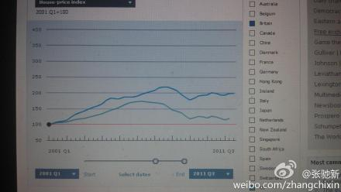
Housing prices in Australia, Canada and France, which had only a slight wobble颤动 in 2008 before climbing to new highs, look particularly frothy有泡沫的. In contrast, prices in America have fallen so far that they now look cheap when compared against both rents and income. But given the huge stock of foreclosed homes that is yet to come on to the market, the chances are that they could yet fall further. http://www.economist.com/blogs/dailychart
- 2012趋势展望
1. 流程图和F4有可能杂交
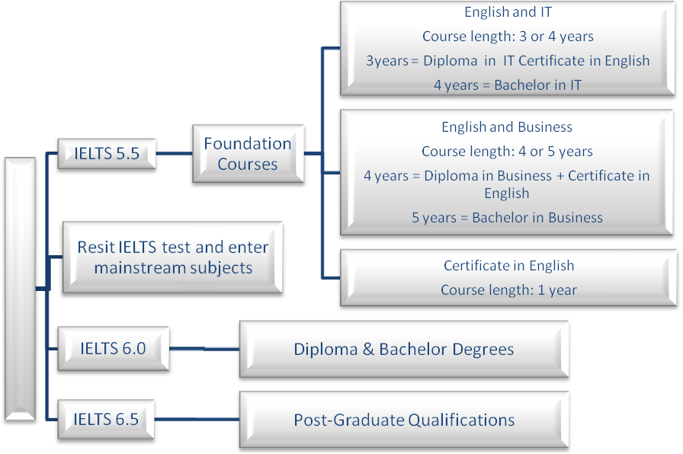
2. F4杂交
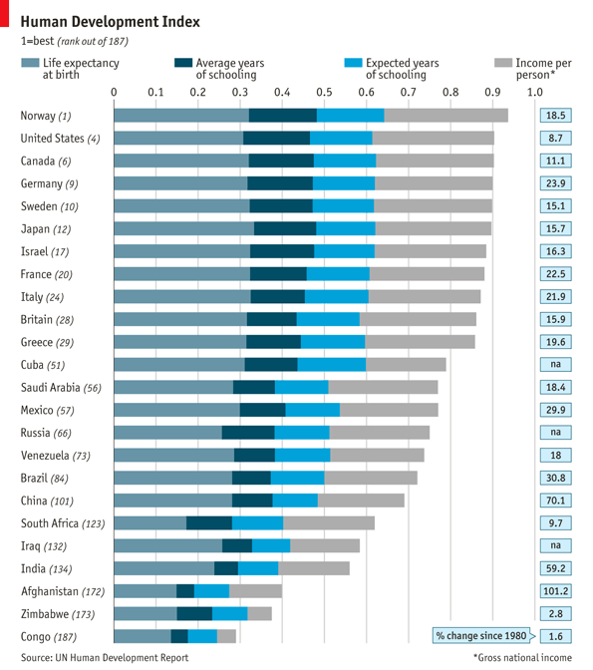
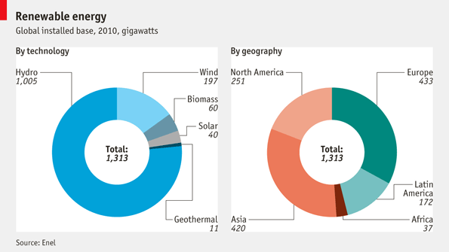
3. 多数据交织，加大比较的难度
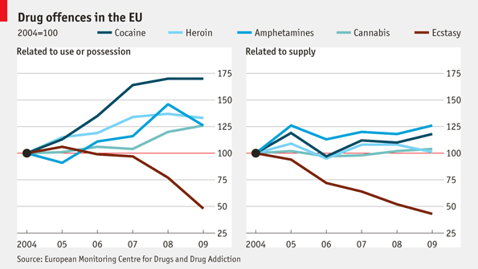

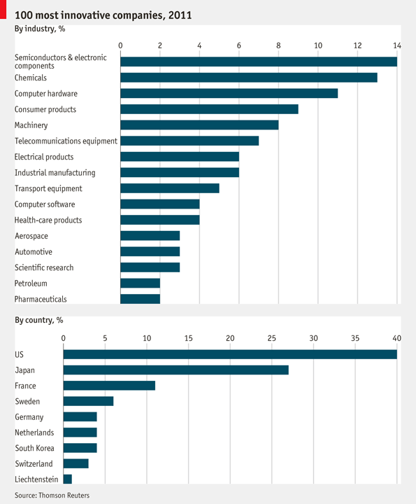
4. 流程图/地图难度增加
5. 大作文题型Combo比例的加大
2011.11.26 Task 2
People in both developed countries and developing countries are richer for economic growth. Studies show people in developing countries are happier than before while people in developed countries are not. Analyze reasons and what can we learn?
Reason+Discursive（无限制）
- 下载哪些写作资料？
博客地址：http://blog.hjenglish.com/zhangchixin
邮件地址：zhangchixin@xdf.cn
微博：http://weibo.com/zhangchixin
“中国最强雅思培训”微群：http://q.weibo.com/210064
随笔分类
雅思写作互动及欣赏区——写作资料集中“赢”
雅友大联盟——非写作类资料&出国留学信息荟萃
新东方雅思取经——每次考试心得总结

- 6.5分小作文写作纲要
分成4 块模式：
- special terms：appear, emerge,不合要求， make one’s debut
Agree, in favor of, advocate高端词汇
- 架构和过度：改变结构，使用新颖句型和连接成分。
1. referable. 2.个性化
- temporal topics: broad topics: 文章论据相似，题目千变万化，但大主题是一样的， 一共有十大主题，合并后有六大主题：生涯规划、 基础设施、抽象题、科技、马斯洛生理需求、全球化。

- TASK ONE: (F4)
饼图/ 柱状图/表格题/曲线图，其中柱状图考察频率最高。
- 考试高分必备表1——Trend
 | INCREASE |  | DECREASE |  | STABILIZATION
 | 词语 | 说明 | 词语 | 说明 | 词语 | 说明
Junk  words | increase |  | decrease |  | Stand at  remain stable  stay steady  keep constant  the same | 没有相对比较时用  掌握一种讲法
Junk  words | rise |  | fall |  |  | 没有相对比较时用  掌握一种讲法
Junk  words | raise(n) |  | drop |  |  | 没有相对比较时用  掌握一种讲法
Junk  words | grow |  | decline |  |  | 没有相对比较时用  掌握一种讲法
Junk  words | climb |  | descend |  |  | 没有相对比较时用  掌握一种讲法
Favorable  Words | rocket | 90 | plummet |  | maintain  remain plane  stay unvarying  keep balanced  *morose  *slack  *sluggish  *gloomy  *stagnant | *表示为形容词。通常作系表架构。如：  The market was morose.  反义词为：buoyant, active, firm。如：  The market has been active.
Favorable  Words | escalate | 80 | plunge
Favorable  Words | swell | 70 | collapse
Favorable  Words | soar | 60 | slump
Favorable  Words | surge | 45 | subside
Favorable  Words | boom | 30 | ebb
Favorable  Words | ease up | 20 | ease down
Favorable  Words | edge up | 10 | edge down
Favorable  Words | creep up | <10 | creep down
Special  words | rally | 反弹 | retrieve | 反降 | reach a plateau | 高位平稳
Special  words | accrue | 小平 | abate |  | level off/out | 低位平稳
Special  words | leap | 大平 | dip |  | even out | 中位平稳
 | FLUCTUATION(Fluctuate)
同义词 | 动undulate, vacillate, waver, shift, vary, alternate, flutter, swing |  |  |  | Illustration
同义词 | 形volatile, variable, mutable, capricious, fluid
 | It fluctuated
四种必备句型 | - from…to…/during…and… |  |  |  | 用于任意两个无特征性数字
四种必备句型 | 2. within a (large/small) range of… |  |  |  | 用于两个差值为十、百、千的整数
四种必备句型 | 3. reaching a peak at (statistics) in (year) and bottoming out at (statistics) in (year) |  |  |  | 第一种方法的复杂版，通过表示伴随状况的从句揭示最高最低点
四种必备句型 | 4. 2+3 |  |  |  | 此句为小作文必备，每次都会用到
450  425  202  125 | 1950 1980  American Consumer’s Expenditure |  |  |  | 1970 1980  Russian Consumer’s Expenditure

- 考试高分必备表2——Extent
 | Words | Illustration | Sample sentence
程度大,斜率大于1 | considerably  dramatically  sharply=steeply  significantly  tremendously  immensely  noticeably  rapidly  substantially |  | It rises dramatically=  There is a dramatical increase in the number of …=We can witness a dramatically increase in the percentage of …
程度大,斜率大于1 | maximally | 三根或以上曲线中程度最大
程度小，斜率小于1 | slightly  gently  slowly  steadily  subtly  minimally |  | It rises gently=There is a gentle increase in the number of …=We can witness a slight increase in the percentage of …
程度小，斜率小于1 | slightly  gently  slowly  steadily  subtly  minimally | 三根或以上曲线中程度最小
程度中等，接近于1 | moderately  in moderation  medium(adj.) |  | It rises moderately  =There is a medium growth in the number of…=The number of…is in moderation.
比较地 | comparatively  relatively | A B  C  D | B曲线必须说成It rises comparatively gently,以区别于A曲线It rises sharply.即遇上两根相同变化幅度的曲线就要用上。
平滑地 | gradually  regularly  continuously  progressively  smoothly | A  B | A: It rises gradually  B: It rises gently  A曲线也可说成It rises gently,但效果就差了，所以“逐渐地”是一个优先表达的意思。
大约地 | about  around=some  roughly  nearly  more or less  in the neighborhood of  approximately  circa  - almost  - well nigh | 整数级的数据  个位数的数据  小数点后的数据 | 图表作文经常要表达“大约”的意思，左表根据精确度进行升序排列。  * almost和well nigh只能修饰程度，绝对不能跟数字连用。其余应准备黑体词语。
分别地 | respectively |  | The numbers of students in UK and Japan are 2100 and 2155 respectively.
相应地 | correspondingly  proportionately | A  B | B: It leveled off initially and surged correspondingly.表示某部分的变化趋势与另外一根一样。
均匀地 | evenly |  | 对于这样的曲线确实很难讲清楚，但是我们发现曲线的起点和终点较接近，可说成It rises and falls evenly.表示不管怎么变化，涨幅和跌幅相同，起落同幅。
- 考试高分必备表3——Phrase
摸高 | 探底 | 平均值 | 天龙八部
reach a peak  reach a summit  reach a zenith  reach a pinnacle  reach an apex  reach a vertex  reach an acme  reach a culmination | bottom out  hit a trough  nadir  base  underside  nether part  floor  deepest part | average out at  take an average  strike a balance  reduce to a mean  equate  equalize | rise and fall evenly
Task 1的三种基本句型：
1.主位模式
2. there be模式
3. We can witness…
F4整体备战：
1.饼图：Pie Chart
Paraphrase and enrich the expression of statistics
1）数据的paraphrase
- 60%= three-fifths// three out of five
= a/the majority of >50%
= a large/striking/potent/overwhelming/dominant/leading/astounding
/splendid/extraordinary/bulky/superfluous/magnificent
portion/part/share/ratio/proportion/percentage/margin of
- >80% （93%）= a lion’s share
- <50%=a minority of, a marginal/micro/slim/slender/tiny
/small-scaled/meagre/barren/unnoticed/neglectable/pathetic portion
- 35%:comparatively majority
- 37.8%= maximum/comparatively a majority of （<50%的最大值）
- 40% 35% 25%
- 65% 20% 15%：comparatively a minority of WRONG
40% 35% 20% 5%
- 40%: comparatively a majority(描述)
- 5%: a minimal portion (极值)
- 20%: one-fifth (分数)
- 35%: in moderation, moderate share//medium share (描述)
饼图的三句万能句型
- 数据+抄题+导入宾语
- 主语+“占据”（先特征，后数据）
- 剩余数据
“占据”的讲法：
  - constitute
  - make up
  - be the factor(s)/instrument(s) of 致成物
the remaining 35% a.
the rest (35%) a./n.
the remainder n.剩余物
the remnant n.
the remainder of 35%
in the charge of – sb
due to//owing to//attributed/ascribed/attached to//for//oriented to//belong to—sth归因于
Pie Chart的审题过程：非常简单
- 看文字信息
- 标题审题 标1\2\3 2>1>3
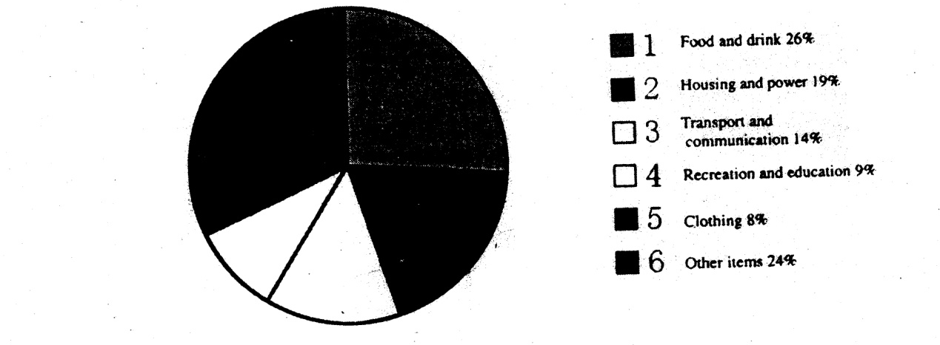
Food and drink, Other items covered comparatively a majority of the Average weekly expenditure, at 26% and 24% respectively.
小作文时态：
1.过去时——过去时间
2.将来时——将来时间
从过去到将来——现在时
3过去进行时
4现在完成进行时
两种禁忌时态：
- 现在完成时（描述阶段）
Since 1970, there has been a large increase in ______.
最后段文字总结的时候可能会用到现在完成时
- 现在进行时
On the other hand, Recreation and education, Clothing accounted for a small portion of the expenditure, at 17% altogether/en masse.
“累加”的写法：
totaling 17%//amounting to 17%//adding up to 17%//with a total of 17%//equaling 17%//summed up as 17%//put together as 17%
When added up, they amount to ___19% of the expenditure was shared by Housing and power. Furthermore, the remaining 14% was due to Transport and communication.
两个饼状图的写作顺序：
- 先写一个，另一个再比
- 直接联动
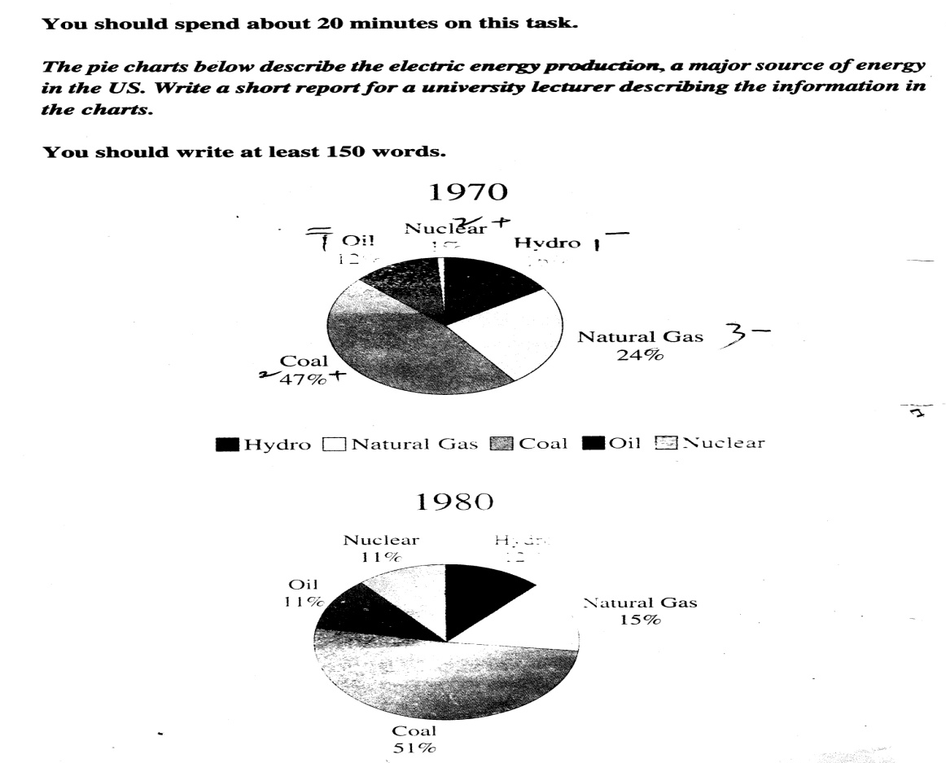
Coal occupied the maximal portion//was the biggest instrument of the sources of energy, at 47% while Nuclear accounted for a tiny share, with only 1%. Furthermore, 28% altogether of the energy was shared by Oil and Hydro. The remaining 24% was due to Natural Gas.
Task 1的五种基本句型：
- In 1980, the percentage of Coal increased/crept up by 4%//to 51%.
- There was an increase/creeping-up of 4% in the percentage of Coal.
- We can witness…
- The year of 1980 (Place) witnessed/reflected/saw/signaled/found …
eg. New York witnessed an unprecedented economic growth in the 21st century.
- A outnumbers/ out percentage B by…
A比B大3000. A outnumbers B by 3000.
A比B大20%. A outpercentages B by 20%.
A: Coal in/of 1980
B: that in 1970=its counterpart(in 1970)对等物
eg. Coal in 1980 outpercentaged its counterpart by 4 percent.
Coal was the biggest/leading//predominant/outstanding/striking instrument among its counterparts，while Nuclear skyrocketed by 10 times.
the percentage of Nuclear was 11 times//eleven-fold that of its counterpart
There was an increase of 10 times in Nuclear.
We can witness …
The year of 1980 witnessed…
Coal in 1980 outpercentaged its counterpart by 10 times
Oil almost remained stable.
There was a decrease of 4% in the percentage of Hydro. In addition, the year of 1980 witnessed a slump of 9% in Natural Gas. What is worth mentioning is Oil was almost morose during the decade.
Through the charts, we can easily draw the conclusion that the new source of energy, particularly Nuclear was given full play while the traditional ones, though still dominant, reached their bottleneck/ceiling to some extent.
两个图的写作原则：3+5
第一张图——3句万能句型
第二张图——涨/跌/平的比较，5个数据。2涨+2跌+（1平）
数据很多的时候，第一张图分三种情况：
最大的——2号句型
最小的——1号句型
中间的——3号句型
Social…, ad, edu, sci cover comparatively a majority of their main fields of study, at …respectively, while 2.24%, 1.84% and 2.10% are shared by... The remaining percentages are in moderation, at 5.53% for , 7.4% and 9.35% respectively.
increase max:
min Social Science
Comparatively a majority of Australians aged between 55 and 69 chose Social Sciences, Arts, Engineering, Administration and Education as their main fields of study. On the other hand, Veterinary, Agriculture and Architecture became the least popular subjects to be majored in, accounting for 2.0% and 2.96% respectively. The remaining statistics were in moderation, with an approximate share of 11%.
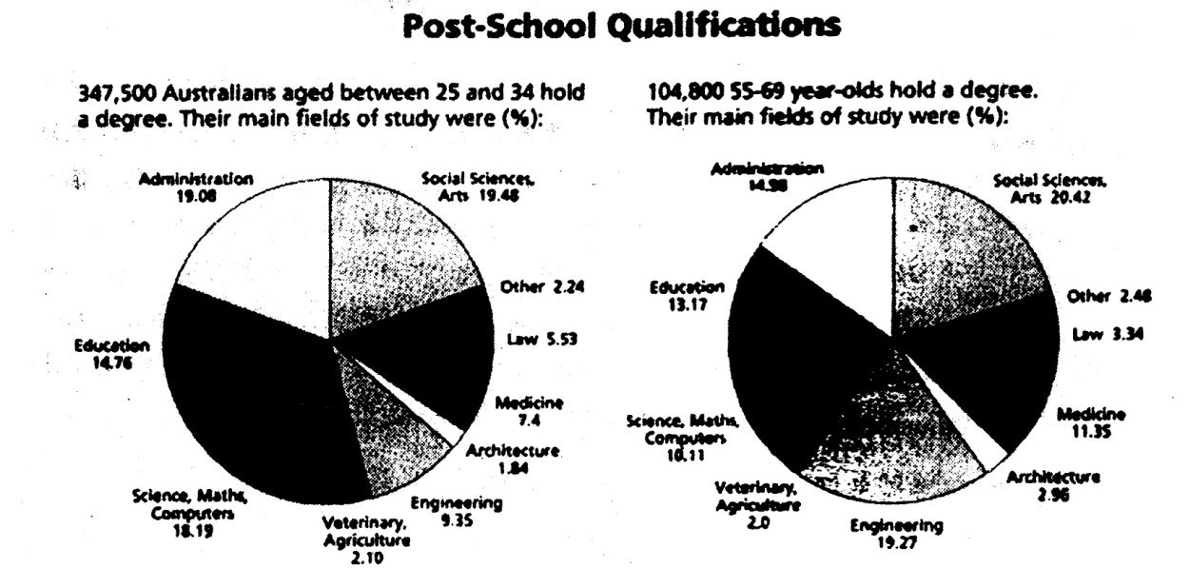三个（以上）图的写作原则
分两段，先写最早的。
直接联动（曲线图写作模式）
四个（以上）图的写作原则
参考剑7第四篇，从时间和空间上分析，先时间后空间进行分析。

饼图总结：
一个图：3句万能句型
两个图：3+5
三个图：分两段，先写最早的
四个图：从时间和空间上分析，先时间后空间进行分析。

2. Line Chart
曲线图写作模式：（动态图的写作模式）
要求：1）天龙八部的运用， 10篇以上
2）总分部分，先宏观概括，在作出阶段性的分类。
方法：
1.形态划分：根据四大基本形势变化或者变化的程度进行划分。
eg:汉堡销量图
The graph below shows Harry’s annual sales of hamburgers in 1998. Write a report for a university lecturer describing information shown below.
HARRY’S annual sales of hamburgers (1998)
3000
2500
2000
1500
1000

Jan Feb Mar Apr May Jun Jul Aug Sep Oct Nov Dec
Para 2:总分句
All trends(动态)/statistics(静态)/charts(多图) can be categorized/classified into ____ stages(时间)/groups(无时间)/types(多图) with (“general” trends or characteristics).
General trends=junk words
with fluctuating from Jan to June, rising sharply from June to Aug, falling sharply from Aug to Oct and rising gently from Oct to Dec.
with fluctuating from Jan to Jun, rising from Jun to Aug, Oct to Dec, falling from Aug to Oct.
with fluctuating gently from Jan to Jun and fluctuating sharply from Jun to Dec.

eg:
The graph below shows the number of people at a London underground station from 6:00 to 22:00.
Write a report for a university lecturer describing information shown below.
Number of people at a London underground station

400
300
200
100

6 7 8 9 10 11 12 13 14 15 16 17 18 19 20 21 22 Time
Both trends can be catergorized into 2 stages, with rising and falling sharply, from 6-10,16-20; and rising and falling evenly, from 11-15, 20-22.
这个例子就是水平划分法——极其复杂的图根据曲线变化的相似度进行划分。
2.点位划分法： （合并起点和终点）
with fluctuating evenly and gently from Jan to Jun and fluctuating evenly and sharply from Jun to Dec.
- 形态划分法——最简单的图
- 点位划分法——较复杂的图
- 水平划分法——极其复杂的图 根据曲线变化的相似度进行划分。
- 比较划分法——两根曲线
Comparative Classification:
popularity of
- predominance/prevalence of
- preference to
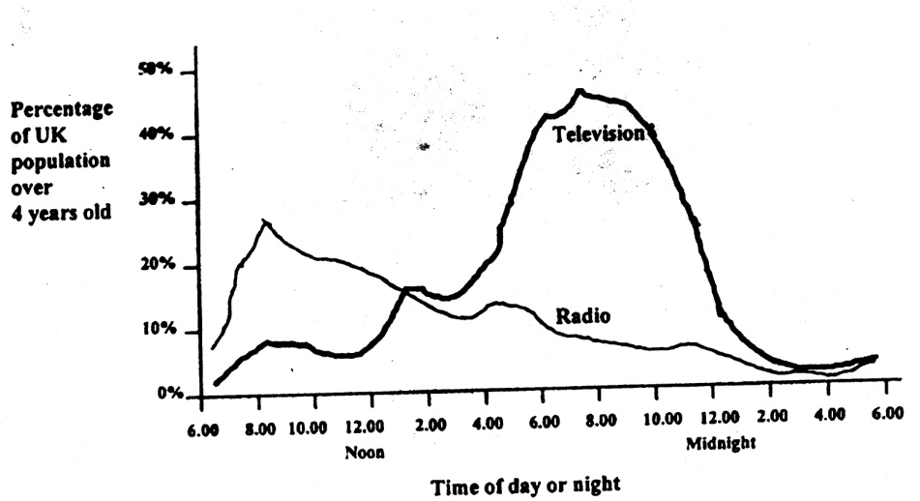
All statistics can be categorized into 2 stages with the popularity of listening to radio/predominance of radio audiences/preference to listening to radio from about 6 am to 1 pm and the popularity of watching TV/predominance of TV audiences during the rest of the day.
单线//分线描写（天龙八部）
As to the radio audience, it soared from about 6 am to 8 am, reaching the peak at about 25% at 8 am, followed by ebbing till the end of a day. We can witness the nadir occurred at around 4 in the morning.
Back to the people watching TV, most of them watched TV from 5 pm to 12 am. The trend almost rose and fell evenly with sharp rise and fall. 8 in the evening was the peak hour for people to watch TV. Furthermore, after 3 am, less than 5% of people would listen to radio or watch TV.
What is worth mentioning is that 8 am and 8 pm are the peak hours for people to listen to radio and watch TV respectively.
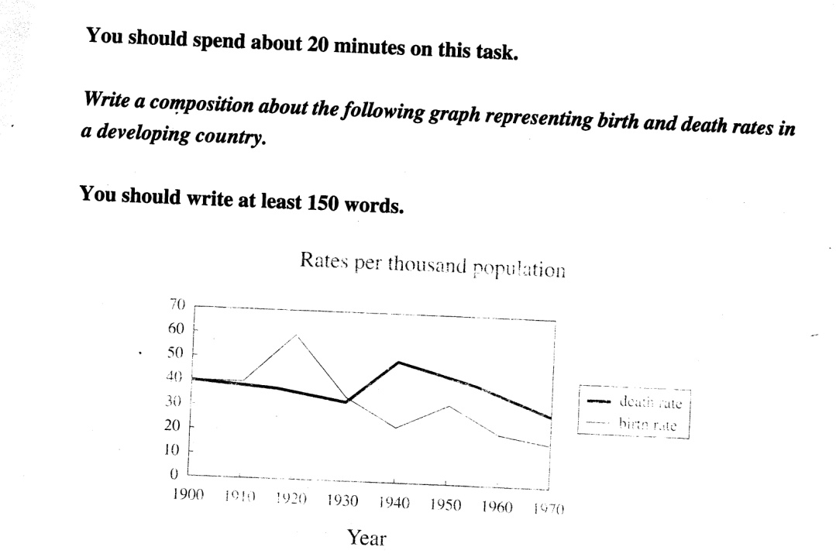
All statistics can be categorized into 3 stages with the equilibrium均势 of/between the birth and death rates in the first decade of the 20th century, the predominance of birth rate in the following two decades, and the predominance of death rate from 1930 to 1970(in the consecutive 40 years).
As to the birth rate, stabilization in the first ten years was followed by leaping to its zenith at 60 per thousand in 1920. We can witness a clear slump to almost one-third of the zenith in 1940. The next 20 years reflected an even rise and fall. Finally it abated to the trough in 1970.
Contrary to the birth rate, the death one continued to creep down after the overlapping period till 1930, when a rally was shown between 1930 and 1940. Fortunately, fewer people died in the rest years, with ebbing to the nadir in 1970. What is worth mentioning is that both birth and death rates reached the bottom level in 1970.

As to death rate, it abated from 1900 to 1930, followed by soaring to its peak at 5% in 1940. We can see an ebbing till 1970.
In the respect of birth rate, the first decade witnessed stabilization, followed by leaping to its peak/zenith at nearly 6% in 1920. It slumped to 2% in 1940 and rose and fell evenly in the next two decades. Finally it had the similar trend with its counterpart, death rate.
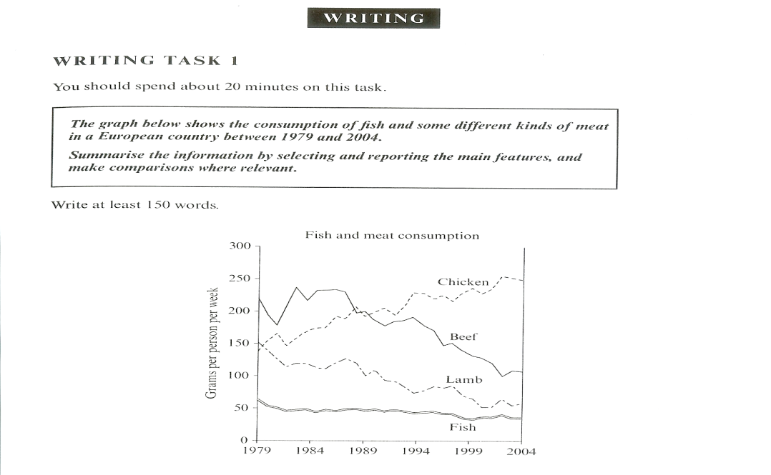
Chicken 再涨， Fish变化不是很大
剑7test2 第四篇练习。

3.表格题
数据很多，大概20多个
描述的主线是时间线。非时间线作为副线。横向纵向皆以时间线为主。
The first chart below shows the results of a survey which sampled a cross-section of 100,000 people asking if they traveled abroad and why they traveled for the period 1994-98. The second chart shows their destinations over the same period.
Write a report for a university lecturer describing information shown below.
VISITS ABROAD BY UK RESIDENTS BY PURPOSES OF VISITS(1994-98)
 | 1994 | 1995 | 1996 | 1997 | 1998
Holiday | 15,246 | 14,898 | 17,896 | 19,703 | 20,700
Business | 3,155 | 3,188 | 3,249 | 3,639 | 3,957
Visits to friends and relatives | 2,689 | 2,628 | 2,774 | 3,051 | 1,181
Other reasons | 982 | 896 | 1,030 | 1,054 | 990
TOTAL | 22,072 | 21,610 | 24,949 | 27,447 | 28,828
这张图的重点是横向。
Basically soared, almost soared, or soared except in 1995.
下面这张图正好相反，纵向比较重要。
DESTINATIONS OF VISITS ABROAD BY UK RESIDENTS BY MAIN REGION(1994-98)
 | Western Europe | North America | Other areas | Total
1994 | 19,371 | 919 | 1,782 | 22,072
1995 | 18,944 | 914 | 1,752 | 21,610
1996 | 21,887 | 1,167 | 1,905 | 24,949
1997 | 23,661 | 1,559 | 2,227 | 27,447
1998 | 24,519 | 1,823 | 2,486 | 28,828
This is the similar trends of sth.
Sample
You should spend about 20 minutes on the task.
The table below shows the average family expenditure in Britain.
Write a report for your teacher describing in the information shown below.
You should write at least 150 words.
Average family expenditure in Britain (%)
ITEM | 1967 | 1977 | 1996
Food | 21 | 19 | 18
Alcoholic drink | 7 | 7 | 4
Tobacco | 6 | 4 | 2
Clothing and footwear | 9 | 8 | 6
Housing | 12 | 14 | 16
Fuel, light and power | 5 | 5 | 4
Household goods and services | 10 | 7 | 14
Transport and communications | 9 | 14 | 16
Recreation, entertainment and education | 7 | 9 | 11
Other goods and services | 14 | 12 | 8
Other items | -- | 1 | 1
该图中横轴概念是主线。
Food always accounts for the largest portion of the expenditure.
先趋势后数据
- 先趋势
左边标编号： food跌，写1， 1表示第一种变化，趋势。后面下跌的都标1.最多标到4.
总分句：all trends can be catergorized into four groups. With falling in items such as food…. rising in items including housing, fluctuating household goods and services , and stabilizing in other items.
- 后数据
表格右边，记住编号代号。1.极端数据，2. 范围 3 . 平均值
类比可不标4直接连在一起。反比连在一起，后面写一个“反”
以上是表格题动态图。
下面是表格题静态图：
The table illustrates the information of the countries of Madagascar and Mauritius around the Indian Ocean with the following statistics in 1999
Write a report for a university lecturer describing the information shown below
 |  | Madagascar | Mauritius
surface area(km2) |  | 12823 | 2189
population(thousands) |  | 2678 | 456
GDP(US$ per capita) |  | 120 | 360
growth rate of population |  | 12% | 2%
enrolment of school: | primary | 97% | 99.52%
enrolment of school: | secondary | 51% | 73%
表格静态图： 使用纯比较原则，因为无法单独罗列数据。
数字系统比较：较数据大小的两种形式：1. 多少 2. 倍份
文字系统比较：静态图使用占50%。
Sample: Writing of FAQ for IELTS Task 1
Passage 2
The table makes a detailed comparison and contrast of different items of Madagascar and Mauritius around the Indian Ocean in 1999.
Madagascar was leading in the following items: surface area, population and growth rate of population, which was almost 6 times that of the Mauritius. The surface area of Madagascar reached 12823 km2 while that of Mauritius only accounted for 2189. The percentage of growth rate of population covered 12%, 5 times above that of the counterpart.
However, some of the indexes were led by Mauritius. The GDP per capita of Mauritius amounted to 360 US$, three times that of Madagascar. As for the percentages of enrollment of school, Mauritius also outpercentaged Madagascar in primary and secondary school. The difference was 2.52% for primary school and 22% for secondary school.
What is worth mentioning is that the indicators of wealth of a country are contradictory with the statistics of population and growth rate of population.
WRITING TASK 1(Passage 5)
The table below shows the kilometers of route, date opened and passengers per year (unit: thousand) of the underground railway system in 6 cities.
 | kilometers of route | date opened | passengers per year
London | 1997 | 1878 | 1900
Paris | 1503 | 1900 | 2400
Tokyo | 1122 | 1917 | 3996
Washington | 400 | 1945 | 300
Los Angles | 15 | 1967 | 400
Miyazaki | 11 | 1978 | 122
考察横向纵向的描述顺序，静态图。

文字系统常用的表达：
- Be given full play.
- Be attached a more importance to
- Maintaining a momentum
剑7 第二篇 Chicken consumption is attached more importance to.
Chicken gained upper hand to beef.
There is equilibrium between A and B.
最后看两个词：
Imparallel: there is an imparallel gap between A and B.
Unrival: number1 . A is unrivaled among sth.
Counterpart: 一般的小作文基本上会用到。
Chicken’s consumption is unrivalled among its counterparts.
We would be optimistic/ pessimistic about sth.
Sth would foresee a bright future.

4.柱状图
本质是其他三个题型的柱子版
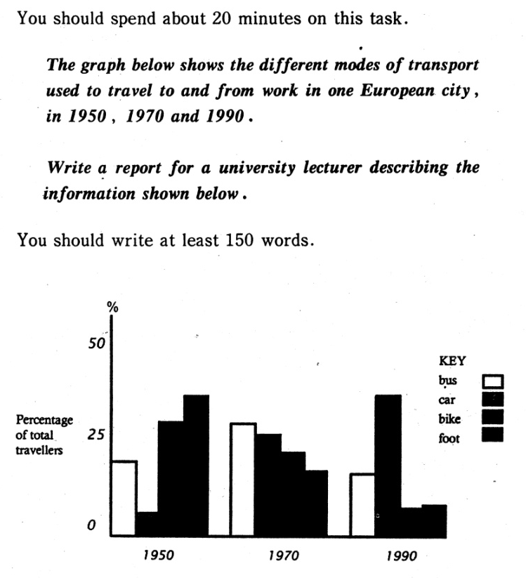
百分比
All trends can be categorized into 3 groups，with fluctuating in bus, rising in car, and falling in bike and walk.

- 小作文整体写作框架
Opening: 不要说的太详细（时间、类型、单位、趋势）
    - Vary /differ
    - paraphrase
    - Glance at the bar chart,
    - 图与图之间没有联系的加上respectively.
    - As it shows in the bar chart, (中国和英国的四大行业)
    - The percentage of total commuters in Europe city
    - 真假主语自己通过语义判断。
通过剑桥练习OPENING 的改写。
    - Body: 形态划分是主流 （两线相交用比较划分法）
    - Statistics: 雅思对主体段的分段比较松，不同类型图标分段写，同类型的也可分开写，分层次。
    - 反义词的题目需要注意。
    - Debut现象，food那张表。
    - Ending :小作文就是量的问题。
流程图写作技巧：包括流程图加上地图题
Opening:按格式去套
Body：按顺序原则写（as to, as for , in regard to, concerning, on sth, given）
Ending: through a brief introduction of sth, we come to realize that..
Having a general glance of sth.
实例分析：剑六蚕丝制作。
不要花太多时间在结构上。
涉猎的语法现象：
- 被动语态： put in to the basket, the eggs..
- 定语从句：减少主语重复
- 状语从句：时间、地点、方式、原因、结果、目的
- 分词短语
- 介词短语：with , by ,through , to
五个重点：
1. 整体格式
2 句式的丰富
（被动语态、过去分词、定语从句、状语从句、分词短语、介词短语）
3. 过渡的自然：
4. 词汇量的拓展
5.适当的展开加联想
实例分析：剑六蚕丝制作。
这里分析有关瓶子的作文
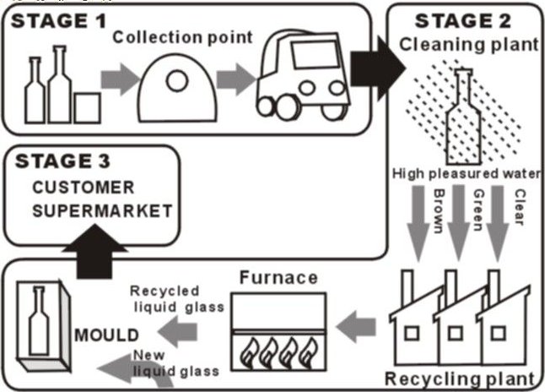
There are 3 stages.
Stage1:
So that they are easily transported by trucks or vans .
In the second stage, they get high pressure water.
There are 3 different channels in the plant, which represent 3 different colors of the glass, or three tenors. After recycling in the furnish, glass products are melt into … compound is finally modeled into solid.
Thus the glass will go to the customers for different purposes.
地图题重点：1.方位词汇准备好 lie, be located in , sits in , Appear, disappear,
2.注意设施的有无增减
TASK1.总结 ：20分钟按顺序做，F415篇以上，流程图练习四到五篇。

TASK2: 雅思大作文的讲解：
上来先读最后一句， 马上知道题型。
discussive: 无限制模式、双边模式
To what extent Do you agree or disagree?
What’s your opinion?
1.单边同意， 2.单边反驳
3. 三七开的双边 4. 五五开中立
题型：（0:19 处）4大类
1、2单边
3、4双边
段落数的分配：雅思个性化在语言文字
单边写：opening+两到三段+ending
B+AA : 先写弱势，再写优点
AA+B: 先写优势，再写弱势
双边模式：
双边写： opening+两端（70﹪）/一段（30﹪）+ending
Agree or disagree题型：两个观点是互斥，先读大学还是先工作
Which opinion do you prefer? Which is your favorite opinion?
biased, partial
评分标准： TR:2-9分
CC:
CRA:
- 读题目先读最后一句
- 大作文至少250个字，下载纸。
- 格式错误，注意格式，格式有两种：
1. 顶格写，段与段之间空一行
2. 段首空四个字母
题型判断失误
没有切中文章主题
雅思大作文整体结构：
- opening: 3-4句话,50-70字。
General situation: 总的局势的介绍，引出主题。
Discussive的写法：
改写：1.同义字 2.词性改动 3.语态改动： 主动变被动
2. body：
3. ending：2+2+2

十大主题的关系：
雅思大作文十大主题的关系：
- 首先去掉4号球和7号球
- 4号球 媒体：traditional media（TV、newspaper、books）基本划分到口语，不需要花太多时间
Multimedia（Internet、computer、digital device）在5号球科技里面 包含
- 7号球 hobby：主要在口语部分
- 然后是8号球和10号球：被其他球（话题）代替 或者扩充
- 因此基本上只要准备6个话题：1、2、3、5、6、9；其中以1、2、3、5四个话题占主要的部分，约占90%，因此以此为讲解的主要内容
1、身价规划
2、基础设施
3、抽象题
5、科技
剩余6、9了解和流程图比例差不多

1号球： 教育方面：老师功能、知识pk经验、少小离家（abroad、away、leave）利弊
1) 老师的功能：pk电脑等。
a-传授知识
b-学习方法
c-人生的解惑
- key words：
- qualified(合格)teacher： import (传授)or cram(填鸭式)(教授知识);
- experienced or senior teacher：关键是可以improve study motivation和good habitat;
- mentor：人生的指引、生涯规划、职场规划 ，是最高级super teacher ，soul- mate知己spiritual friend
- lecture : 要不要废除，teacher通过lecture传授知识；不够，还有互动的课程，谈老师第二功能； counseling 毕业后规划等，以身分享
- 家人和老师的角色who好：老师功能写出；老师厉害点，更专业；家长也是老师，家长接触时间早，时间长
- 学习在学校好还是家里好：混答题，家里主要通过电脑 网络等科技了，而campus主要是老师，老师的三个功能，想写2、3点，可以单面沟通，学校可以和学长、同学交流
- 网络的优势：versitality 多种多样、instant 更新速度快、多媒体的好处
2) 知识pk经验（重点）：通常偏向一边写，两者各自的功能
- 知识：横向和纵向功能，对社会竞争和职场规划很重要，专业知识是立足社会的基础、知识需要更新，不然会abandoned
纵向的生存和横向的sustainable 构成知识的两个重要的好处
- Specialist or generalist：纵向是专才，professional与时俱进/学科前沿/专家，诺贝尔通常表彰专才
- 通才功能：未雨绸缪，通才会比较容易适应环境，是社会持续发展必不可少的
- 可以各写一半，都很重要；或者偏向专业，
- 学生根据各自爱好分班好坏：分班是专才，不分的就是通才. 专才和通才各自的优势，通才的适应性，in the long run 前途无量。成功人士是否永远成功：是—通才，不是-专才，without update 就不行了，discarded by the world –奶酪理论；更新就可以了，举例：先成功后失败的案例 以及以前成功后来还成功。
- 经验：实践是检验真理的唯一标准 accuracy；眼泪是检验幸福的唯一标准。Career path is the minor of checking the quality of oversea study！留学看以后的职业
科学定律一开始都是错的，后来对的 “日心说”。
- 对知识的反作用力：目标更明确 ，出国，如：管理---财务管理
- 效率、 学的时候不懂 工作后就懂了。
- 经验要凌驾于知识之上
3）少小离家：leave 、abroad、away
3好2坏
- 3好：
- 眼界scope、horizon；积累知识，各种知识；个人阅历
- Independent，生活自理
- 超能力：人脉积累、同学会，校友会；兼职 college ；邻居 关系
- 鉴定自己的性格，决定职场方向；
- 2坏：
- 缺乏社会经验，社会不良的势力，遇到挫折，导致学习分心，误入歧途。
- 单纯性下降 simplicity 小童星长大后下降 flexible下降。
2号球：基础设施
1）solid infrastructure 自然界即社会问题：交通、环保、城市规划
2）soft infrastructure 反社会的一些话题 Social evil：妇女青少年犯罪、孩子体罚。
话题1：交通拥挤
- 政府最大的责任：政府缺乏基础设施建设，traffic planning、traffic singal、transport tools /Facilities、education、supervision、affection：很多的社会问题都是缺乏社会监管、家庭关心、父母不了解小孩为什么看暴力电影、法制（law、stipulation、regulation、rules）野生动物法、森另管理法、交通法等等。
政府缺乏“建管法”
媒体、家长：权威机构、监管不力、社会治安–公安不力。
- 2、个人公民意识：Sense of responsibility 道德、素质。
四大意识：责任 道德 自律 可持续发展

1-交通traffic security
2-EP 环保意识：
妇女犯罪：现在主要不是缺乏法律意识 而是自律和EQ；很多social evil都和自律有关
Sustainable development 之追求眼前利益 忽略长远的利益
建议：税收/投资 学校 无形的东西（师资力量、教材和设施更新），不能一篇论文定终生
- 颁布相关的法律，加大力度；
话题2、穷国越穷，富国越富：经济全球化、历史上的资源掠夺、政治上的霸权主义
- 权威机构：undeveloped transportation technology 资金资本 人才 人最重要；但是人往高处走，易外富国去
- 可持续发展意识，一味追求GDP 破坏环境和人的身体健康；自杀式的发展
- 缺东西 缺意识 警察要不要佩戴枪支：不要，社会治安问题，找其他的solution 又回到law上了

3号球-抽象题
话题1：压力来源
理念：从physic到 mental
1-不良的作息习惯
2-营养物的功能
3-body building
4-财富的功能
5-创新hobby
6-art and music
解决方案：营养元素、锻炼、财富 、hobby relieve the stress 陶冶情操
话题2、幸福定义不一样
每个人定义不一样：有钱、健康、精神追求和充实
话题3：关注现在还是未来
现在的人民生活水平，未来的建设，可持续发展
人民的精神追求和艺术追求

5号球-科技 （比较好写的）

学术类大作文（议论文）

- (ETHIC)
In some country women should be allowed to join the armed forces, while someone think women don’t suit for army. Do you agree or disagree? Use your own experience and reasons
- (CAREER DEVELOPMENT)
Some people think the university education should prepare students for future employment, others think it should have other functions. Discuss and say what other functions you think the university should have.
- (CAREER DEVELOPMENT+SCIENCE AND TECHNOLOGY)
In the modern world, the school has become unnecessary for children to study at, they can use internet which has a wide range of information available for children so that children can study at home instead. To what extent do you agree or disagree?
- (ABSTRACT)
Today, people are getting greedy and selfish. Some people argue that we should attempt to go back to the older day, and show respect for the family and community. So we can make the world better to live. To what extent do you agree or disagree?
- (INFRASTRUCTURE)
The environmental problem is so serious to most countries and individuals that to solve it should be based on the international level rather than individuals and individual countries. Do you agree or disagree with the opinion?
- (SCIENCE AND TECHNOLOGY)
Motorized flight is the most important invention in the modern world. Not any other invention has had such a significant impact on our lives. To what extent do you agree or disagree?
- (INFRASTRUCTURE)
Police in Britain do not carry guns. Some people believe that it will make citizens unprotected, but others suggest that it would reduce the violence in society. Discuss those two views.
- (GLOBALIZATION)
International tourism is now the world’s biggest industry. Unfortunately, it creates tension more than makes people understand the different culture. To what extent do you agree or disagree with the opinion?
- (INFRASTRUCTURE)
Traffic and housing problems in major cities could be solved by moving big companies, factories and their staff to countryside. To what extent do you agree or disagrees with this point of view?
- (MASLOW’S THEORY)
Human beings landed on the moon thirty years ago. It cost plenty of money and resources to develop the space technology. Do you agree or disagree that people should do that?
- (INFRASTRUCTURE)
Many old buildings are protected by law because they are part of a nation's history. However, some people think they should be knocked down to make way for new ones because people need houses and offices. Do you think it is important to maintain old buildings? What kind of solutions can you suggest to alleviate the problem?
- (INFRASTRUCTURE)
Police in Britain do not carry guns. Some people believe that it will make citizens unprotected, but others suggest that it would reduce the violence in society. Discuss those two views.
- (MASLOW’S THEORY)
Some people say the government shouldn’t put money on arts such as music and painting, instead, they should spend more money on construction of public facilities. Do you agree or disagree with the opinion?
- (INFRASTRUCTURE)
Nowadays, the increased demand for fresh water has became a global problem, discuss the causes of the increased demand and what measures should government and individuals do to alleviate this problem?
- (SCIENCE AND TECHNOLOGY)
Someone maintained computers are less helpful to children's study and they have a negative effect on children's physical and mental development. Do you disagree or agree with the statement?
- (INFRASTRUCTURE)
The government should control the amount of violence in films and on television in order to decrease the violent crimes in society. To what extent do you agree or disagree with this issue?
- (GLOBALIAZTION)
Advertising plays a significant role in the promotion of products, while it may discourage us from being different individuals and act what it want us to and look upon things in a similar way. How far do you agree with the opinion?
- (GLOBALIAZTION)
Some people say that the increasing business and culture contacts between countries have a positive effect on global development, others say it would the identities of countries can be lost due to the progression. Discuss both sides and give your opinion.
- (SCIENCE AND TECHNOLOGY+MEDIA)
Many people think public libraries should provide only books and shouldn't waste their limited money on expensive hi-tech media such as software of DVDs or videos. What’s your opinion towards the statement?
- (INFRASTRUCTURE)
As for the fact that some people dare not go outside at night for fear of violent crimes incurred, someone maintain more actions and precautions must be adopted to prevent crimes while others believe it will be of no use. Which opinion do you prefer to?
- (COMPARE AND CONTRAST)
Air transport is increasingly used to export types of fruits and vegetables to countries where those plants cannot grow or out of season. Some say it is a good thing, but others consider that this use of air transport can’t be justified. Discuss both views and give your own opinion.
- (ABSTRACT)
Nowadays advertising is employed frequently to customers. Some think the positive effects of advertising outweigh the negative effects. To what extent do you agree with the opinion?
- (CAREER DEVELOPMENT)
Schools should teach children the academic subjects which will be beneficial and helpful in their future career, so other subjects like music and sports are not important. To what extent do you agree or disagree with the opinion?
- (GLOBALIAZTION)
With the progression of globalization, at least several languages die out every year, which is a loss to the cultural heritage. Yet, there is some voice claiming it is not important and global communication would be facilitated by less diversity of languages. To what extent do you agree or disagree？
- (SCIENCE AND TECHNOLOGY+CAREER DEVELOPMENT)
Many people use distance-learning programs such as study material post，TV and Internet to study at home，but some people think that it can not bring the benefit as much as attending college or university. Do you agree or disagree with it?
- (ETHIC)
Parents and teachers make many rules for children to encourage good behavior and to protect them from danger. However, children would benefit from fewer rules and greater freedom. To what extent do you agree or disagree？
- (CAREER DEVELOPMENT)
Nowadays, someone believes college students should focus on the specific subjects, others claim that university should encourage them to study the whole range of the subject. To what extent do you agree with the opinion?

