1．


2．
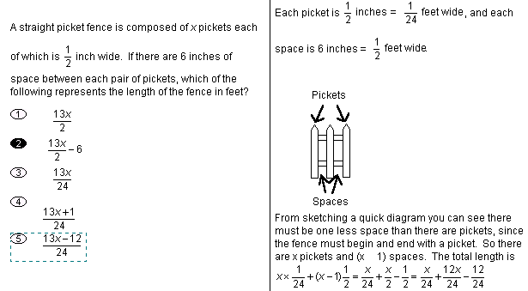
1 foot =12 inches =0.3048 meter
1 yard =3 feet =0.9144 meter
1 inch =25.4 mm

3.
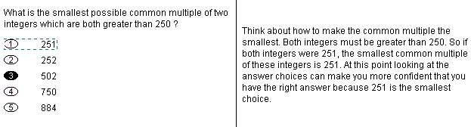

4.

